**N-Puzzle**

**Team members:**

* **محمد رفعت ابو الحمد حمدان 20191700903**
* **يوسف محمد جمعه محمد 20191700785**
* **محمد احمد عبد الرحمن عبد العليم 20191700494**

**Team id: T040**

**Entire source code:**

**Class Node:**

* 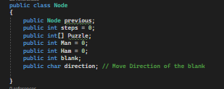**That include information of tree of moving of blank Puzzle**

**CalcMan Function:**

* 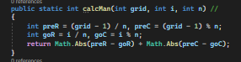**Calculate Manhattan**

**Analysis: O(1)**

**isSave Function:**

* **Check validation of one movement**

**Analysis: O(1)**

**Reading from files:**

**Reading test cases files**

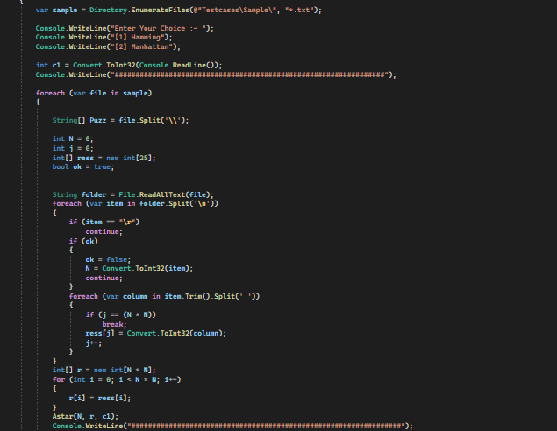

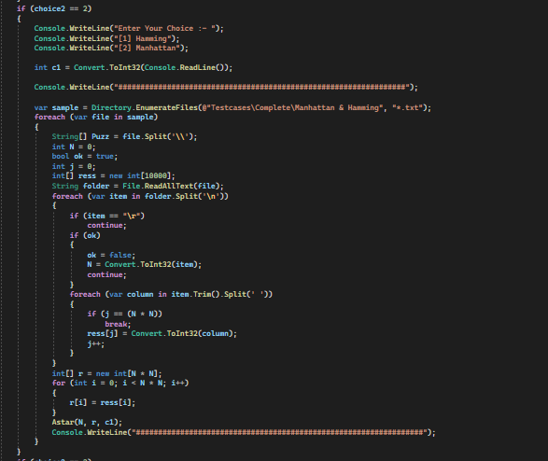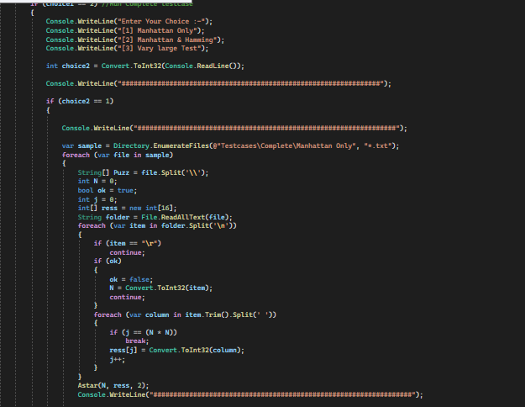

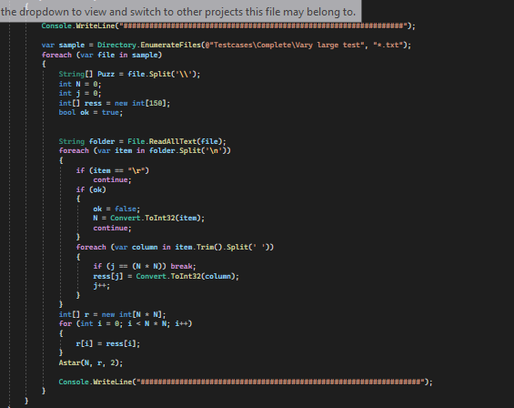

**Astar function:**

* **Check the puzzle is solvable or not**

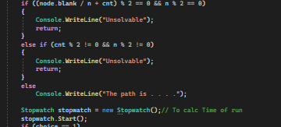

* **Solve puzzle by**

1. **Hamming**

**Calc number of misplaced items**

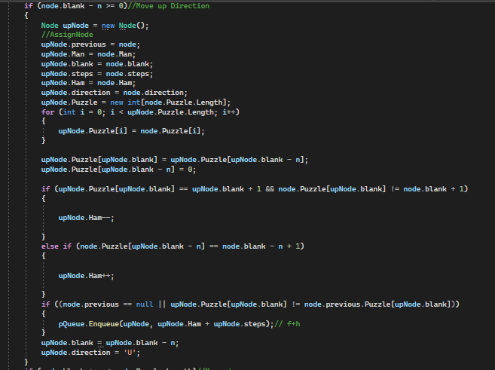**Check availability of moving blank (UP,Down,Left,Right)**

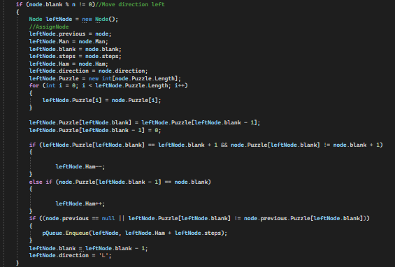 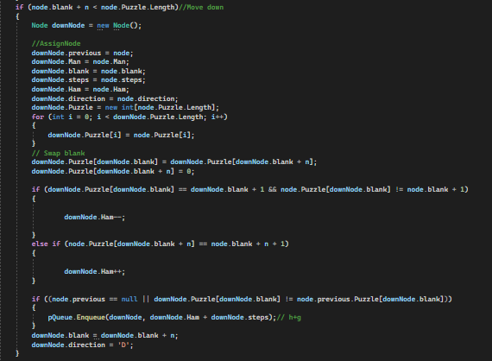

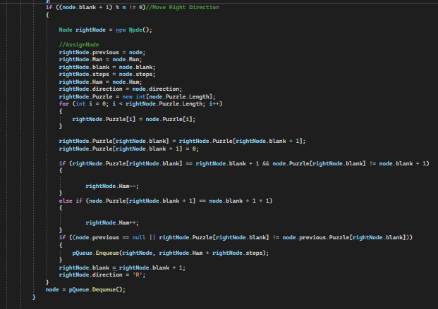

1. **Manhattan**

* **Calc distance of goal position and state position items**
* **Check availability of moving blank (UP,Down,Left,Right)**

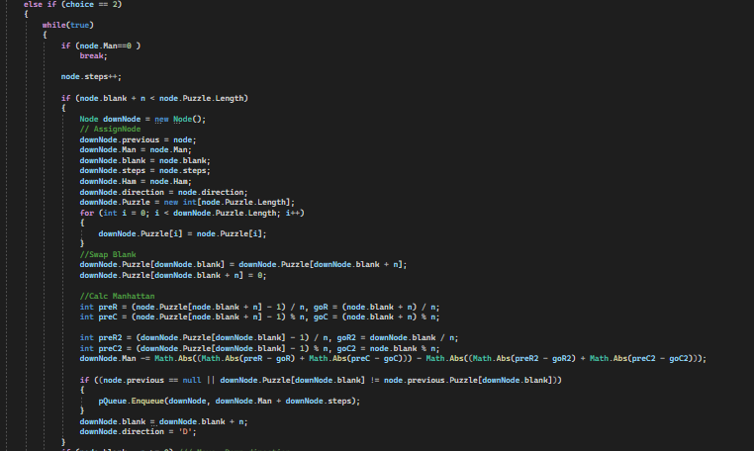

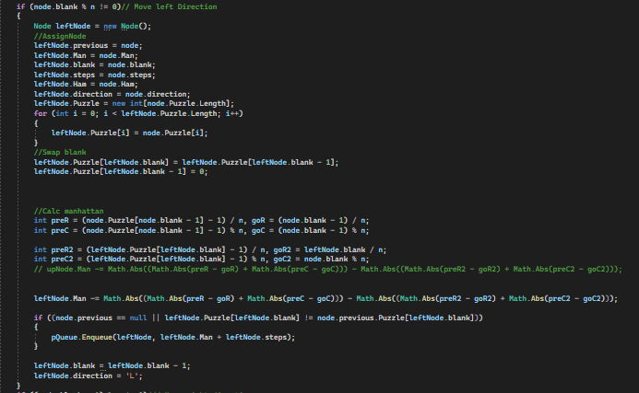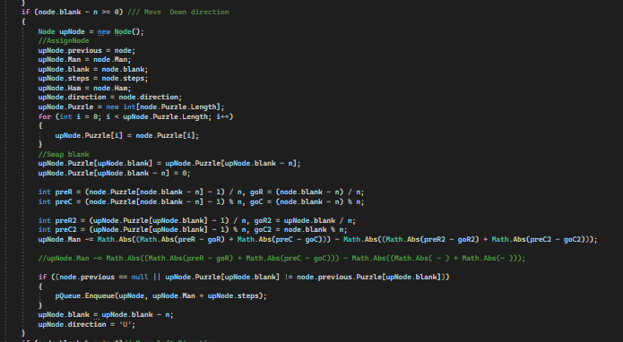

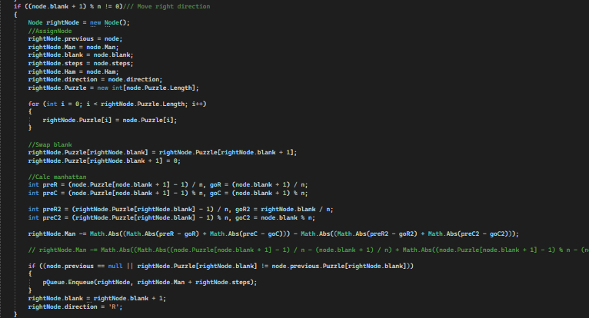

* **Add Node To LIST**

Add information of class new node to list to display it

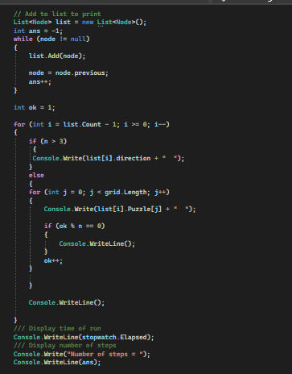

**Analysis:**

Solvable or not :O(N2)

Astar : O(E log(V))

**Test Cases time:**

**Sample**

|  |  |  |
| --- | --- | --- |
| **Test Case** | **Hamming** | **Manhattan** |
| 8 Puzzle (1) | 0.001 | 0.005 |
| 8 Puzzle (2) | 0.006 | 0.005 |
| 8 Puzzle (3) | 0.032 | 0.024 |
| 15 Puzzle 1 | 0.087 | 0.061 |
| 24 puzzle 1 | 0.221 | 0.148 |
| 24 puzzle 2 | 0.15 | 0.103 |

**Complete**

**Manhattan Only**

|  |  |
| --- | --- |
| **Test Case** | **Manhattan** |
| 15 Puzzle 1 | 4.086 |
| 15 Puzzle 2 | 0.832 |
| 15 Puzzle 3 | 0.816 |
| 15 Puzzle 4 | 24.17 |

**Manhattan & Hamming**

|  |  |  |
| --- | --- | --- |
| **Test Case** | **Hamming** | **Manhattan** |
| 50 Puzzle | 0.227 | 0.019 |
| 99 Puzzle 1 | 0.173 | 0.028 |
| 99 Puzzle 2 | 0.035 | 0.083 |
| 999 Puzzle | 0.005 | 0.005 |

**V large** : 17.18 sec

**GitHub:**

# ***https://github.com/Mohammed-Refat***

**References:**

A* Pseudocodo [**https://en.wikipedia.org/wiki/Iterative_deepening_A\***](https://en.wikipedia.org/wiki/Iterative_deepening_A*)

Solvability [**https://www.geeksforgeeks.org/check-instance-15-puzzle-solvable/?fbclid=IwAR1XzWKH3fxPFj-q7Yh5NjWyXVfh2j9OZPzOUnqzEaBgYsUd4lQ--SE1IM8**](https://www.geeksforgeeks.org/check-instance-15-puzzle-solvable/?fbclid=IwAR1XzWKH3fxPFj-q7Yh5NjWyXVfh2j9OZPzOUnqzEaBgYsUd4lQ--SE1IM8)