========================================================================== Mohamed Ahmed Mohamed Abd Elgani =
= Lab3 =
=========================================================================

1. Create function which takes number and return if this number is odd or even

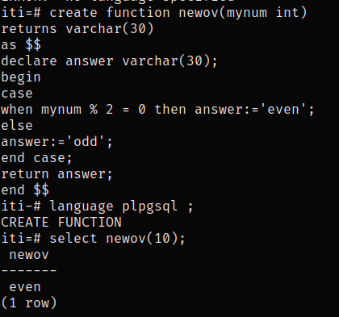

2. Create function which takes track id and return name of students in this track.

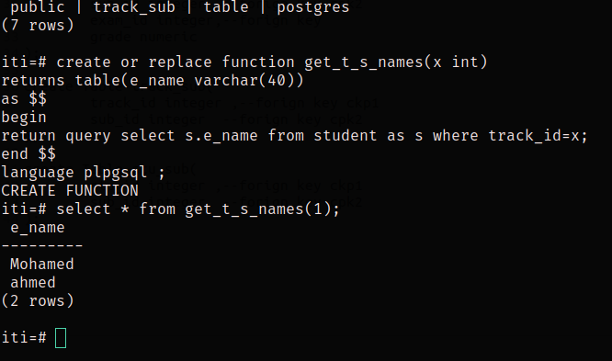

3. Create function which takes student id and subject id and return score the student in subject.

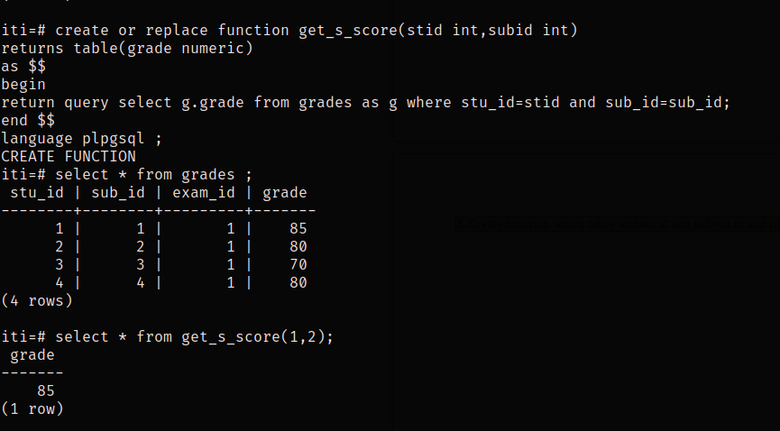

4. Create Table called Deleted_Students which will hold the deleted students’ info (same columns as in student tables).
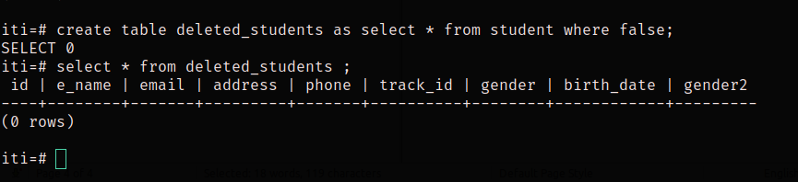
5. Create trigger to save the deleted student from Student table to Deleted_Students.

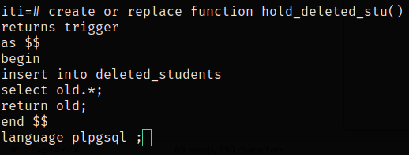

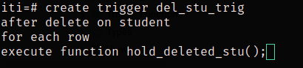

6.Create trigger to save the newly added students to Student table to Backup_Students.

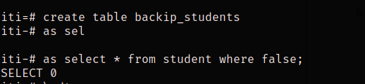
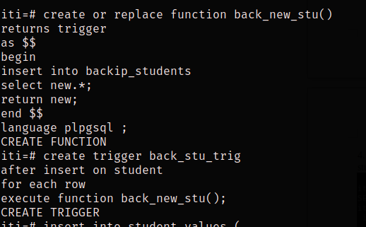

7. Create trigger to keep track of changes of student table(add/update rows). It will log the time of action and
description of action to another table.

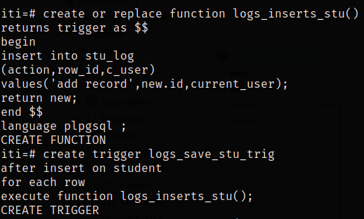
a- add trigger

b-update trigger
