=-=-=-=-=-=-==========-=-=-=-=-=============-=-=-=-=======================-=-==-= Mohamed Ahmed Mohamed Abd elgani = = Docker lab1 =
========================================================================

CMD | ENTRYPOINT
Allow us to run shell commands at startup.  -can be overridden by adding a command while starting the container.  -execute only the last CMD command. | -Allow us to run shell commands at startup.  -can’t be overridden by adding a command while starting the container.

COPY | ADD
Allow us to copy dirs and files from the local work dir to the image | Also Allow us to copy dirs and files from the local work dir to the image in addition to it can fetch files from remote urls

Problem 1:
1-Run the container hello-world

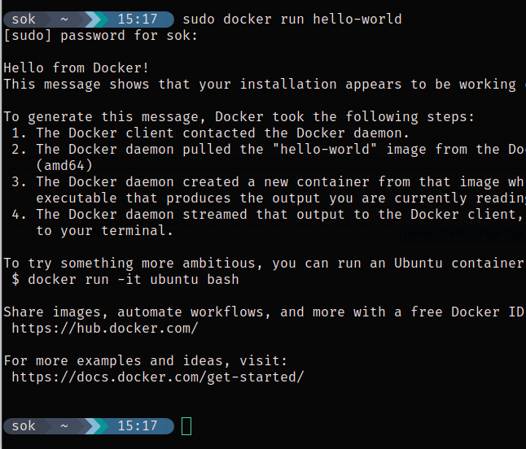

2-Check the container status &&&3-Start the stopped container
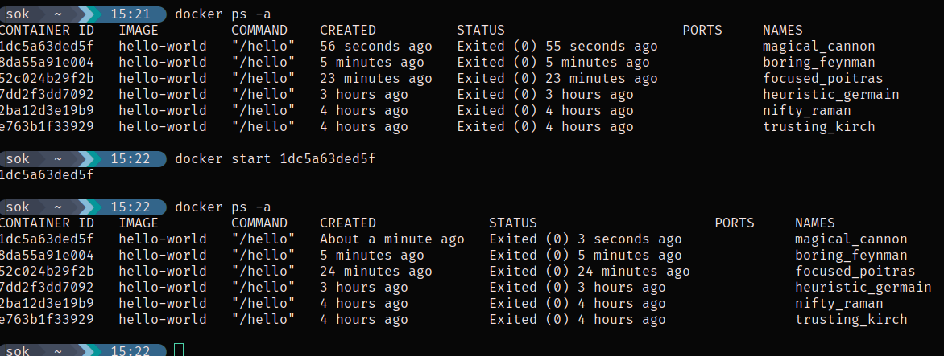

4-Remove the container
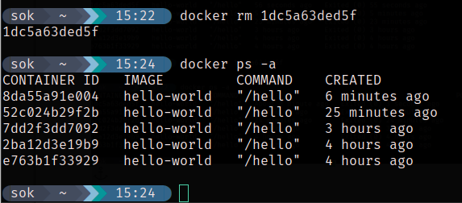

5-Remove the image

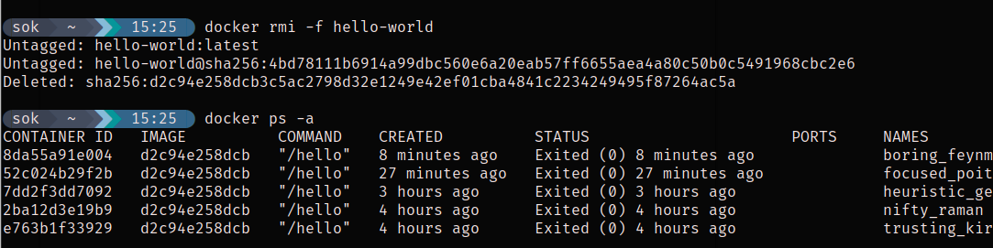

Problem 2:

1-Run container centos or ubuntu in an interactive mode
2-Run the following command in the container “echo docker ”
3-Open a bash shell in the container and touch a file named hello-docker
4-Stop the container and remove it. Write your comment about the file hello-docker
5-Remove all stopped containers
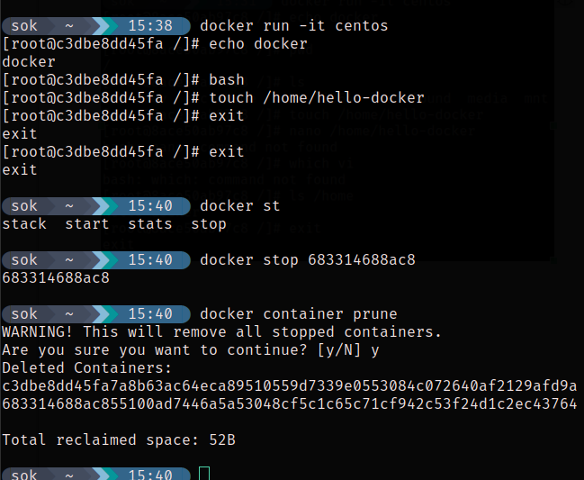

Problem 3:
Deploy a MySQL database called app-database. Use the mysql latest image, and use the
-e flag to set MYSQL_ROOT_PASSWORD to P4sSw0rd0!. The container should run in the
background.

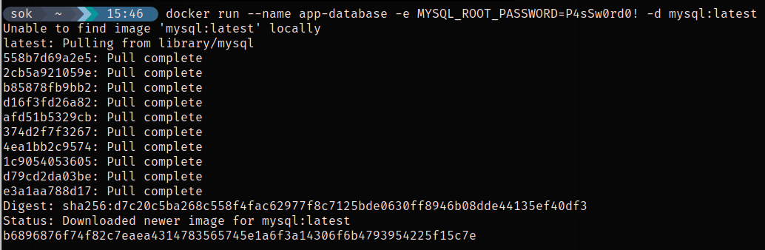

Problem 4:
Run the image Nginx
Add html static files to the container and make sure they are accessible
Commit the container with image name IMAGE_NAME

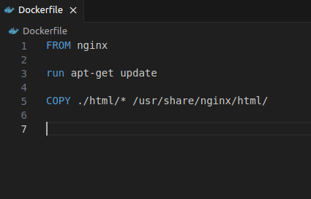

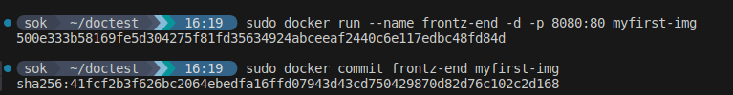

Problem 5:
Create a python simple app
Create a dockerfile to containerize the python app
Build the image and test it

Push the created image into your docker hub repo

