=========================================================================
= Mohamed Ahmed Mohamed Abd Elgani =
= lab1 apache =
=========================================================================

2. Create two simple html pages named “page1.html, page2.html” then use the suitable
directive to automatically redirect from localhost/page1.html to
localhost/page2.html.
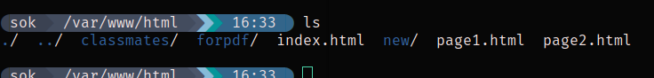
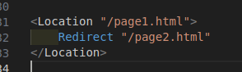

3. Ask for user name and password when accessing a directory

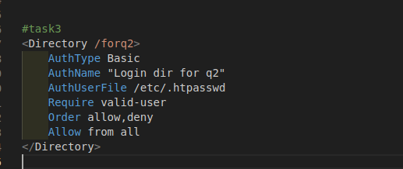

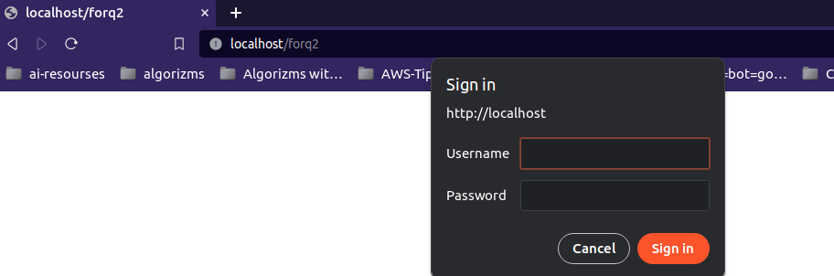

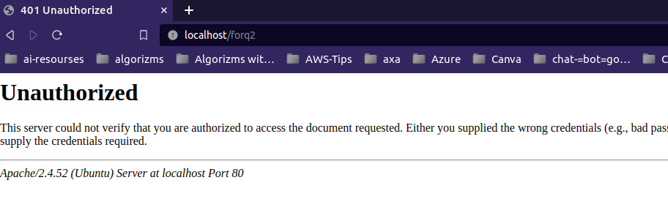
4. Apply authentication before downloading PDF files.
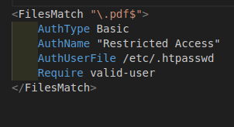

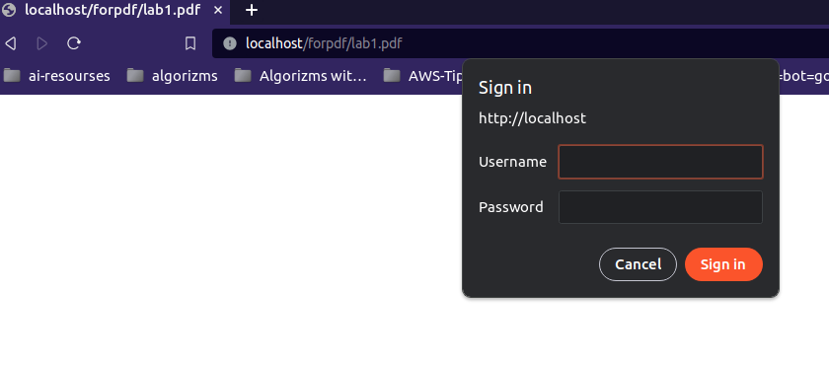

5. Create a directory then allow access to one of your classmates only.

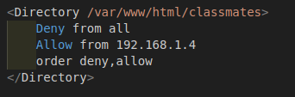

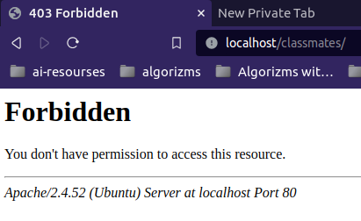

6. Disable listing the directory content (hint use indexs)

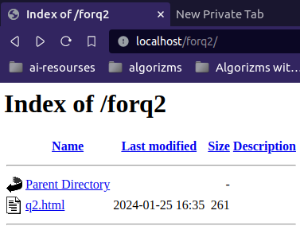
before --→ after
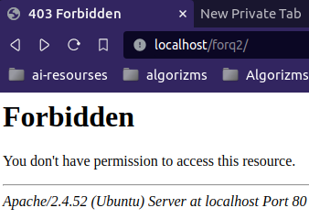

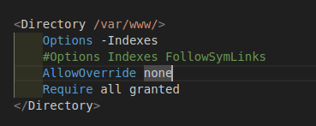

7. Change the default index page to be default.html instead of index.html (use
DirectoryIndex)
