=========================================================================
= Mohamed Ahmed Mohamed Abd Elgani =
= lab2 apache =
=========================================================================
1. Configure apache to use Worker MPM
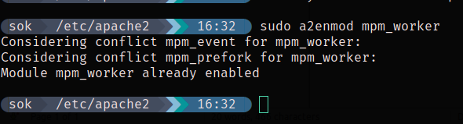
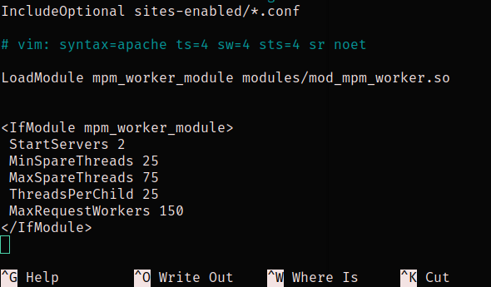

2.Check the status of rewrite_mod and enable it if it is enabled.
