=-=-=-=-=-=-==========-=-=-=-=-=============-=-=-=-=======================-=-==-
= Mohamed Ahmed Mohamed Abd elgani =
= Docker lab2 =
========================================================================
Problem 1:
▪ Run a container nginx with name my-nginx and attach 2 volumes to
the container
▪ Volume1 for containing static html file
▪ Volume2 for containing nginx configuration
▪ Edit the html content
▪ Remove the container
▪ Run a new 2 containers with the following:
•Attach the 2 volumes that was attached to the previous container
in two different ways (volume mount – bind mount)
•Map port 80 to port 8080 on you host machine
•Access the html files from your browser

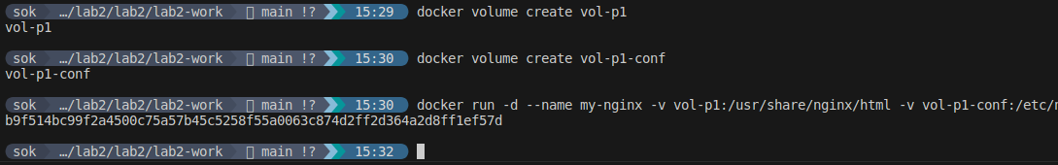
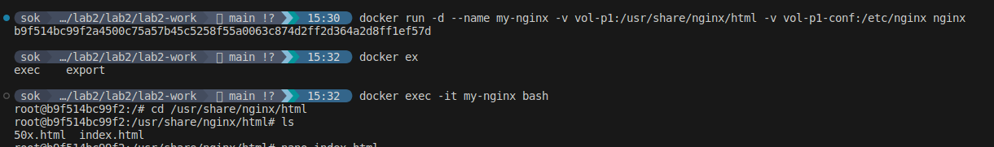
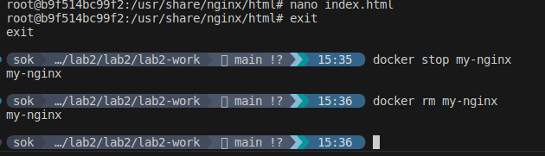

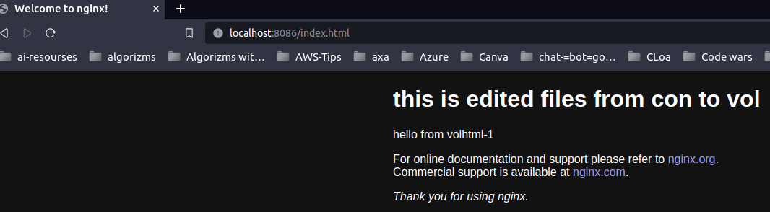
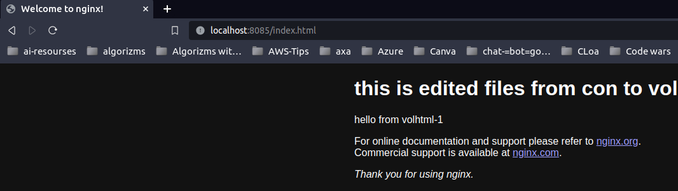

Problem 2:
▪ Create 2 nginx containers with network type bridge, enter to one of
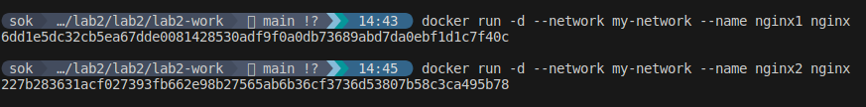
them and use curl command to view the content of the othercontainer.

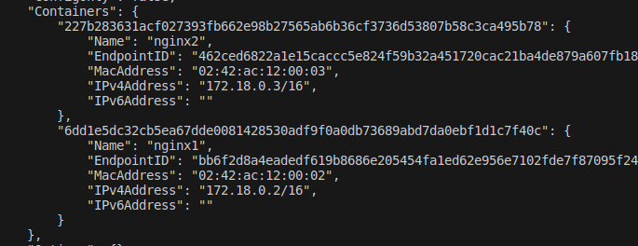

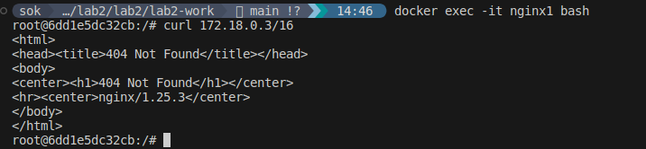

Problem 3:
Run a container Nginx with name my-nginx and attach a volume for
containing static html file
Remove the container
Run a new container with the following:
Attach the volume that was attached to the previous container
Map port 80 to port 9898 on you host machine
Access the html files from your browser

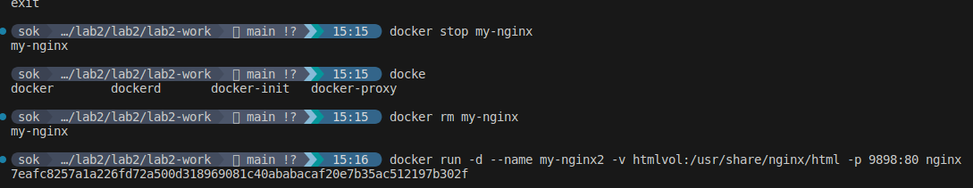

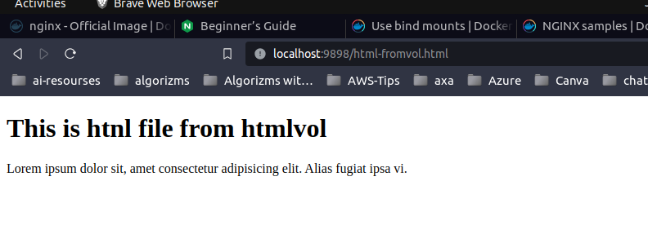

Problem 4:
▪ Create docker compose with:
Two services (nginx and mysql )
Add needed ports and environments for both services
Mysql service depends on nginx service
