Team CS_H43

* Mohamed Abdelalem Hosny
* Mohamed Safwat Mostafa
* Mohamed Samir Mohamed
* Mohamed Moataz Mohamed
* Mohamed Abdelkader Tawfik

**Model 1:**

**Preprocessing:**

We used CV2 to resize images to 200 then flip and rotate it clockwise.

**Model:**

1. We then used keras to build CNN model with 11 layers with kernel size 5 and with relu as an activation function with filters 32/64.
2. We used max pooling between some layers with pool size 2 and strides 2x2 to take largest features in the matrices.
3. We used flatten to transform the pooled layer to single layer to send it to fully connected layer
4. We dropped out some features by 0.5 to decrease overfitting
5. Then we used Softmax activation function on the fully connected layer since it is a multi-class classification
6. Then we calculated loss using categorical cross entropy

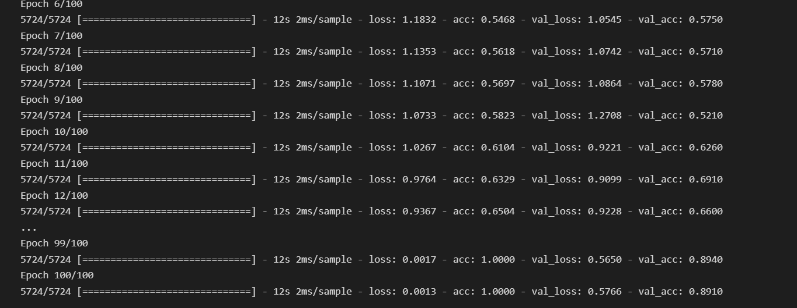

**Model 2:**

**Preprocessing:**

1. We used CV2 to resize images to 224.
2. We used Image Data Generator with zoom range=0.15, width shift range=0.2, height shift range=0.2 and shear range=0.15.

**Model:**

1. We used Res Net 50 algorithm with 50 layers and 3 neural network layers.
2. We used padding by zeroes with dimensions 3x3 for the input layer.
3. After the first layer we used Batch normalization to make it all on the same scale.
4. We used activation function relu in the hidden layers.
5. We used max pooling after the first layer with pool size 3 and strides 2x2 to take largest features in the matrices.
6. We then added a set of convolutional and identity blocks with filters 64/128/256/512.
7. Then we used Average pooling after the last layer with pool size 2 to take average feature in the matrix.
8. We used flatten to transform the pooled layer to single layer to send it to fully connected layer
9. Then we used Softmax activation function on the fully connected layer since it is a multi-class classification

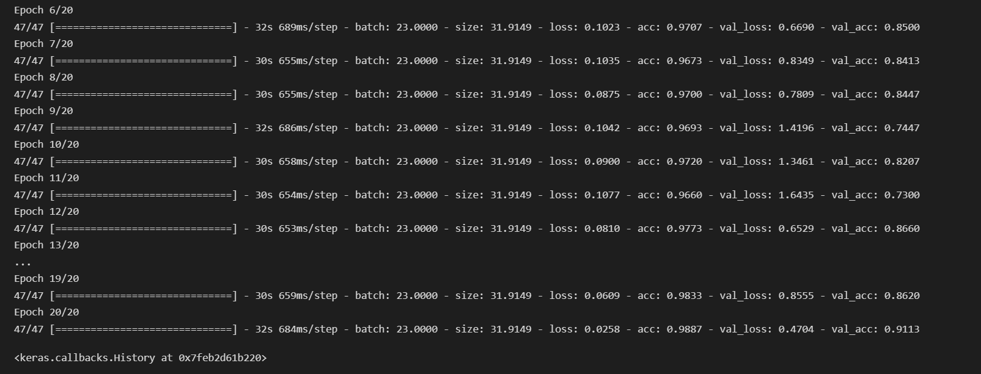

**Previous Tries**

|  |  |  |  |
| --- | --- | --- | --- |
|  | Architecture tf learn | Epochs | Accuracy |
| Model1 | Image was Gray Scale  We use ft learn with 5 Convolution With Size 5X5 layer with activation Function relu and 5 pooling layer with size 5x 5 with 2 fully with 2 fully connected Layers using Softmax function and dropout 0.5 And use our Validation all training data  archietecture was Conv ,pool, conv ,pool,conv,pool,… | **10** | We get  Score: 0.69417  Private score: 0.67028 |
| Model 2 | Image was Colored Image  We use ft learn with 5 Convolution With Size 5X5 layer with activation Function relu and 5 pooling layer with size 5x 5 with 2 fully connected Layers using Softmax function and dropout 0.5 and Extra Fully connected Layer And use our Validation 0.1 of training data  archietecture was Conv ,pool, conv ,pool,conv,pool,… | **10** | Score: 0.65776  Private score: 0.71014 |

* **We here Discovered When image is colored we get more accuracy because some details appear.**

**Previous Tries.cont**

|  |  |  |  |
| --- | --- | --- | --- |
|  | Architecture tflearn | N.Epochs | Accuracy |
| Model3 | We use ft learn with 5 5 Convolution With First Conv with Size 13 x 13 and the rest 4 conv with Size 5X5 layer with activation Function relu and 5 pooling layer with size 5x 5 with 2with 2 fully connected Layers using Softmax function and dropout 0.5 Validation 0.1 of training_data  archietecture was Conv ,pool, conv ,pool,conv,pool,… | **10** | We get  Score: 0.66747  Private score: 0.7355 |
| Model 4 | We use 5 Convolution With First Conv with Size 13 x 13 and the rest 4 conv with Size 5X5 layer with activation Function relu and 5 pooling layer with size 5x 5 with 2with 2 fully connected Layers using Softmax function and dropout 0.5 And use our Validation all training data  archietecture was Conv ,pool, conv ,pool,conv,pool,… | **10** | Score: 0.67961  Private score: 0.67028 |

**Note : We noticed if size of filter exceeds 9 x 9 we get bad accuracy so best size of filter will be 9x9 or less**

|  |  |  |  |
| --- | --- | --- | --- |
|  | Archietecture Tf learn | N.epochs | Accuracy |
| Model5 | We use 7 Convolution With Size 5X5 layer with activation Function relu and 5 pooling layer with size 5x 5 with 2 fully with 2 fully connected Layers using Softmax function and dropout 0.5 And use Validation 0.1 of training_data  archietecture was Conv ,pool, conv ,pool,conv,pool,… | **18** | We get  **Score: 0.74029**  Private score: 0.73188 |
| Model 6 | We uses Image generator and  We use 5 Convolution With Size 5X5 layer with activation Function relu and 5 pooling layer with size 5x 5 with 2 fully connected Layers using Softmax function and dropout 0.5 and Extra Fully connected Layer And use our Validation 0.1 of training data  archietecture was Conv ,pool, conv ,pool,conv,pool,… | **10** | **Score: 0.72572**  Private score: 0.75362 |

* **Note: Image generator make improvement to accuracy and increasing number of epochs make improvement also**

|  |  |  |  |
| --- | --- | --- | --- |
| Model7 | We use 5 Convolution With Size 5X5 layer with activation Function relu and 5 pooling layer with size 5x 5 with 2 fully with 2 fully connected Layers using Softmax function and dropout 0.5 And use our Validation 0.1 of training_data  archietecture was Conv ,pool, conv ,pool,conv,pool,… | **30** | **We get**  **Score: 0.76213**  **Private score: 0.77536** |
| Model 8 | We uses Image generator with early Stopping  We use 5 Convolution With Size 5X5 layer with activation Function relu and 5 pooling layer with size 5x 5 with 2 fully connected Layers using Softmax function and dropout 0.5 and Extra Fully connected Layer And use our Validation 0.1 of training data  archietecture was Conv ,pool, conv ,pool,conv,pool,… | **10** | we get  Score: 0.65776  Private score: 0.6413 |

* **Note :Early Stopping with Image generator not the best thing but increasing number of epochs to 30 we make improvement to our accuracy**

|  |  |  |  |
| --- | --- | --- | --- |
|  | Archietecture Keras | N.epochs | Accuracy |
| Model9 | Using Image Augmentation,  we use 11 Convolution With Size 5X5 layer with activation Function relu and 5 pooling layer with size 5x 5 with 2 fully with 2 fully connected Layers using Softmax function and dropout 0.5 And use our Validation 0.1 of traning_data | **100** | We get  **Score: 0.77912**  Private score: 0.78985 |
| Model 10 | We uses Keras and data generator And using resnet50 architecture | **25** | **We get**  **Score: 0.83252**  **Private score: 0.81884** |

* **Since we get two best Model accuracy using Keras**