Agile Software (CSE233)
Lab (5)


Submitted By:
Mohamed Ahmed Abdelhamid 22P0287

Submitted To:
Dr/ Mohamed El Gazzar
Eng/ Abdelrahman Salah

Table of Contents
- Question 1 3
- Question 2 Error! Bookmark not defined.
- Question 3 Error! Bookmark not defined.

Question 1

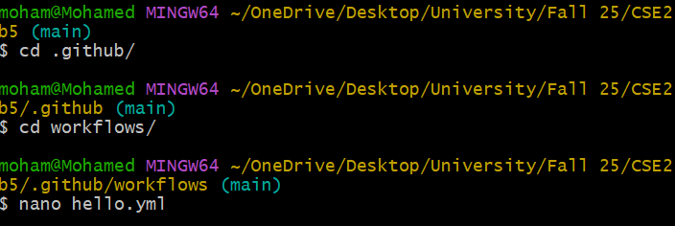
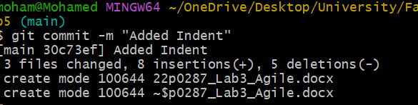
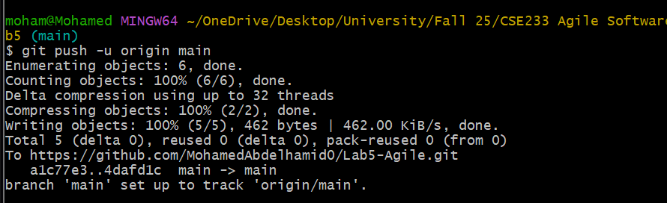

Question 2
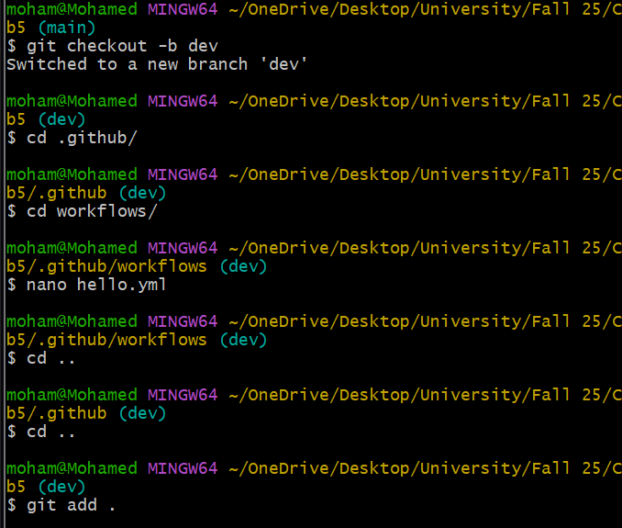
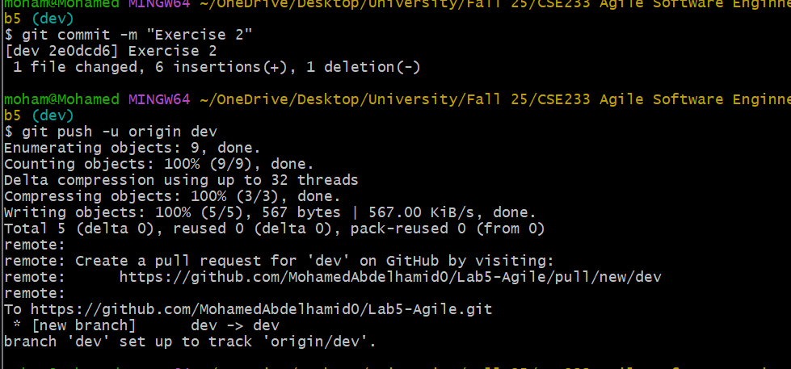

Question 3
