**ABET defines engineering as**

“Profession in which knowledge of mathematical and natural sciences

the scientist seeks to know, the engineer aims to do.

­

*Engineering Technologist:* planning, construction, and operation

*Engineering Technicians*: drafting, surveying, estimating, collecting data

*Craftsmen* : are skilled workers who produce the materials and products or facilities specified by the design.

The man who held this position was a general construction expert who was known as the **king’s “chief of works”.**

**From the eighteenth through early nineteenth century**, civil and mechanical engineers changed from practical artists to scientific professionals.

**The responsibilities of an engineer:**

1. Safety of the public

2. Welfare of the society

3. Environmental concerns

4. Abide by laws, regulations, standards and ethical code

5. Produce products/devices that have the following characteristics:

o Adequate performance

o Cost-efficient

o Low operating and maintenance cost

o Longevity/durability

1. Research involves seeking new knowledge or a better

understanding.

2. Development involves making the discoveries and results of research available in the form of useful products, methods, or processes.

3. Design is the process of converting concepts and information into detailed plans and specifications from which a finished product or facility can be constructed.

4.Production is the industrial process by which products or articles are manufactured from raw materials.

5. Construction is the process of translating designs and materials into structures and facilities such as buildings, highways, and power and communication facilities.

6. Operations in engineering means the application of engineering principles or the performance of practical work. Engineers are prominently involved in the operations of utility companies

7. Sales in technological industries often requires services of trained engineers to recommend the machines, tools, or services to serve the customers’ needs.

8. Management positions in many industries are occupied by engineers. They are responsible for the solution of problems of policy, finance, organization, public relations, and sales.

**How to be a Good Listener ?**

1. Maintain natural eye contact with the speaker.

2. Show by your posture that you are alert and interested.

3. Go to class a few minutes early.

4. Review your notes before class .

5. Ignore distractions such as side talks or other external noise.

6.Take notes on the speaker’s most important points and prepare questions.

7. Be sure to turn off cell phones.

**Guidelines To Study Effectively**

1.Connect class work to long range goals

2.Become Active and involved in learning

3. Get control over your time by time scheduling

o Make a Weekly master plan.

o Make a semester calendar.

* Stick to your schedule, fight Laziness, day dreaming and practice patience.
* Best Time to study is right after class
* Study your difficult classes early afternoon
* Incorporate self-testing into your study schedule.
* Begin to prepare for tests a week in advance

**SQ3R STAND FOR:**

**SURVEY**: Read the chapter title, introduction, summary and end of chapter questions. Also review heading and subheadings and graphics. This will provide an overview of the chapter.

**QUESTION:** Prior to reading each section, turn each heading into

one or more questions.

**READ :** As you read each section, look for answers to your questions.

**RECITE:** After you have finished reading a section and before moving on to next section of the chapter, go back to your questions to see if you can answer them

**REVIEW:** Again, review your questions to see if you can answer

them. This step helps to refine your mental organization and begin to build your memory and

understanding of the material.

A condition that can hinder effective problem studying is called **fixation or mental set.**

**A number of engineering writers have set steps or phases that comprise the “engineering design method.”**

Typically, the list includes

**1. Identification of the problem.**

**2. Gathering needed information :** This phase involves gathering and evaluating information

that is already available. Subsequently, it may be necessary to supplement this information by making additional measurements.

**3. Searching for creative solutions :**

- *Brainstorming*: 6 to 12 members with different backgrounds meet in a session that lasts less than an hour

– *Checklists*

- *Attribute* *Listing:*

All the major attributes of a product, object, or idea are isolated and listed

For each attribute, ideas are listed as to how each of the attributes could be changed.

Each of the various ideas is evaluated, bringing to light possible improvements that can be made in the design of the product or system.

– *Forced* *Relationship* *Technique:*

Force a relationship between the fixed element and the randomly chosen element.

- *Morphological* *Analysis:*

*Define the problem in terms of its dimensions or parameters*

**4. Stepping from ideation to preliminary designs (including modeling):**

unworkable ideas are discarded

Engineers rely on models in making preliminary plans.

**5. Evaluation and selection of preferred solution:**

Feedback, modification, and evaluation may occur repetitively as the device or system evolves from concept to final design.

• Depending on the nature of the problem to be solved,

evaluation may be based on any number of factors (safety,

cost, reliability, and consumer acceptability, .…)

**6. Preparation of reports, plans, and specifications:**

After the preferred design has been selected, it must be

communicated to those who must approve it, support it,

and translate it into reality.

**7. Implementation of the design.**

The final phase of the design process is implementation the

process of producing or constructing a physical device, product, or system.

Your resume the most important document you will ever prepare.

• It is a document of your “ professional self”.

• The Resume is essentially an advertisement and YOU are the product.

The primary function of the resume is not to win a job but to convince an employer to interview you.

The average employer spends less than 30 seconds reviewing your resume.

**There are three basic formats depending on amount of work experience and your emphasis:**

1. **Chronological Resume (most common)**

The chronological format lists your most recent employment history (or education) first, ordering your jobs by date in a time line.

***When to use it?*** →

You have a steady work history with few breaks in your employment time line.

• You’re staying in the same field.

• Your job titles show increased responsibility and higher position levels

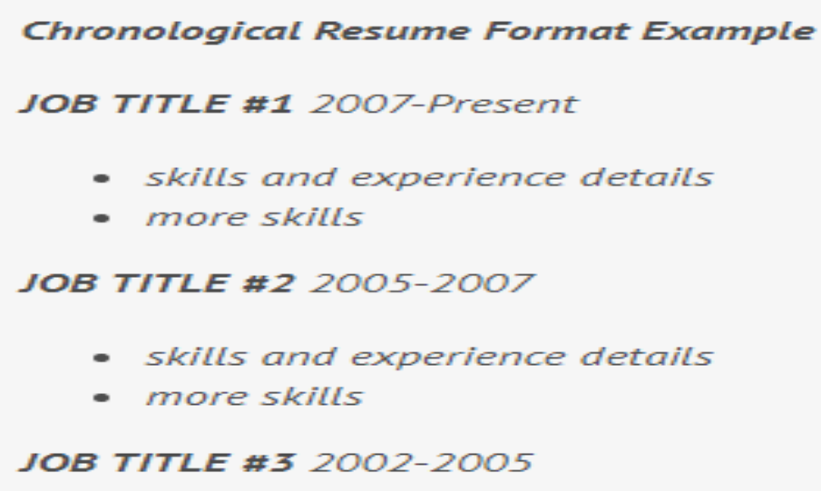

**2. Functional Resume Format**

The functional resume focuses attention on skills and achievements, rather than job titles and places of employment, making it a winner for career changers or new college graduates.

***When to use it?*** →

You want to highlight specific skills, knowledge, or abilities.

You’re looking for your first job or are a new college graduate.

The primary purpose of the interview is to know your skills, your goals, and your personality and then to determine how well you would fit into the position.

**Interview Tips**

* Do your homework
* Dress professionally
* Arrive 10 minutes early
* Introduce yourself properly-first impression
* Eye contact.
* Understand the question
* Posture
* Organize your thoughts
* Thank the interviewer

Don’t use abbreviations in your resume

Don’t use nicknames

Include your current information

There are **seven base** units of **SI**.