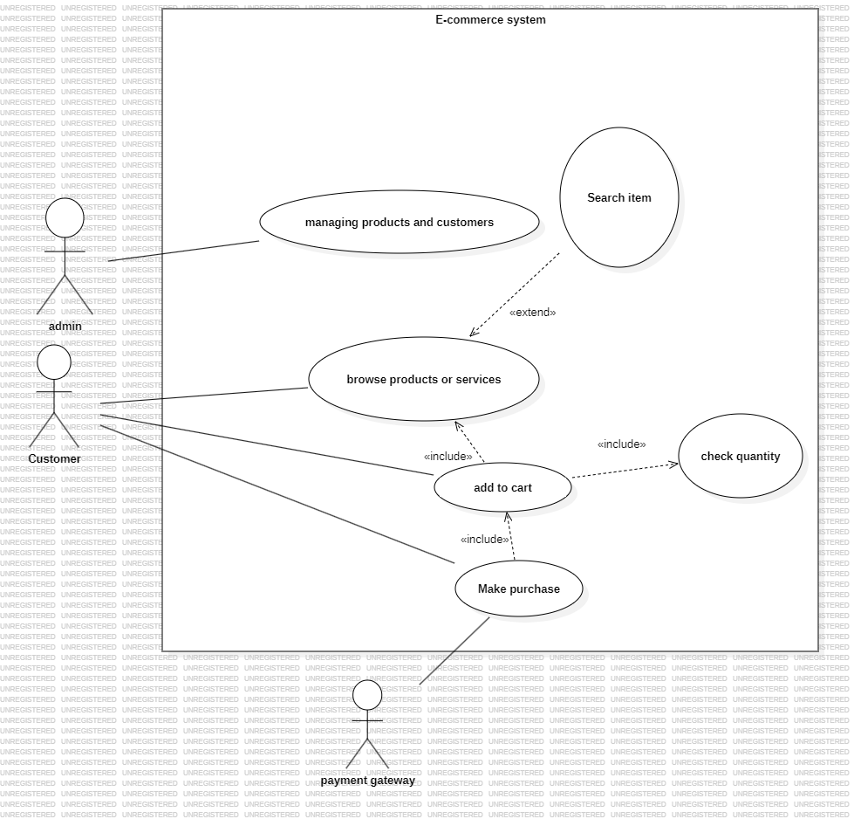

* The search engine extends the browse, as we assume that the home page of the system is just to search.
* Adding to cart includes the browse, as we can’t add before browsing
* Adding to cart includes “check quantity”, as it can’t exceed a specific number of items per cart (ex. 5, 6 ..etc.) .
* Make purchase includes “add to cart “, as we can’t pay without having a cart.
* We added the payment gateway as an actor , as we couldn’t specify its role properly.

|  |  |  |
| --- | --- | --- |
| Add to cart | E-commerce system | |
| Goal | Allow the customer to add selected products or services to their shopping cart for potential purchase later. | |
| Preconditions | The customer must be logged in or have a session active.  The product or service must be available in the product catalog.  The product must have sufficient quantity available. | |
| Success End Condition | The selected product is successfully added to the customer's shopping cart.  The cart is updated to reflect the new product, quantity, and price.  The customer can view the updated cart at any time. | |
| Failed End Condition | The product cannot be added due to unavailability or out-of-stock status.  The cart remains unchanged.  The system displays an appropriate error message. | |
| Primary Actors | Customer (main actor)  E-commerce system (system actor) | |
| Trigger | Customer selects a product and clicks the "Add to Cart" button. | |
| Description / Main Success Scenario | Step | action |
| 1  2  3 | Customer selects a product and clicks “Add to Cart.”  System verifies product availability and adds it to the cart.  System updates the cart and confirms the addition to the customer. |
| Alternative Flows | Step  1  2  3 | Branching action  System checks product stock and finds it unavailable.  System notifies the customer the product cannot be added.  Customer chooses to select a different product or wait for restock. |