API: Get all posts

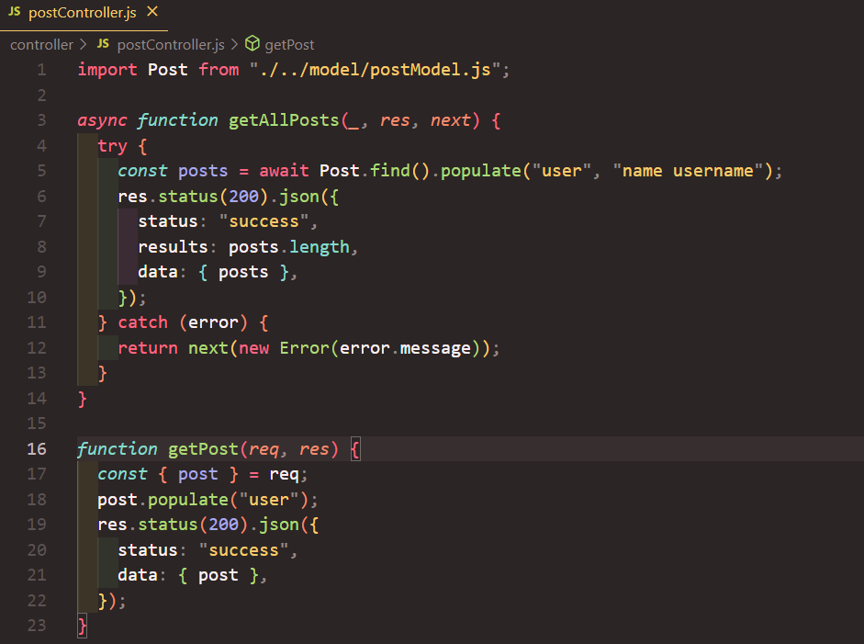

API: Create a new post

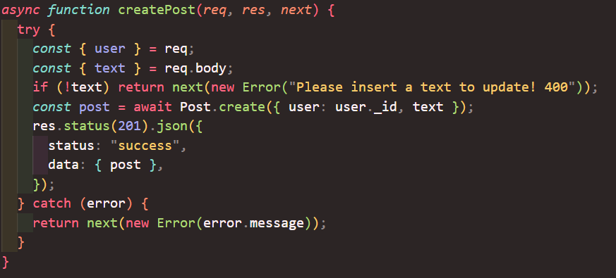

API: Delete a post

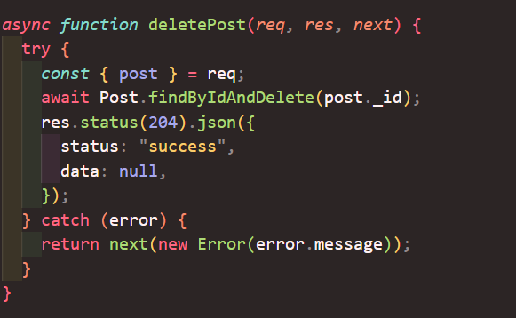

API: Register new user

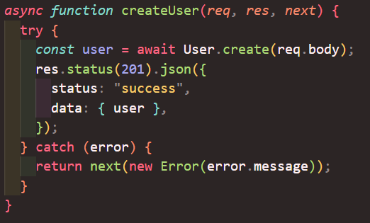

API: Logon

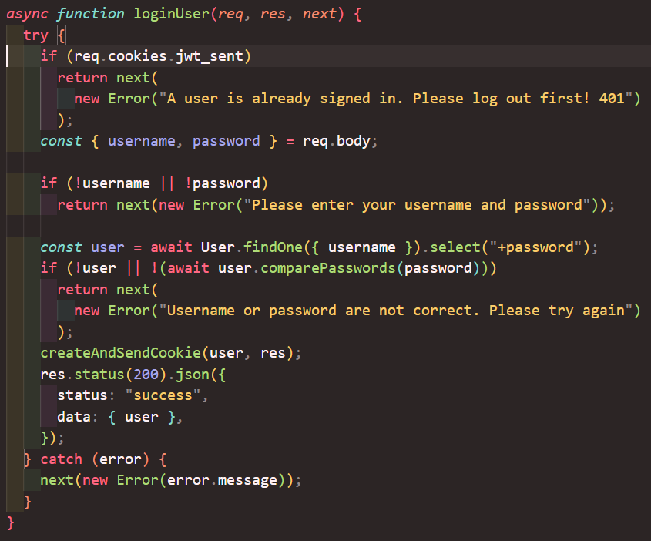

SECURITY: Implement SSL including private key and certificate generation

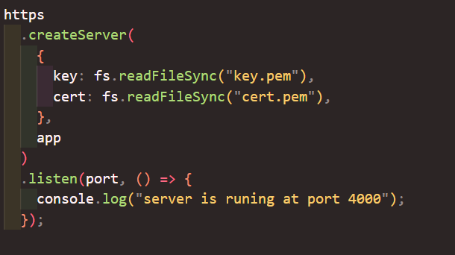



1. $ openssl genrsa -out key.pem . . used code for generating self-signed certificate generation.
2. $ openssl req -new -key key.pem -out csr.pem . used code for generating certificate service request (CSR).
3. $ openssl x509 -req -days 9999 -in csr.pem -signkey key.pem -out cert.pem . used code for generating certificate.

SECURITY: Cater for CORS



SECURITY: Store encrypted password

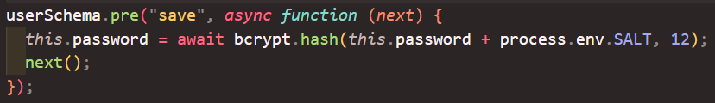

SECURITY: Protect routes

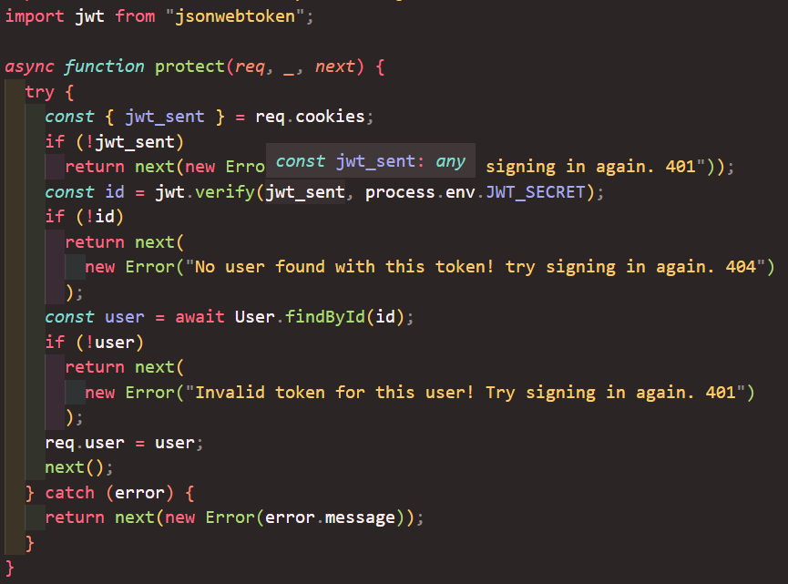

SECURITY: Persist authentication information

