In this section, we focus on using wheel encoder sensor data for two purposes:

- Closed Loop PID Control
While open loop control is simple to implement, it does not always work reliably when running on an actual robot because a combination of environmental (i.e. friction from floor) and intrinsic factors (i.e. differences between left and right motors) play a role.

Closed loop control uses sensor data (i.e. wheel encoders) to adjust motor control through feedback (i.e. error as the difference between target and measured). PID control is a popular closed loop controller that is simple to implement.

- Odometry w/Dead Reckoning
Odometry is valuable because it is: 1) a necessary input for using the ROS navigation stack in the future and 2) allows us to see the robot's trajectory

We combine wheel encoder readings from both wheels (dead reckoning) to estimate the robot's position over time (odometry).

Overview: Closed-loop Control of a Robot

Goal: Use of wheel encoder sensor data for closed-loop PID control and estimating robot odometry

Purpose: Learning to incorporate feedback from sensor data to improve robot control and state estimation

Outline:
- Read robot wheel encoders
- PID control of both wheels
- Dead reckoning to estimate robot odometry

Repository Code
git clone -b closedloop https://github.com/richardw05/gopigo_ws.git

Architecture
Once again, we have a host machine and a robot connected through WiFi. As illustrated below, we add two ROS nodes. gopigo_state_updater is run on the robot and transforms wheel encoder data into angular wheel velocity estimates. We extend gopigo_controller to use these encoder readings for PID control. diffdrive_odom is run on the host machine and uses encoder estimates to perform dead reckoning.
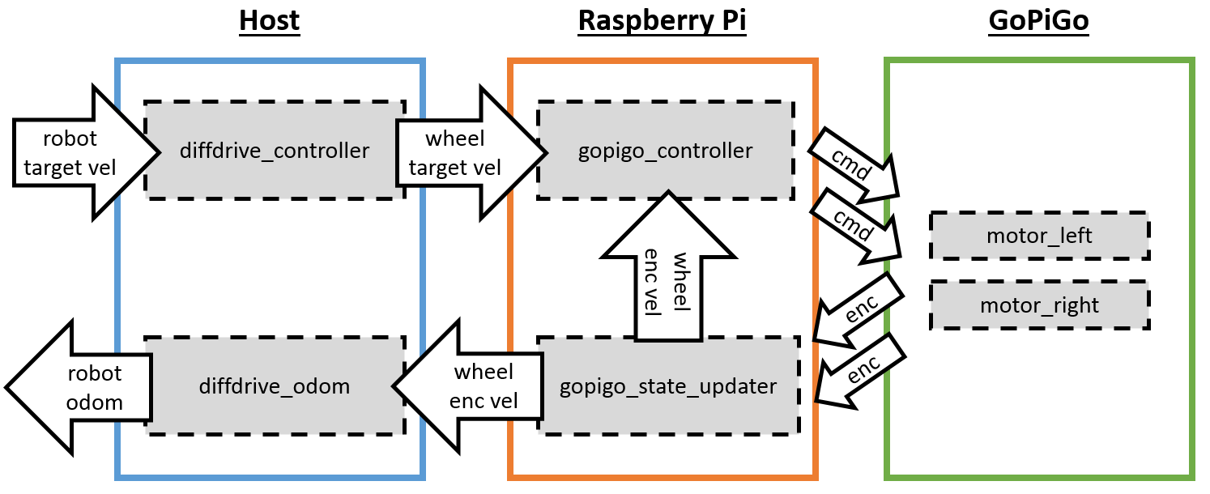
Shown below are the ROS messages transmitted between these ROS nodes.

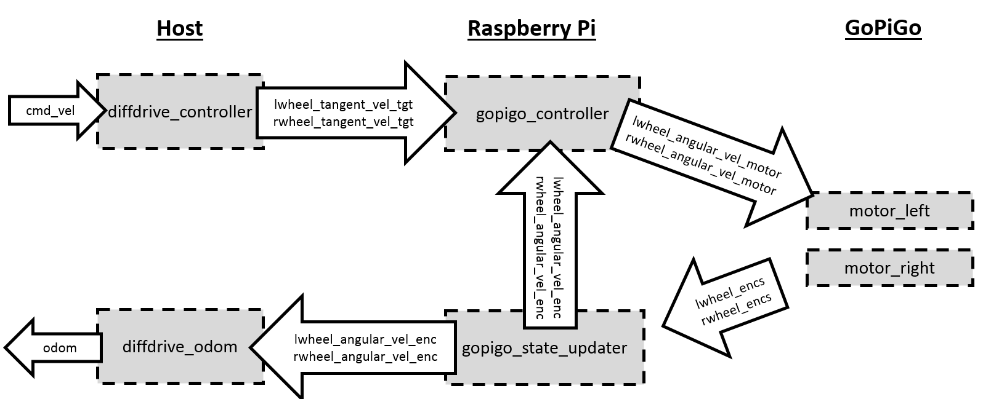

Operationally, we first estimate angular wheel velocities from wheel encoder readings. These are used for the PID controller which will reduce the error between target and measurement velocities. Next, we perform dead reckoning by using forward kinematics to recover the robot's linear and rotational velocities, which are used to estimate robot odometry.

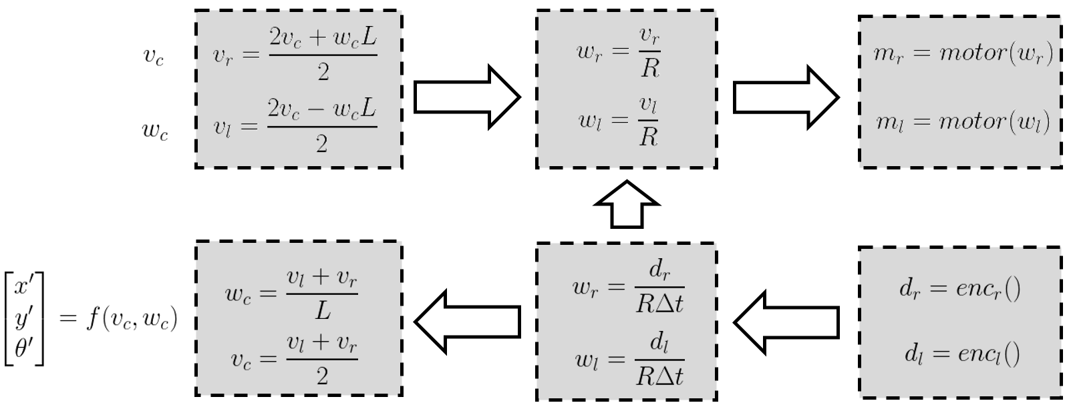

Implementation
We will turn our open-loop controller into a closed-loop controller by creating a new gopigo_state_updater node and editing the gopigo_controller node. We then perform dead reckoning in a new diffdrive_odom node.

- GoPiGo State Updater
Wheel encoders measure how much each wheel actually turned and estimate their actual angular velocity. Later on, our PID controller will correct for mismatches between target and actual wheel velocity. First, the gopigo_state_updater node must transform wheel encoder readings to angular velocity.

Interestingly, the GoPiGo's wheel encoders returns the number of centimeters traversed; in contrast, most encoders return the number of ticks traversed. Either measurement type can be transformed into angular velocities. For our wheel encoder data, we can compute the radians traversed as a proportion of the encoder distance traversed. We then compute the anuglar velocity by dividing over the time taken.

Define the following:
  - d: change in distance from encoders
  - R: robot wheel radius
  - : time to move distance read from encoders
  - w: angular velocity of wheel

To compute the angular velocity, we first use the encoder distance to compute the proportion of the wheel's circumference traversed. We multiply this by the total radians for one rotation (obviously 2 Pi). Finally, we divide by the time taken to move that distance.

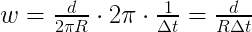

This equation can be simplified further resulting in the wheel's angular velocity. This primary purpose of the gopigo_state_updater node is to publish these angular wheel velocities.

- GoPiGo Controller w/PID Control
Once we have a measured angular wheel velocity, we can apply a PID controller to correct for the error (target angular wheel velocity - measured angular wheel velocity). Recall that the target angular wheel velocity for each wheel is given by the diffdrive_controller node. Intuitively, the idea is that if our motors are not moving at our target velocity (too slow or too fast), then we should adjust our motor control commands (faster or slower) to correct for these differences. For example, if floor friction causes the wheels to spin slower than expected, then we need to give a higher motor control command to compensate.

PID controllers are well-studied so let us just provide a bit of intuition. It is often easier to envision a one-dimensional example like a car's cruise control. The state of the system is the robot's current velocity. The cruise control sets a target velocity. The control command adjusts the gas pedal. If moving too slow, then push harder on the gas pedal and vice versa. The measurement is the odometer that tells us the vehicle's speed. The error is the difference between the measurement and target. Adjusting the error to 0, means we will achieve our target velocity. In most physical systems, we do not want to instantly jump from 0 to 100 mph so we need to compute control commands that gradually adjust car speed. A PID controller basically a sum of three separate control adjustment techniques that cover different situations:

  - (P)roportional - control command is a proportion of the current error (e.g. push enough on gas pedal to slowly ramp up to a target velocity)
  - (I)ntegral - control command is a proportion of past errors (e.g. more gas if we have had large error for a while)
  - (D)ifferential - control command is a proportion of the future change in error (e.g. react quickly to changes in error)

Notice that the key difference is the time frame considered (past, current, and future). It is actually not necessary to use all three of the control adjustments so feel free to adjust as needed. Please see these resources for more details.
Resources:
  - https://www.coursera.org/learn/mobile-robot
  - https://en.wikipedia.org/wiki/PID_controller

In addition to understanding PID control conceptually, we also need to implement it. Whereas the equations are given in a continuous representation, our computing platforms must contend with a discrete representation. For proportional control, we only consider current measurements so it is simply a proportion of the current error (target minus measured). For integral control, we can compute a rolling sum of errors. For differential control, we just compute the difference between the current and previous error.

Hopefully, the pid_control function shows how simple it is to implement a PID controller. Of course, the key will be experimenting to determine the proper gains (Kp, Ki, Kd) to use.

- Differential Drive Odometry
Through dead reckoning, we can combine wheel encoder sensor data from both wheels to not only recover the robot's linear and rotational velocity (in a perfect system, we would recover the input /cmd_vel) but also estimate its position over time. Forward kinematics refers to the sequence of equations (based on models of how the physical system reacts to given inputs) to transform sensor data into robot odometry. Our kinematic equations assume no wheel slippage, drag, and other factors that are inherently difficult to accurately predict in realistic environments so odometry estimates are inherently not going to perfectly match reality.

Let us define the following inputs:

  - L: distance between robot's wheels
  - w_l: angular velocity of left wheel
  - w_r: angular velocity of right wheel
  - : change in time for update
  - x: robot's previous x position
  - y: robot's previous y position
  - : robot's previous orientation

Define the following outputs:

  - R: radius of instantaneous center of curvature
  - v_l: tangential velocity of left wheel
  - v_r: tangential velocity of right wheel
  - v_c: robot's linear velocity
  - w_c: robot's rotational velocity
  - : robot's current x position
  - : robot's current y position
  - : robot's current orientation

We use simple forward kinematic equations that assume one of two scenarios when our differential drive robot is moving: either the robot is moving straight forward or moving around an "instantaneous center of curvature (ICC)".

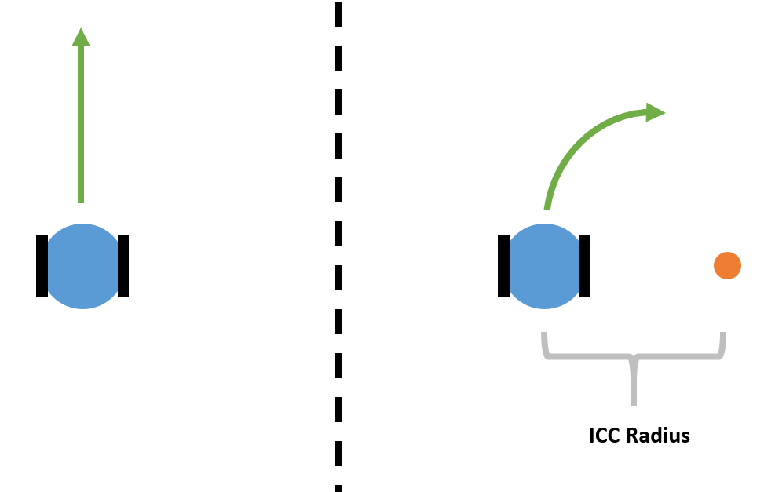

  - Moving Straight Forward
If moving forward, the dynamics are simple. Notice that the robot's angular velocity is 0 because both wheels move at the same speed:

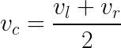

Naturally, we can update the robot's pose (global position and orientation) as:
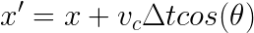

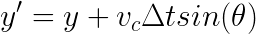

  - Rotating Around a Circle
We first compute the radius of the circle around which the robot is following (at this instant). This allows us to compute the robot's rotational velocity.
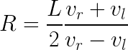

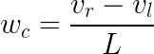

We can then compute the center of this circle.
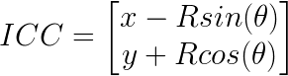

We follow by updating the robot's pose.
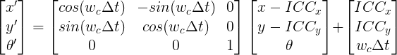

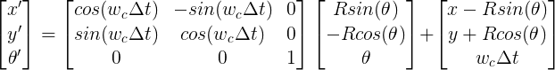

We publish the compute robot's global pose in the world to both the robot's tf transform and odometry messages. The odometry message also includes velocity information, which of course means that the odometry message includes more information about the robot's state (position, orientation, linear velocity, rotational velocity).
Resources:
  - ROS Odometry Implementation: http://wiki.ros.org/navigation/Tutorials/RobotSetup/Odom
  - ROS Odometry in Python: answers.ros.org/question/79851/python-odometry

Launching

We are going to use wheel encoder sensor data for 1) PID feedback control and 2) estimating the robot's odometry.

We are using the same launch files nav_behaviors.launch and gopigo_interface.launch. We edited them to run additional ROS nodes (diffdrive_odom for nav_behaviors.launch and gopigo_state_updater for gopigo_interface.launch). Try running the following scenarios.

- Odometry in Simulation
As a basic sanity check, we want to ensure that our forward kinematic transformations are correct by showing that we can recover the original cmd_vel message.

In gopigo_interface.launch, set the following for all:
<param name="gopigo_on" value="False"/>

Now run the launch files. On the host machine:
roslaunch nav_behaviors nav_behaviors.launch

On the Raspberry Pi:
roslaunch gopigo_description gopigo_interface.launch

Print the following messages to verify that our computations are correct:
rostopic echo /cmd_vel
rostopic echo /lwheel_tangent_vel_target
rostopic echo /rwheel_tangent_vel_target
rostopic echo /lwheel_angular_vel_target
rostopic echo /rwheel_angular_vel_target
rostopic echo /lwheel_angular_vel_control
rostopic echo /rwheel_angular_vel_control
rostopic echo /lwheel_angular_vel_motor
rostopic echo /rwheel_angular_vel_motor

rostopic echo /lwheel_angular_vel_enc
rostopic echo /rwheel_angular_vel_enc
rostopic echo /lwheel_tangent_vel_enc
rostopic echo /rwheel_tangent_vel_enc
rostopic echo /cmd_vel_enc

Send target /cmd_vel messages and see how the messages change.
./nav_forward.sh
./nav_rotate.sh

When we set gopigo_on to False, the gopigo_state_updater node will basically copy over the target angular velocity (in essence, simulating as if the encoder readings perfectly match our given model). Check that /cmd_vel and /cmd_vel_enc match.

- Odometry on the GoPiGo
Let us compute odometry using actual wheel encoder sensor data.

In gopigo_interface.launch, set the following for all:
<param name="gopigo_on" value="True"/>

Run the same launch files listed above. Also print out the same ROS messages.

Verify that /cmd_vel and /cmd_vel_enc are similar. This should tell you how well reality matches our expected model.

- PID Control on the GoPiGo
PID control is supposed to ensure that the wheels are rotating at the expected speed.

In gopigo_interface.launch, set
<param name="pid_on" value="True"/>

Try running the robot on surface with different friction and verify that the robot more reliably travels the same distance when PID control is turned on.

