“Fuel Station”  
  
ERD (Entity Relationship Diagram)

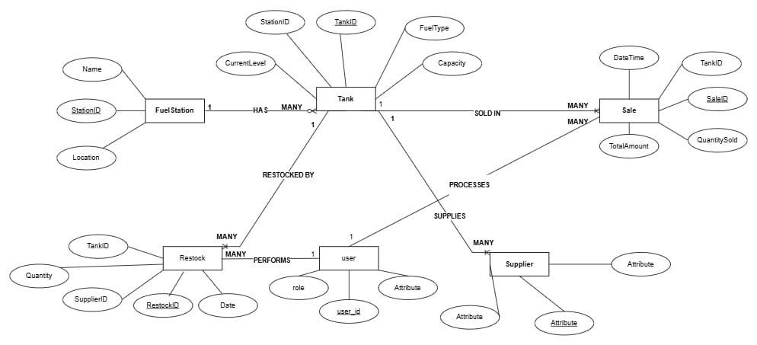

Schema  
  
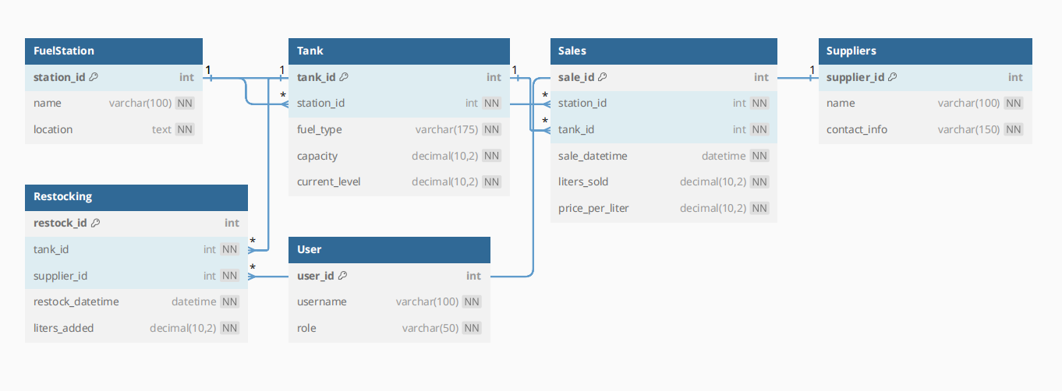

Sql - Script  
  
**1-Tables**

CREATE DATABASE DailyFuel;

USE DailyFuel;

CREATE TABLE FuelStation (

station_id INT IDENTITY(1,1) PRIMARY KEY,

name VARCHAR(100) NOT NULL UNIQUE,

location TEXT NOT NULL

);

CREATE TABLE Tank (

tank_id INT IDENTITY(1,1) PRIMARY KEY,

station_id INT NOT NULL FOREIGN KEY REFERENCES FuelStation(station_id),

fuel_type VARCHAR (175) NOT NULL,

capacity DECIMAL(10,2) NOT NULL,

current_level DECIMAL(10,2) NOT NULL

);

CREATE TABLE Sales (

sale_id INT IDENTITY(1,1) PRIMARY KEY,

station_id INT NOT NULL FOREIGN KEY REFERENCES FuelStation(station_id),

tank_id INT NOT NULL FOREIGN KEY REFERENCES Tank (tank_id),

sale_datetime DATETIME NOT NULL,

liters_sold DECIMAL(10,2) NOT NULL,

price_per_liter DECIMAL(10,2) NOT NULL

);

CREATE TABLE Suppliers (

supplier_id INT IDENTITY(1,1) PRIMARY KEY,

name VARCHAR(100) NOT NULL,

contact_info VARCHAR(150) NOT NULL

);

CREATE TABLE Restocking (

restock_id INT IDENTITY(1,1) PRIMARY KEY,

tank_id INT NOT NULL FOREIGN KEY REFERENCES Tank (tank_id),

supplier_id INT NOT NULL FOREIGN KEY REFERENCES Suppliers(supplier_id),

restock_datetime DATETIME NOT NULL,

liters_added DECIMAL(10,2) NOT NULL

);

CREATE TABLE "User" (

user_id INT IDENTITY(1,1) PRIMARY KEY,

username VARCHAR(100) NOT NULL UNIQUE,

role VARCHAR(50) NOT NULL

);

**2-Insertion Data**  
-- 1. FuelStation

INSERT INTO FuelStation (name, location) VALUES

('Station A', 'Cairo'),

('Station B', 'Giza'),

('Station C', 'Alexandria'),

('Station D', 'Mansoura'),

('Station E', 'Tanta'),

('Station F', 'Aswan'),

('Station G', 'Luxor'),

('Station H', 'Hurghada'),

('Station I', 'Port Said'),

('Station J', 'Suez');

-- 2. Tank

INSERT INTO Tank (station_id, fuel_type, capacity, current_level) VALUES

(1, 'Diesel', 10000.00, 8000.00),

(1, 'Petrol 92', 8000.00, 5000.00),

(2, 'Petrol 95', 7000.00, 3000.00),

(3, 'Diesel', 12000.00, 10000.00),

(4, 'Petrol 92', 9000.00, 6000.00),

(5, 'Petrol 95', 8500.00, 4000.00),

(6, 'Diesel', 11000.00, 9000.00),

(7, 'Petrol 92', 7500.00, 5000.00),

(8, 'Petrol 95', 8000.00, 6000.00),

(9, 'Diesel', 10000.00, 300.00);

-- 3. Suppliers

INSERT INTO Suppliers (name, contact_info) VALUES

('Supplier X', 'x@example.com'),

('Supplier Y', 'y@example.com'),

('Supplier Z', 'z@example.com'),

('Supplier Alpha', 'alpha@example.com'),

('Supplier Beta', 'beta@example.com'),

('Supplier Gamma', 'gamma@example.com'),

('Supplier Delta', 'delta@example.com'),

('Supplier Epsilon', 'epsilon@example.com'),

('Supplier Eta', 'eta@example.com'),

('Supplier Theta', 'theta@example.com');

-- 4. Users

INSERT INTO "User" (username, role) VALUES

('admin', 'Admin'),

('manager1', 'Manager'),

('manager2', 'Manager'),

('cashier1', 'Cashier'),

('cashier2', 'Cashier'),

('supervisor1', 'Supervisor'),

('auditor1', 'Auditor'),

('operator1', 'Operator'),

('operator2', 'Operator'),

('guest', 'Guest');

-- 5. Sales

INSERT INTO Sales (station_id, tank_id, sale_datetime, liters_sold, price_per_liter) VALUES

(1, 1, GETDATE(), 100.00, 8.50),

(1, 2, GETDATE(), 150.00, 9.25),

(2, 3, GETDATE(), 200.00, 10.00),

(3, 4, GETDATE(), 120.00, 8.75),

(4, 5, GETDATE(), 180.00, 9.50),

(5, 6, GETDATE(), 220.00, 10.20),

(6, 7, GETDATE(), 160.00, 8.60),

(7, 8, GETDATE(), 190.00, 9.30),

(8, 9, GETDATE(), 210.00, 10.10),

(9, 10, GETDATE(), 170.00, 8.80);

-- 6. Restocking

INSERT INTO Restocking (tank_id, supplier_id, restock_datetime, liters_added) VALUES

(1, 1, GETDATE(), 2000.00),

(2, 2, GETDATE(), 1500.00),

(3, 3, GETDATE(), 1800.00),

(4, 4, GETDATE(), 2200.00),

(5, 5, GETDATE(), 1700.00),

(6, 6, GETDATE(), 1600.00),

(7, 7, GETDATE(), 2000.00),

(8, 8, GETDATE(), 1500.00),

(9, 9, GETDATE(), 1800.00),

(10, 10, GETDATE(), 2200.00);

3-Queries

SELECT * FROM FuelStation;

SELECT * FROM Tank;

SELECT

T.tank_id,

F.name AS station_name,

T.fuel_type,

T.capacity,

T.current_level

FROM Tank T

JOIN FuelStation F ON T.station_id = F.station_id;

SELECT

tank_id,

fuel_type,

current_level,

capacity,

(current_level / capacity) * 100 AS percent_full

FROM Tank

WHERE current_level < (capacity * 0.2);

SELECT

F.name AS station_name,

SUM(S.liters_sold * S.price_per_liter) AS total_sales

FROM Sales S

JOIN FuelStation F ON S.station_id = F.station_id

GROUP BY F.name;

SELECT

CONVERT(DATE, sale_datetime) AS sale_date,

T.fuel_type,

SUM(liters_sold) AS total_liters_sold

FROM Sales S

JOIN Tank T ON S.tank_id = T.tank_id

GROUP BY CONVERT(DATE, sale_datetime), T.fuel_type

ORDER BY sale_date;

SELECT

R.tank_id,

T.fuel_type,

SUM(R.liters_added) AS total_restocked

FROM Restocking R

JOIN Tank T ON R.tank_id = T.tank_id

GROUP BY R.tank_id, T.fuel_type;

SELECT

R.tank_id,

MAX(R.restock_datetime) AS last_restock

FROM Restocking R

GROUP BY R.tank_id;

SELECT * FROM "User"

ORDER BY role;

-- ================================

-- DDL – Data Definition Language

-- ================================

ALTER TABLE Suppliers ADD is_active BIT DEFAULT 1;

ALTER TABLE Tank ALTER COLUMN fuel_type VARCHAR(100);

-- ================================

-- DML – Data Manipulation Language

-- ================================

UPDATE Tank SET current_level = current_level - 100 WHERE tank_id = 1;

INSERT INTO Sales (station_id, tank_id, sale_datetime, liters_sold, price_per_liter)

VALUES (1, 1, GETDATE(), 120, 8.75);

DELETE FROM Restocking WHERE restock_id = 1;

SELECT name, location FROM FuelStation;

-- ================================

-- DCL – Data Control Language

-- ================================

GRANT SELECT ON FuelStation TO guest;

REVOKE INSERT, UPDATE, DELETE ON Sales FROM guest;

-- ================================

-- TCL – Transaction Control Language

-- ================================

BEGIN TRANSACTION;

INSERT INTO Sales (station_id, tank_id, sale_datetime, liters_sold, price_per_liter)

VALUES (2, 3, GETDATE(), 100, 9.50);

UPDATE Tank SET current_level = current_level - 100 WHERE tank_id = 3;

COMMIT;

BEGIN TRANSACTION;

DELETE FROM Tank WHERE tank_id = 5;

ROLLBACK;

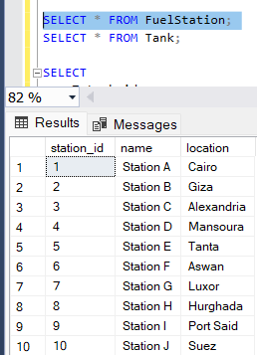   
  
  
  
  
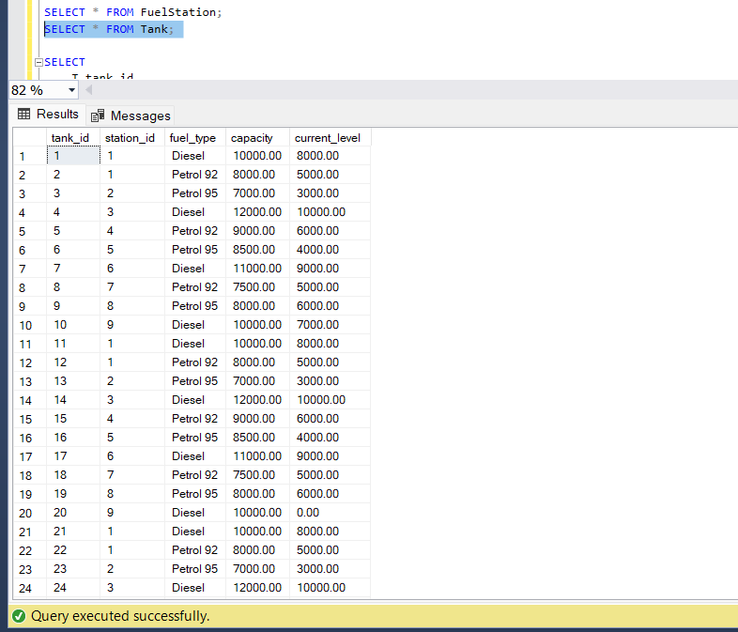  
  
  
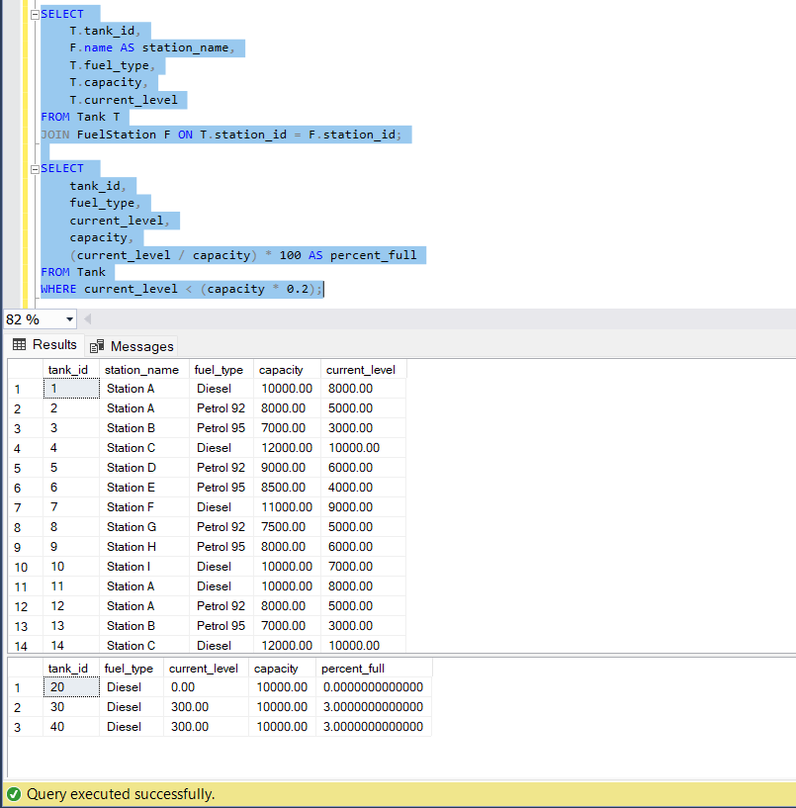  
  
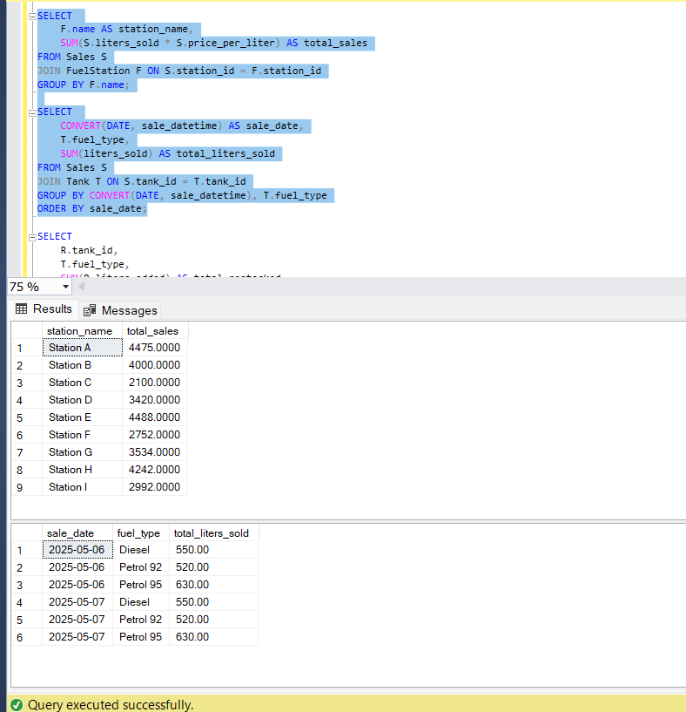  
  
  
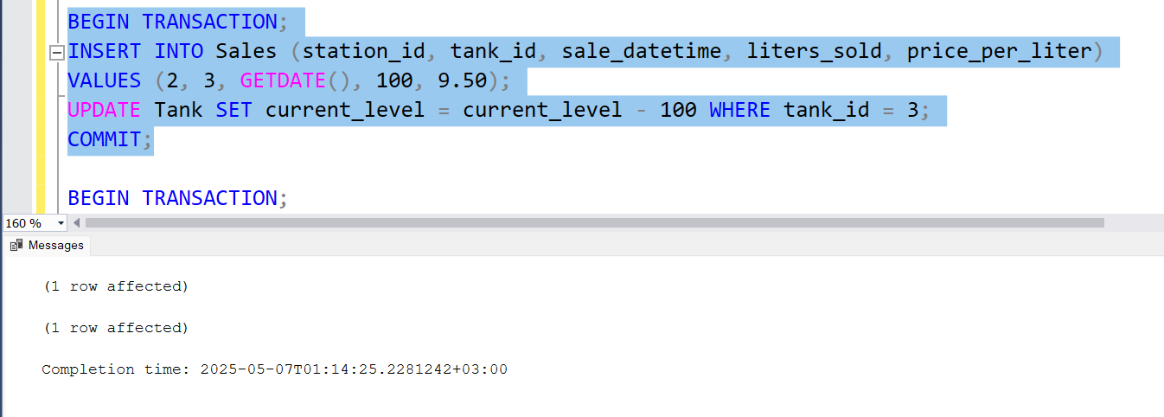  
  
  
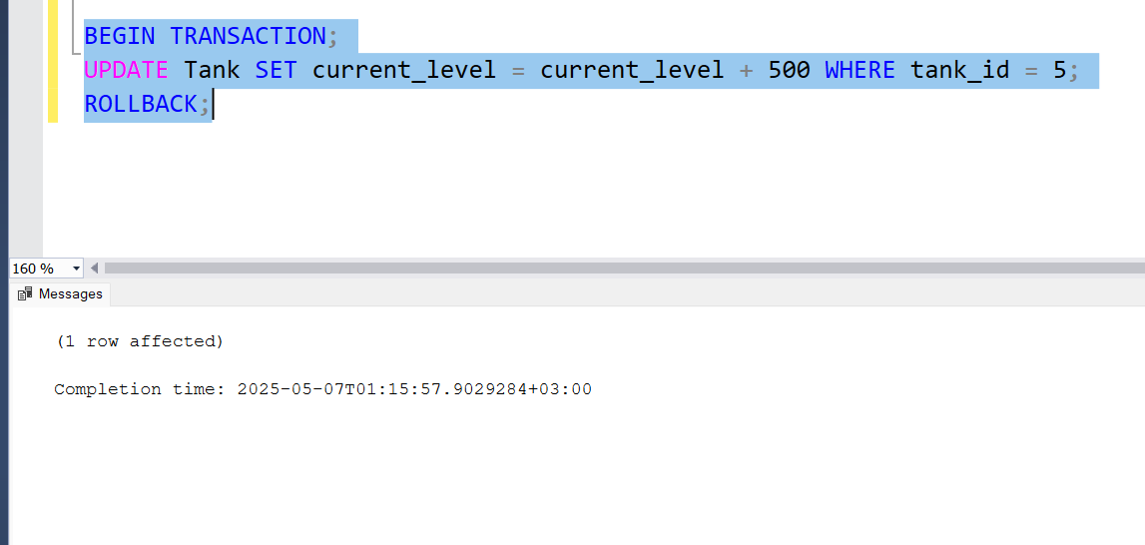

Answer sql Question  
  
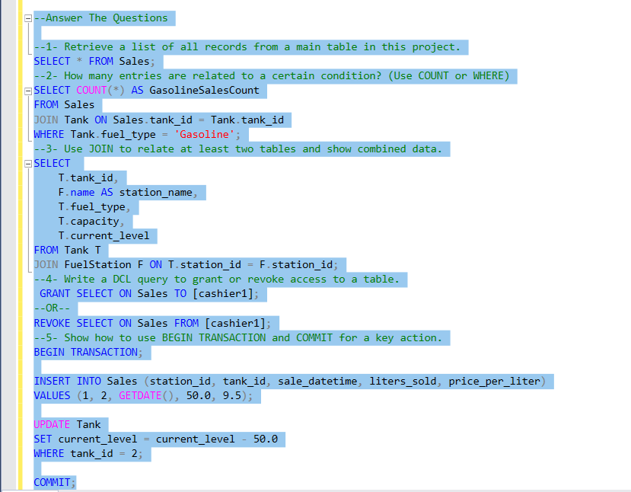

|  |  |  |
| --- | --- | --- |
| Name | ID | Grade |
| Mohamed Ahmed | 692300194 |  |
| Ahmed Maged | 692300194 |  |
| Ziad Nasr | 692300194 |  |
| Ahmed Mohamed | 692300194 |  |