By

**User Stories**



Mohamed Ahmed Ali

Under the Supervision of : Eng.Mohamed Adel

***User Stories***

- User Stories are a fundamental concept in Agile software development. They are a way to capture and express user requirements from an end user's perspective.

- User stories describe a feature or functionality that delivers value to the end user. These stories are an part of the Agile method.

*Benefits user stories in Agile software development :

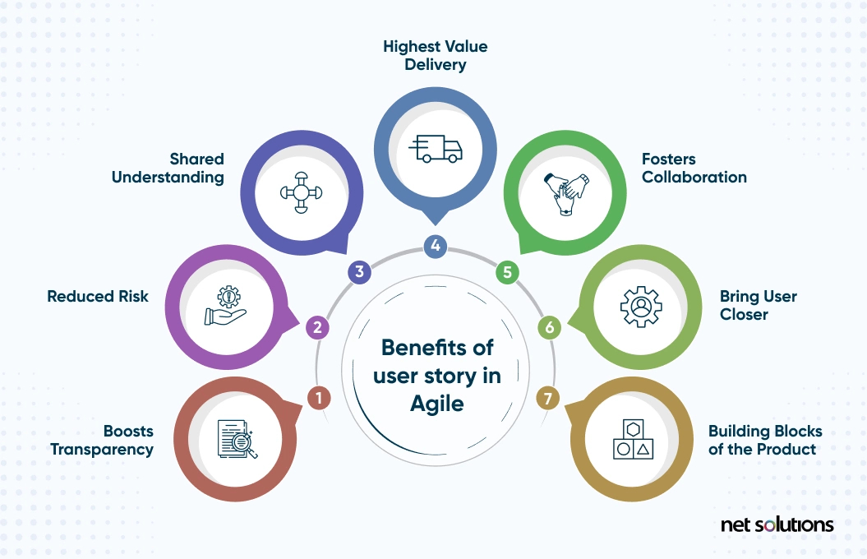

***User Stories example***

In the Agile , user stories follow a simple template. The chosen user story format will outline the “who,” “what,” and “why” of a particular requirement.

Who wants something?

What do they want?

Why do they want it?

The following template is one of the most common:

“As [persona], I want to [action], so that I can [benefit]

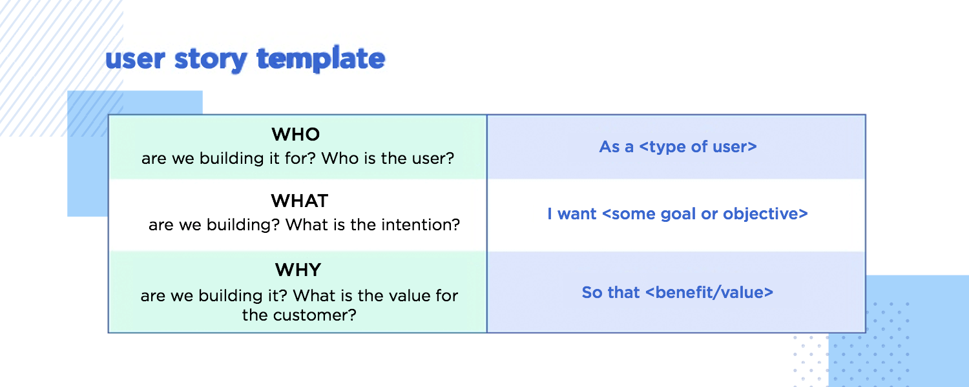

* ***Who Writes the User Story?***

Product owners, stakeholders, product managers and other business team and development team, tester members participate in writing user stories.

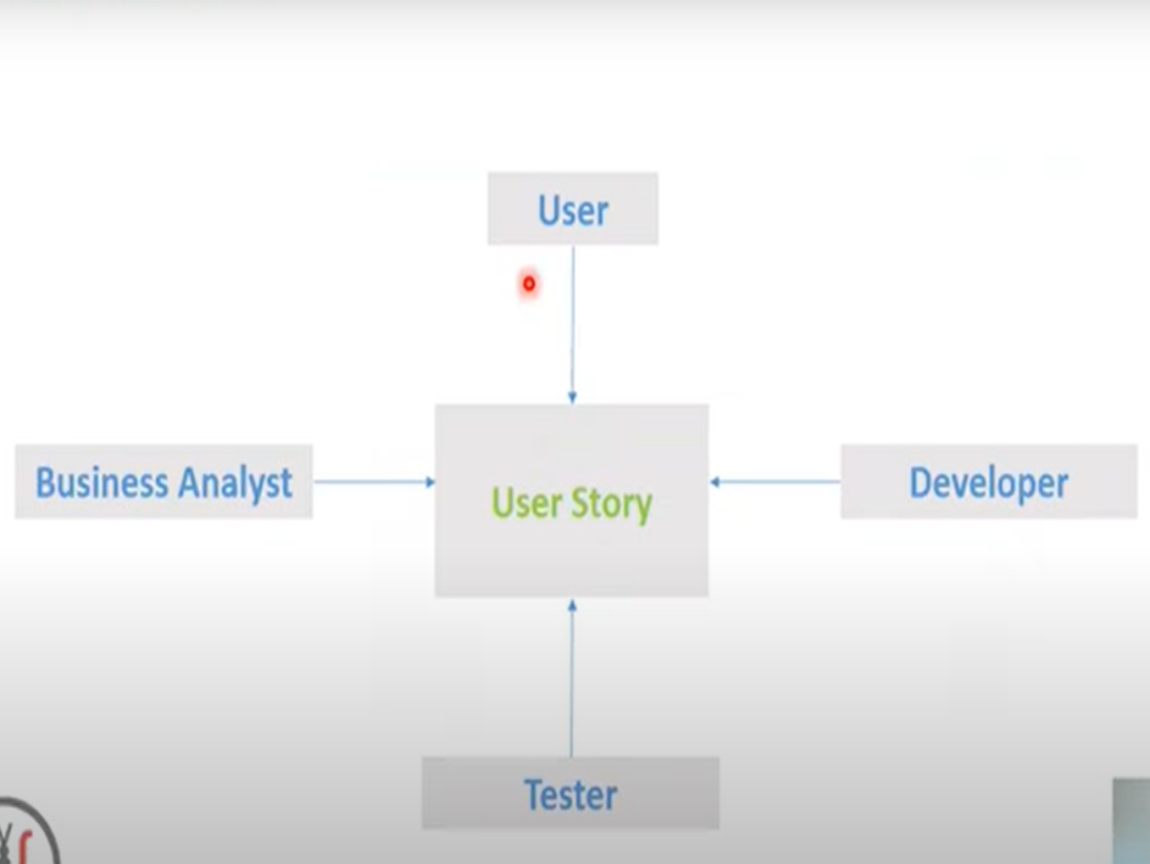

***Agile Principles***

There are 12 agile principles outlined in The Agile Manifesto

* Working software is the primary measure of progress.

* Is to satisfy the customer through the early and continuous delivery of valuable software.

* Business people and developers must work together daily throughout the project.

* The best architectures, requirements, and designs emerge from self-organizing teams.

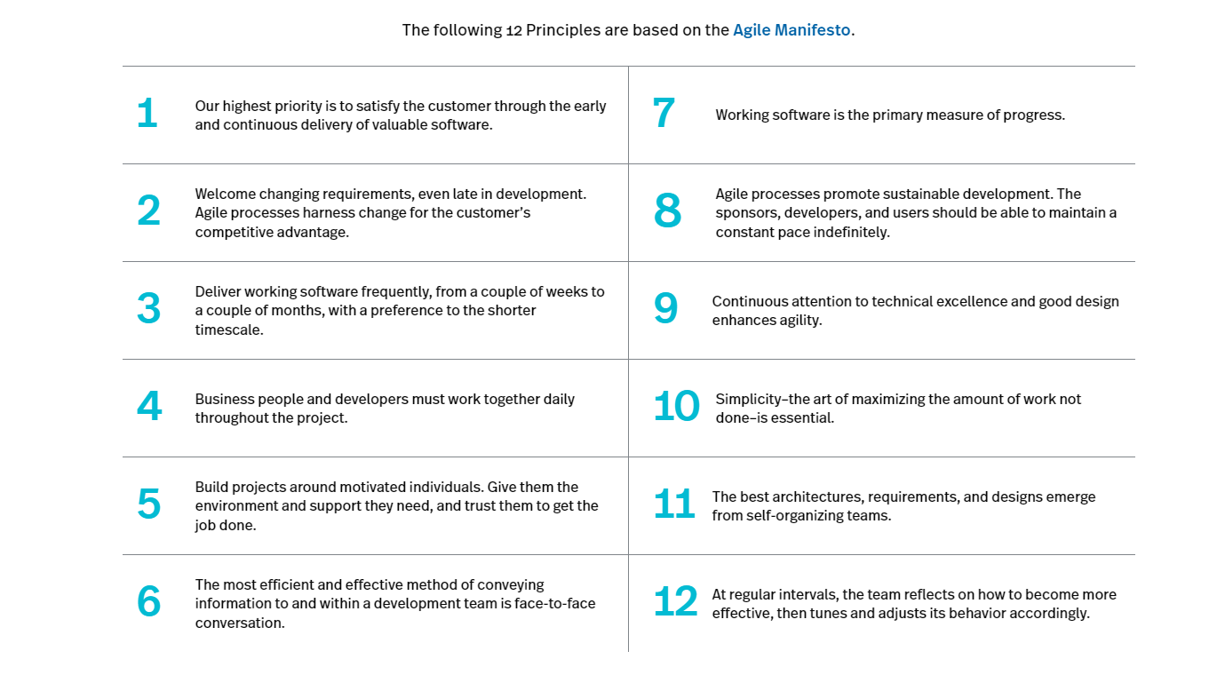

***Kanban board***

-These Kanban board indicate the details of the task and the expectations that must be met to complete it

-User Stories Important in Kanban to communicate what your teams need to do enables you to deliver high levels of customer value.

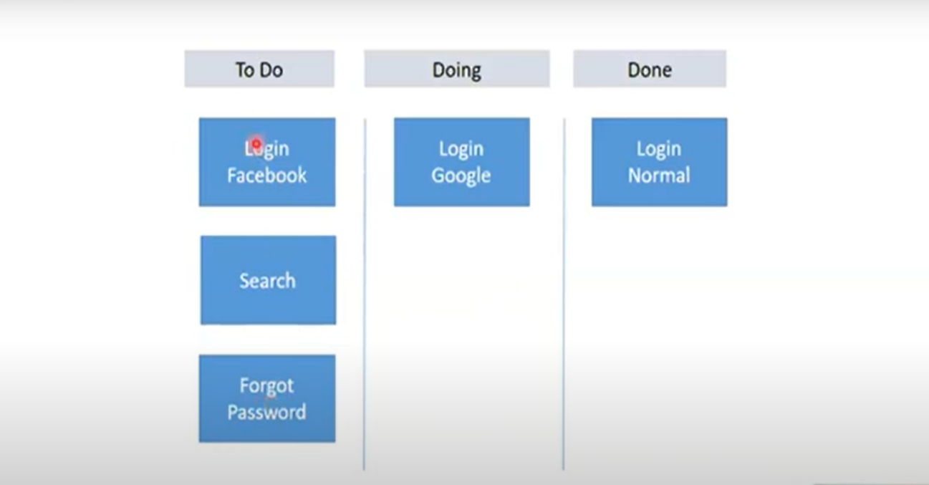

***User Stories tools***

1. **Azure DevOps**

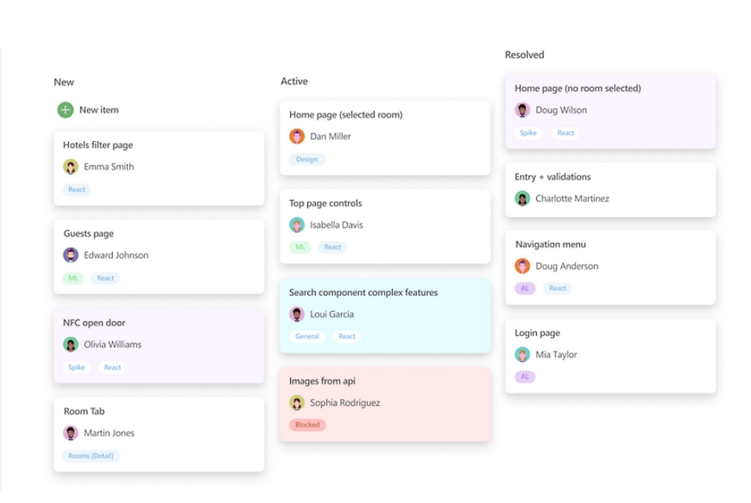

**2-Jira**

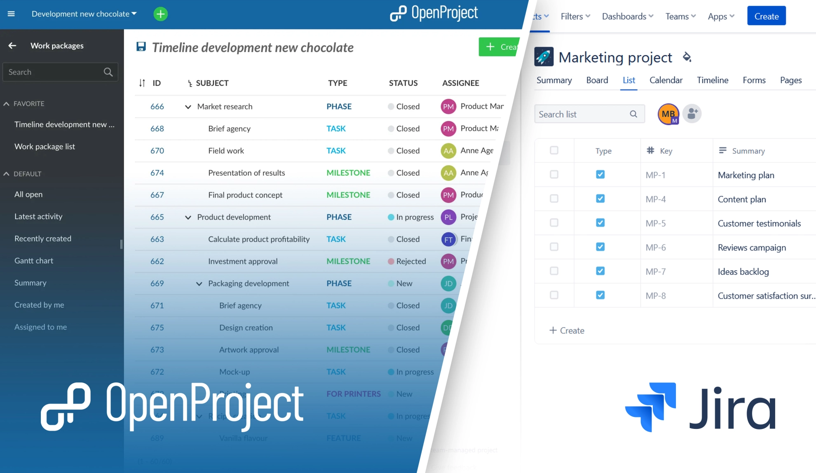

***Reference***

<https://www.youtube.com/watch?v=uoSaok0Jbf0>

<https://www.wrike.com/agile-guide/user-stories-guide/>

<https://kanbanzone.com/2021/what-is-a-user-story-and-its-importance-in-kanban/>

<https://www.agilealliance.org/agile101/12-principles-behind-the-agile-manifesto/>

<https://www.openproject.org/blog/open-source-jira-alternative/>

<https://theproductmanager.com/tools/best-user-story-software/>