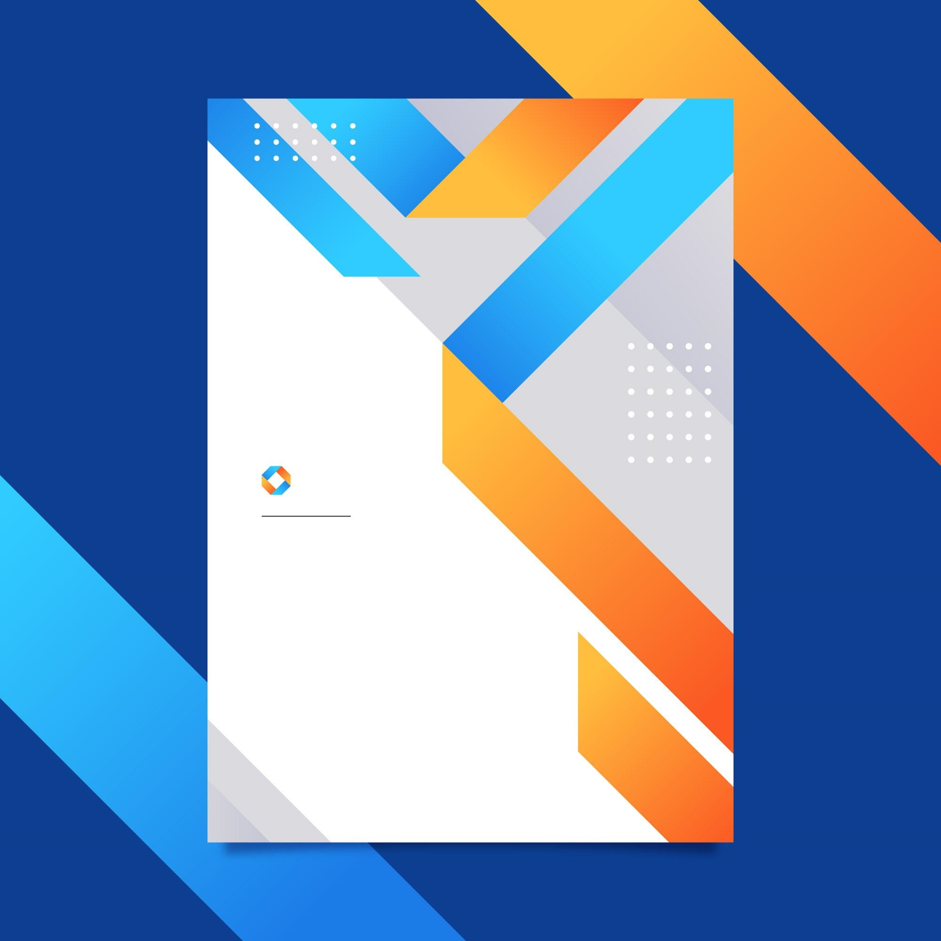
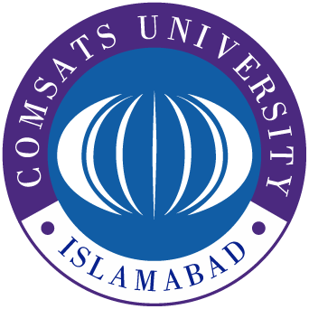
Comsats University Islamabad
Submitted by: Mohamed Ahsan Wakir
Reg No: FA22-BCT-001

Submitted on October 14, 2024

Submitted to: Ms.

