Analyzing and Visualizing WeRateDogs

*By Mohamed Al-Mokadem*

**Introduction**

Have you heard about one of the most famous meme of 2016 *“they’re good dogs Brent”* and the twitter account WeRateDogs*?* Probably yes, but if not. Here I can tell you a bit about it and better than that I can show you some fun analysis of WeRateDogs tweets data.

First, WeRateDogs is a Twitter account that rates people's dogs with a humorous comment about the dog. These ratings almost always have a denominator of 10. The numerators however are almost always greater than 10 (11/10, 12/10,

13/10, etc.). In theory the rates should be 1 to 10. However, WeRateDogs

disagree, they admit almost all dogs deserve a 10 and sometimes more than that.

WeRateDogs has over 6 million followers and has received international media

coverage. One of those coverages were about the quote *“they’re good dogs Brent”,* this was an exchange in which WeRateDogs shut down a person having an issue with its rating system in humorous ways.

So what does this rate do? Which dog type (breed) is most common dog in the

tweet dataset? What dog type has the highest average rating? These questions

and more are answered in the following insights:

**Most common dog type**

WeRateDogs has over 6000+ tweets. I was able to analyzed around 1500+

tweets. The most rated dog was golden retriever with more than 140 ratings.

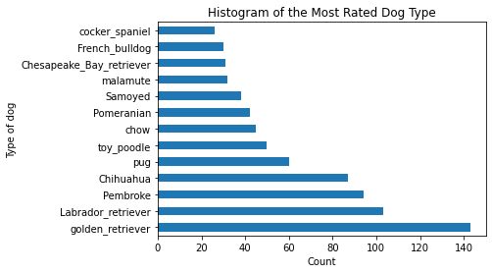

**Lowest average rating among dog types**

Almost all dogs deserve ratings above 10. This is a notable exception (for the curious ones). This Japanese spaniel has the lowest average rating.



This is an example of the most rated dog type (Golden retriever). The average rating was also high (11.59). No wonder why! Cute!



**Golden retriever stands out!**

The blue dot on the very right represents the approximately 140 ratings of golden retriever. On average these ratings are high 11.59. This really shows that the golden retriever is very popular.

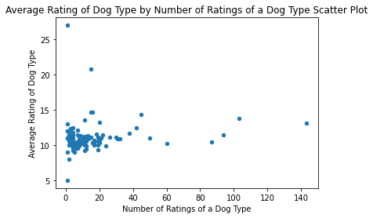

**Retweet counts**

Amazingly many tweets have been retweeted more than 1000 times some more than even 50000 times. There is not a clear relationship between the ratings and the retweets.

