**Capstone Stage 1**



Description

Intended User

Features

User Interface Mocks

Screen 1-2

Screen 3-4

Screen 5-6

Screen 7-8

Screen 9-10

Key Considerations

How will your app handle data persistence?

Describe any corner cases in the UX.

Describe any libraries you’ll be using and share your reasoning for including them.

Describe how you will implement Google Play Services.

Next Steps: Required Tasks

Task 1: Project Setup

Task 2: Implement UI for Each Activity and Fragment

Task 3: Handle Corner Case

Task 4: Setup Async Tasks

Task 5: Setup Notifications

# GitHub Username: [MohamedAlaaEldin636](https://github.com/MohamedAlaaEldin636)

VIP Reminder

Description

VIP Reminder helps you to remind everything by typing a label and even long description of each task you need to do.

It comes with an awesome feature, unlike other reminders that depend only on time, it as well can depend on specific place, for example when I get near to my parents’ house, I want to remember to get them a present with me. (you can combine depend on time or place or both together)

App notifies user with notification with title shows if it is due to time, place or both.

Also, reminders will be filtered in 5 categories 🡺 Today, Tomorrow, Upcoming, Done and Overdue (time for reminder passed the current time and it wasn’t marked as done).

Intended User

This app for all people, especially people who have a lot of events.

Features

Main Features

* Save, edit and delete tasks that user adds.
* Tasks can be added depending on time or place or both with condition option that both must be met or not, with repeat and actions.
* Shows tasks in an organized way, so that you know if the task will be today or has been done or in favorite section.

User Interface Mocks

These mocks have been done by the layout.xml in android studio, I have provided

All possible UI screens in the app.

**Screen 1 - 2**

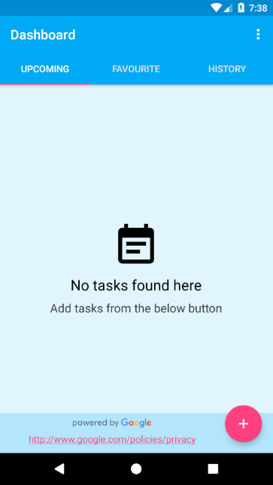 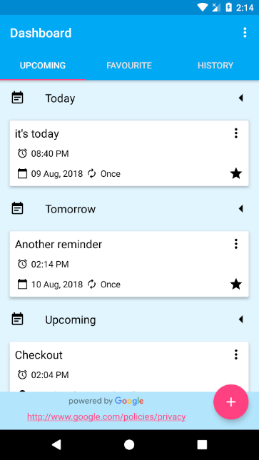

The first screen that appears on app launch, which shown list of tasks created by user or empty view if no tasks exist.

You can edit, delete or add as favorite for any task in the list, and can share or copy

The label to the clipboard as well (it has powered by google logo in case a reminder

has a place)

**Screen 3 - 4**

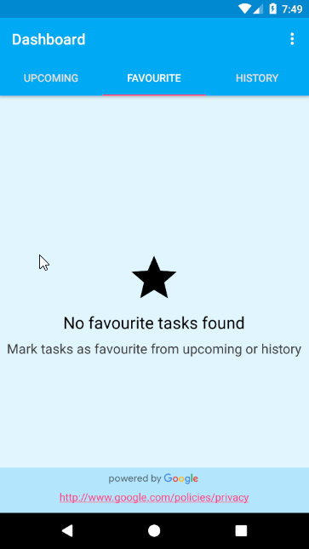 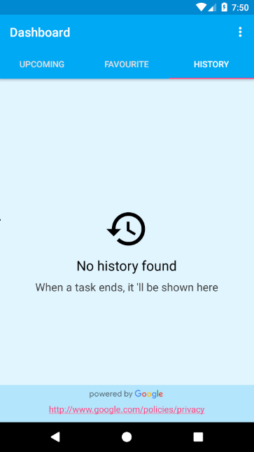

Empty views of other sections in the view pager, in case user didn’t add tasks that can be put in these sections.

**Screen 5 - 6**

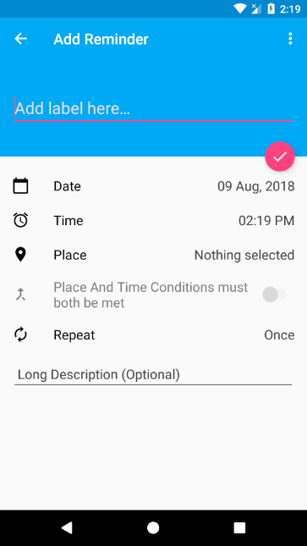 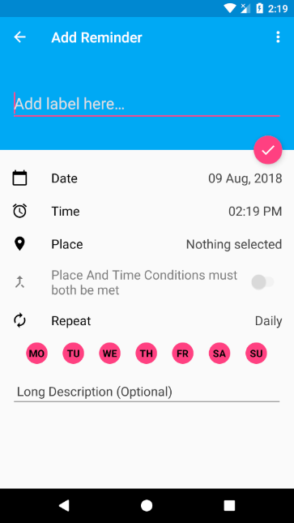

Adding or editing reminder Activity, it gives you options to save the reminder with validation that checks label to be not empty, and checks if time is passed or not, and can proceed if time passed only in case there is place and the condition is false.

Also note difference in the 2 images, that if repeat is not once a circle of all days in week

Will appear, so user can un-check any of them, so the reminder can ring in the checked ones

For ex. If I make repeat daily and un-checked SA(Saturday) then reminder will make notification every day except Saturday.

**Screen 7 - 8**

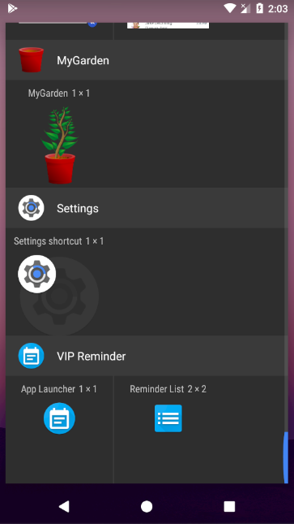 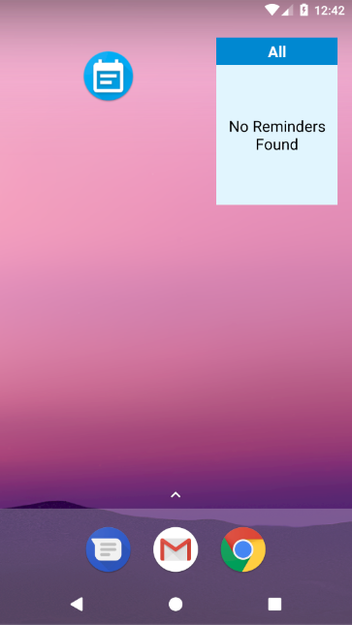

I have 2 different widgets in the app one is just to launch the application, which is done due to giving user quick access to launch the app, instead of searching between other apps in the device, the second widget with other images explained below in Screen 9 – 10.

**Screen 9 - 10**

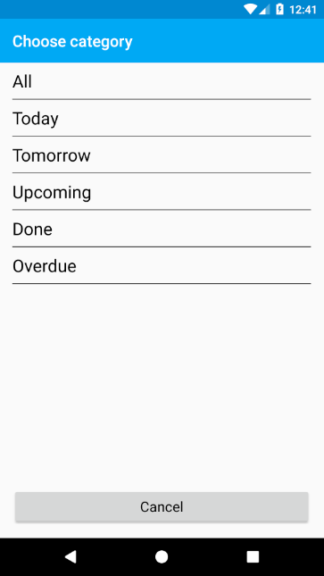 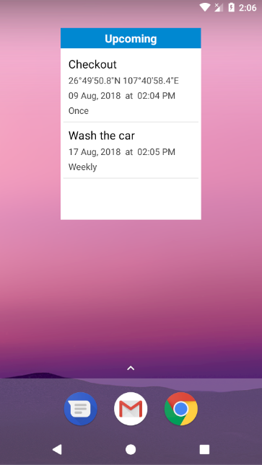

The second widget is to show user list of reminders of whatever category he wants for example one would need to show reminders of today only or for favorite ones or All reminders, and that’s why this widget has a configuration activity.

Key Considerations

1- App is written solely in the Java Programming Language.

2- App utilizes stable release versions of all libraries, Gradle, and Android Studio.

3- App includes content descriptions for Images, and use navigation using a D-pad for Tv

**How will your app handle data persistence?**

This app uses Room Library to save tasks added by user.

**Describe any edge or corner cases in the UX.**

App uses coordinator layout, tool bar and fabs to provide nice and beautiful UI.

**Describe any libraries you’ll be using and share your reasoning for including them.**

Used all latest versions in all the libraries

Data Binding 🡺 to bind views easily.

Timber (4.7.0) 🡺 to make logging way easier.

Room (1.1.1) 🡺 to persist data

Live Data and View Model with Java8 support (1.1.1) 🡺 live data used to observe data from room when we query it, and view model used for several reasons like interacting directly with xml and to have variables that survive configuration changes.

Work Manager (1.0.0-alpha06, Note It is latest version by the way from the android documentation itself) 🡺 to schedule tasks to notify the user at the specific time he wanted to be notified at.

**Describe how you will implement Google Play Services or other external services.**

Places 🡺 used when add reminder to get place data from Place Picker and get places data from place id when opening the app since we cannot save place data, we can only save the place id and re-get the data.

Location 🡺 to get geofences added by user in place Picker, and to get as well current location when reminder is set with time and place both must be met so I will make work manager and inside that work I will check the current location, to see if requirements are met.

Next Steps: Required Tasks

This is the section where you can take the main features of your app (declared above) and break them down into tangible technical tasks that you can complete one at a time until you have a finished app.

**Task 1: Project Setup**

Before I begin developing my app, I’ll first need to add Room as a dependency in my app’s build.gradle file. Once I have Room available, I’ll be able to save and retrieve the data users will be creating in the app, as well as other libraries that I talked about in the above section of using libraries.

**Task 2: Implement UI for Each Activity and Fragment**

* Build Main Activity with View Pager and Loading Progress bar
  + Inside the view pager I will use fragment to display each section given page title to behave correctly (show favorite list, other section list).
  + The layout of that fragment will have 3 views
    - Recycler View to display reminders
    - Fab to add new Reminder
    - Empty View if there are no reminders added
* Build Add Reminder Activity to add or edit reminder.
  + It will have options to be modified for the reminder such as label, date, time, place, repeat and long description if user wants to add more info.
  + I will implement Date and Time Picker as well as Place Picker, and I will create a dialog for selecting the repeat option.
  + And when user finally decide to create the reminder, I will check for data input and if it is ok, I will add to database that new reminder row and schedule Work Manager or add geofence according to the data of the reminder.

**Task 3: Handle Corner Case**

If user add reminder that depend on time only, I will schedule work manager.

And If user add it depending on place only, I will use geofence.

But what if both exist, well there is 2 situations here

1- Both must not meet at the same time (Switch condition option in add reminder activity is set to false).

* Then I will make both Work Manager and Geofence.

2- if the Switch is set to true

* Then I will just schedule Work Manager and when time comes, I will check for current place and if it is < 50 meters (like geofence) than the place that user added in the reminder, The app will notify the user with the notification, else nothing will happen.

**Task 4: Setup Async Tasks**

1- Yes, I will use room to query from database, but when I want to Insert, Update or Delete from database, I will use async task.

2- second case to use it is when I want to make filtering to the database, in another meaning when I want to select which is today tasks, which are tomorrow, and which are Upcoming, and which are marked as done, and finally which considered to be overdue.

**Task 5: Setup Notifications**

Add notifications to notify users when the reminder is up and take into consideration the Oreo notification channel to be setup since I intend to support from API 16 to API 27.