**Instructor: Dr. Samy Soliman**

**TAs: Eng. Heba Raafat & Samar Ali**

**Team members:**

Amr El-Gendy _ 201304826

Omar Hagrass _ 201304766

Mohamed Alaa Farghaly _ 201305056

Omar Merghany _ 201304322

Project Report

Communications Theory and Systems CIE431

**Part I:**

**Case1:**

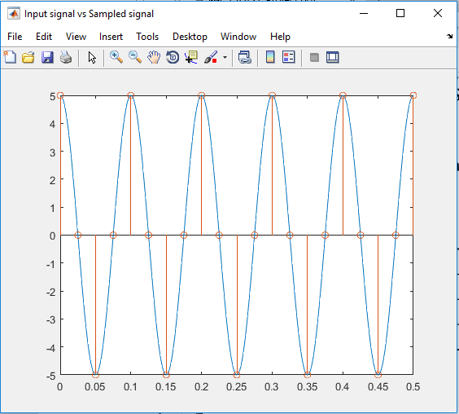

The opposite figure represents an input signal sampled at a rate higher than the Nyquist rate thus no aliasing is present.

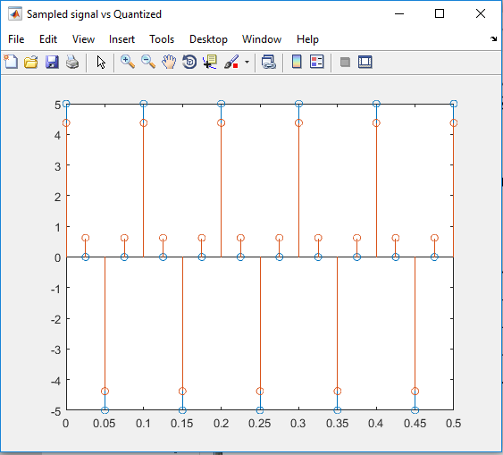

The opposite figure represents the quantized (red) and the sampled signals (blue). The difference in amplitude is due to low number of quantization levels (only 8), thus increasing the quantization error

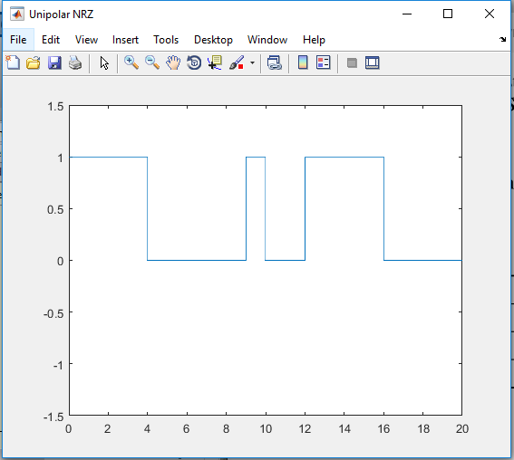

The opposite figure represents the encoded signal by Unipolar NRZ, where the period of each pulse is 1, and the default amplitude is also 1.

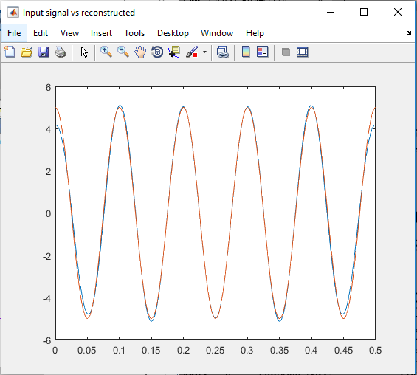

As shown, the reconstructed signal (blue) is nearly perfectly reconstructed, since it was sampled by a frequency above the Nyquist rate. The error from reconstruction is due to the quantization error.

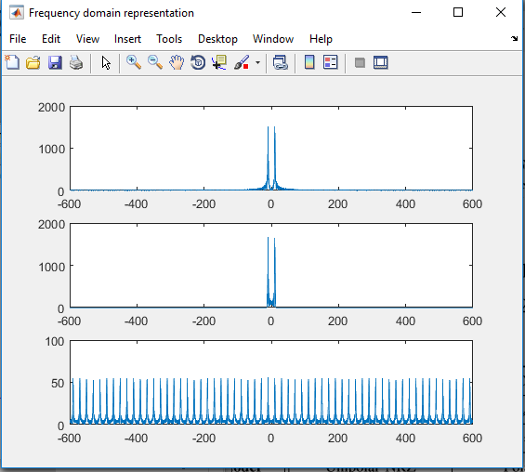

The first two figures represent the input signal and the reconstructed signal respectively.  
The third one represents the sampled signal.  
  
**No Aliasing**

**Case2:**

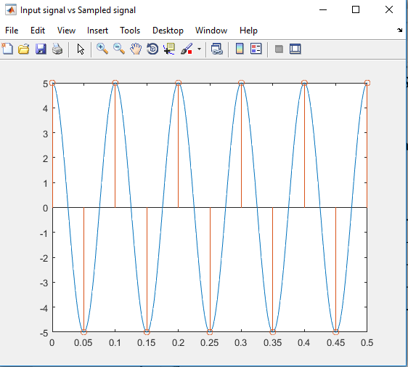

The opposite figure represents an input signal sampled at a rate equal to the Nyquist rate thus, still, like the previous case, no aliasing is present.

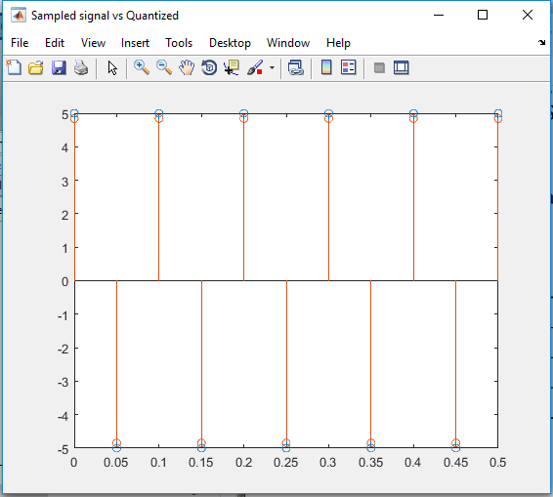

Increasing the number of quantization levels to L=32 decreased the quantization error, i.e. the difference between the sampled value and the quantized value decreased.

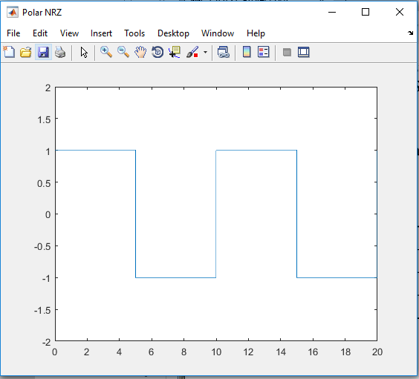

The opposite figure represents the encoded signal by polar NRZ, where the period of each pulse is 1, and the default amplitude A is also 1.

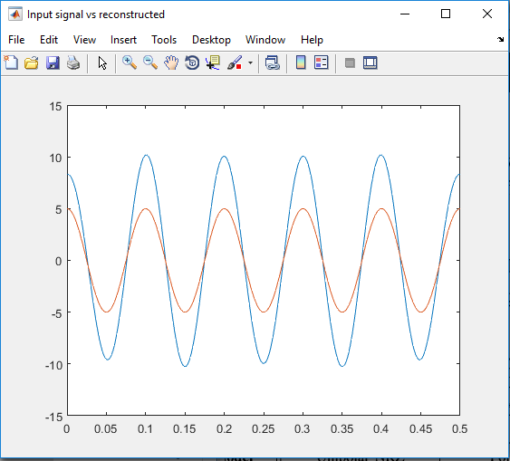

As shown, the reconstructed signal’s (blue) amplitude is not correct since it was sampled by a frequency equal to the Nyquist rate with some error plus error from quantization error.

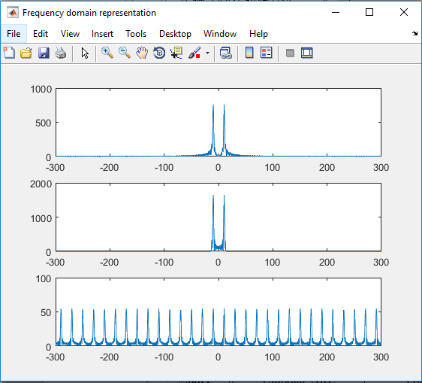

The first two figures represent the input signal and the reconstructed signal respectively.  
The third one represents the sampled signal.

**No Aliasing**

**Case3:**

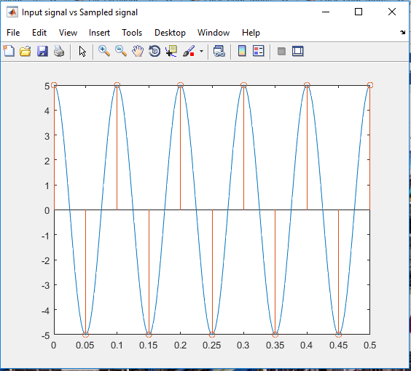

The opposite figure represents an input signal sampled at a rate equal to the Nyquist rate thus, still, like the previous case, no aliasing is present.

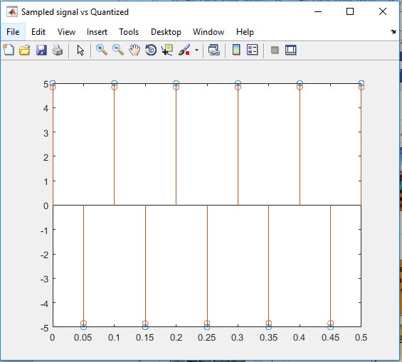

As shown in the opposite figure, using non uniform quantization didn’t have any effect compared to the previous case of uniform quantization. The same number of levels was used.

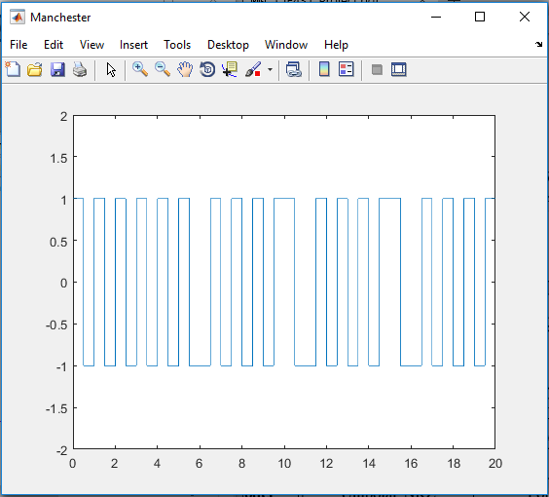

The opposite figure represents the encoded signal by using Manchester code, where the period of each pulse is 1, and the default amplitude A is also 1.

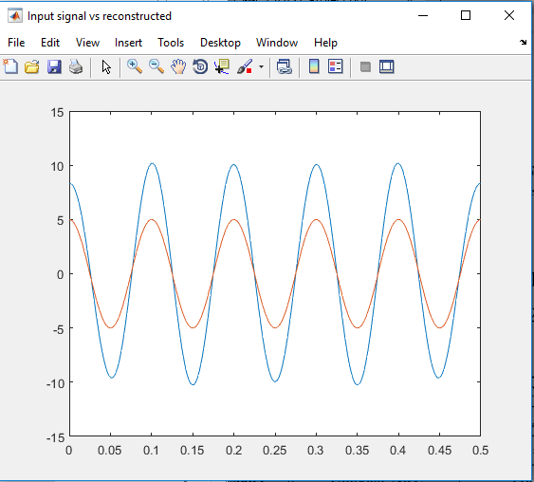

Same as with the previous case, the non-uniform quantization didn’t make any difference in terms of the quantization error

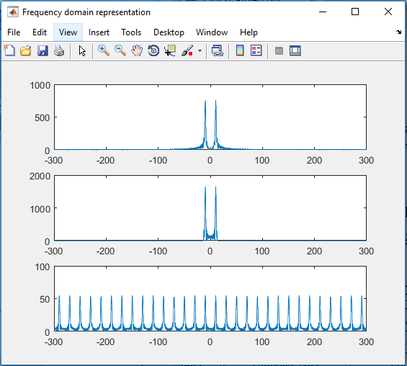

The first two figures represent the input signal and the reconstructed signal respectively.  
The third one represents the sampled signal.

**No Aliasing**

same as the previous case

**Case4:**

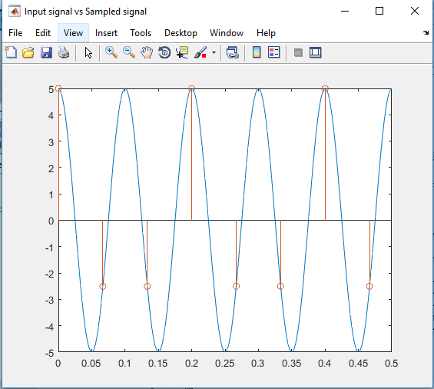

In this case, the sampling frequency is less than the Nyquist rate, thus resulting in aliasing and lose of information

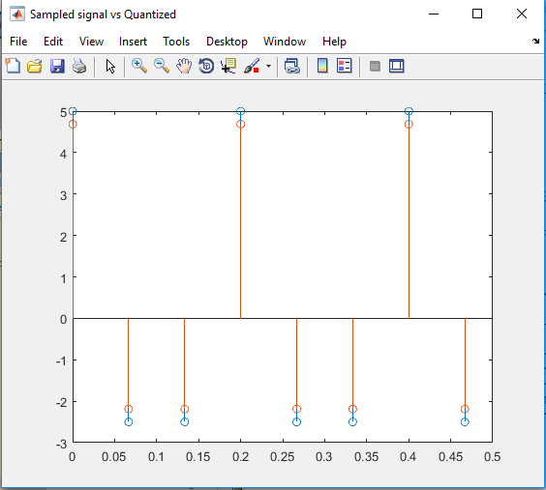

Decreasing the number of levels to 16 increased the quantization error in comparison to case 2 and case 3.

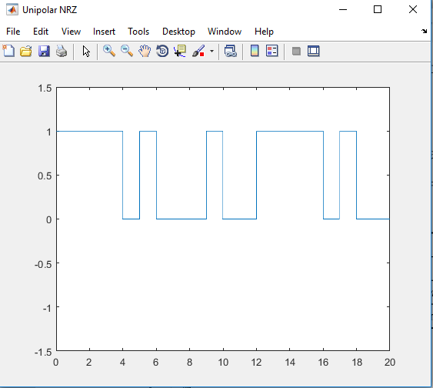

The opposite figure represents the encoded signal by Unipolar NRZ, where the period of each pulse is 1, and the default amplitude is also 1.

Same as case 1.

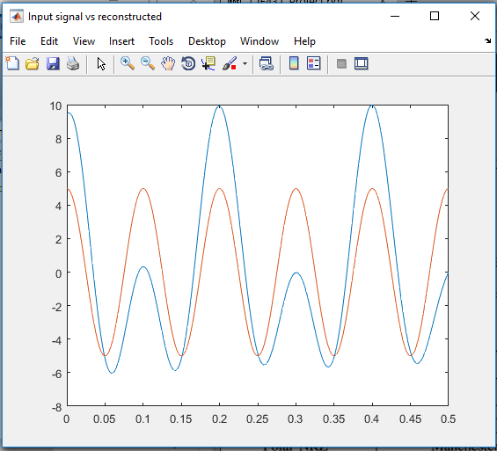

From the figure opposite, it can be observed that Aliasing took place which resulted in a distorted signal.

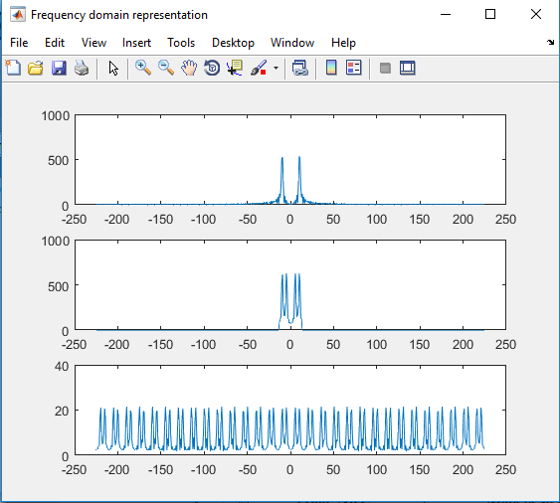

From the figure opposite, in the second plot and the third plot, it is apparent that aliasing took place which distorted the signal and resulted in information loss.

**Part 2 A**

PAM level 2

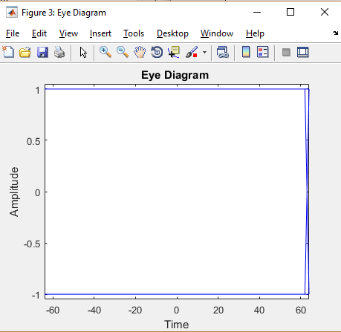NRZ

It’s totally open eye, so zero ISI effect.

It can be sampled at any point.

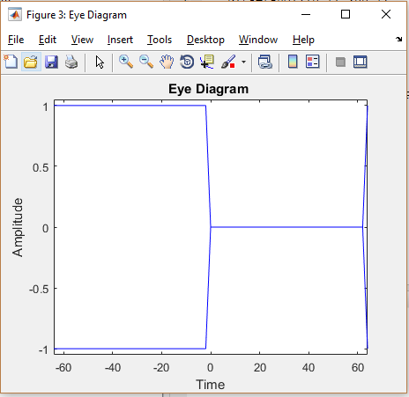RZ

It can be sampled only where the eye is opened. Because any small noise can change the value at amplitude zero (eye closed)

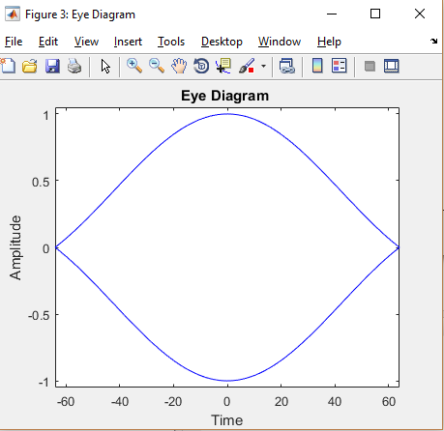Ideal Nyquist

Eye is maximum opened at midpoint(zero ISI), the receiver should sample at the midpoint

Raised cosine pulse

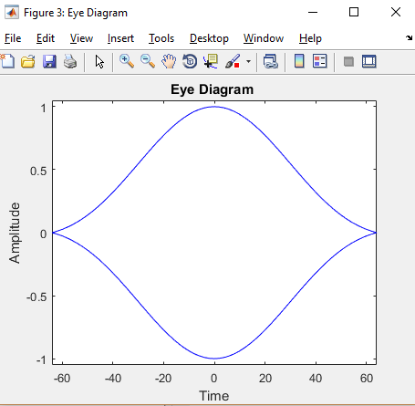

Eye is maximum opened at midpoint(zero ISI), the receiver should sample at the midpoint.

Note: Slope shows less sensitivity to sampling time than the ideal Nyquist

4-level PAM

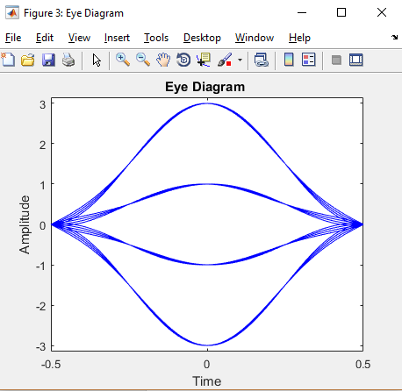Raised cosine

Eye is maximum opened at midpoint(zero ISI), the receiver should sample at the midpoint.

Note: Slope shows less sensitivity to sampling time than the ideal Nyquist

At the edges (eye is closed) do not sample

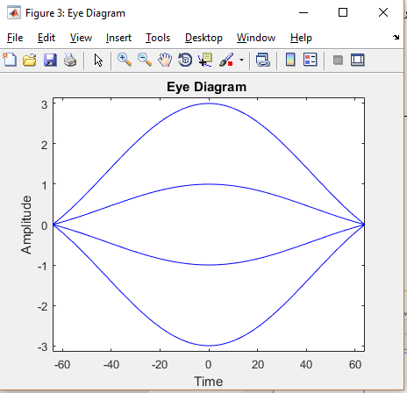Ideal Nyquist

Eye is maximum opened at midpoint(zero ISI), the receiver should sample at the midpoint

Wider error free sampling region than raised cosine pulse.

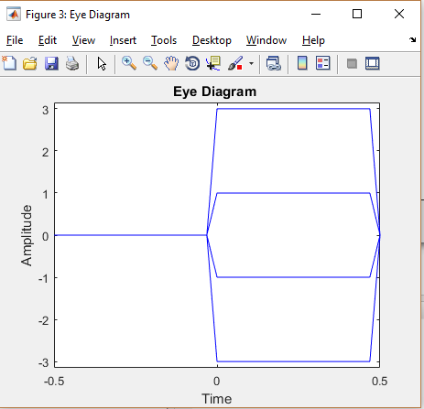RZ

It can be sampled only where the eye is opened. Because any small noise can change the value at amplitude zero (eye closed)

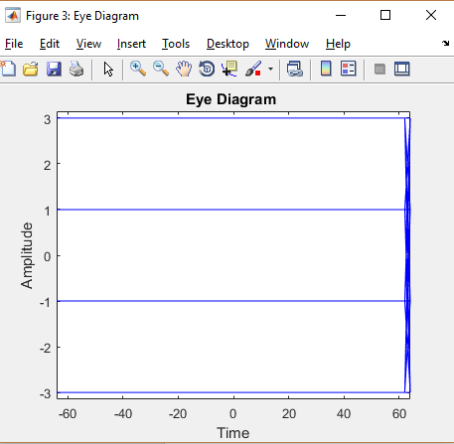NRZ

It’s totally open eye, so zero ISI effect.

It can be sampled at any point

2eyeduration 2*TS 4pam

The diagrams have the same ISI properties as described above

NRZ

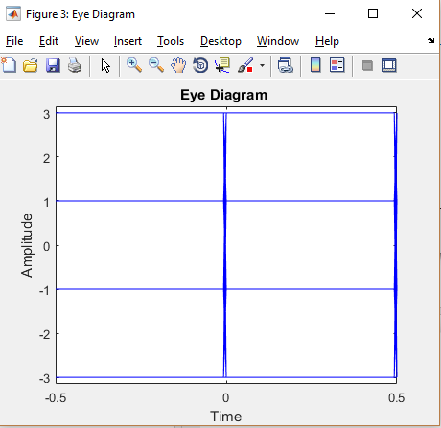

RZ

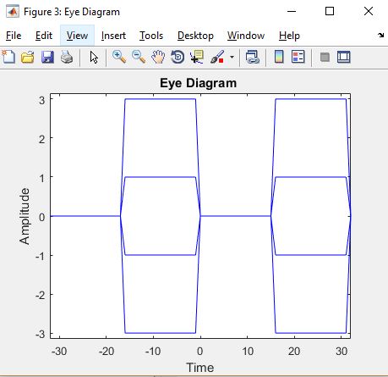

Ideal Nyquist Pulse

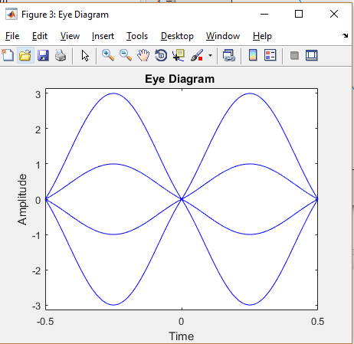

Raised Cosine

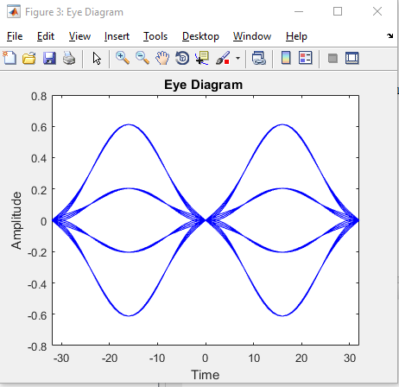

2*TS eye duration Binary PAM

The diagrams have the same ISI properties as described above in binary PAM

Raised cosine

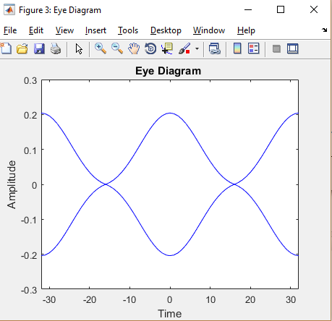

Ideal Nyquist

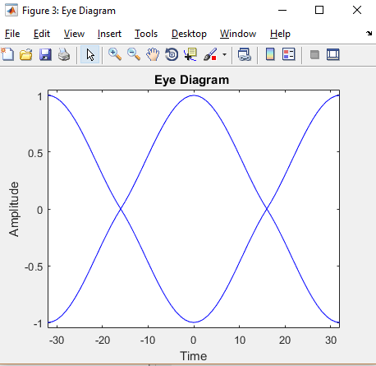

RZ

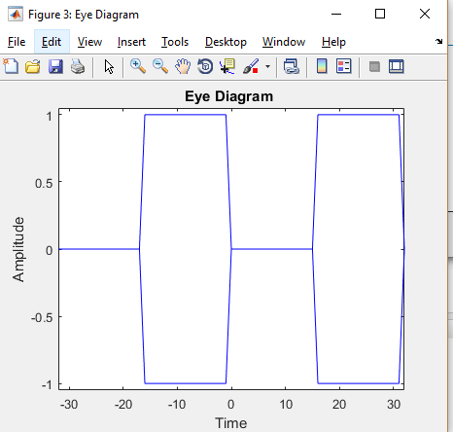

NRZ

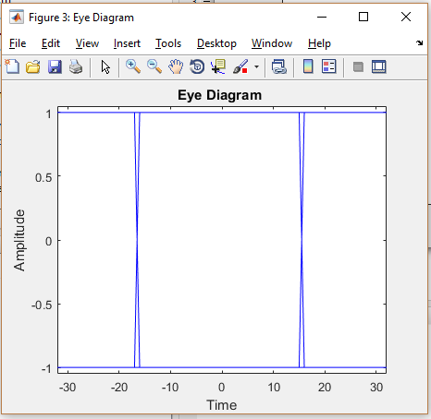

**PART2 B**

NRZ 0dB Case 1

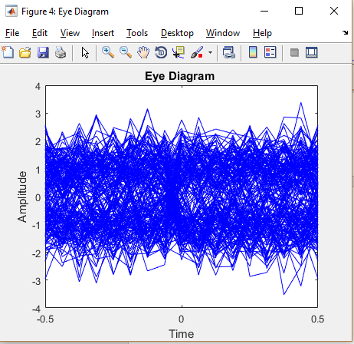

The noise exceeds the noise margin so the eye is completely closed and distorted.

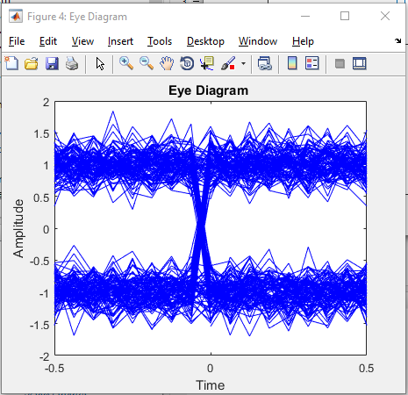NRZ 10dB Case 3

The noise does not exceed

The noise margin So the wide opened eye remains open and tolerate the noise. Sampling can be done at these opened areas to avoid error.

Widest error free sampling region

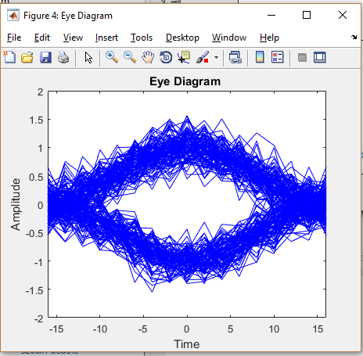Raised cosine 10dB

The noise does not exceed

The noise margin So the wide opened eye remains open and tolerate the noise. Sampling can be done at themed point to avoid error.

Raised cosine 0dB

The noise exceeds the noise margin so the eye is completely closed and distorted.

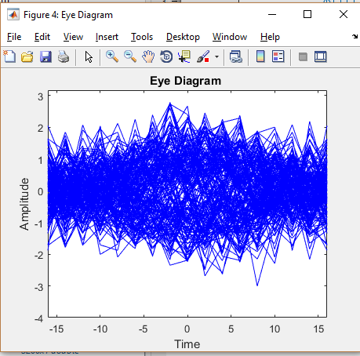

**Part 2C**

