****

**CIE203**

**Software Engineering**

Project Name

Software Design Document

Team Name

Team Leader

Month & Year

Contents

[Instructions [To be removed] 3](#_Toc467163228)

[Team 3](#_Toc467163229)

[Document Purpose and Audience 3](#_Toc467163230)

[System Models 4](#_Toc467163231)

[I. System Decomposition 4](#_Toc467163232)

[II. Class diagrams 7](#_Toc467163233)

[III. Sequence diagrams 8](#_Toc467163234)

[Class - Sequence Usage Table 10](#_Toc467163235)

[IV. Physical Entity-Relationship Diagram 11](#_Toc467163236)

[V. User Interface Design 11](#_Toc467163237)

[VI. Algorithms and Data Structures 13](#_Toc467163238)

[Ownership Report 13](#_Toc467163239)

[Policy Regarding Plagiarism: 13](#_Toc467163240)

[References 13](#_Toc467163241)

[Authors 13](#_Toc467163242)

# Team

# 

|  |  |  |  |
| --- | --- | --- | --- |
| **ID** | **Name** | **Email** | **Mobile** |
| 201300812 | Khaled hefnawy | [s-Khaled.mohamed@zewailcity.edu.eg](mailto:s-Khaled.mohamed@zewailcity.edu.eg) | 01066394056 |
| 201301691 | Mohamed Wasfy | [s-mohamed.safieddin@zewailcity.edu.eg](mailto:s-mohamed.safieddin@zewailcity.edu.eg) | 01110594119 |
| 201305056 | Mohamed Alaa el-din Fargaly | [s-mohamed.fargaly@zewailcity.edu.eg](mailto:s-mohamed.fargaly@zewailcity.edu.eg) | 01002680520 |
| 201306057 | Hazem Hamdy | [S-hazem.alromisy@zewailcity.edu.eg](mailto:S-hazem.alromisy@zewailcity.edu.eg) | 01288449661 |

# Document Purpose and Audience

# System Models

## I. System Decomposition

**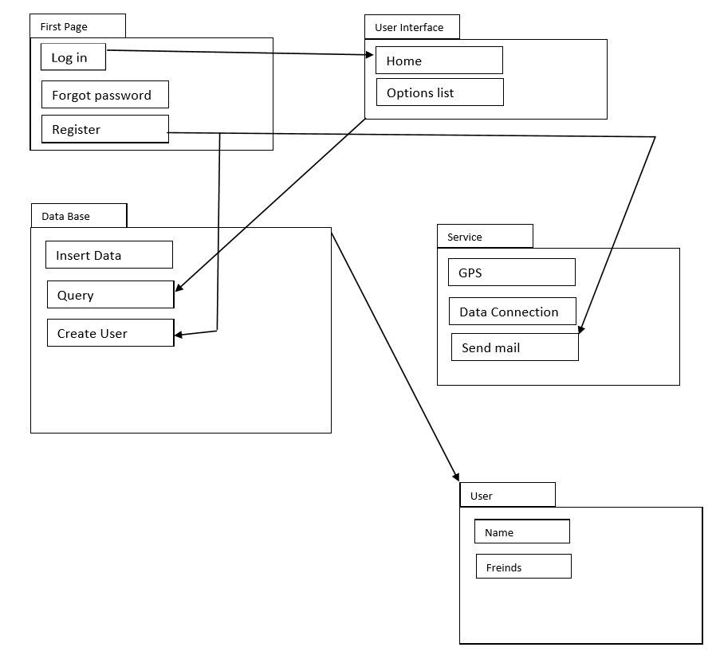**

## II. Class diagrams

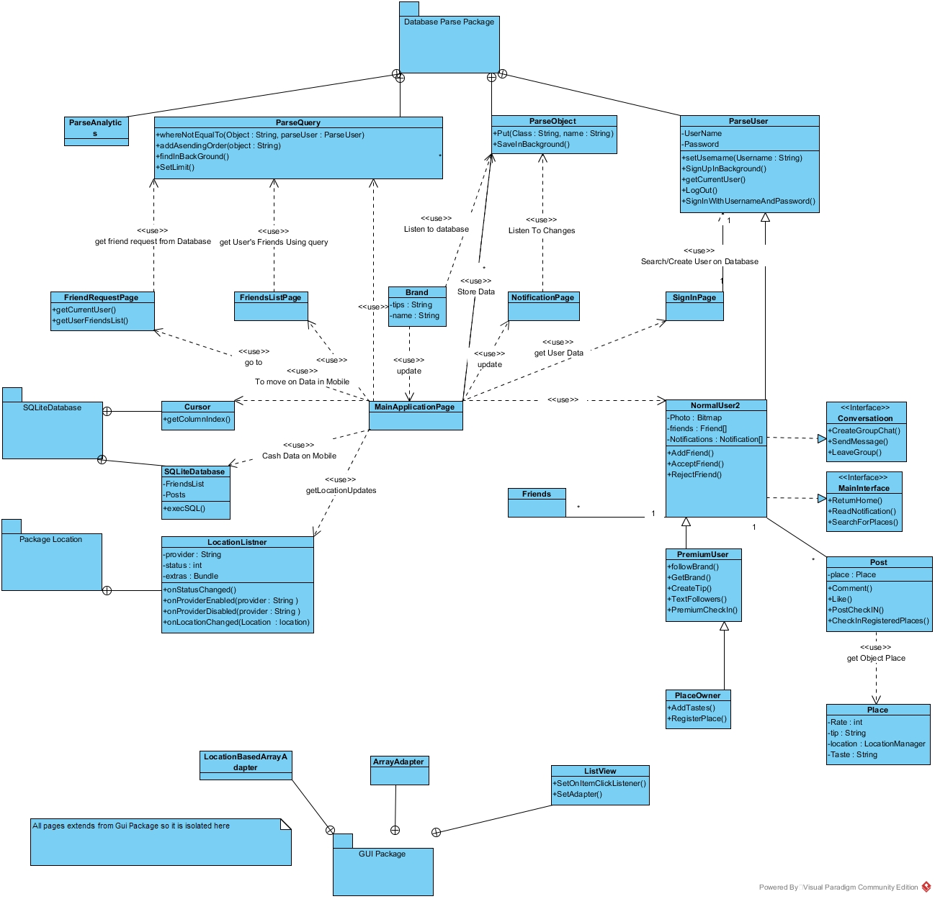

| **Class ID** | **Class Name** | **Subsystem ID** | **Description & Responsibility** |
| --- | --- | --- | --- |
| 1 | Normal User | App Main Subsystem | Navigate between different message,notification and posts |
| 2 | Place Owner User | App Main Subsystem | Navigate between different message,notification and posts  Add place  Add brand |
| 3 | Premium user | App Main Subsystem | Navigate between different message,notification and posts  Add brand |
| 4 | Place | CheckIn subsystem | Create Objects stored on database to be retrieved when user needs to check in a place to choose one from them |
| 5 | Post | CheckIn subsystem | Object to be posted on database that take user’s name, photo, place and user’s friends list and update database with it |
| 6 | Brand | CheckIn subsystem |  |
| 7 | Taste | CheckIn subsystem |  |
| 8 | Notification | CheckIn subsystem |  |
| 9 | Conversation | MessagingSubsystem |  |
| 10 | Friends | CheckIn subsystem |  |
| 11 | ParseObject | Database subsystem | Storing usersID, Locations,checkins in database |
| 12 | ParseUser | Database subsystem | SignIn functions on database |
| 13 | Parsequery | Database subsystem | All types of quesires to retrieve messages, friend’sList,brands and posts |
| 14 | Parseanaylitics | Database subsystem | Store users experience with the app |
| 15 | LocationListener | Sensors Subsystem | Retrieve user’s location |
| 16 | SharedPreferences | Mobile cash subsystem | Store user’s setting and styling for the app |
| 17 | SQLiteDatabase | Mobile cash subsystem | Cash posts and messages on mobile phone |

## III. Sequence diagrams

Open them in the attached folder numbered and named

### Class - Sequence Usage Table

| **Class Name** | **Sequence Diagrams** | **Overall used methods** |
| --- | --- | --- |
| MainPageGUI | 1,4 | Save, GetData |
| ParseObject | 1,2,3,5 |  |
| LocationListener | 3,7 |  |
| NotificationClass | 3 |  |
| FriendsListPage | 4 |  |
| NormanlUser | 1,2,5,6 |  |
| PremiumUser | 1,2,5,6 |  |
| ParseQuery | 1,2,3,4,5,6,8,9 |  |
| ParseUser | 1,11 |  |
| ParseObject | 4,5,6,10 |  |

## IV. Physical Entity-Relationship Diagram

## C:\Users\Khaled\Desktop\Last\15327570_939733052827947_323452787_n.jpg

## V. User Interface Design

LoginPage

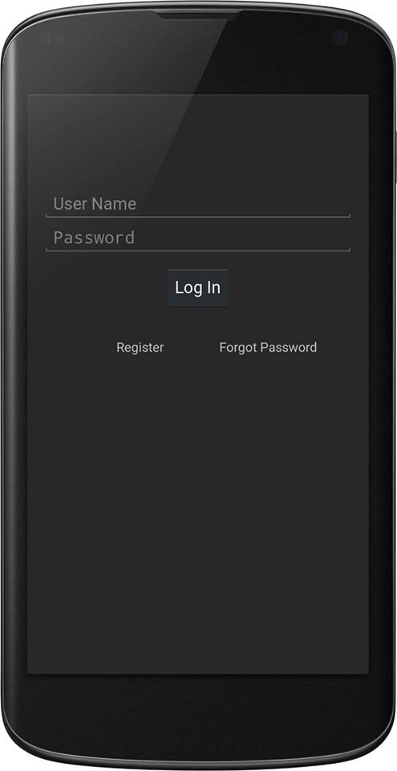

MainPage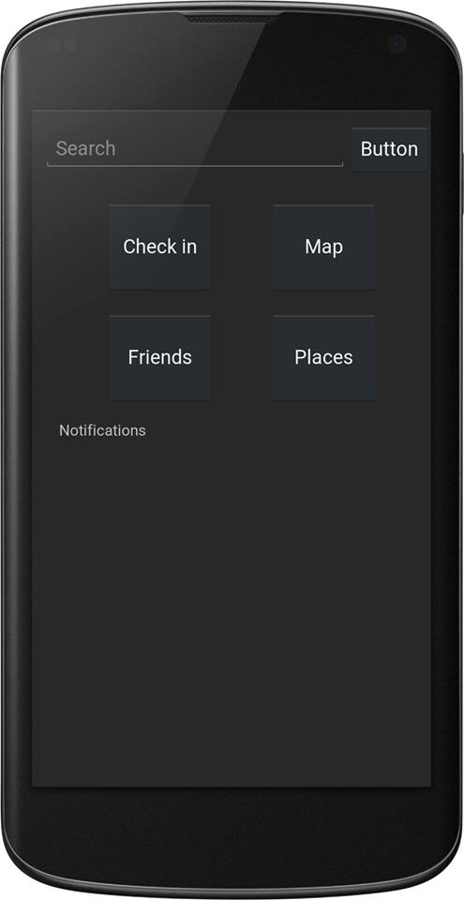

NotificationPage/ Messages page

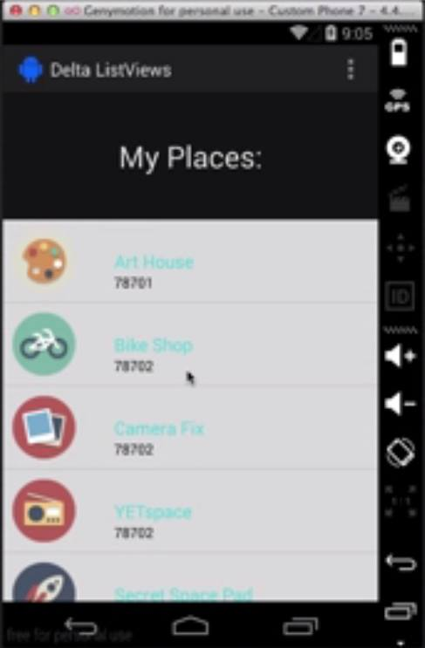

## VI. Algorithms and Data Structures

## C:\Users\Khaled\Desktop\Last\Project FlowCharts\Drawing26.pngC:\Users\Khaled\Desktop\Last\Project FlowCharts\Drawing25.pngC:\Users\Khaled\Desktop\Last\Project FlowCharts\Drawing24.pngC:\Users\Khaled\Desktop\Last\Project FlowCharts\Drawing23.pngC:\Users\Khaled\Desktop\Last\Project FlowCharts\Drawing22.pngC:\Users\Khaled\Desktop\Last\Project FlowCharts\Drawing21.pngC:\Users\Khaled\Desktop\Last\Project FlowCharts\Drawing20.pngC:\Users\Khaled\Desktop\Last\Project FlowCharts\Drawing19.pngC:\Users\Khaled\Desktop\Last\Project FlowCharts\Drawing18.pngC:\Users\Khaled\Desktop\Last\Project FlowCharts\Drawing17.pngC:\Users\Khaled\Desktop\Last\Project FlowCharts\Drawing16.pngC:\Users\Khaled\Desktop\Last\Project FlowCharts\Drawing15.pngC:\Users\Khaled\Desktop\Last\Project FlowCharts\Drawing14.pngC:\Users\Khaled\Desktop\Last\Project FlowCharts\Drawing13.pngC:\Users\Khaled\Desktop\Last\Project FlowCharts\Drawing12.pngC:\Users\Khaled\Desktop\Last\Project FlowCharts\Drawing11.pngC:\Users\Khaled\Desktop\Last\Project FlowCharts\Drawing10.pngC:\Users\Khaled\Desktop\Last\Project FlowCharts\Drawing9.pngC:\Users\Khaled\Desktop\Last\Project FlowCharts\Drawing8.pngC:\Users\Khaled\Desktop\Last\Project FlowCharts\Drawing7.pngC:\Users\Khaled\Desktop\Last\Project FlowCharts\Drawing6.pngC:\Users\Khaled\Desktop\Last\Project FlowCharts\Drawing5.pngC:\Users\Khaled\Desktop\Last\Project FlowCharts\Drawing4.pngC:\Users\Khaled\Desktop\Last\Project FlowCharts\Drawing3.pngC:\Users\Khaled\Desktop\Last\Project FlowCharts\Drawing2.pngC:\Users\Khaled\Desktop\Last\Project FlowCharts\Drawing1.png

# Ownership Report

|  |  |
| --- | --- |
| **Item** | **Owners** |
| Class diagram and sequence diagram | *kHALED hefnawy* |
| GUI and system decomposition | *Mohamed wasfy* |
| Algorithms and datastructure | *Mohamed alaa* |
| Entity relation ship | *Hazem hamdy* |