Question 1 : What is The Output ..? 1-

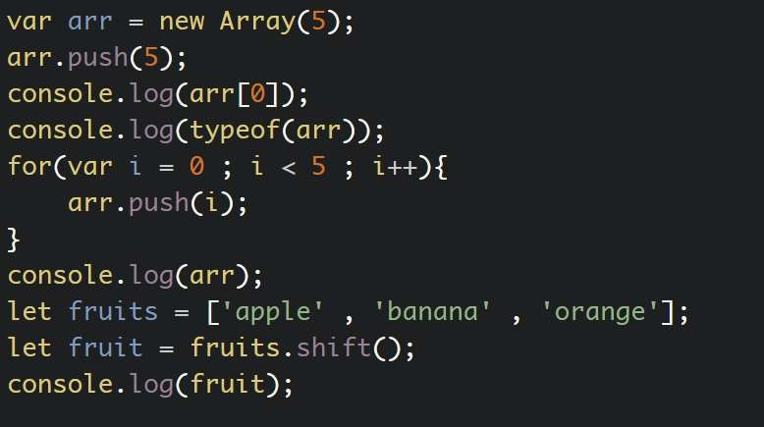

2-

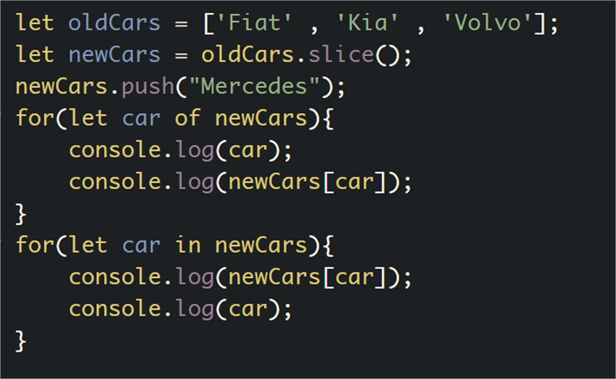

3-

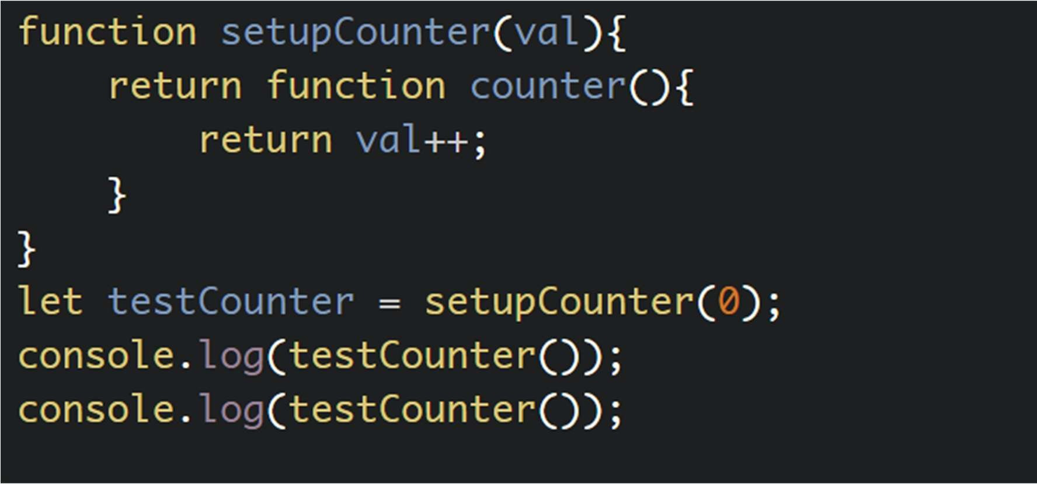

4-

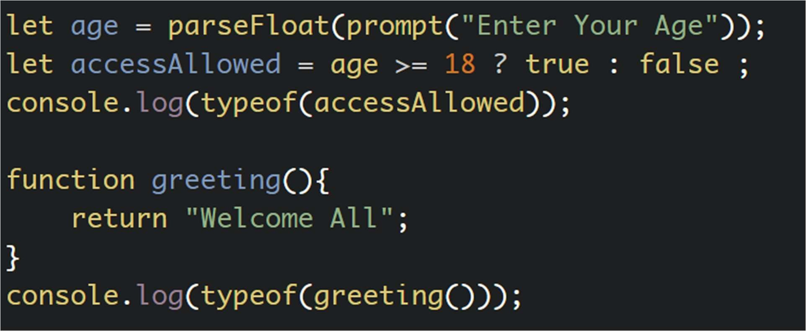

5-

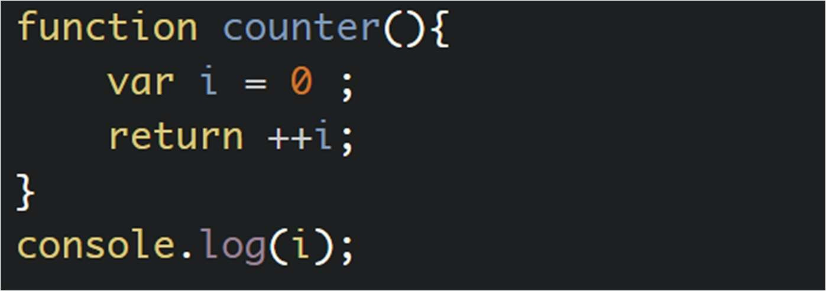

6-

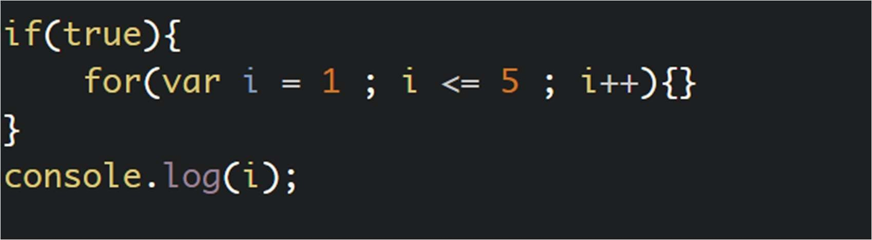

7-

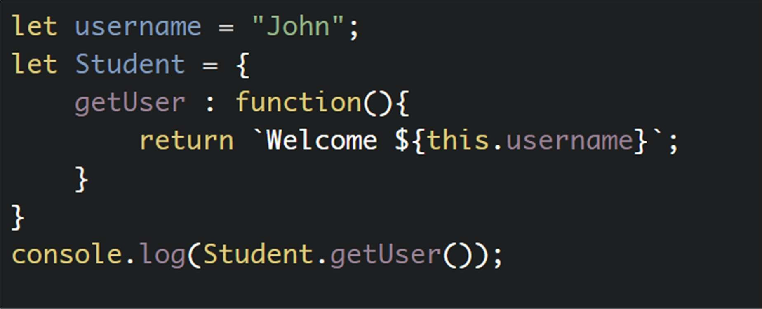

8-

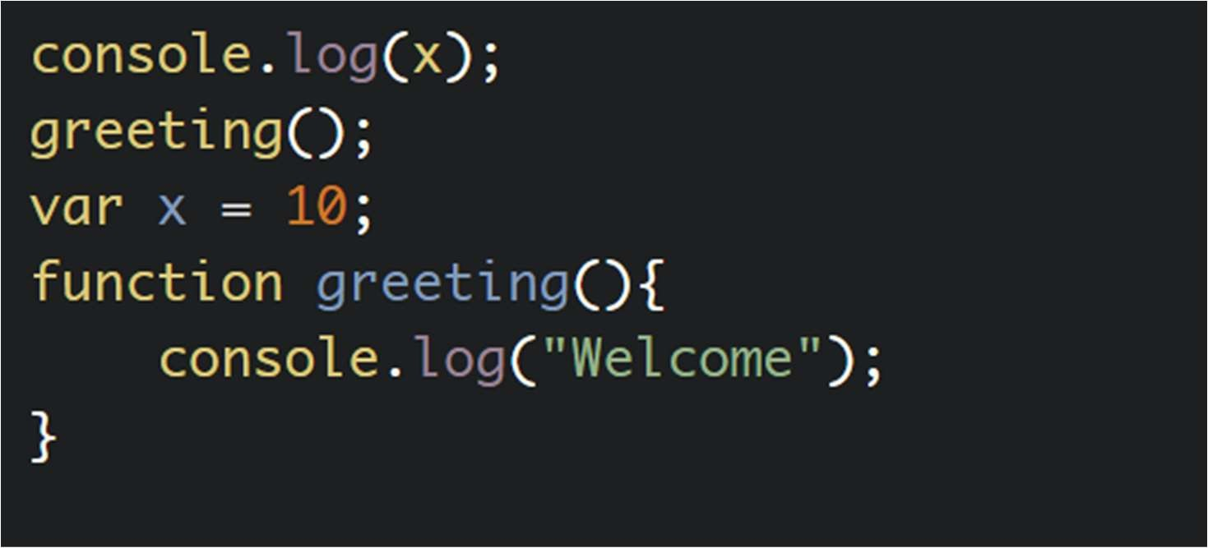

9-

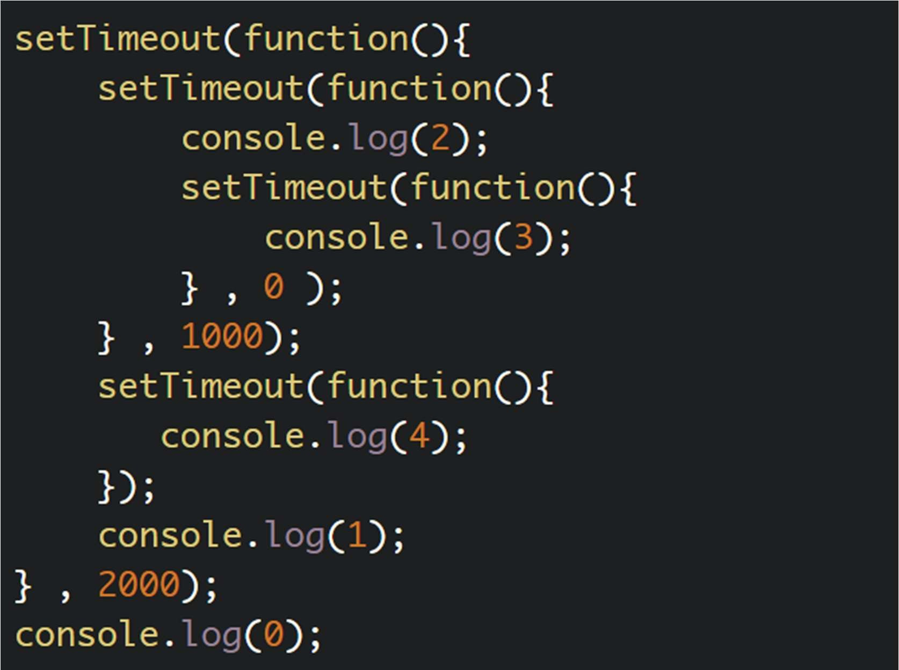

10-

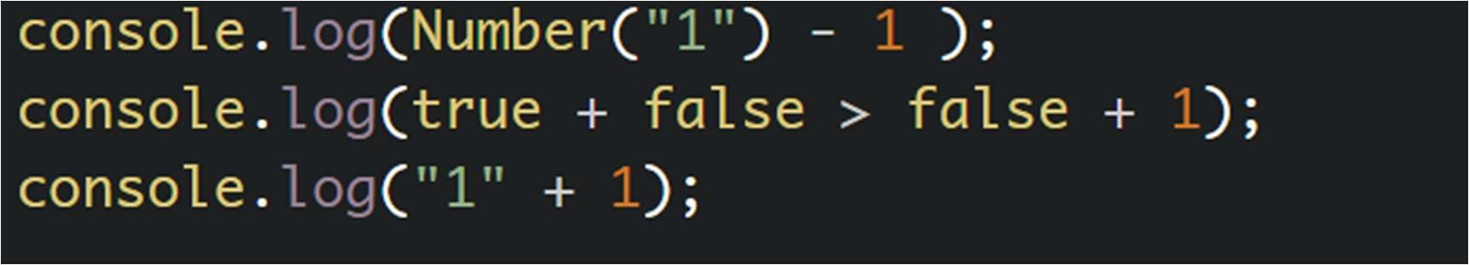

Question 2 : Write Javascript Code To Solve These Problems

1. Reverse String For Example => Welcome => emocleW
2. FizzBuzz Game
3. Using Recursion Compute The Factorial Of 5

Bestwishes , GoodLuck ◆:v