**What is the sprint’s goal?**

The goal of the sprint is to identify the approach of tackling the product backlogs that we have identified which will result in designing and implementing the product.

The sprint will include:

- brainstorming assumptions and testing them.

- Identify risks and mitigations.

- identify new features.

For the first sprint we will work on enabling the restaurant to view the orders and track the customers orders.

For this, we will identify the mechanism of listing orders based on timing of the order and view notes and special requests in the same page.

We will discuss the design of the template in a user-friendly way and mechanism to priorities and list orders.

We will also list down the risks of system bugs which may result in delaying the order to be sent to the restaurant and the frequency of refreshing the list.

We will also discuss the tracking mechanism of the order status, ensuring our system provide an easy end user experience.

Finally, we will identify the end user view or the delivery status and updates they should receive on the status.

**What is the team capacity?**

We’re a team of four members.

**What is the Product Backlog items to include based on their estimate and the goal?**

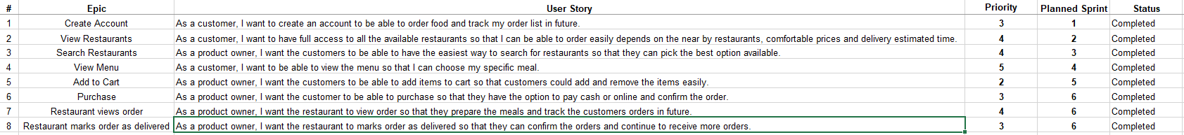

**The team assigns the different backlog items to team members?**

* Team member 1 assigned to work on Epic 1&2
* Team member 2 assigned to work on Epic 3&4
* Team member 3 assigned to work on Epic 5&6
* Team member 4 assigned to work on Epic 7&8