**Monitoring via EVM**

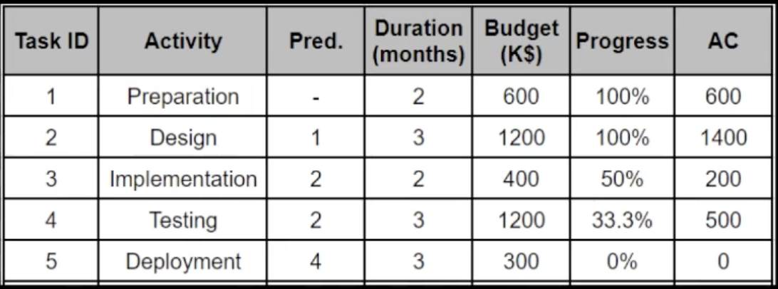

1. **By How much, is it over/under budget?**

* Over budget by 300K$

1. **By How many days, is it ahead/behind the schedule?**

* Behind by 3 months.

1. **By the end of the project how much will it be over/under budget?**

* Budget (3700K$)
* Task1(600), Task2(1400), Task3(200*2), Task4(500*3), Task5(300) = 4200K$.
* Over budget by (4200 – 3700 = 500K$)

1. **Calculate CV, SV, CPI, SPI, EAC.**

* EV (Earned Value): 600 + 1200 + (400*0.5) + (1200*0.33) = 2,396
* BAC (Budget at Completion): 600 + 1400 + 400 + (500/0.66) + 500 + 300 = 3950
* CV (Cost Variance): EV - AC = 2400 - 2700 = -300
* SV (Schedule Variance): EV – PV (Planned Value) = 2400 - 3700 = -1300
* CPI: EV / AC = 2400 / 2700 = 0.88
* SPI: EV / PV = 2400 / 3700 = 0.65
* EAC (Estimated at Completion) BAC / CPI = 3950 / 0.88 = 4,488.64