Performing Linux Network Commands using Kali Linux
Name: Mohamed Ali Mohamed
SAP ID: 52755
Instructor: Hamanyu Raza

Introduction
This laboratory exercise demonstrates the practical execution of essential Linux networking commands using Kali Linux. The lab focuses on understanding network interfaces, IP configuration, routing, connectivity testing, traffic capturing, and network analysis. Each task was performed in the Kali Linux terminal environment and verified using screenshots. Every screenshot in this report is explained individually based on the command output shown.

Task 1
This screenshot shows all available network interfaces along with their assigned IPv4 addresses and MAC addresses, confirming the active interface used in the lab.
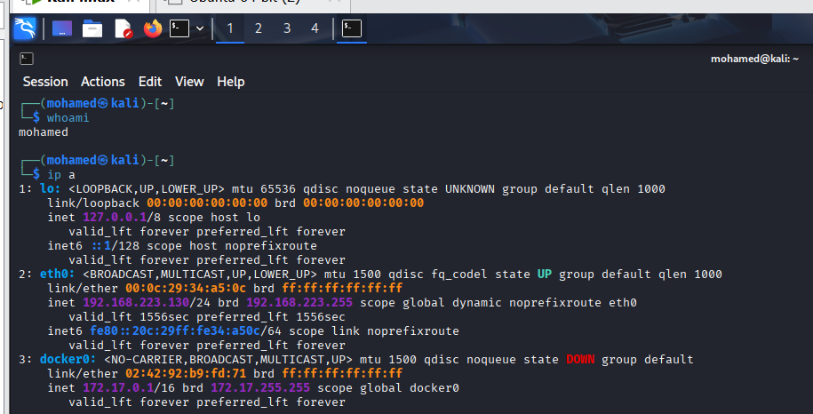

Task 2
This screenshot verifies the operational status of the network interfaces, showing whether each interface is up or down at the link layer.
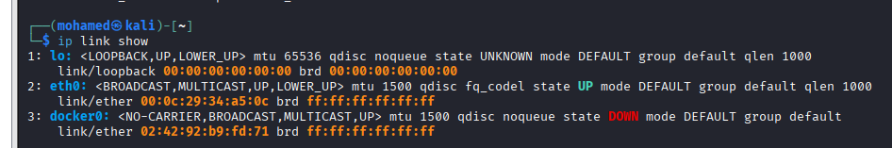

Task 3
This screenshot displays the routing table of the system, highlighting the default gateway used to forward outbound network traffic.
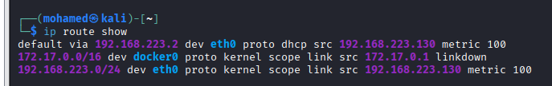

Task 4
This screenshot demonstrates the process of assigning a temporary IP address to the network interface for testing purposes.
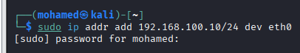

Task 5
This screenshot confirms the successful removal of the temporary IP address, ensuring that the interface returned to its original configuration.
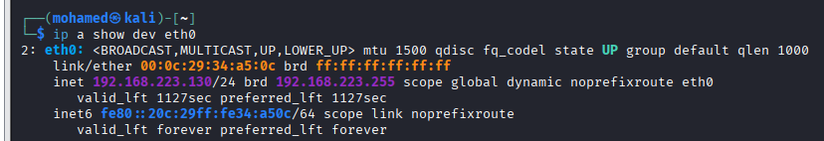

Task 6
This screenshot shows the result of sending ICMP echo requests to a public server, confirming that the system has active network connectivity.
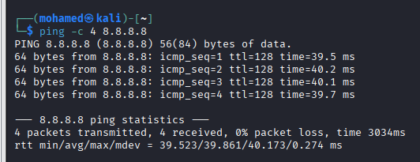

Task 7
This screenshot illustrates the path taken by network packets from the local system to an external destination, including intermediate hops.
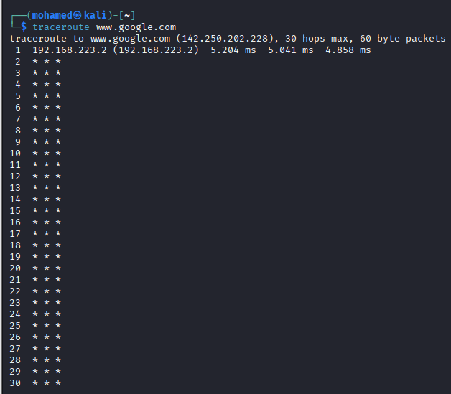

Task 8
This screenshot presents latency and packet loss statistics across the network path, providing insight into network performance.
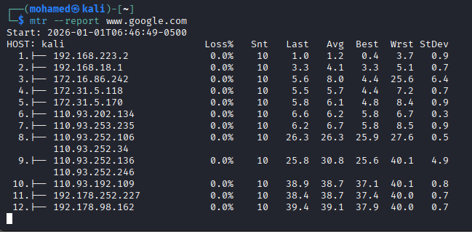

Task 9
This screenshot lists all active listening ports and network services currently running on the system.

Task 10
This screenshot demonstrates live network traffic capture and confirms that packets were successfully saved to a capture file.
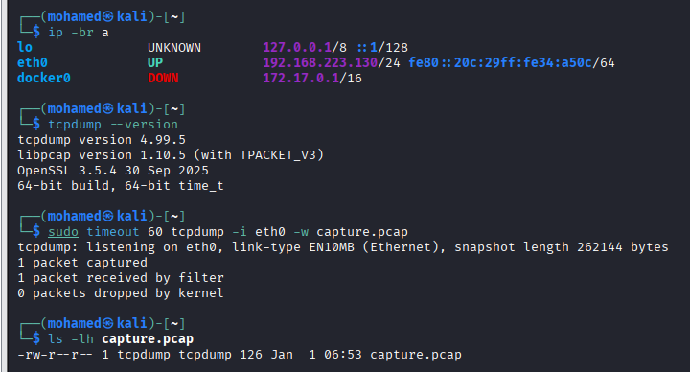

Task 11
This screenshot shows the ARP cache, mapping IP addresses to their corresponding MAC addresses within the local network.
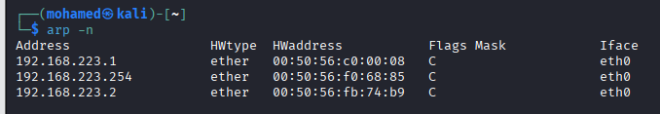

Task 12
This screenshot displays the DNS resolver configuration, indicating the name servers used for domain name resolution.
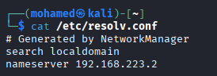

Task 13
This screenshot demonstrates an open TCP listening port created in a controlled lab environment for testing purposes.
