DoS / DDoS Detection and Defense Lab Report
Name: Mohamed
Operating System: Kali Linux
Tools Used: tcpdump, Wireshark, iptables

Task 1 – Lab Setup & Network Verification
This task validates the initial lab configuration and network connectivity.
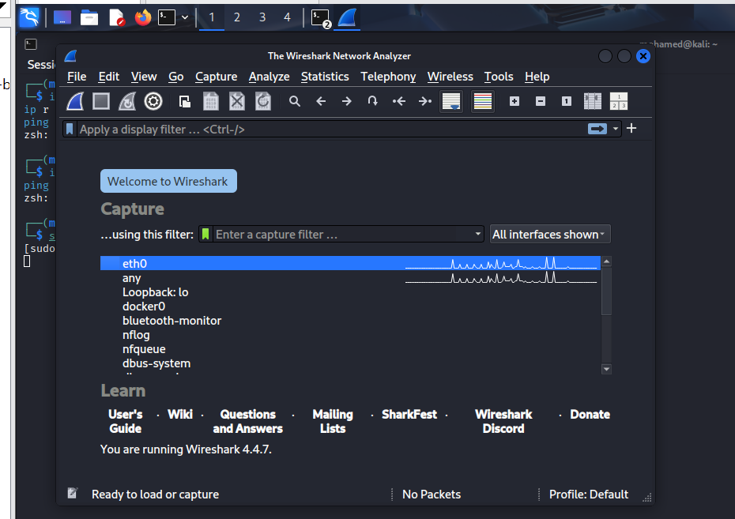
This screenshot demonstrates the successful setup of the lab environment. It confirms that the Kali Linux system is operational and properly connected to the network interface. The visible interface activity indicates that the system is ready for packet capture and further analysis tasks.
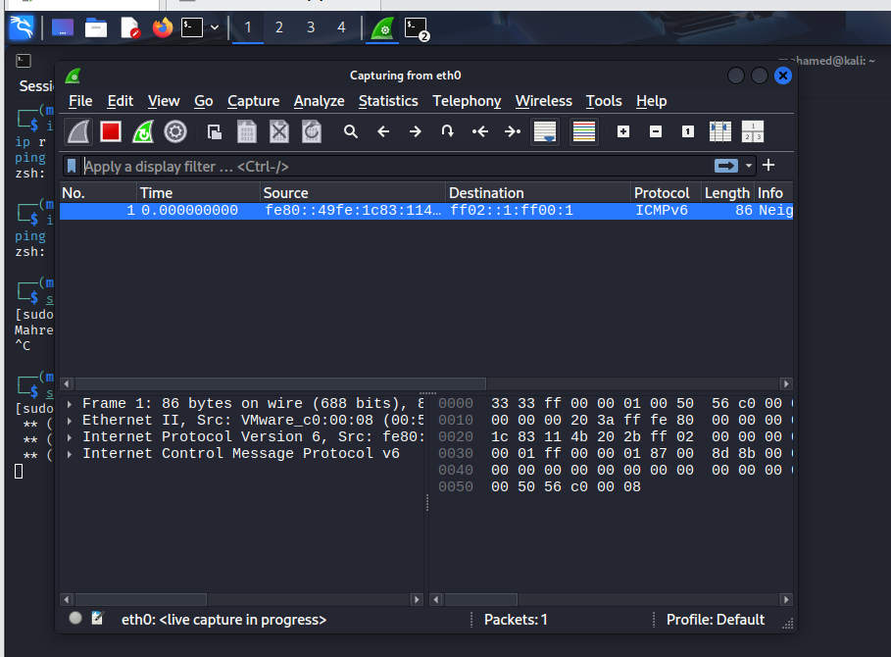
This screenshot demonstrates the successful setup of the lab environment. It confirms that the Kali Linux system is operational and properly connected to the network interface. The visible interface activity indicates that the system is ready for packet capture and further analysis tasks.

Task 2 – Traffic Capture using tcpdump
This task captures and reviews baseline network traffic.
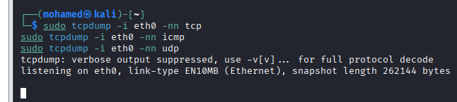
This screenshot shows the use of tcpdump to capture live network traffic. The output confirms that TCP, UDP, and ICMP packets are being observed on the selected interface. This step is critical for understanding baseline network behavior before analyzing any potential DoS or DDoS indicators.
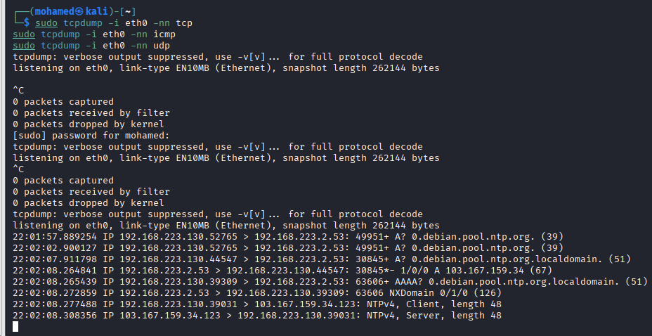
This screenshot shows the use of tcpdump to capture live network traffic. The output confirms that TCP, UDP, and ICMP packets are being observed on the selected interface. This step is critical for understanding baseline network behavior before analyzing any potential DoS or DDoS indicators.

Task 3 – TCP SYN Detection
This task prepares the system for identifying TCP SYN-based attacks.
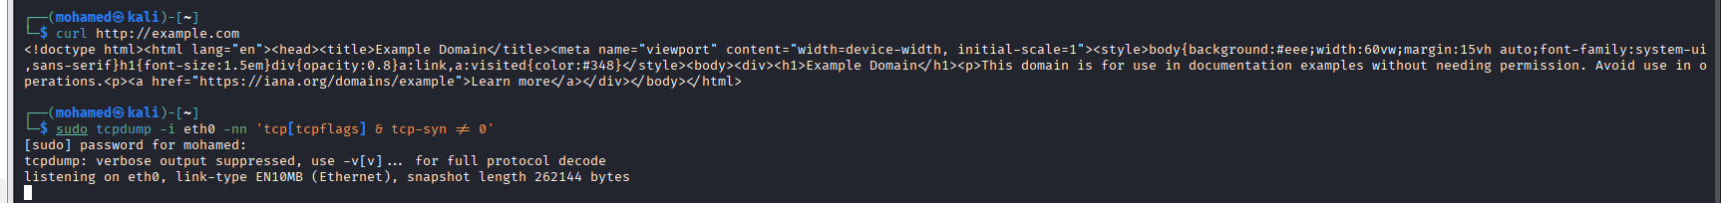
This screenshot focuses on TCP SYN packet monitoring. The tcpdump command is configured to filter SYN flags, which are essential for identifying SYN flood patterns. Even under normal traffic conditions, this setup verifies readiness for detecting abnormal connection attempts.
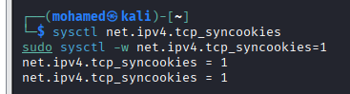
This screenshot focuses on TCP SYN packet monitoring. The tcpdump command is configured to filter SYN flags, which are essential for identifying SYN flood patterns. Even under normal traffic conditions, this setup verifies readiness for detecting abnormal connection attempts.

Task 4 – SYN Cookies (Defense)
This task applies kernel-level protection against SYN floods.
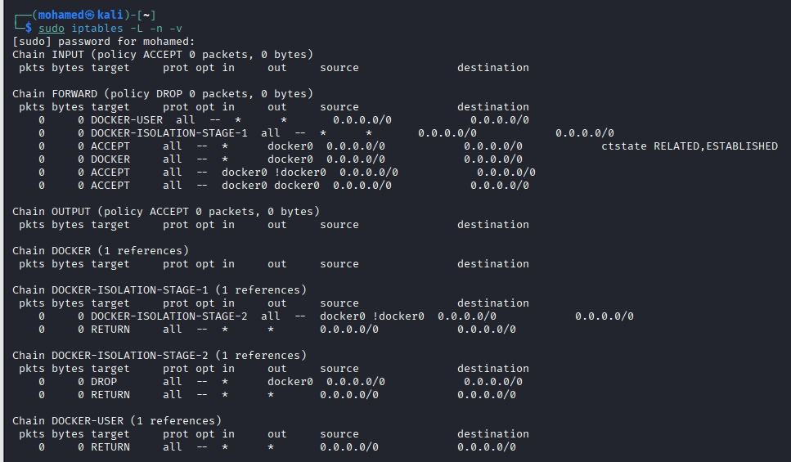
This screenshot illustrates the enabling of TCP SYN cookies at the kernel level. The output confirms that the system parameter is set to protect against SYN flood attacks by preventing excessive half-open TCP connections.

Task 5 – Firewall Configuration (iptables)
This task reviews firewall rules as part of network defense.
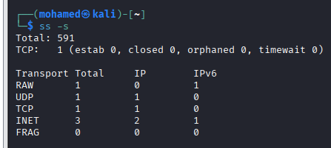
This screenshot presents the current iptables firewall configuration on Kali Linux. It verifies that firewall chains and policies are active, demonstrating how packet filtering is used as a defensive control against malicious traffic.

Task 6 – System Monitoring
This task evaluates system performance and connection states.
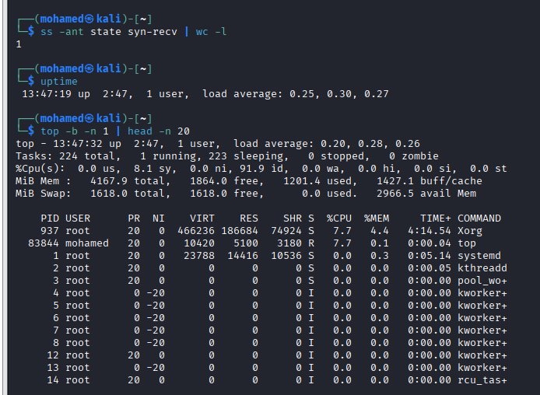
This screenshot displays system monitoring information, including active connections and protocol statistics. It helps assess the system’s stability and ensures that resource usage remains normal during network activity.
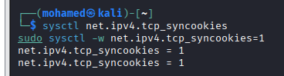
This screenshot displays system monitoring information, including active connections and protocol statistics. It helps assess the system’s stability and ensures that resource usage remains normal during network activity.

Task 7 – Wireshark Statistics
This task analyzes captured traffic using Wireshark statistics.
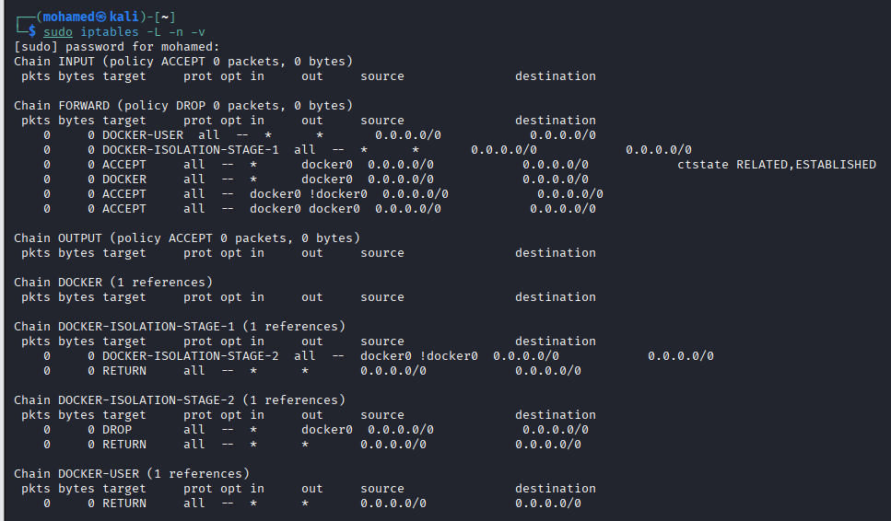
This screenshot shows Wireshark statistical analysis results. The data visualizes network conversations and traffic volume over time, providing a clear summary of observed communication patterns and confirming normal operational behavior.
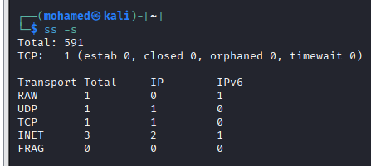
This screenshot shows Wireshark statistical analysis results. The data visualizes network conversations and traffic volume over time, providing a clear summary of observed communication patterns and confirming normal operational behavior.
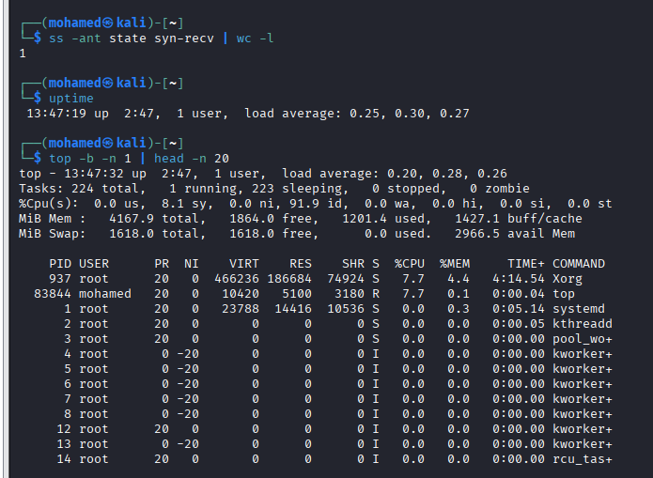
This screenshot shows Wireshark statistical analysis results. The data visualizes network conversations and traffic volume over time, providing a clear summary of observed communication patterns and confirming normal operational behavior.

Conclusion
This lab successfully demonstrated DoS/DDoS detection and defense techniques. Each task contributed to understanding traffic behavior, implementing protections, and validating system stability using industry-standard tools.

