Ethical Hacking Lab-2
Footprinting & Reconnaissance
This document contains all screenshots captured during the Footprinting and Reconnaissance lab. Each screenshot is placed under its relevant task with an individual explanation.

Figure 1
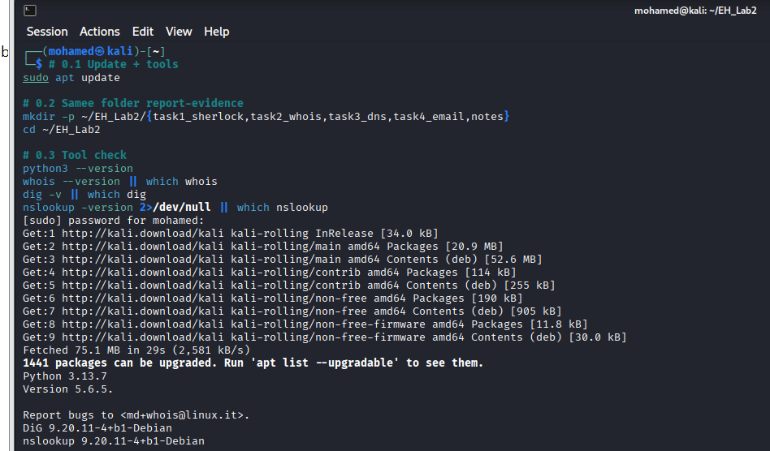
This screenshot shows the execution of the Sherlock OSINT tool in Kali Linux. It searches a username across multiple platforms to identify online presence.

Figure 2
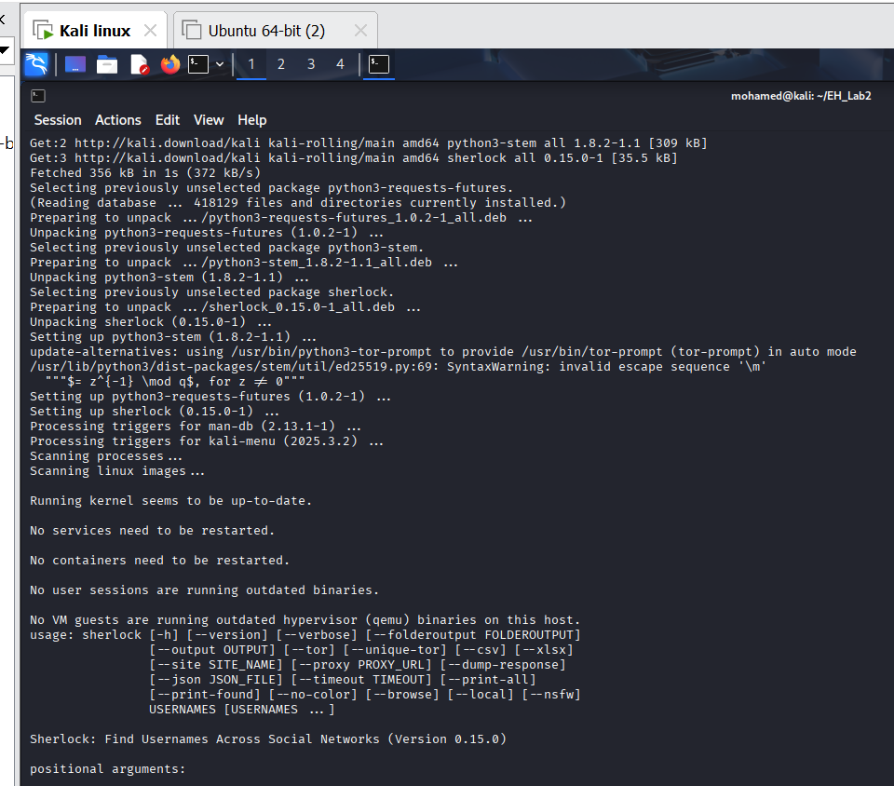
This screenshot demonstrates the Maigret tool running inside a Python virtual environment to validate username footprinting results.

Figure 3
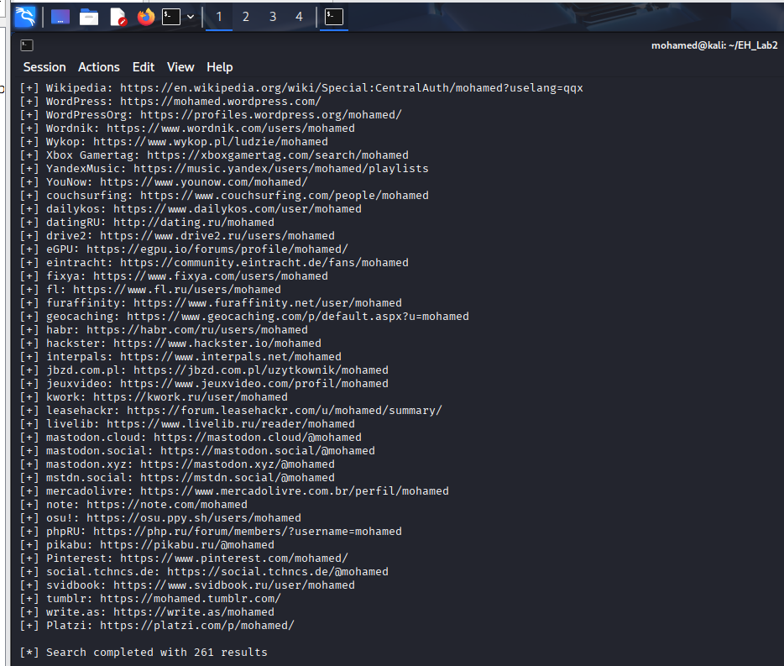
This screenshot displays the directory containing saved output evidence files for Task 1.

Figure 4
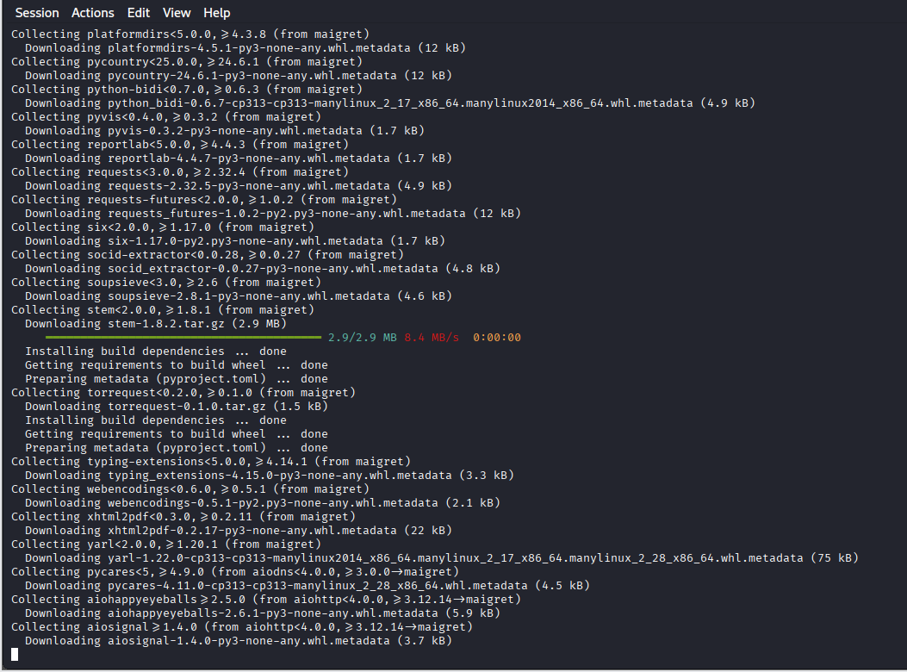
This screenshot shows the WHOIS command output revealing domain registrar, registration, and ownership details.

Figure 5
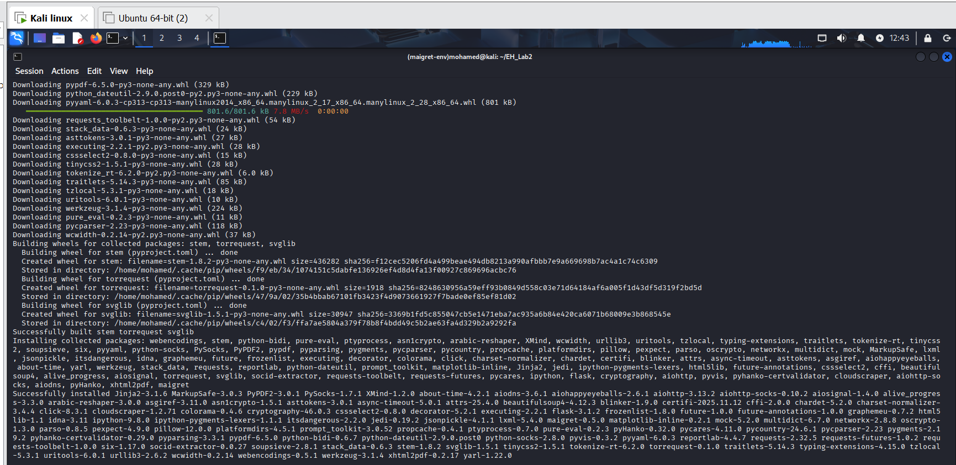
This screenshot illustrates the DIG command retrieving authoritative name server records for the domain.

Figure 6
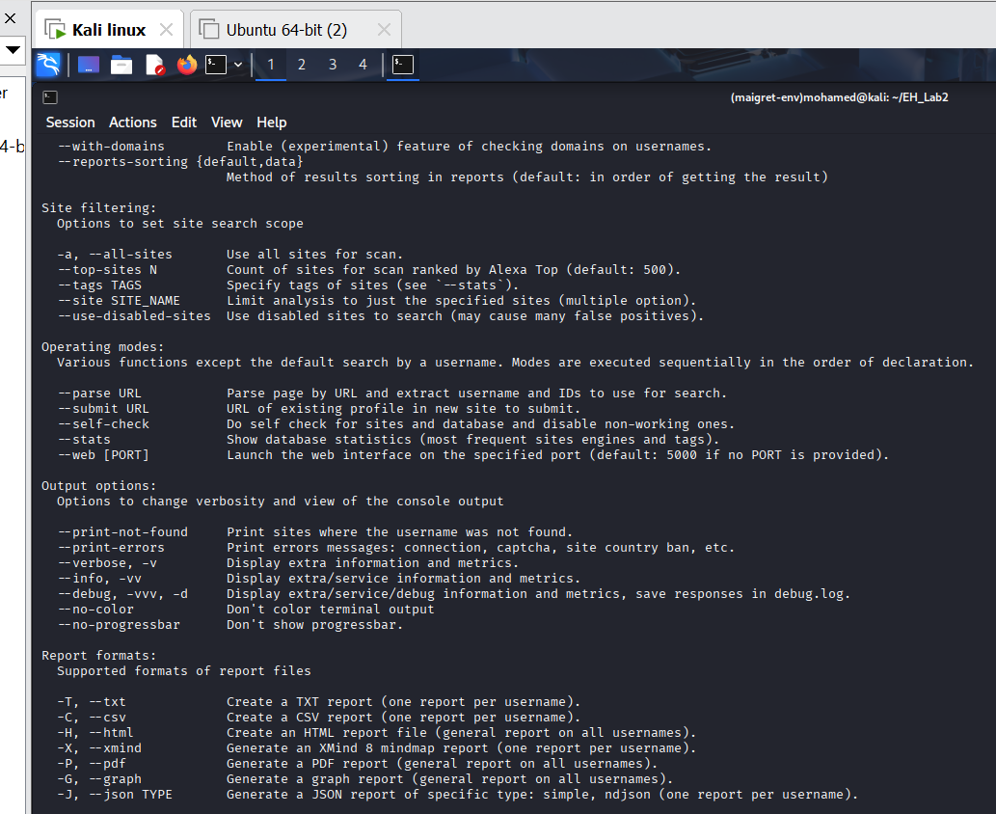
This screenshot presents the HOST command resolving the domain name to its IP address.

Figure 7
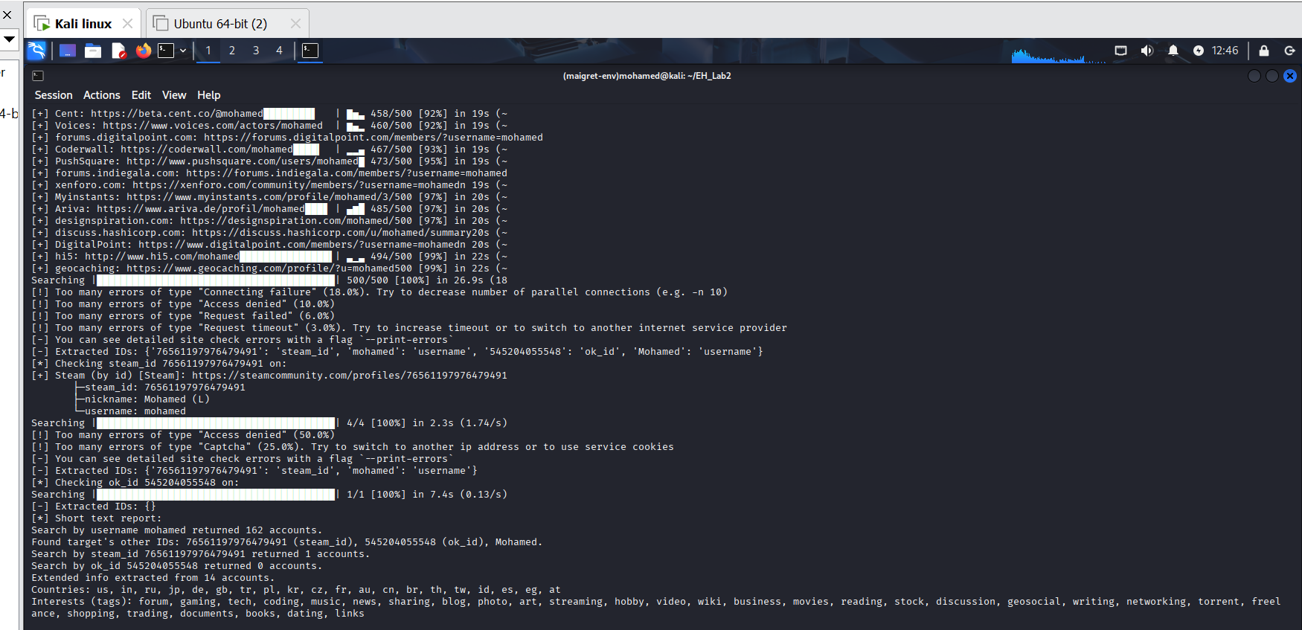
This screenshot shows the NSLOOKUP command querying DNS server information.

Figure 8
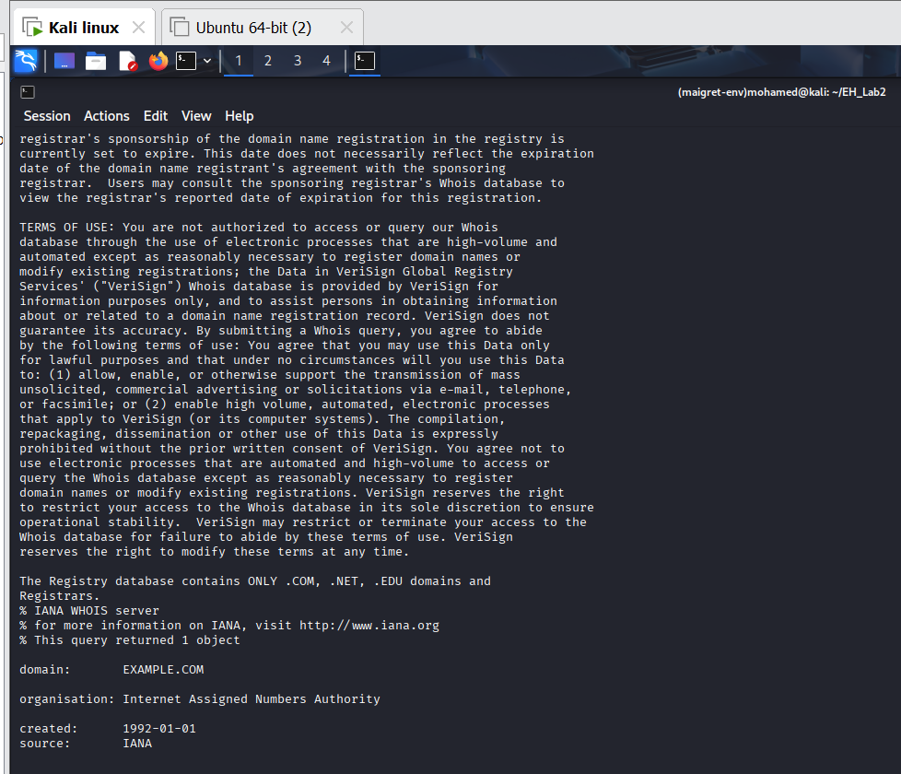
This screenshot demonstrates DIG queries retrieving DNS records such as A, MX, TXT, and NS.

Figure 9
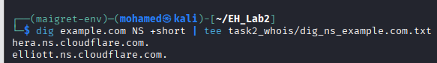
This screenshot shows DNSRecon performing automated DNS enumeration of the target domain.

Figure 10
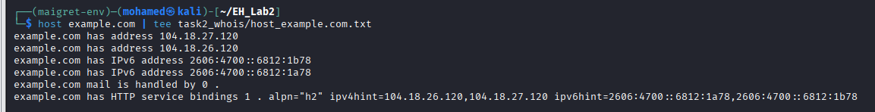
This screenshot displays a raw email header saved for forensic analysis.

Figure 11
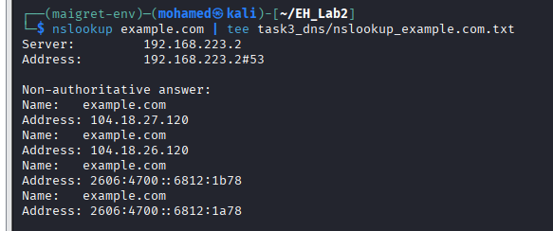
This screenshot illustrates filtering important email header fields using the GREP command.

Figure 12
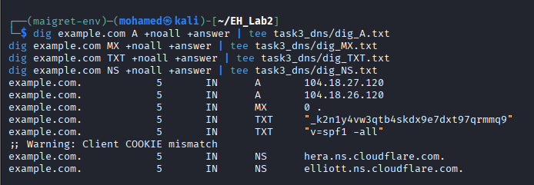
This screenshot shows MX and TXT record lookup for the sender’s email domain.

Figure 13
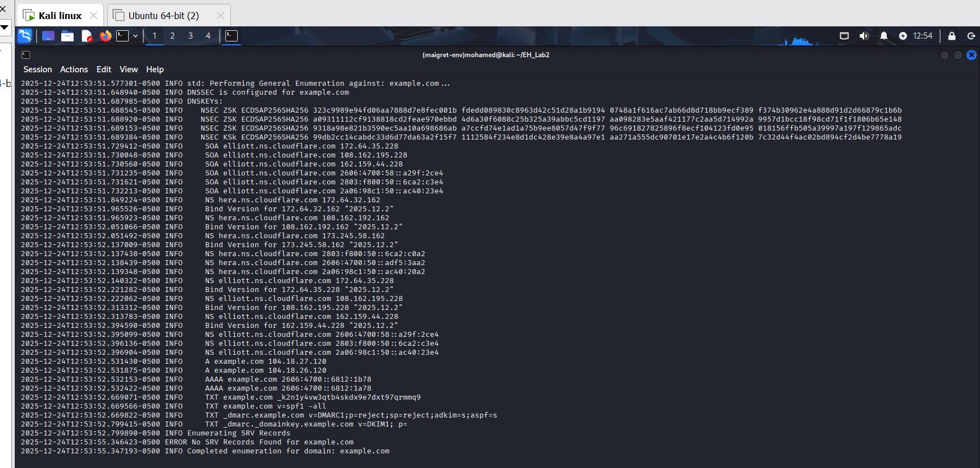
This screenshot demonstrates a WHOIS lookup for the sender’s email domain.

Figure 14
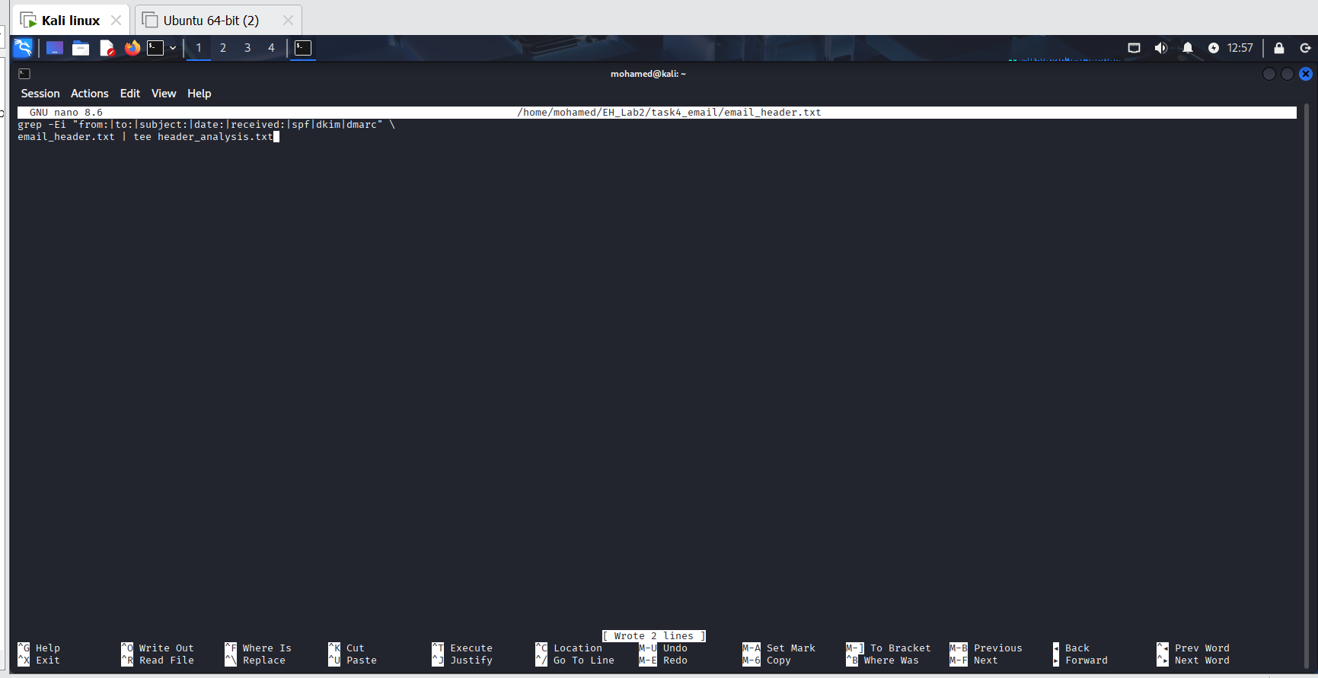
This screenshot presents the final directory structure confirming successful completion of all lab tasks.

Figure 15
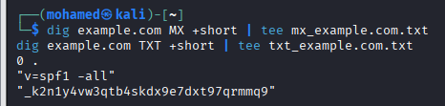

Figure 16
