LAB REPORT
Course: Ethical Hacking
Lab Title: Remote Access using VNC (TightVNC) between Kali Linux and Windows
Name: Mohamed Ali Mohamed
SAP ID: 52755
Instructor: Sir Hamanyu Raza

Introduction
This lab demonstrates the implementation of remote desktop access using the VNC protocol. The objective was to configure, secure, and validate a remote connection from Kali Linux to a Windows system using TightVNC. The lab covers IP identification, connectivity testing, port scanning, firewall configuration, service management, and successful remote access.

Task 1: IP Identification (Kali Linux)
The IP address of the Kali Linux machine was identified using network commands to ensure proper connectivity.
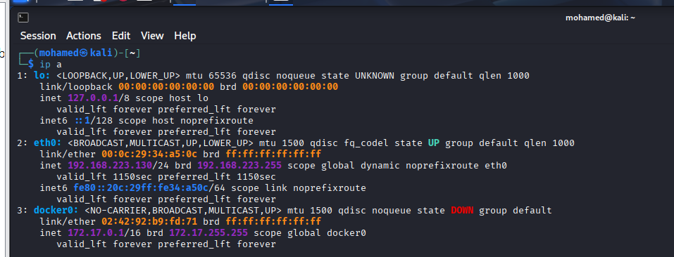

Task 2: IP Identification (Windows)
The Windows IP address was obtained to define the remote access target.
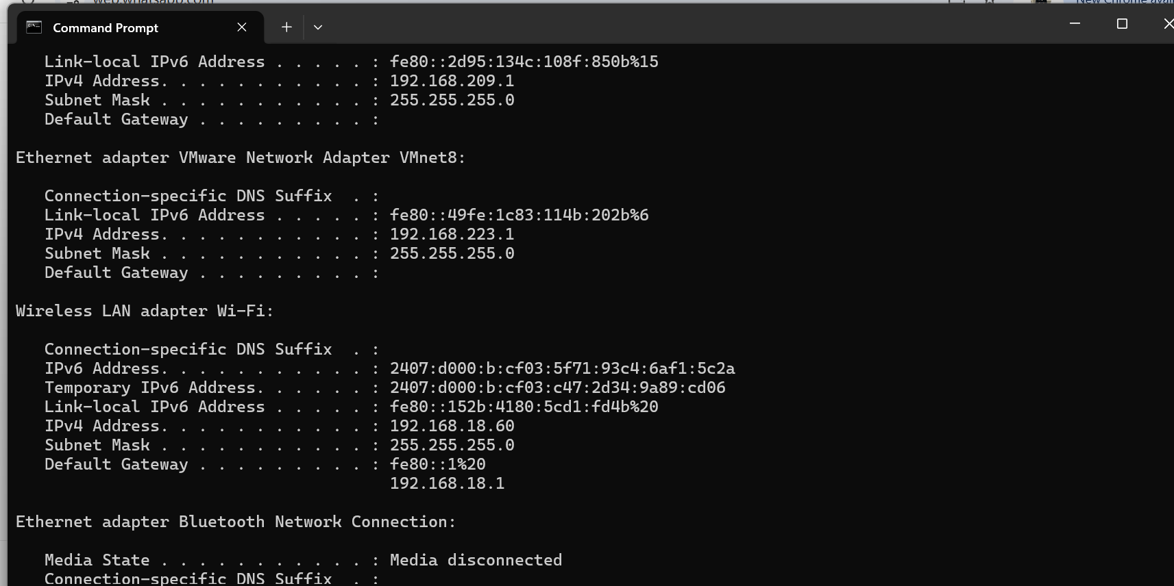

Task 3: Connectivity Verification (Ping)
ICMP ping was used to verify communication between Kali Linux and Windows.
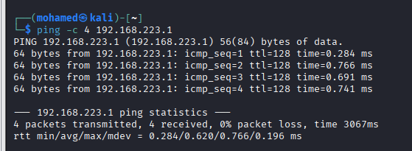

Task 4: Port Scanning (Nmap)
Nmap was used to scan port 5900 to verify the VNC service state.
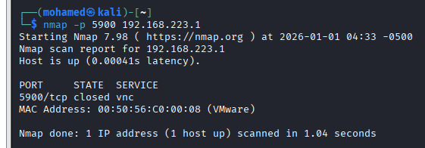

Task 5: TightVNC Installation
TightVNC Server was installed on Windows and configured with a password.
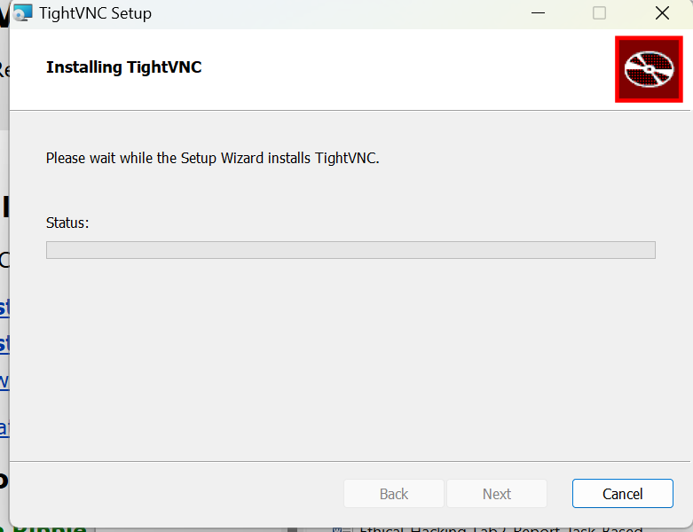

Task 6: Service Verification
The TightVNC service was verified to be running and set to automatic startup.
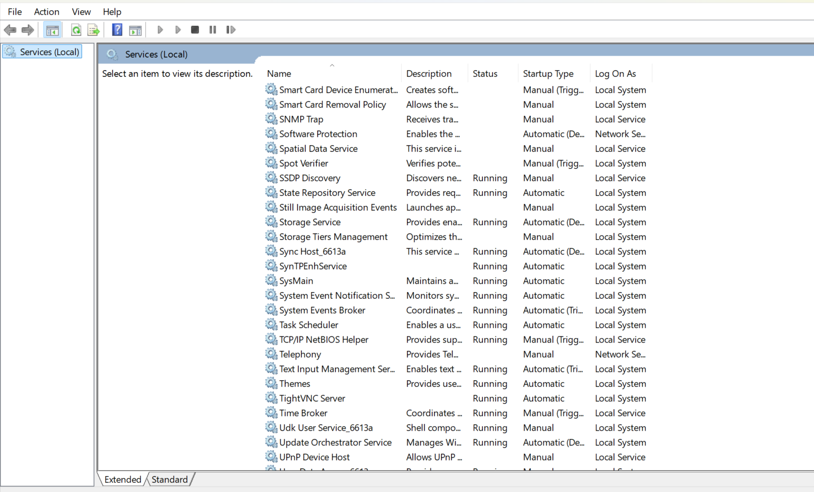

Task 7: Firewall Configuration
An inbound firewall rule was created to allow TCP port 5900.
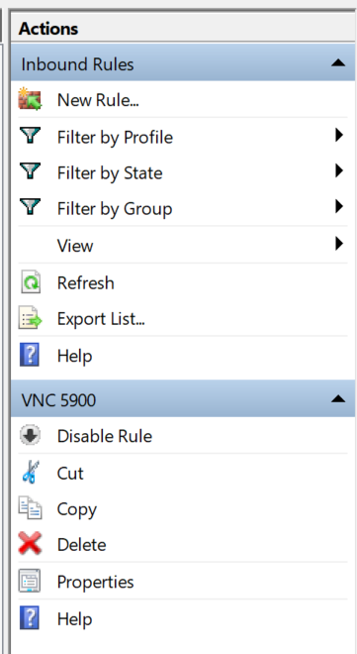

Task 8: Port Verification
Nmap confirmed that port 5900 was open after firewall configuration.
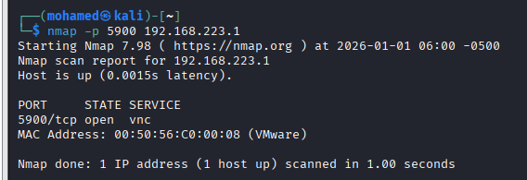

Task 9: VNC Connection
VNC Viewer was used from Kali Linux to successfully access the Windows desktop.
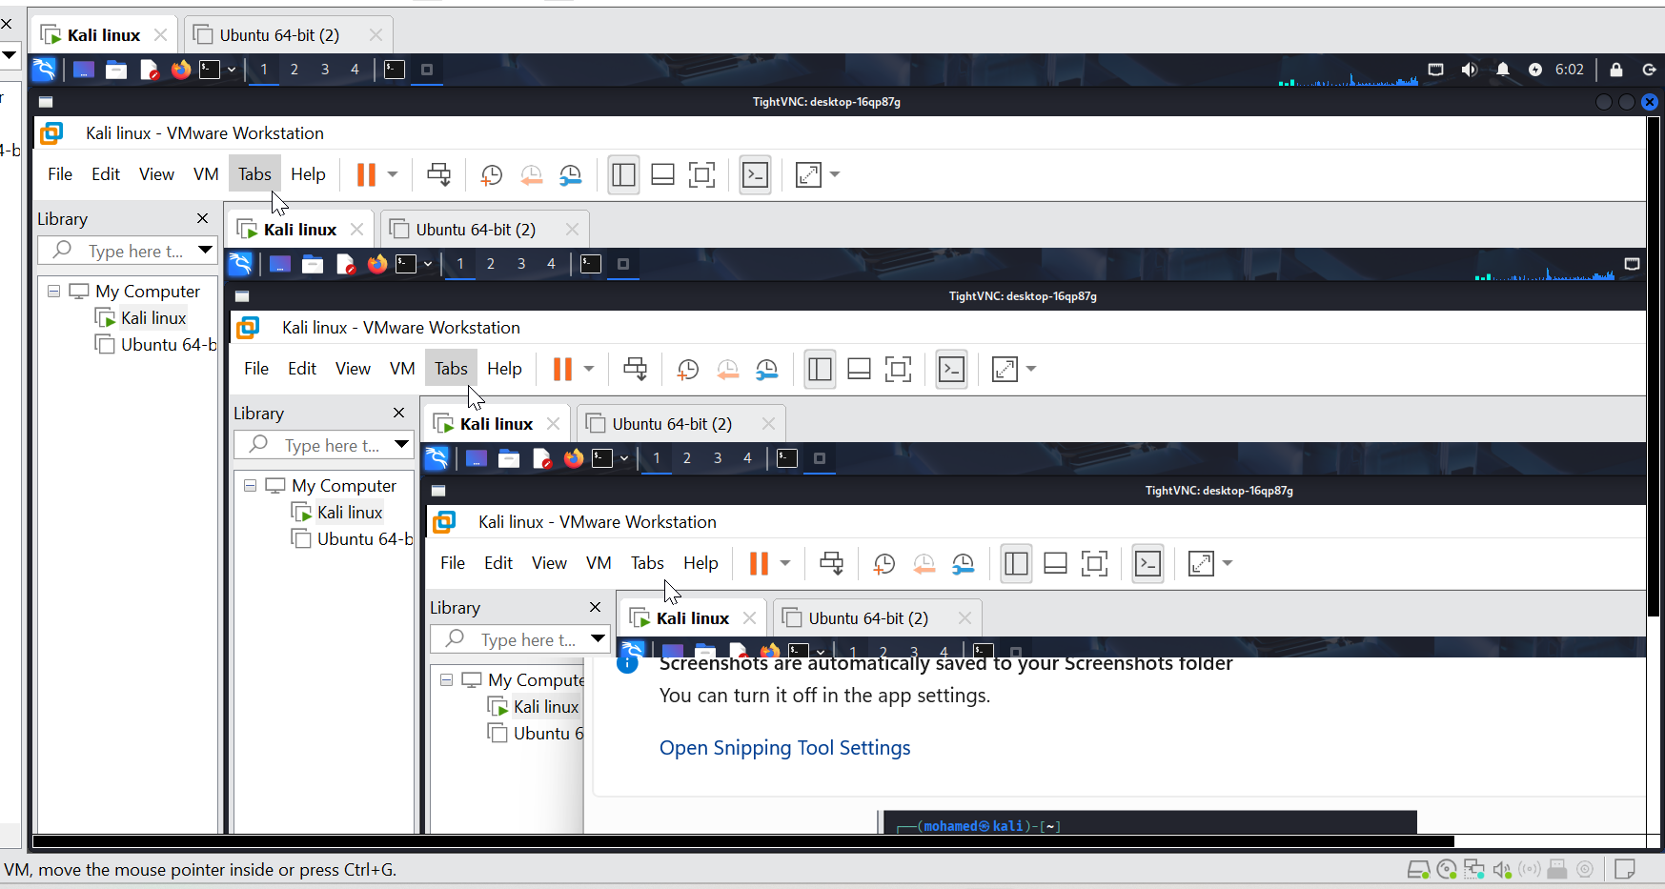

Conclusion
The lab successfully achieved remote access from Kali Linux to Windows using VNC. All security and configuration steps were validated, demonstrating practical skills relevant to ethical hacking and system administration.

