**GDP & GDP PER CAPITA**



Mohamed Mahmoud Ahmed Amer ID:17107584

* Content:

1. Intro.
2. Data Sets Used.
3. Subsets Used In tests.
4. Descriptive Statistics.
5. Descriptive Statistics (Plots).
6. Confidence Intervals.
7. One Sample Test of Hypothesis.
8. Two Sample Test of Hypothesis.
9. Linear Regression.
10. Chi-Squared Test.
11. Wilcoxon Signed Rank Test.

* Introduction:

**Gross domestic product** (**GDP**) is a monetary measure of the market value of all the final goods and services produced in a specific time period, often annually.

* Data Used:

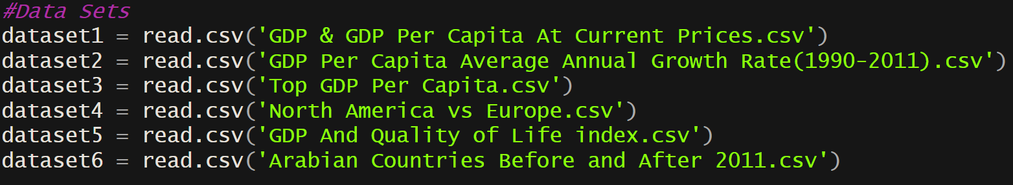

Source : UN Data.Com

* Subsets used in Tests:

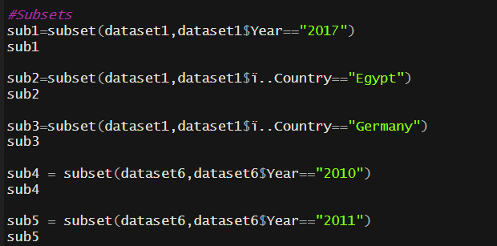

* Descriptive Statistics:

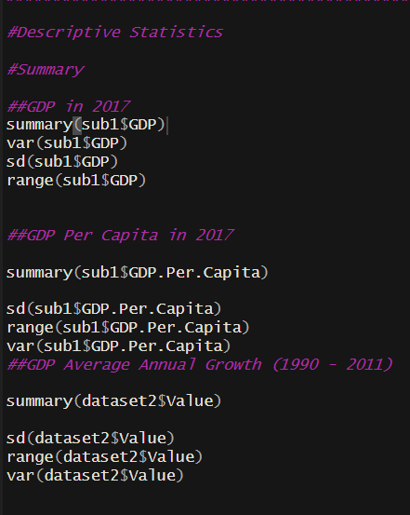

* Plots:

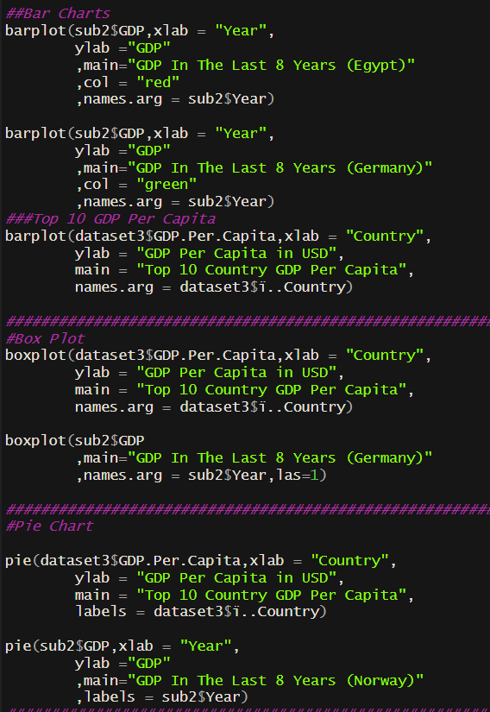

* Confidence Intervals:

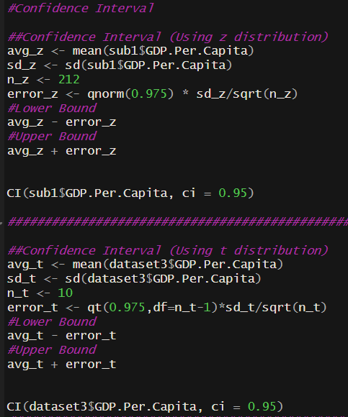

* One Sample Test of Hypothesis:

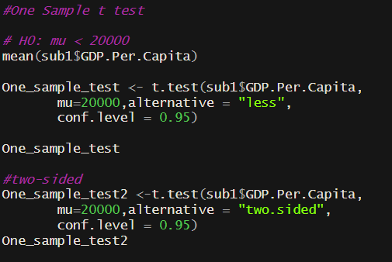

* Two Sample Test of Hypothesis:

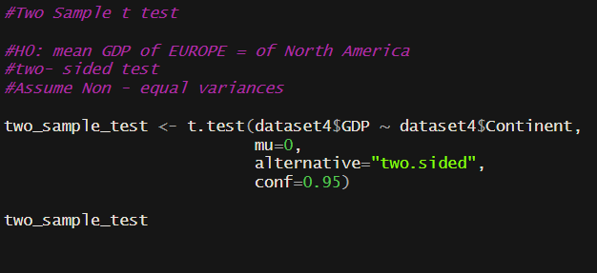

* Linear Regression:

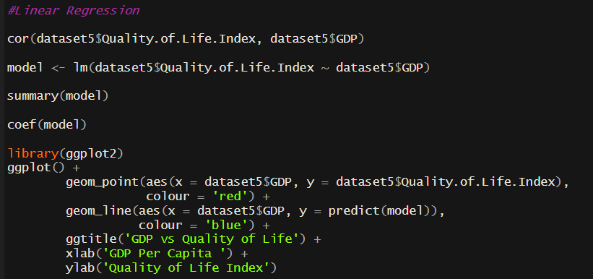

* Chi-Squared Test:

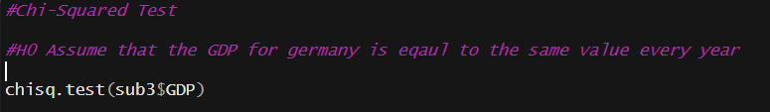

* Wilcoxon Signed Rank Test:

