Big Data Project: Hadoop HDFS Commands
Practice
Student name(s) | Mohamed Amine Klila – Bara Whibi
Dataset name | Synthetic E-Commerce Transactions Dataset
Dataset file | dataset.csv
Dataset size | Greater than 500 MB
Environment | Instructor Hadoop Virtual Machine / VirtualBox
Submission deadline | 8 May 2026

Project Description
This project practices Hadoop Distributed File System commands using a large, structured CSV dataset. The dataset is uploaded to HDFS, inspected with basic commands, managed with file operations, and explored using additional HDFS utilities.

Dataset Description
The dataset is a synthetic e-commerce transactions file. Each row represents an order and includes fields such as order date, customer segment, country, city, product category, quantity, unit price, discount, shipping mode, status, rating, total amount, profit, and marketing channel. It is structured CSV data suitable for HDFS upload and command-line exploration.
Dataset source link: generated locally with generate_ecommerce_dataset.py.

Environment Setup
The project uses the instructor-provided Hadoop virtual machine in VirtualBox. After starting the VM, Hadoop services should be verified with jps. The expected services include NameNode and DataNode for HDFS, and possibly ResourceManager and NodeManager for YARN.

Screenshot: Hadoop running, HDFS directory creation, dataset upload, listing, and size check
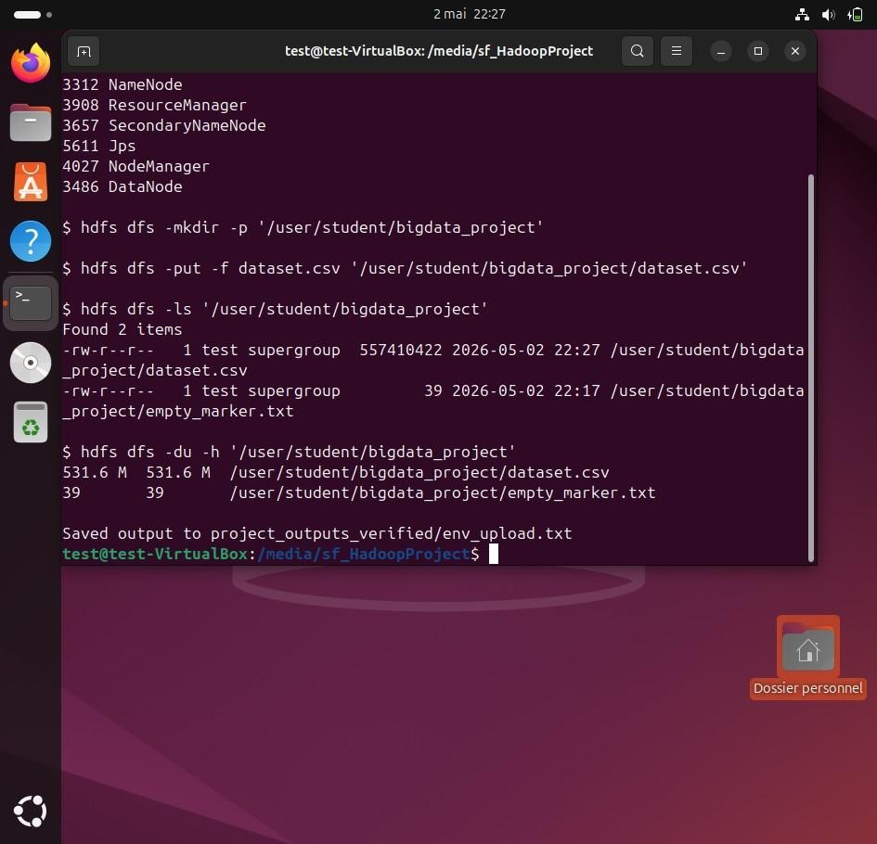

Upload Dataset to HDFS
Command | Purpose / expected result
hdfs dfs -mkdir -p  /user/student/bigdata_project | Creates the HDFS project directory recursively.
hdfs dfs -put dataset.csv /user/student/bigdata_project/ | Uploads the CSV dataset from Linux local storage to HDFS.
hdfs dfs -ls  /user/student/bigdata_project/ | Verifies that the dataset exists in HDFS.

Screenshot: Dataset uploaded to HDFS at /user/student/bigdata_project/dataset.csv


Basic HDFS Commands
Command | Purpose / expected result
hdfs dfs -ls / | Lists files and directories at the HDFS root.
hdfs dfs -cat .../dataset.csv | head -n 5 | Displays the CSV header and first records without printing the whole file.
hdfs dfs -tail .../dataset.csv | Displays the last part of the dataset.
hdfs dfs -cat .../dataset.csv | wc -l | Counts the number of lines in the dataset.
hdfs dfs -du -h  /user/student/bigdata_project | Shows human-readable HDFS disk usage.
hdfs dfs -count  /user/student/bigdata_project | Shows directory, file, and byte counts.
hdfs dfs -cat .../dataset.csv | grep -i Electronics | head | Filters rows containing the keyword Electronics.

Screenshot: Basic content commands: list, cat/head, tail, and line-count command in progress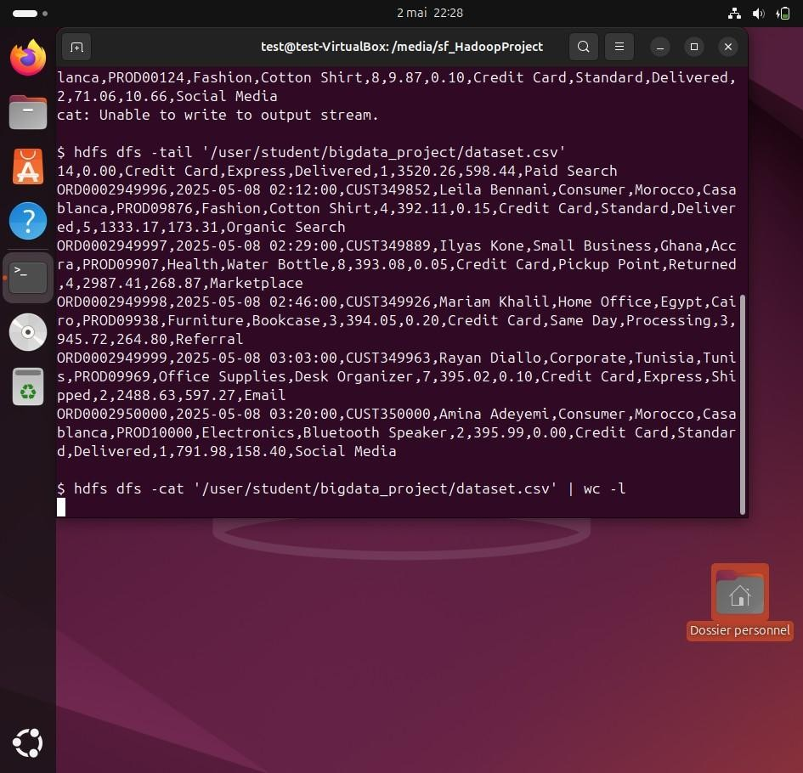

Screenshot: Basic content commands: final line count output
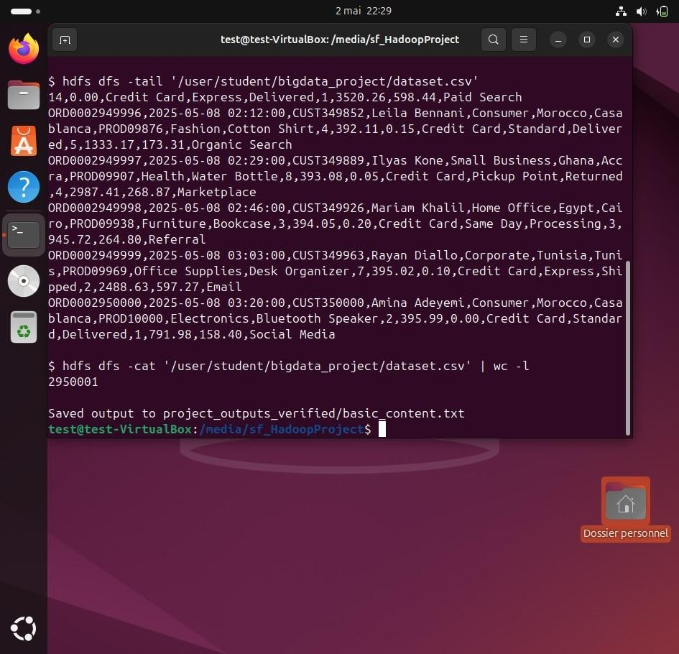

Screenshot: Basic statistics and grep filter output
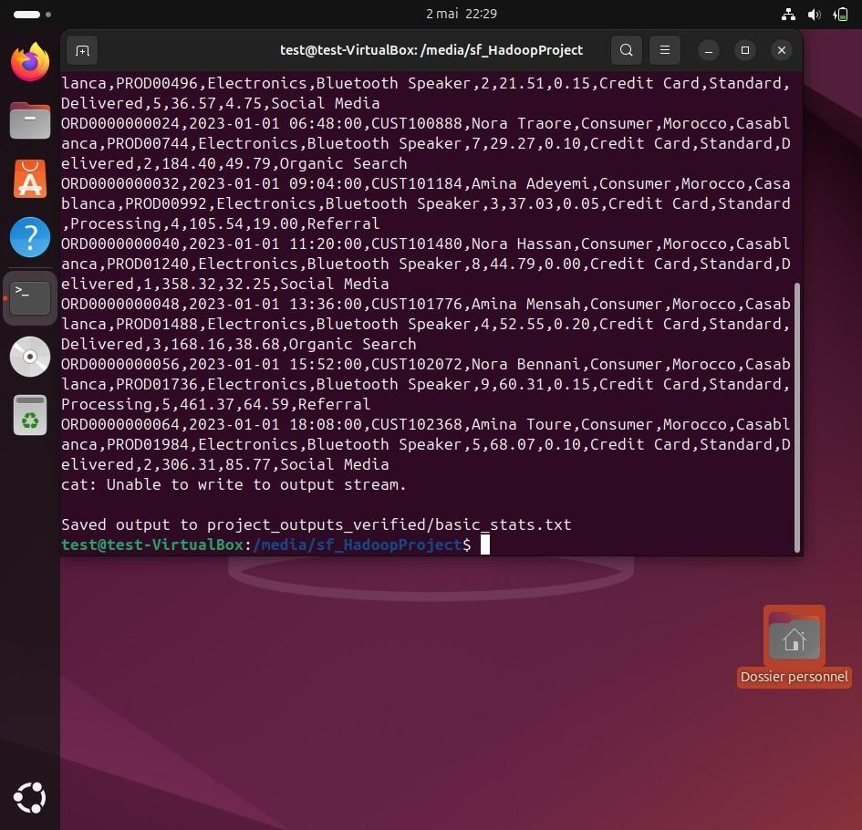

File Management Commands
Command | Purpose / expected result
hdfs dfs -cp .../dataset.csv .../dataset_copy.csv | Copies the dataset inside HDFS.
hdfs dfs -mv .../dataset_copy.csv .../dataset_renamed.csv | Renames or moves the copied HDFS file.
hdfs dfs -chmod 640 .../dataset_renamed.csv | Changes permissions so owner can read/write and group can read.
hdfs dfs -get .../dataset_renamed.csv downloaded_dataset.csv | Downloads an HDFS file back to Linux local storage.
hdfs dfs -rm .../dataset_renamed.csv | Deletes the renamed copy from HDFS.
Screenshot: File management commands: copy, rename, chmod, and get command
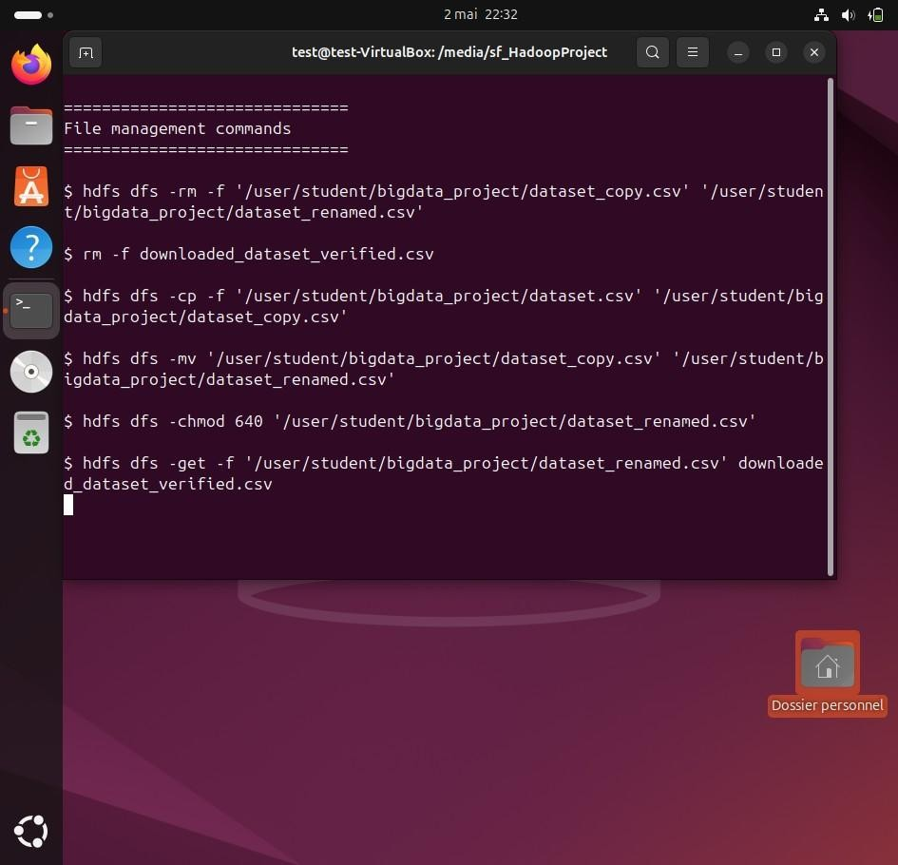

Screenshot: File management commands completed with rm and final listing
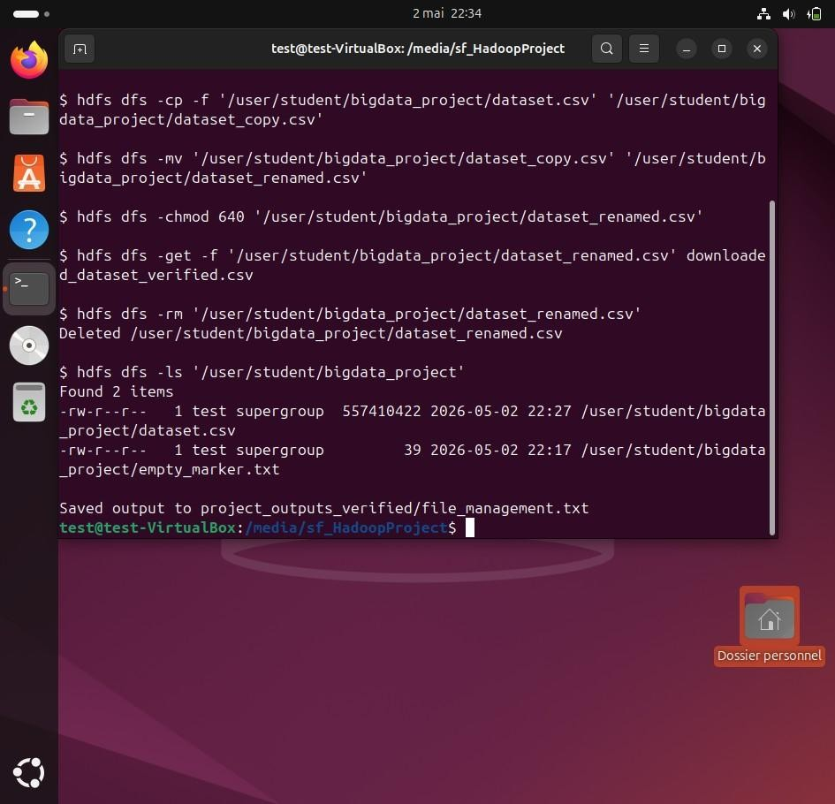

Additional HDFS Commands
Command | Purpose / expected result
hdfs dfs -df -h / | Displays HDFS filesystem capacity, used space, and available space.
hdfs dfs -stat "%n %b bytes %r replication %o block_size"  .../dataset.csv | Displays selected metadata for the uploaded file.
hdfs dfs -checksum .../dataset.csv | Computes the HDFS checksum for data integrity verification.
hdfs dfs -test -e .../dataset.csv && echo exists | Tests whether the file exists and prints confirmation.
hdfs dfs -touchz .../empty_marker.txt | Creates an empty file in HDFS.
hdfs dfs -appendToFile append_line.csv .../empty_marker.txt | Appends local content to an HDFS file.
hdfs dfs -getmerge -nl /user/student/bigdata_project merged_hdfs_files.txt | Merges HDFS files into one local output file.
hdfs dfs -ls  /user/student/bigdata_project | Displays permissions, owner, group, size, date, and file names.

Screenshot: Additional commands: df, stat, checksum, test, touchz, append workflow
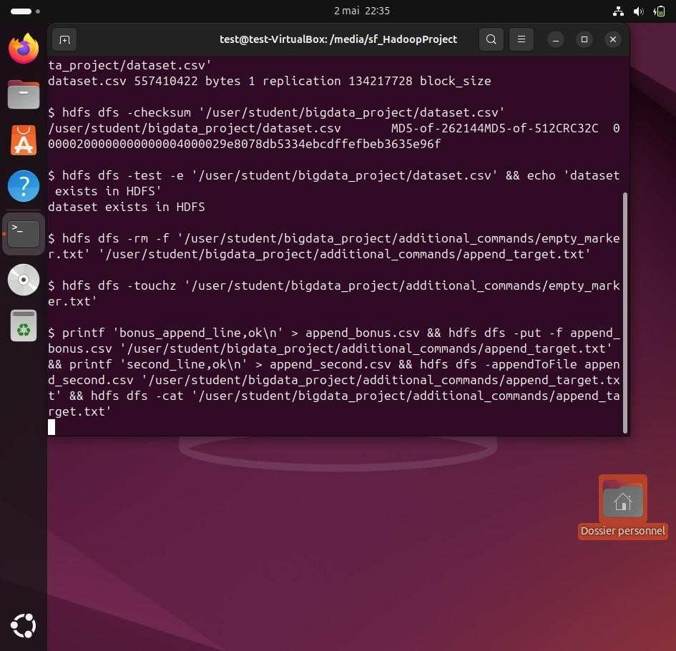

Screenshot: Additional commands completed: appendToFile, getmerge, and find
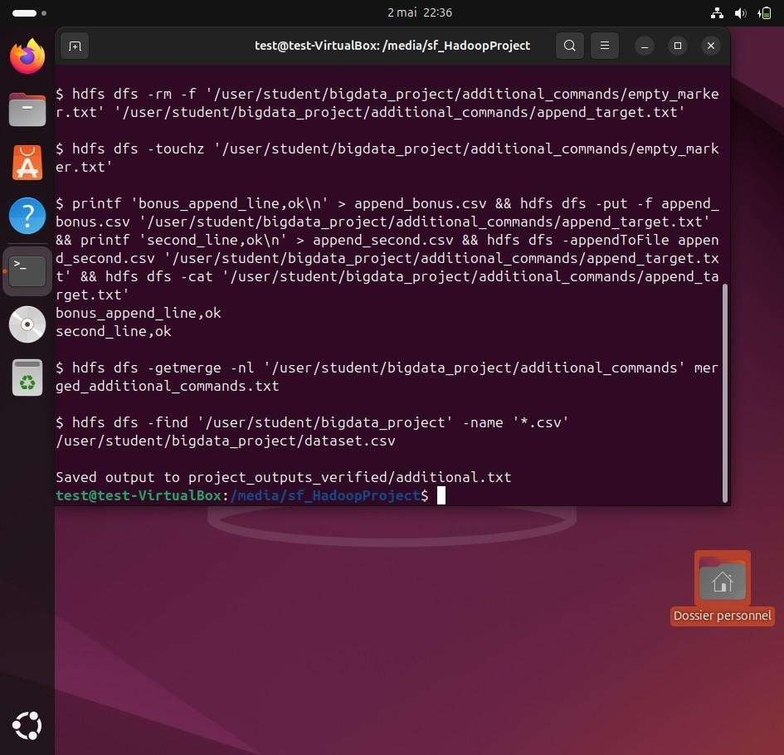

Observed Results
Command | Purpose / expected result
hdfs dfs -du -h  /user/student/bigdata_project | Dataset size in HDFS: 531.6 M.
hdfs dfs -cat .../dataset.csv | wc -l | Line count: 2,950,001 including the CSV header.
hdfs dfs -count  /user/student/bigdata_project | After bonus work, project directory count: 8, file count: 7, total bytes: 563,195,426.
hdfs dfs -df -h / | HDFS capacity shown in VM during testing: 24.4 G total with enough space for the uploaded project data.
hdfs dfs -checksum .../dataset.csv | Checksum command returned an HDFS MD5-of-CRC32C checksum, confirming the file can be read by HDFS.

Bonus Tasks Completed
The project includes all bonus options: a dataset larger than 100 MB, more than five additional HDFS commands, and directory management with multiple datasets.
Command | Purpose / expected result
Large dataset bonus | The main CSV is 531.6 M in HDFS and has 2,950,001 lines including the header.
More than five additional commands | Executed mkdir -p, df -h, stat, checksum, test -e, touchz, appendToFile, getmerge, find, and ls.
Multiple datasets bonus | Created sales, electronics, and sports sample datasets under /user/student/bigdata_project/bonus_datasets.

Screenshot: Bonus evidence: multiple dataset directories and sample CSV files in HDFS
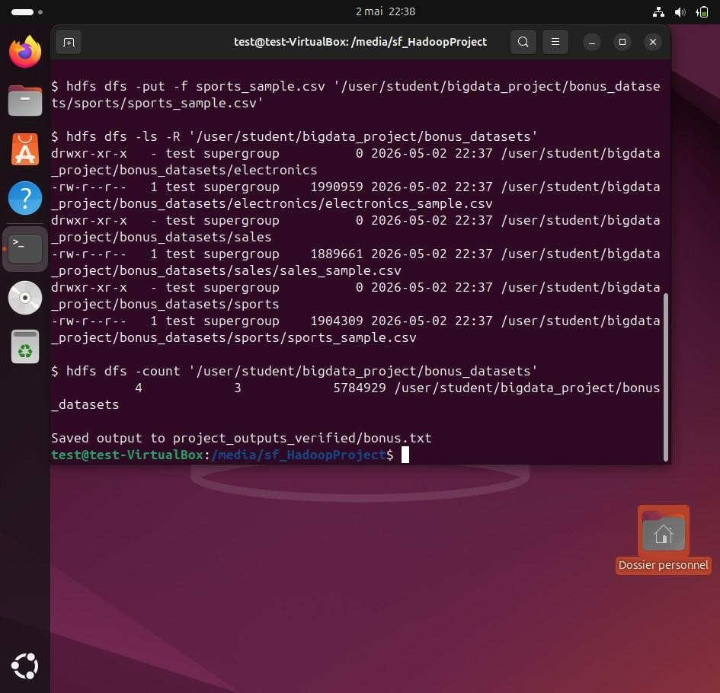

Screenshot: Bonus evidence: large dataset size and row count
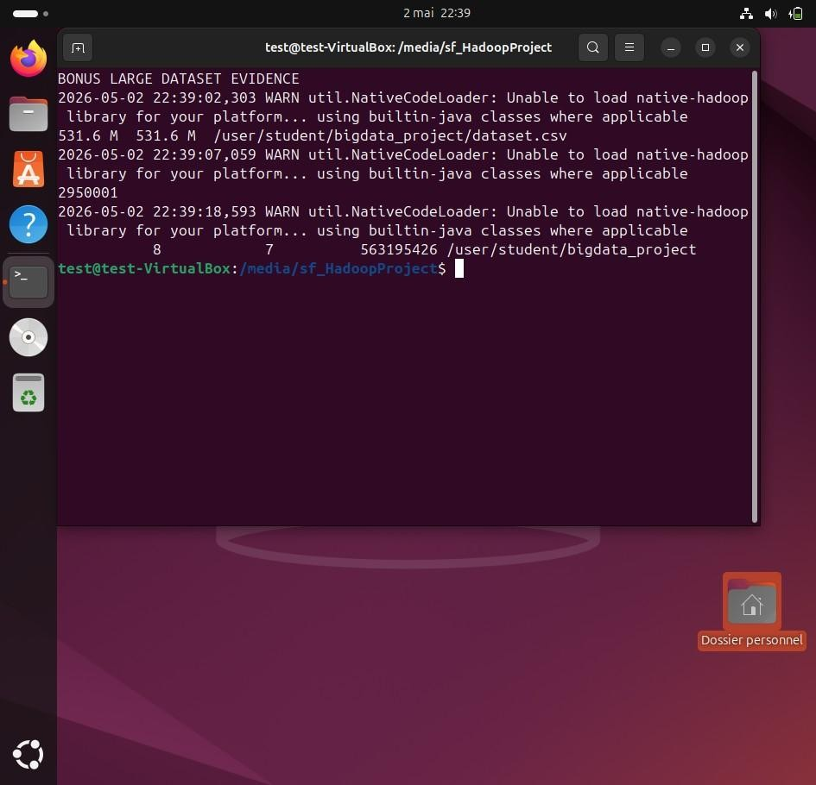

Problems Encountered
Because the dataset is larger than 500 MB, upload and copy commands may take more time than small lab files. The VM should have enough disk space before running hdfs dfs -put, hdfs dfs -cp, and hdfs dfs -get. If Hadoop services are stopped, start HDFS before running the command script. Some commands that pipe a large HDFS file into head can print a harmless broken-pipe style message after the requested rows are displayed, because head closes the stream early.

Conclusion
The project demonstrates practical use of Hadoop HDFS for storing and managing a large structured dataset. The commands show how to create directories, upload files, inspect data, count records, check storage usage, filter records, manage permissions, copy and rename files, download files, delete files, and use additional HDFS utilities for metadata and integrity checks.

