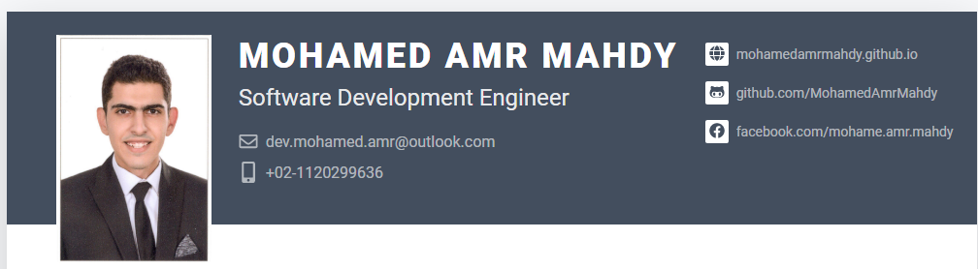

**PROFILE**

Fresh Graduate Hard Working Developer started my own projects to learn various programming technologies and aiming to apply my knowledge from my self-study over real world organizations

|  |  |
| --- | --- |
| VOLUNTEERING EXPERIENCE**Founder / CEO Nano Gaming** 2013 - Present  I have started my development and media life with volunteering in starting a media channel for covering gaming news and reviews and leading a team of +10 volunteer and my main role was covering designs needs like branding & templates for the team to use and technical setups like building the website and hosting it. Social Links: • <https://nanogaming.net/>  • <https://www.facebook.com/NanoGamingME>  • <https://www.youtube.com/NanoGamingME> Technologies used:  **Founder / Game Developer Arab Universe RP** 2018 - Present  Arab Universe RP is a Gamemode developed by me over FiveM framework which uses Grand Theft Auto V game as an assets to achieve player connection over user based servers and let developers use LUA/C#/Javascript to develop Gamemodes over GTA V. and The RP stands for Role Playing where players act like real world roles Mechanic/Medic/Police/Thieves.  My main role was to develop the whole system architecture offering +2000 hours of development and testing to achieve player gameplay ideas. After publishing the server for the community the main role was to maintain the server finding bugs and solving present issue and profiling FPS to reach best performance over players computers and implement new ideas (reached +400 resources each resource serves an idea) while leading the team to serve +3,000 players. Social Links: • <http://arabuniverse.net/>  • <https://discord.gg/HMC2fBG> Technologies used:  GRADUATION PROJECT**Krisp** Top Notch Movie Recommendations  The project's main target is to suggest the suitable movie for everyone to watch using user based collaborative filtering algorithm using big-data. The Method identifies users that are similar to the queried user and estimate the desired rating to be the weighted average of the ratings of these similar user interests.  My Main Role was to develop the User Interface and connect API implementations for the users to view movies, rate them and show the movie suggestions. Moreover, implementing validation, verifications using authentication with bearer tokens Project Link: • <https://github.com/MohamedAmrMahdy/Krisp> Technologies used:  LEARNING-PROJECTS EXPERIENCE**JumpNCrack Game** 2019  JumpNCrack is a 2D game developed over Unity3D game engine. The main idea from the game is to move a ninja blade in sky to cut fruits and dodge obstacles Project Link: • <https://github.com/MohamedAmrMahdy/JumbNCrack> Technologies used:  **BlueBot** 2018  I have started my development and media life with volunteering in starting a media channel for covering gaming news and reviews and leading a team of +10 volunteer and my main role was covering designs needs like branding & templates for the team to use and technical setups like building the website and hosting it.  One of the main achievements for this project was to learn Node.js/Firebase for creating a discord bot and The first move toward finding my skills over leading, problem solving, technical skills Project Link: • <https://github.com/MohamedAmrMahdy/BlueBot> Technologies used:  **Gym System** 2017  Gym System where gym owners get overview for gym status and customers while customers get subscription to gym. Project Link: • <https://github.com/MohamedAmrMahdy/Gym-System> Technologies used:  **YouTube Music** 2017  One of the main achievements for this project was to learn Vue.js/Vuetify/Electron for creating a windows application to play youtube videos as audio only like music player. Project Link: • <https://github.com/MohamedAmrMahdy/youtube-music> Technologies used:  Sudoku Solving/Checking 2016  C console application to solve sudoku using backtracking algorithm and check sodoku for validation for main Sudoku rules. Project Link: • <https://github.com/MohamedAmrMahdy/Sudoku> Technologies used: | Others Knowledge  * **C** * **Python** * **Git** * **DevOps**   **Agile**   * **Sketch** * **WordPress** * **Web Server** * **Dedicated Server** * **Photoshop / AfterEffect / SonyVegas**  EDUCATION  * Faculty of Computer and Artificial Intelligence Helwan University   BSc in Information Systems / Computer Science  Helwan, Cairo, Egypt  2016 – 2020   * Manarat Al-Farouk International School (IGCSE)- High School   Al Tagamoa Al Awal, Cairo, Egypt  2013 – 2016   * Cairo Manara Language School   Prep School  Nasr City, Cairo, Egypt  2013 – 2016 LANGUAGE Arabic (Native)  English INTERESTS Gaming  Volunteering  Leading |