|  |  |  |  |
| --- | --- | --- | --- |
| X’ | Y’ | X’*y’ |  |
| 0.69 | 0.49 | 0.3381 |  |
| -1.31 | -1.21 | 1.5851 |  |
| 0.39 | 0.99 | 0.3861 |  |
| 0.09 | 0.29 | 0.0261 |  |
| 1.29 | 1.09 | 1.4061 |  |
| 0.49 | 0.79 | 0.3871 |  |
| 0.19 | -0.31 | -0.0589 |  |
| -0.81 | -0.21 | 0.1701 |  |
| -0.31 | -0.31 | 0.0961 |  |
| -0.71 | -1.01 | 0.7171 |  |
|  |  | 0.615 | Total |

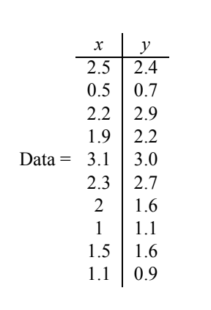

* Mean (x) = sum ( x/n) = 1.81
* Mean (Y) = sum (y/n) = 1.91
* Covariance matrix = 1/N-1 *DA(X) * DA(Y)

COV = [ cov(x’.x’) cov(x’.y’) ]

[ cov(x’.y’) cov(y’,y’ ]

= [ 0.6165 0.615 ] [ λ 0 ]

[ 0.615 0.716 ] - [0 λ] = 0

COV = [ 0.6165 – λ 0.615 ]

[ 0.615 0.716 ] = 0

[0.6165 – λ ] [0.716 – λ] – 0.3782 = 0

λ ^ 2 - 1.3325 λ + 0.0632 = 0

(λ – 1.28) (λ – 0.049 ) = 0

λ = 1.28 λ = 0.049

when λ = 1.28

[ -0.6635 0.615 ] [ x ]

[ 0.615 -0.564] [ y ] = 0

-0.6635 X + 0.615 Y = 0

0.615 X – 0.564 Y = 0

X (-0.617)

Y (-0.735) = Eigen Vector

When λ = 0.049

[0.5675 0.615] [ X ]

[0.615 0.666] [ Y ] = 0

0.5675 X + 0.615 Y = 0

0.615 X +0.666Y = 0

X [ -0.735 ]

Y [ 0.622 ] = Eigen Vector