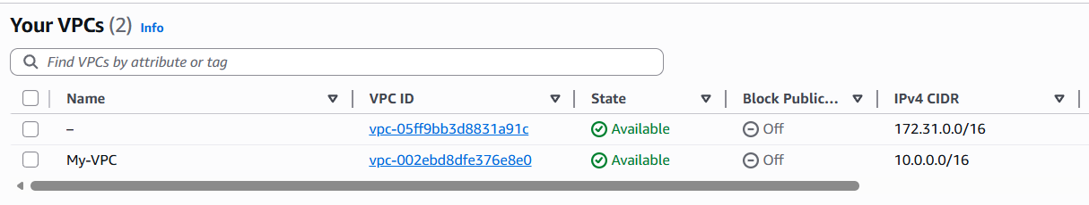
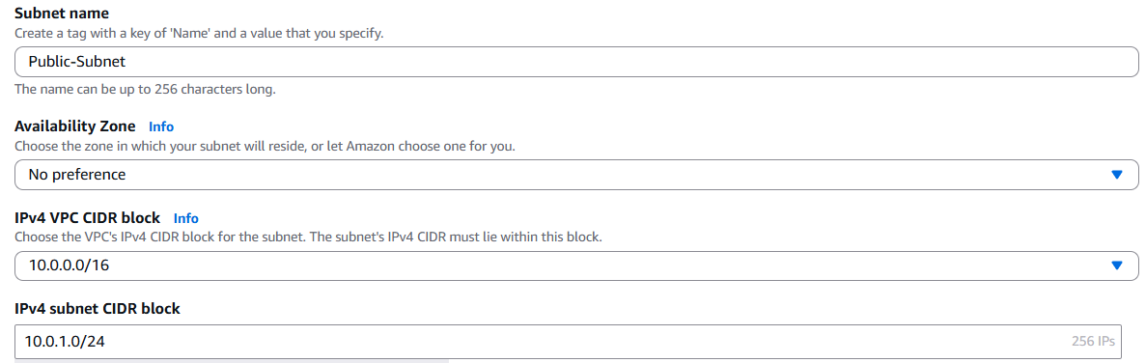
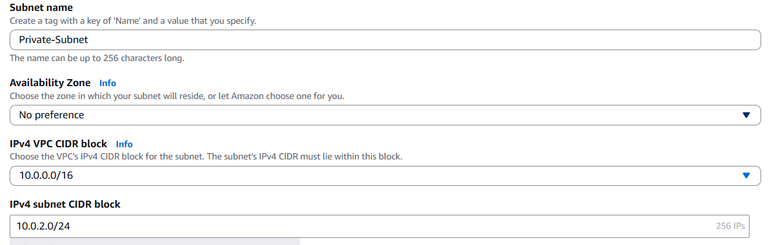
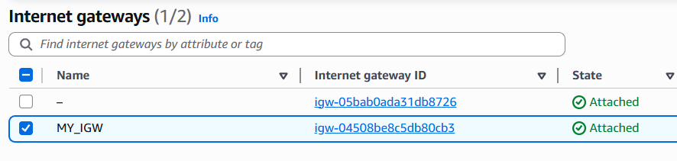
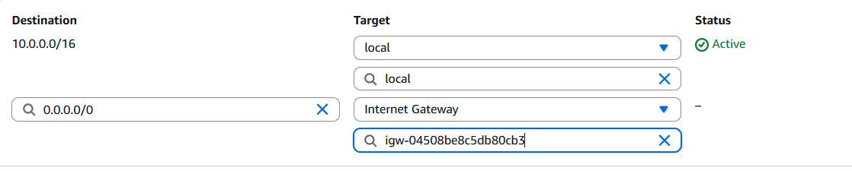
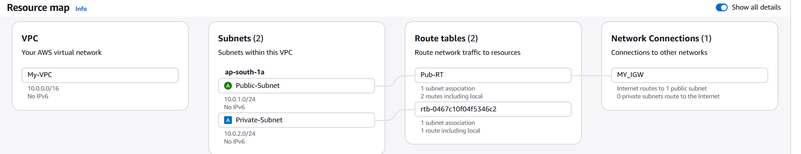
Used MY-VPC to lauch linux EC2 with public subnet :
