**PLACEMENT MANAGEMENT SYSTEM**

**Procedure To Run On Your System**

**Step 1: Install Xampp on Your System**

**Run** https://www.apachefriends.org/download.html

**Step 2: Run Apache Server and MySQL on Xampp Control Panel:**

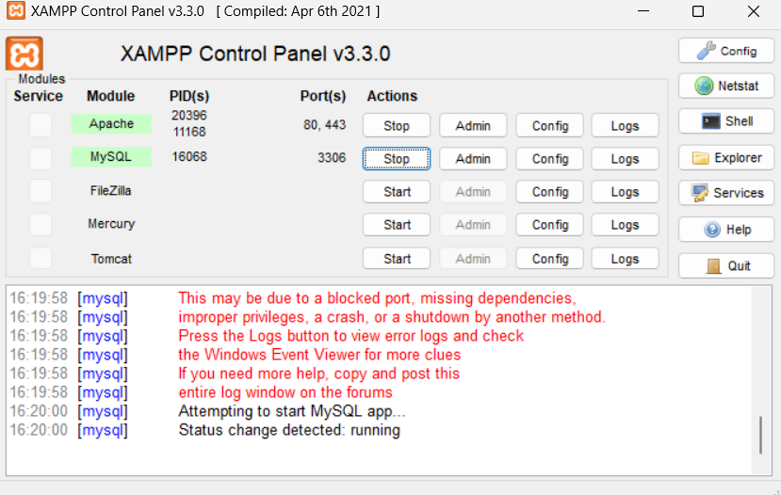

**Step 3: Run** [**http://localhost/phpmyadmin**](http://localhost/phpmyadmin)

**Step 4: In phpMyAdmin use import and import the pms file which is in sql folder**

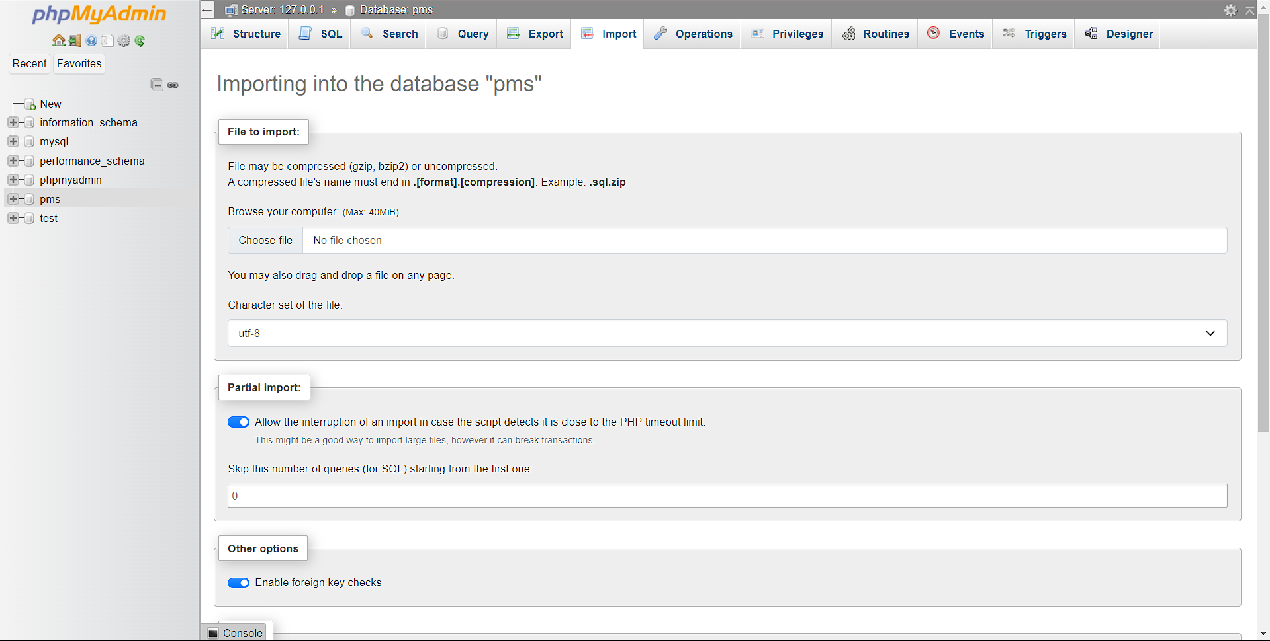

**Step 5: Go to Xampp Folder in Your Sytem and Select htdocs Folder**

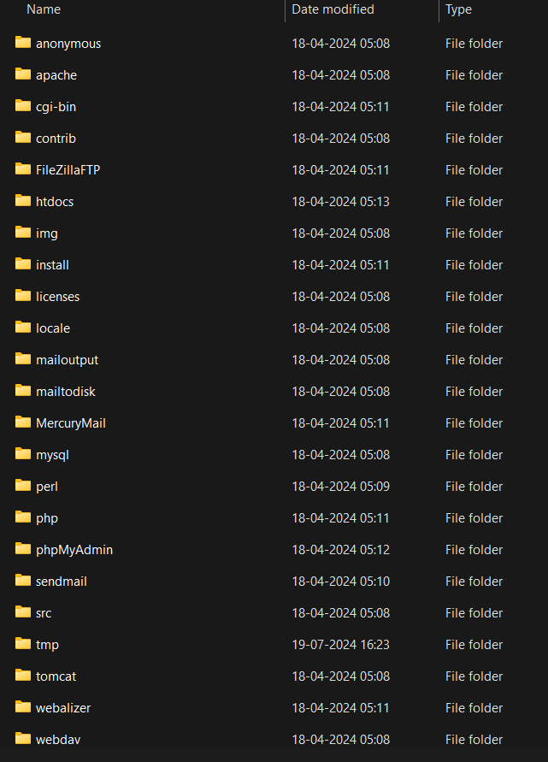

**Step 6: Download the github file and paste it in your htdocs folder**

