Flutter NFC Guide: Using NTAG213 Stickers

Read and Write NFC Tags (NTAG213, 13.56 MHz, 25mm)

# What is NFC?

Near Field Communication (NFC) is a wireless technology that enables data exchange between devices over a short distance (typically < 4 cm). It is used in contactless payments, access cards, and smart tags.

# Recommended Tag for Flutter Testing:

- Type: NTAG213

- Frequency: 13.56 MHz

- Format: Round Transparent Sticker (25mm)

- Capacity: 144 bytes (suitable for text, URLs, small data)

- Works with: iOS (13+), Android (most phones)

- Rewritable: Yes (10,000+ times)

# Requirements:

- Flutter environment set up

- NFC-compatible smartphone (iPhone 7+ with iOS 13+ or Android with NFC)

- `nfc_manager` Flutter package installed

## Add to pubspec.yaml:

dependencies:

nfc_manager: ^4.0.2

nfc_manager_ndef: ^1.0.1

## Info.plist (for iOS):

<key>NFCReaderUsageDescription</key>  
<string>This app uses NFC to read/write data.</string>

## Add NFC capability in Xcode (iOS):

- Open Runner in Xcode > Signing & Capabilities > Add "Near Field Communication Tag Reading"

# Flutter Code Overview:

- Read: Start NFC session and read the first NDEF text record.

- Write: Start NFC session and write a text message using NDEF.

# Flutter Code Snippet (Read/Write):

NfcManager.instance.startSession(  
 onDiscovered: (NfcTag tag) async {  
 final ndef = Ndef.from(tag);  
 if (ndef == null || !ndef.isWritable) return;  
 await ndef.write(  
 NdefMessage([  
 NdefRecord.createText("Hello from Flutter!"),  
 ]),  
 );  
 NfcManager.instance.stopSession();  
 },  
);

# iOS vs Android:

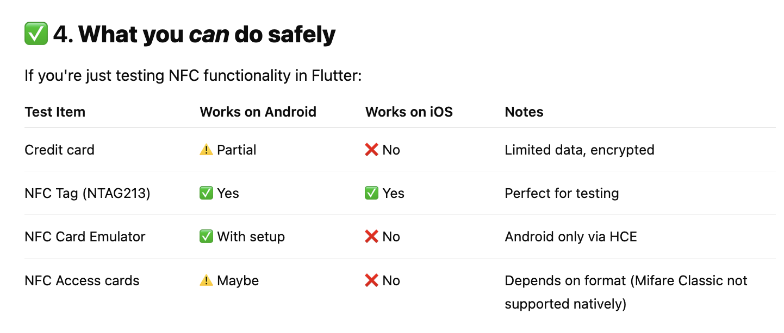

* NFC tag to buy:
  + <https://www.amazon.eg/-/en/10PCS-Sticker-25mm-Round-13-56/dp/B0CKC14LLM/ref=sr_1_1?crid=2P4AQGEIOX04&dib=eyJ2IjoiMSJ9.aQLXzArSOoECUMLrzn4Cd4IAP9QxmNGUgwqziENriXZc1eAy08q_BP2NyomCaXgU4LTAwO6f1SZFA3tO8osb6qhTgpFrfcYIcTwE6Ie9n8TPwgcrNRoi997PmHfJ5yeD.0tHOh5QeemMB85IdGD1HrRMd00_odorBsnp_KVADg5Y&dib_tag=se&keywords=NTAG213&qid=1750592538&sprefix=ntag213%2Caps%2C200&sr=8-1>

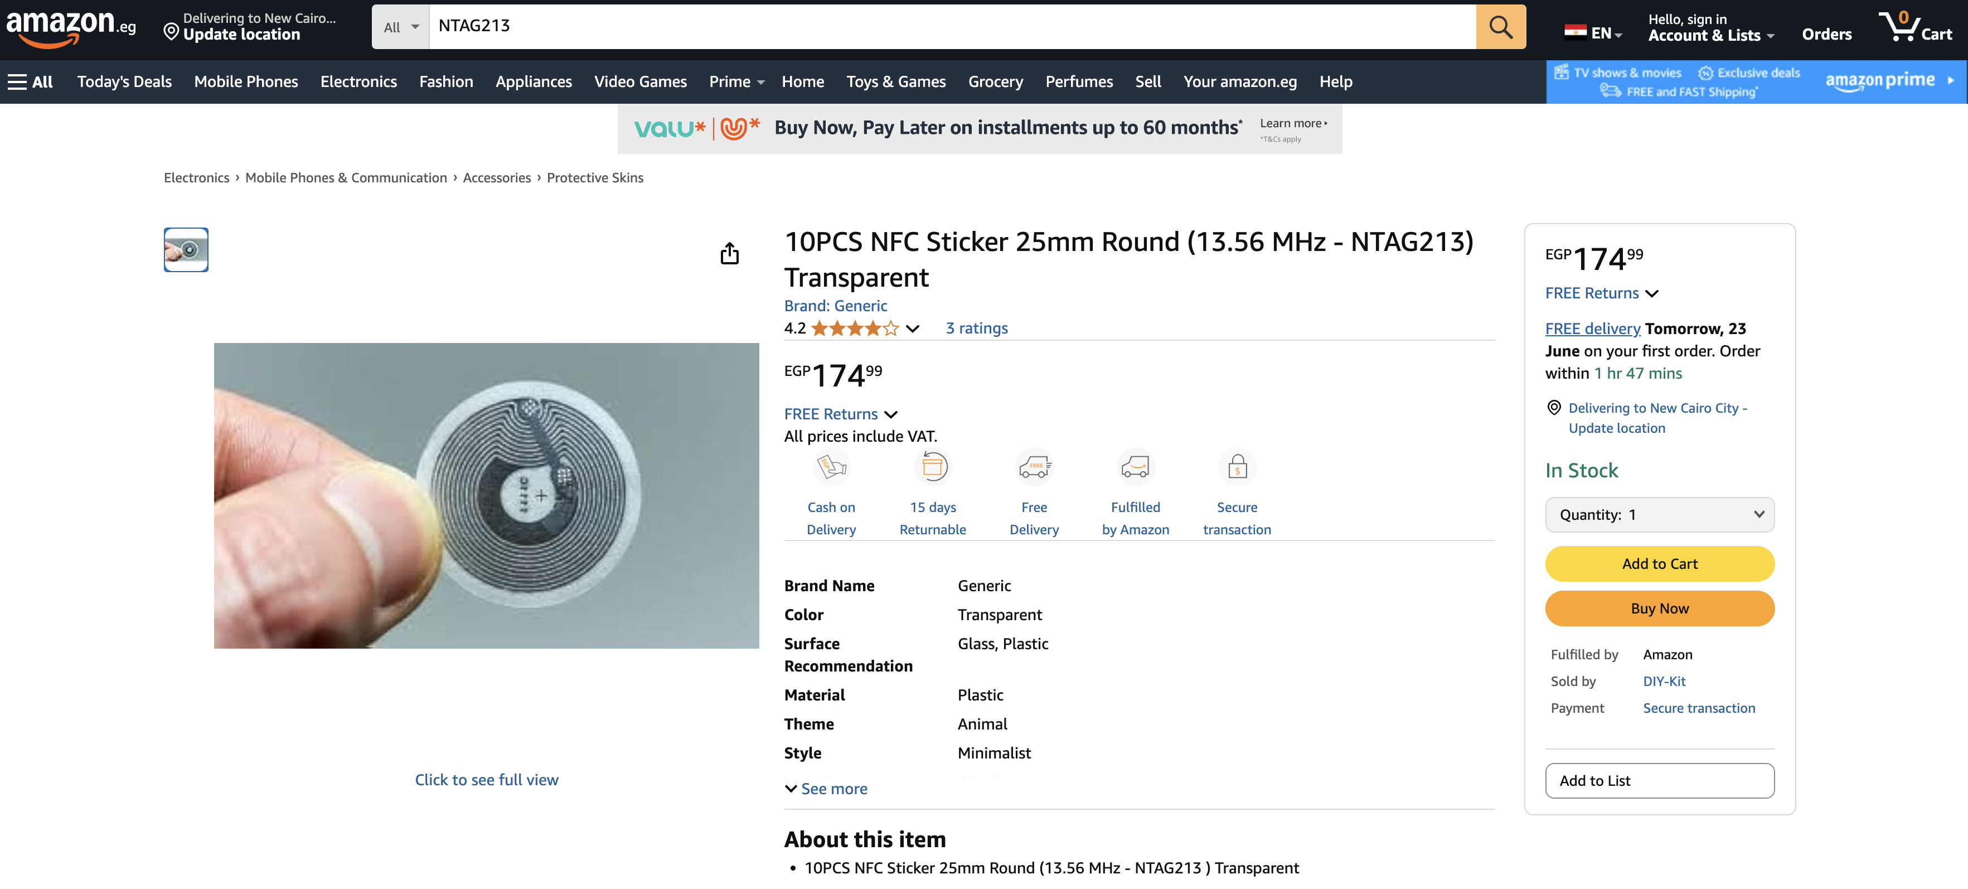

Ref:

1. <https://medium.com/@codetrade/implement-nfc-in-flutter-to-transfer-peer-to-peer-data-64efeaa5377c>
2. <https://blog.stackademic.com/implementing-nfc-in-flutter-a-complete-guide-319594827cf1>