**CO2 Emissions per Capita from 1990 to 2010 Dashboard**

**Motivation**

The United States has one of the largest CO2 emissions per capita in the world.

Carbon emissions are primary influenced by population, economics, and geography. Traditional analysis of CO2 emissions often focus on raw numbers when plotting geographic data, however the EPA now uses CO2 emissions per capita for their guidelines [1]. The exploration of CO2 emissions per capita as well as sector and geographic influences can be performed to:

1) Identify certain geographic regions of the country that have high CO2 emissions.

2) Ascertain what sectors are contributing to high CO2 emissions in high emission states.

3) Informing decision makers of causes of high CO2 emissions to better devise CO2 emissions guidelines

**Tasks:**

Given CO2 emissions and population data from 1990 to 2010 (EIA’s State Energy Consumption, Price and Expenditure Estimates), the following questions are of interest: What sectors and states are the biggest contributors to CO2 Emissions? What geographic and yearly trends are notable? Furthermore, general data exploration can be completed.

**Dashboard:**

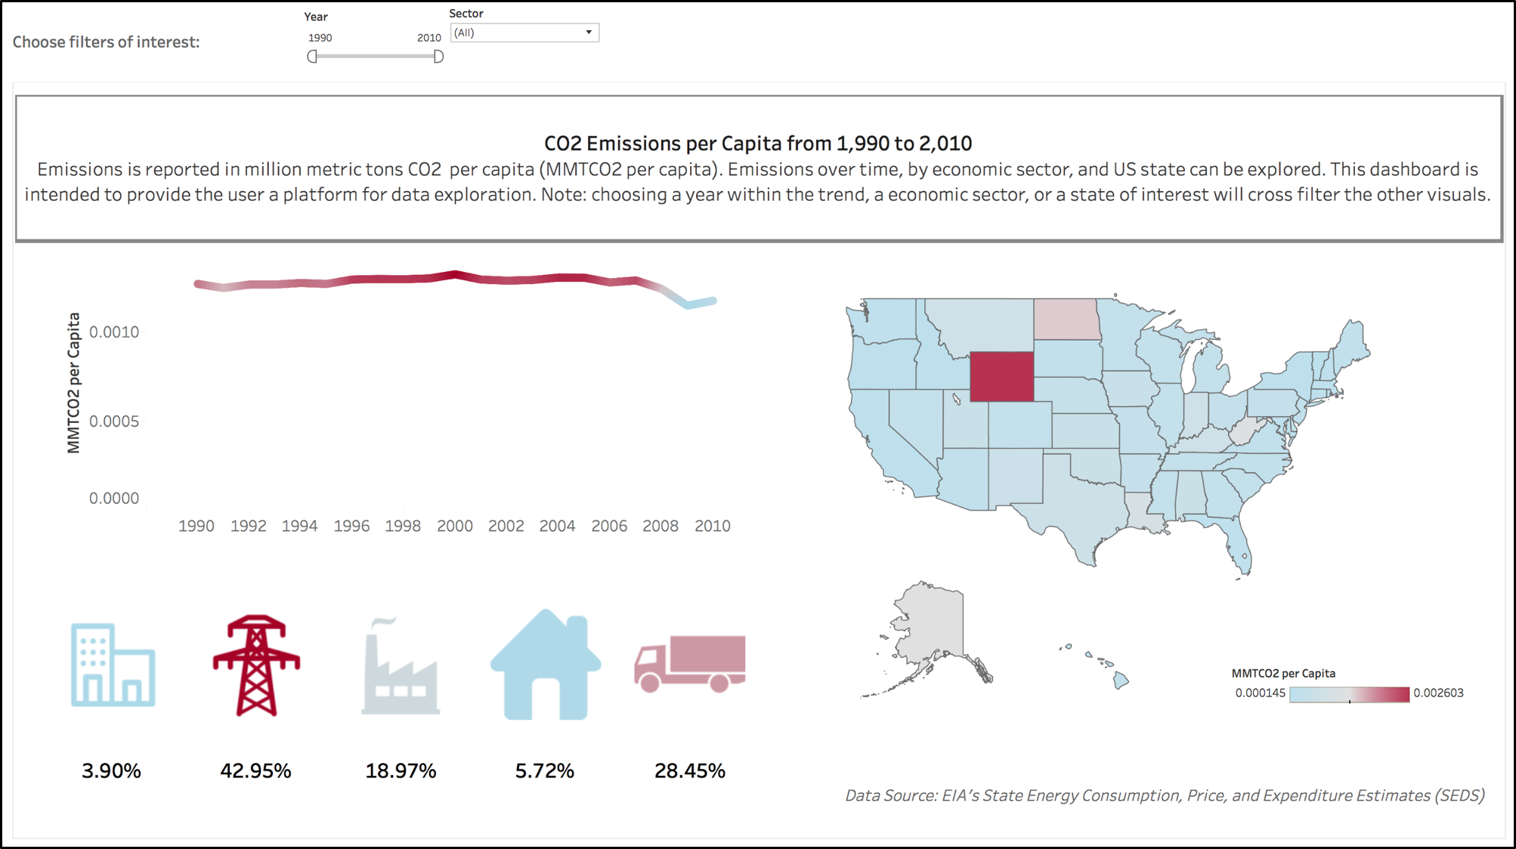

An interactive dashboard was created to answer all of these questions ([see online](https://public.tableau.com/profile/orysya.stus#!/vizhome/CO2EmissionsPerCapita_TimeSectorState/TotalCO2Emissions)). The idioms and features selected for the dashboard include a line chart, a choropleth map, emission percentage as known via KPI icon callouts, interactivity via filters and cross filtering sections, and tooltips for providing additional information. A legend common to all of the idioms was chosen, showing CO2 emissions per capita (MMTCO2 per capita) which highlights the major emitters in red and lower emitters in blue (ColorBrewer tested the colors for color blindness). Note no data was omitted from the dataset.

**Line Chart: What yearly trends of CO2 emissions per capita are notable?**

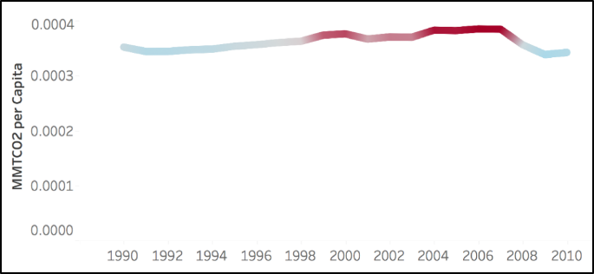The line chart was created to show the trend of CO2 emissions over the years. Year was encoded into the x-axis and CO2 emissions was encoded in the y-axis. A diverging color scheme was used, to signify the peaks of CO2 emission per capita. The year and emissions per capita were encoded into tooltips for each mark. It can be seen above that CO2 emissions peaked in 2007 (for all sectors and states).

**Choropleth Map: What states are the biggest contributors to CO2 Emissions? What geographic trends of CO2 emissions per capita are notable?**

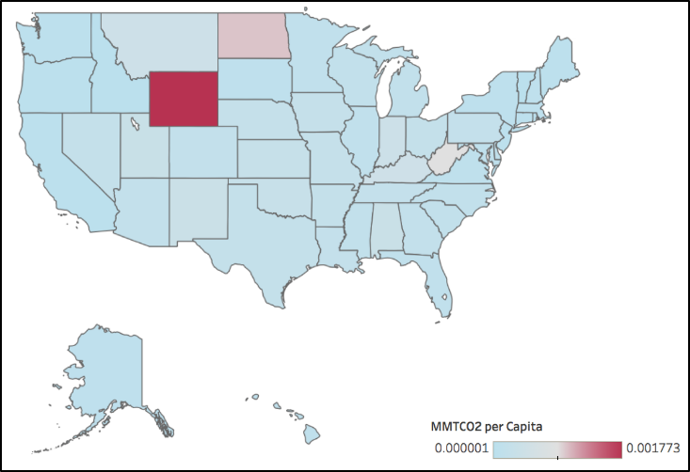The choropleth map shows the quantitative CO2 emissions per capita encoded as color over the area marks (states) delimited as area marks, where the shape of each region is a US State. This map shows the different geographic areas of the country that are high CO2 users and when hovering over state the rank of that state by emission per capita in the tooltip appears. One immediate finding is that Wyoming is the highest CO2 emitter per capita (for all sectors across 1990 to 2010).

**KPI Icon Callout: What sectors are the biggest contributors to CO2 Emissions?**

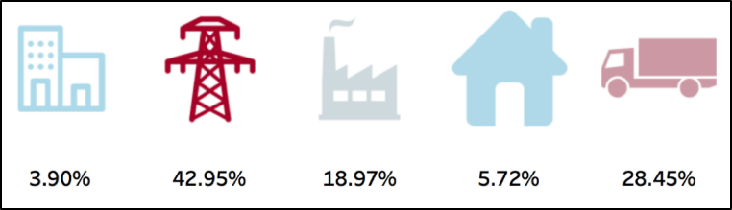

These visuals break down emission by percentage and correspond. Immediately the eye is drawn to the electric power icon via the color channel (from all states from 1990 to 2010). Although a pie chart could have sufficiently compared sector contributors to CO2 emission potentially better, the KPI icon callouts are aesthetically pleasing. Furthermore, although the icons are not labeled with their corresponding sector names, hovering over any of the icons reveals a tooltip with the sector name and emissions per capita.

**Interactivity: Filter drop down selections and visual cross filtering**

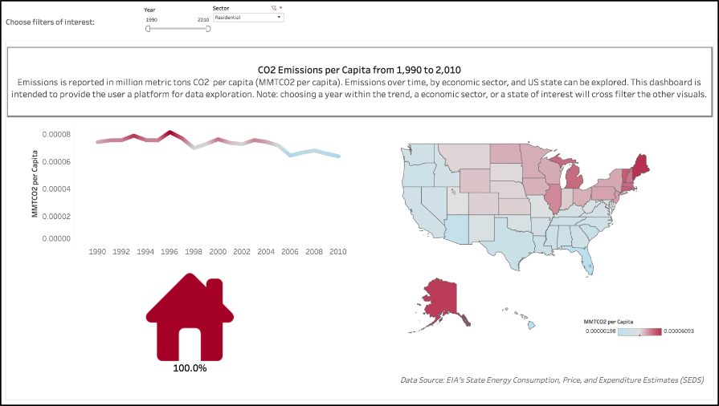

The two filters on the top of the dashboard Year and Sector allow the user to choose the year range and to choose any number of sectors. Once selected, the rest of the dashboard updates. In this example, sector filter was utilized to select Residential, showing a geographic trend that most of the northern states have higher emissions.

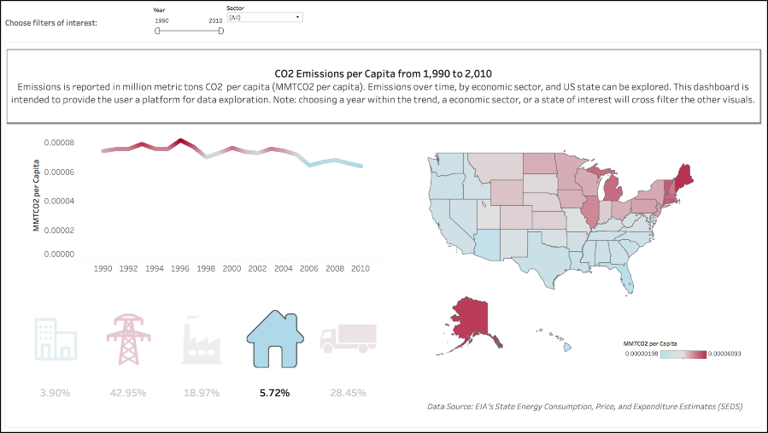Additionally, the dashboard allows for cross filtering interactivity between visuals meaning that selection of a sector icon, year in the line chart, or a state in the choropleth map will filter the visuals accordingly. Above, you can see that residential was again selected but via cross-filtering, showing the line chart and choropleth map filtered but with the other sectors in the KPI icon callout subdued in hue.

Sources

[1] https://www.sciencedirect.com/science/article/pii/S1364032113008162