**Exercise 7 | Fix a Visualization**

**Category 1 - US Spending Budget - Pie chart**

**Data Description.** The estimated outlays in billions for the 2016-2021 fiscal years are provided through usgovernmentspending.com.

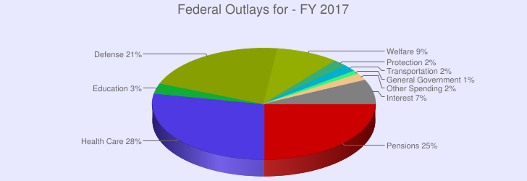**Original Visualization.** The *US Spending Budget - Pie chart* is a unsorted, 3D pie chart which unnecessarily utilizes a depth channel, causing depth disparity and perspective distortion. A pie chart shows the relative contributions of parts to a whole, such as percentages, using both area and angle judgements [1, pg. 168]. The tilt/angle, area, and color hue channels were used appropriately to encode the data but the addition of a depth channel does not encode any additional pieces of data but produces a visual with depth disparity as well as perspective distortion. The visualization is not more accurate due to the addition of the depth channel, but relies heavily on data labels. The visualization displays perspective distortion since the distant pie chart sections appear smaller and cannot be accurately compared to the other Federal Outlay types effectively.

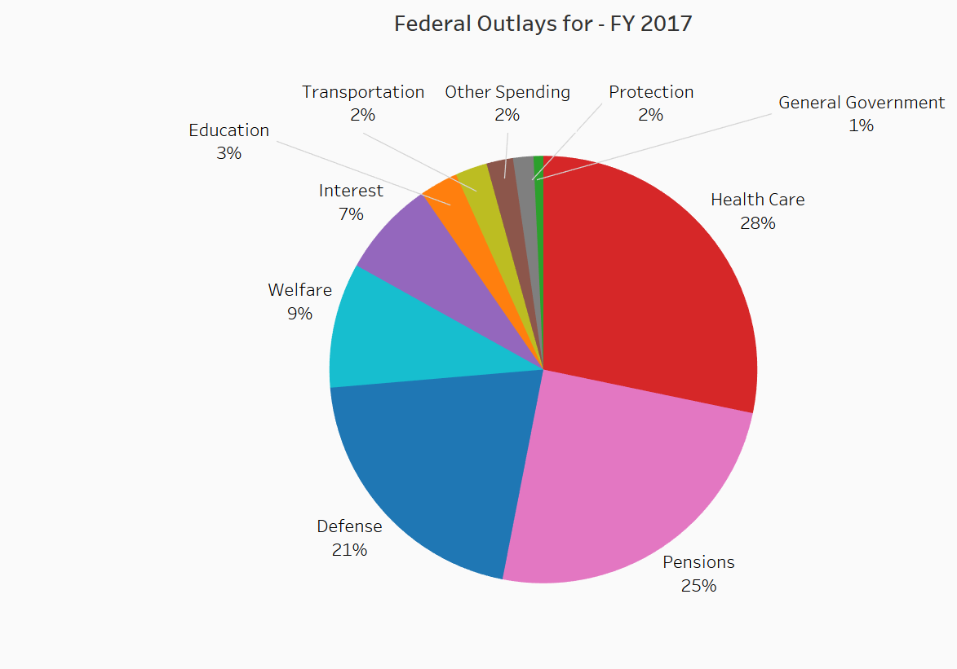**Fixed Visualization.** Similar to the original visualization, the tilt/angle channel encodes the sections of different Federal Outlay spending from the whole, the area channel encodes the percentages of Federal Outlay spending, and the color hue channel encodes the different Federal Outlay spending types. Each of these encodings use the most effective channels for both magnitude and identity. Additionally, the Federal Outlay spending percentages were sorted in descending order to allow the viewer to quickly understand which Federal Outlay types had the most money budgeted for them. The depth channel was, of course, excluded.

**Category 2 - PIOMAS Arctic Sea Ice Volume**

**Data Description.** The monthly average PIOMAS arctic sea ice volume readings from January 1979 to March 2014 are provided through psc.apl.washington.edu.

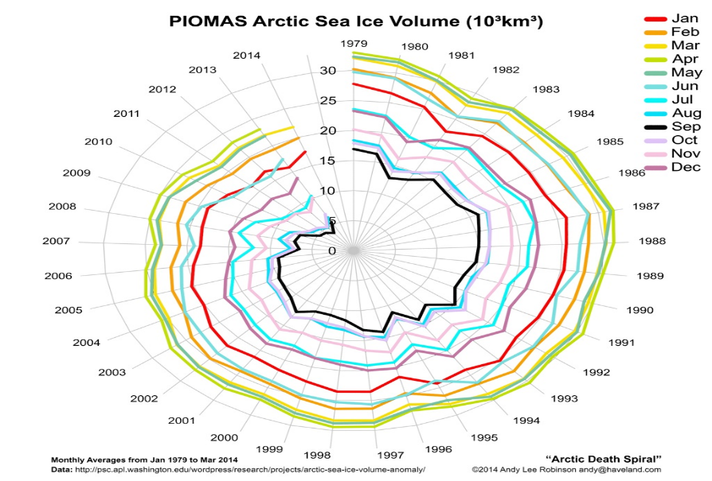**Original Visualization.** The *PIOMAS Arctic Sea Ice Volume* visualization utilizes a radial layout in order to dramatically demonstrate the decreasing volume of arctic sea from January 1979 to March 2014 where the different months are encoded using color hue. Although dramatic, the visualization does not effectively portray the data. Radial layouts are more effective at showing cyclic patterns while rectilinear layouts are most effective at showing the differences between linear and nonlinear trends [1]. Furthermore, Diehl et al. [2] has shown that rectilinear layouts outperformed radial layouts in term of perceptual speed as well as accuracy. Using the angle channel is unnecessary since it does not portray any cyclical data encodings but serves a purely aesthetic purpose.

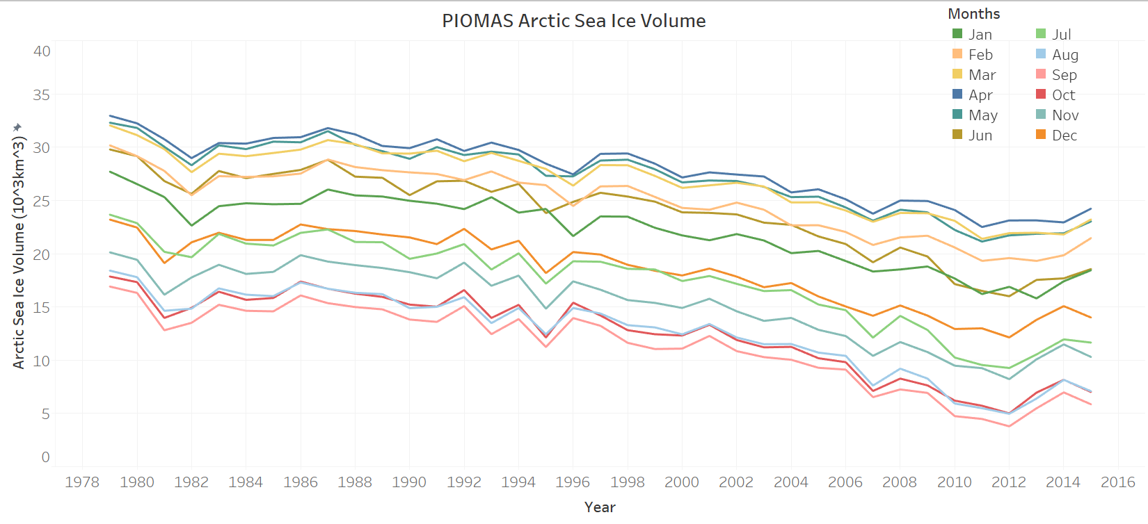**Fixed Visualization.** Line charts show a trend using one quantitative value attribute and one ordered key attribute [1]. Similar to the original visualization, the color hue channel encodes the different months, the position on a common scale encodes the value of sea ice volume, and a trend is depicted using the ascending order of the years. This visualization uses a rectilinear layout to more effectively demonstrate that as the years progress, monthly values of sea ice volume consistently decrease. Rectilinear spatial layouts are the most effective channel for conveying magnitude and identity.

Sources

[1] Munzner, Tamara. *Visualization Analysis and Design*. CRC Press, 2014

[2] Stephan Diehl, Fabian Beck, and Micheal Burch. “Uncovering Strengths and Weaknesses of Radial Visualizations—An Empirical Approach.” *IEEE Transactions on Visualization and Computer Graphics (Proc. InfoVis 10)* 16:6 (2010), 935–942.