**Architecture:**

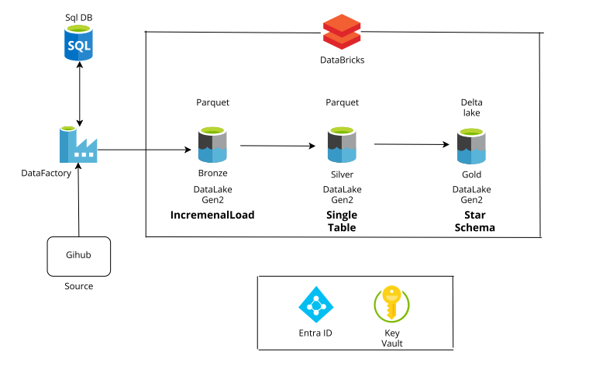

**Environment Setup:**

1. Create a Resource Group for the Project.  
  
2. Create a Azure Data Factory.  
  
3. Create a Azure Data Lake gen 2 storage account.

Under storage account created bronze, silver and gold container.

Bronze → to store the raw data

Silver → to store the processed data

Gold → to store the cleaned data that connect to power bi for end users

4. Create Azure SQL Database.

5. Create Azure Databricks.

6. Create Azure Key Vault

**Dataset required:**

[**Project_dataset**](https://github.com/MohamedBashid/Azure_Project_IncrementalLoad/tree/main/Dataset)

**PHASE 1:**

**1. Created a source table in Azure SQL database.**

create table source_cars_data

(

Branch_Id varchar(200),

Dealer_Id varchar(200),

Model_Id varchar(200),

Revenue bigint,

Units_Sold bigint,

Date_Id varchar(200),

Day int,

Month int,

Year int,

Branch_Name varchar(200),

Dealer_Name varchar(200)

)

In phase 1, we have created a pipeline to copy the data from [**Project_dataset**](https://github.com/MohamedBashid/Azure_Project_IncrementalLoad/tree/main/Dataset) to Azure Sql databse using Azure Data Factory.

Base URL: https://raw.githubusercontent.com

Relative URL: (Initial full load) MohamedBashid/Azure_Project_IncrementalLoad/refs/heads/main/Dataset/SalesData.csv

Relative URL: (incremental load)

MohamedBashid/Azure_Project_IncrementalLoad/refs/heads/main/Dataset/IncrementalSales.csv

**2. Created a Linked service for http(source) and Azure Sql DB(destination).**

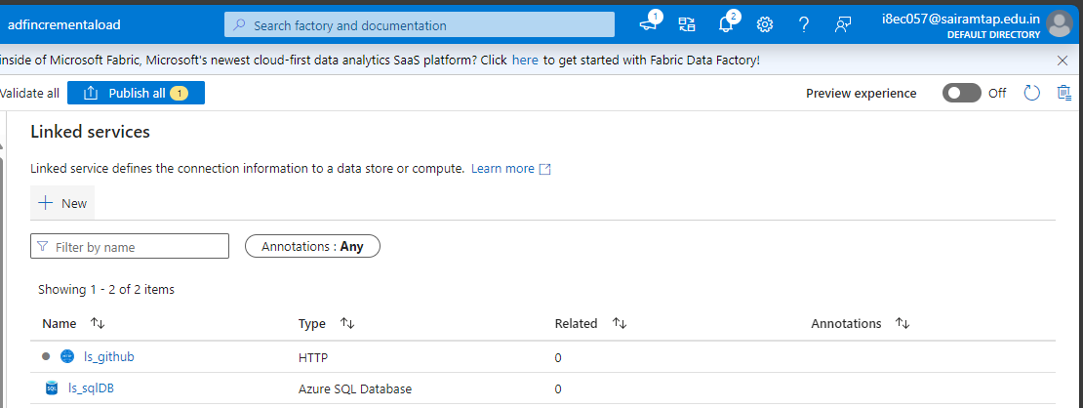

Configured the base url in http(source) linked service.

I have created a pipeline to copy the initial full load of the data from github to Azure SQL DB.

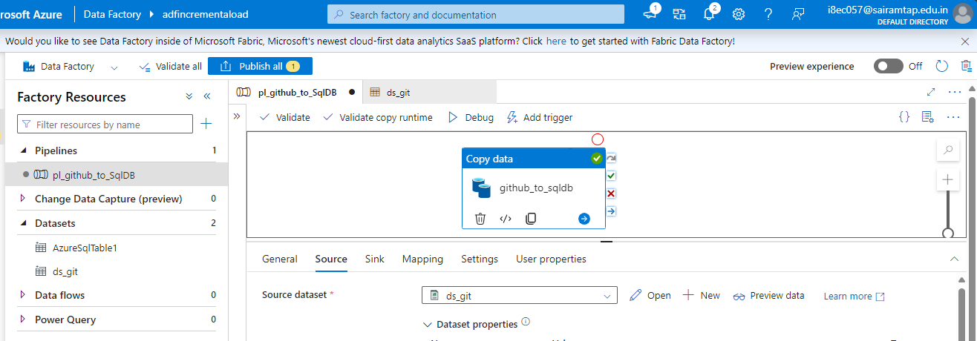

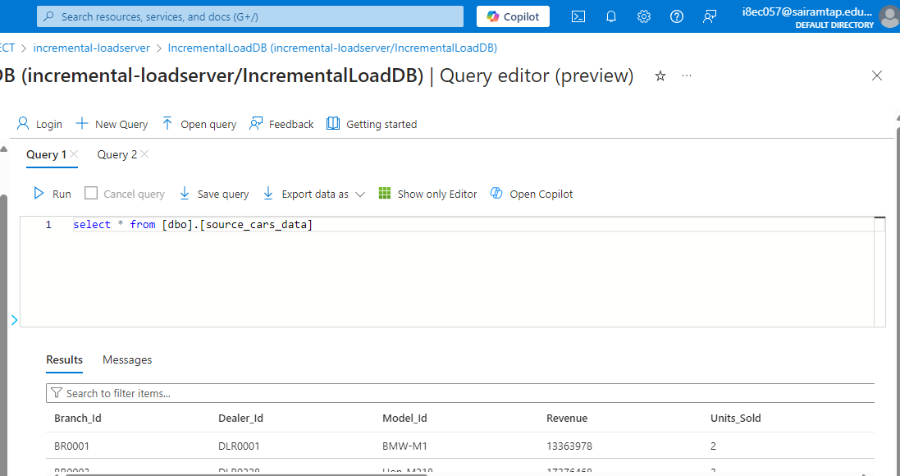

Now, for incremental load i have created a water_mark table and stored procedure in Azure SQL DB.  
  
create table water_table

(

last_load varchar(200)

)

insert into water_table (last_load) values ('DT00000')

create procedure updateWaterMarkTable @lastload varchar(200)

as

begin

begin transaction;

update water_table set last_load = @lastload

commit transaction;

end;

I have created a end to end incremental load pipeline to copy data from Azure SQL DB to Azure ADLS gen2.

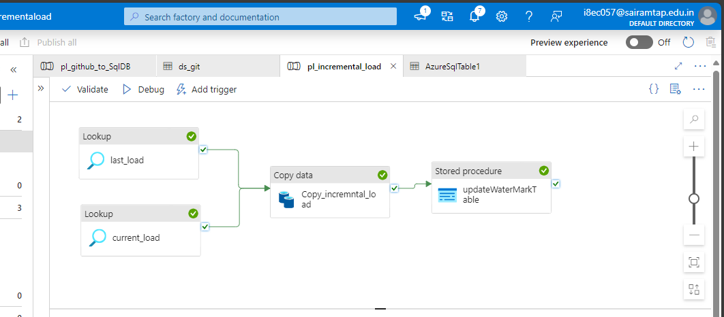

last_load Lookup Activity:

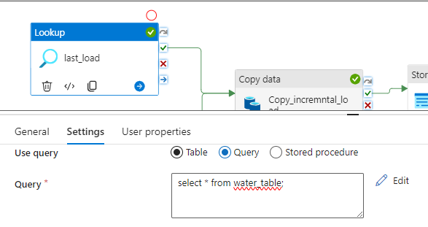

current_load Lookup Activity:

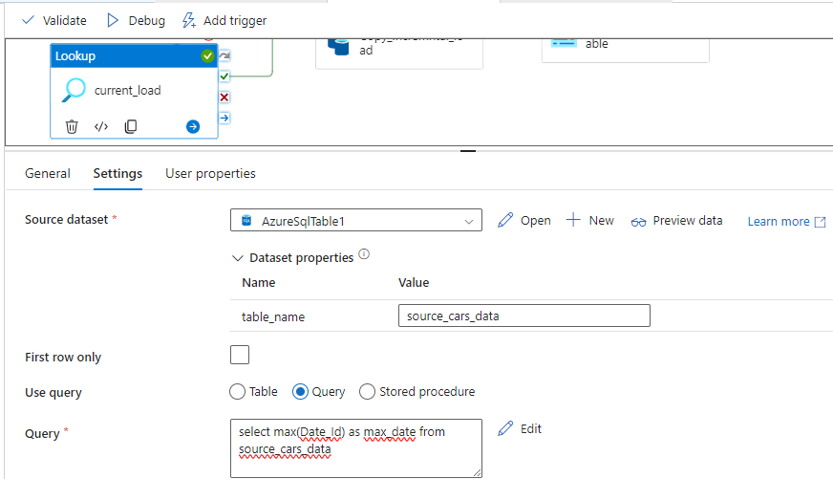

Copy activity:  
  
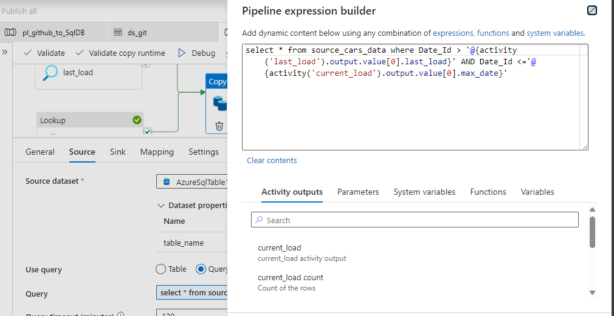

Stored procedure Activity:  
  
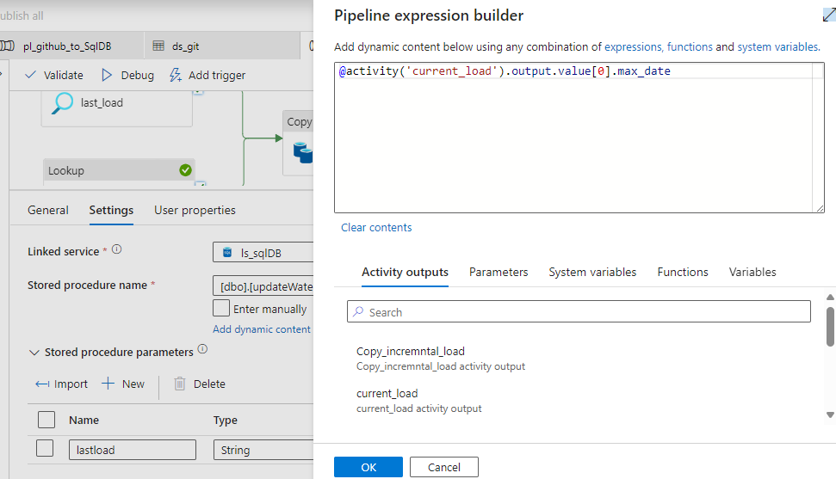

In the above pipeline, last_load lookup activity will contain the start date_id value with the help of water_mark_table and the current_load lookup activity will contain the maximum date_id value with the help of source_cars_data table.  
  
In the copy activity the data from start to maximum date_id value will be copied from DB to Data Lake. In the stored procedure activity the last_load value will be assigned with the current_load which is the maximum value.

**PHASE 2:**

To Set up Unity Catalog:

Create a metastore in Databricks.

I have created a separate container for the unity catalog metstore.

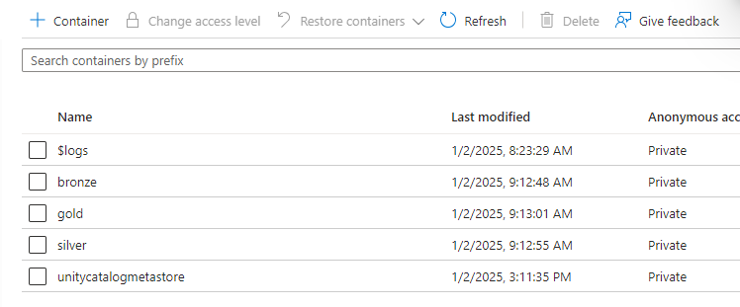

I have created a access connector to connect the data lake with the databricks.

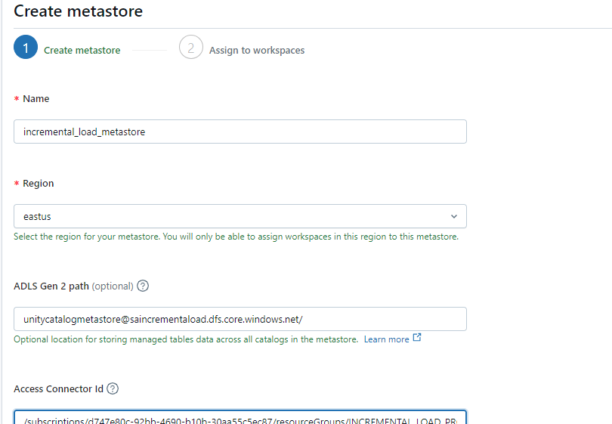

Assign the databricks workspace to the created unity catalog metastore.

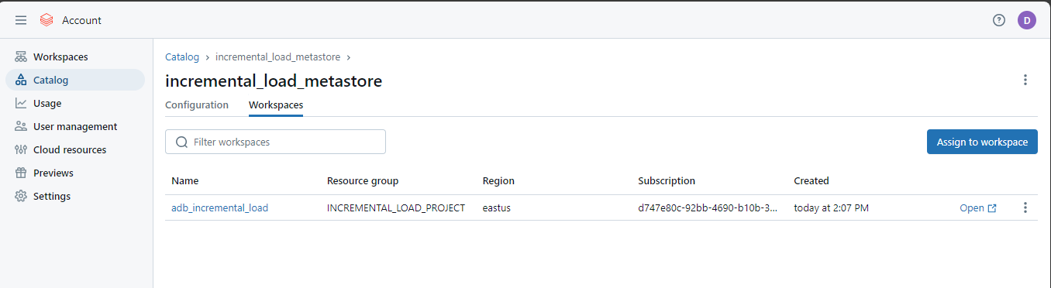

I have created a cluster.

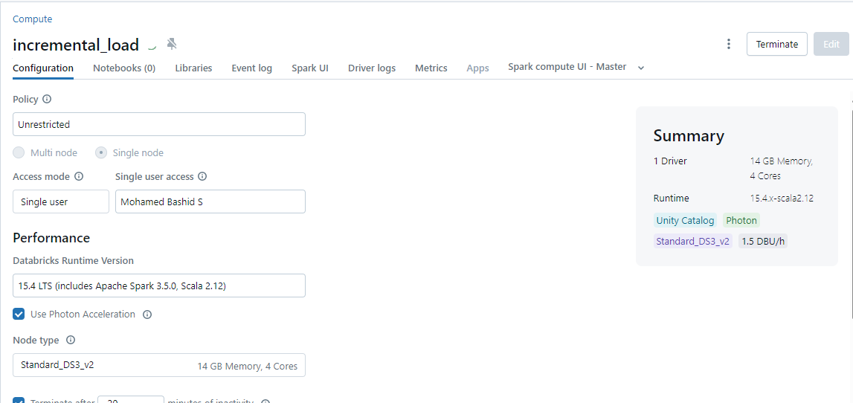

Now, i have created a external location for bronze, silver and gold container.   
To create a external location, storage credential is required.  
For storage credential we can use the created access connector.

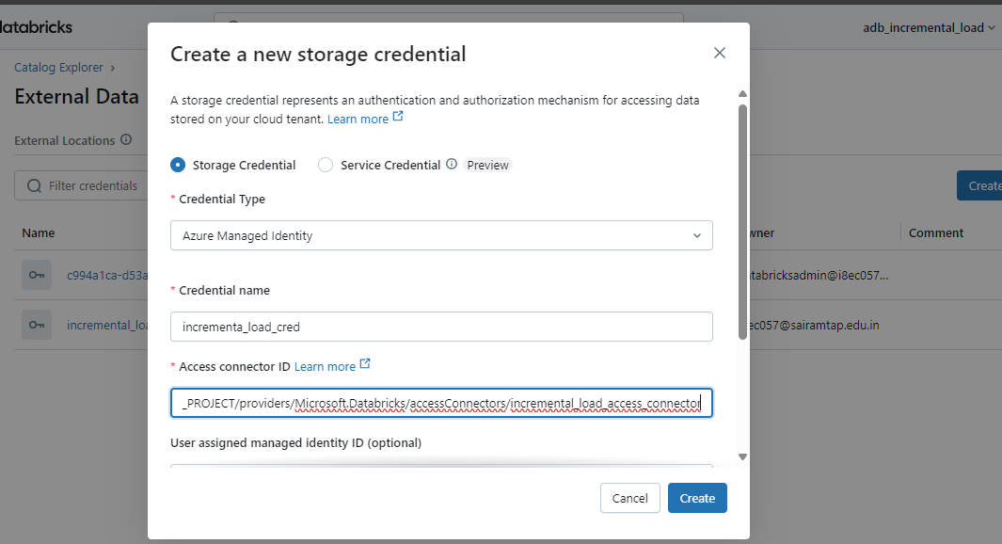

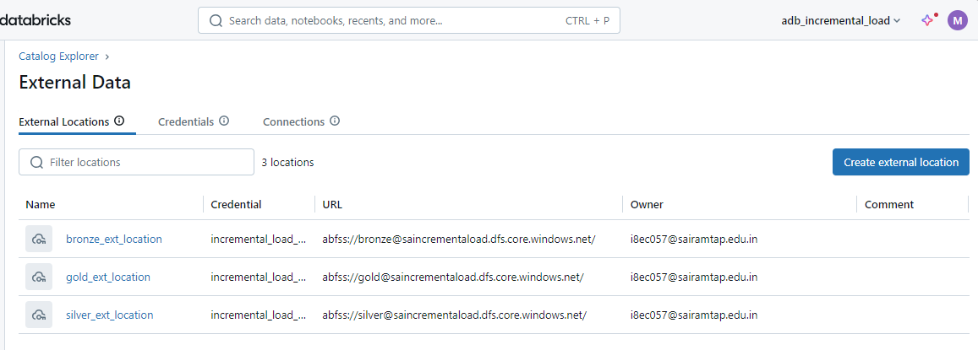

Refer catalog_notebook

Refer silver_notebook

**PHASE 3:**

**Creating Star Schema**

Creating a Dimension Tables:

Refer gold_notebook_dim_model

Refer gold_notebook_dim_branch

Refer gold_notebook_dim_dealer

Refer gold_notebook_dim_date

Creating a Fact Table:

Refer gold_notebook_fact_sales

