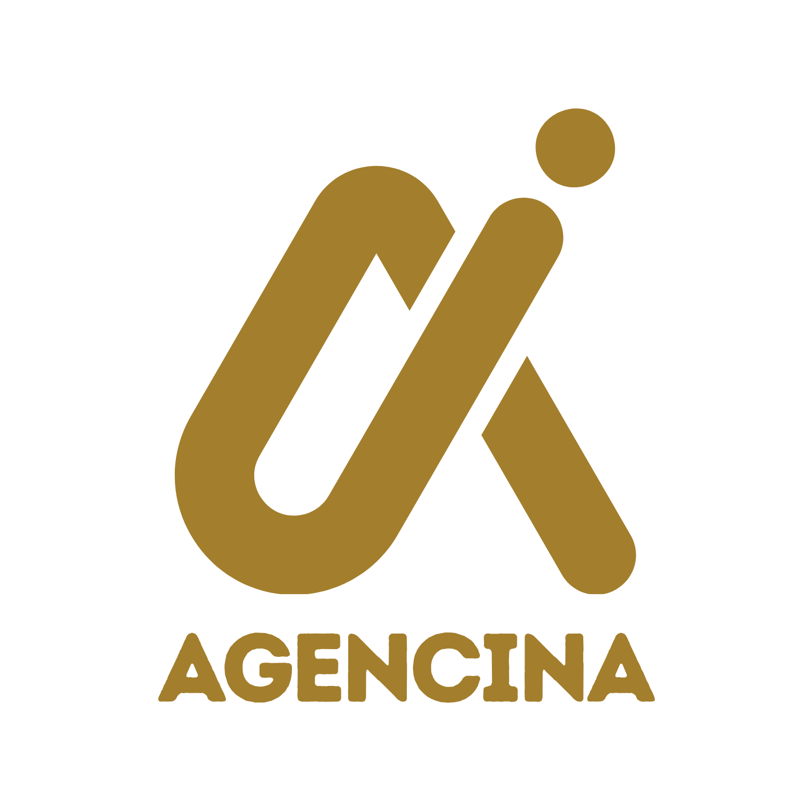  AGENCINA  Creative Agency · Branding & Digital  12 Boulevard Mohammed V  20000 Casablanca, Morocco  hello@agencina.com · +212 522 555 014 | INVOICE  No. INV-2026-0184

BILL TO  Atlas Retail Group  Attn: Karim El Idrissi, Finance  45 Rue Allal Ben Abdellah  20250 Casablanca, Morocco  k.elidrissi@atlasretail.ma | Invoice Date May 18, 2026  Due Date June 17, 2026  Payment Terms Net 30  PO Number PO-2026-7741  Project Q2 Brand Refresh

DESCRIPTION | QTY | RATE | AMOUNT
Brand Strategy Workshop  Two-day on-site facilitation with executive team | 1 | 4,800.00 MAD | 4,800.00 MAD
Logo & Visual Identity Design  Primary mark, secondary marks, and color system | 1 | 6,500.00 MAD | 6,500.00 MAD
Brand Guidelines Document  48-page PDF including typography and usage rules | 1 | 3,200.00 MAD | 3,200.00 MAD
Senior Consultant Hours  Stakeholder interviews and revisions | 12 | 185.00 MAD | 2,220.00 MAD
Stock Photography Licenses  Reimbursable expense (passed through at cost) | 8 | 45.00 MAD | 360.00 MAD

Subtotal | 17,080.00 MAD
VAT (20%) | 3,416.00 MAD
TOTAL DUE | 20,496.00 MAD

PAYMENT INFORMATION  Bank: Attijariwafa Bank  Account Name: Agencina SARL  RIB: 007 780 0001234567890123 45  SWIFT: BCMAMAMC  Or pay online: pay.agencina.com | NOTES & TERMS  Thank you for your business. We appreciate working with you on the Q2 brand refresh.  Payment is due within 30 days of invoice date. Late payments may be subject to a 1.5% monthly finance charge.  Please reference invoice number INV-2026-0184 with your payment.

