

Software Engineering Project Documentation

Course Title: Software Engineering
Group Number: [ TEAM 1 ]
Project Title: (SHEFAA )
Smart Healthcare Entry & Facility Automation Assistant
Submission Date: [17,May,2025]
Team Members:
محمد ايمن فتحي عبد الغنى(leader) | 921220115
محمد خالد سعد كامل منصور | 921220117
عمر أمجد عبد العزيز عبد السلام | 921220092
محمود صلاح عبد المعز حسن السلكاوي | 921220139
كريم احمد سعد محمد ابو العزم | 921220105
عمر هاني صابر فضل | 921220099

Contributions Breakdown
Name | Contributions
محمد ايمن فتحي عبد الغني السيد | 1-Chatbot Integration  2- Functional Requirements Table  3-References & Formatting,  4-implementation system using java.  5- contributed to designing Activity Diagram.  6- contributed to designing class Diagram.  7- choosing and documenting Design Pattern.  8- writing the final Documentation of the Project
محمود صلاح عبد المعز السلكاوي | 1- Security Requirements  2- Interface Requirements,  3- Class Diagram  4- contributed to determine None-Functional Requirements  5- contributed to implementing Java.
كريم احمد سعد أبو العزم | 1- SRS Preface(determine Target Users).  2- System Architecture.  3- Sequence Diagrams.  4- choosing the name SHEFFA for our system.  5- Testing The system.  6-
عمر امجد عبد العزيز | 1- Stakeholder Analysis  2- ERD &Relational model  3- Determines the structure of database SHEFFADB  4- Creating Database using SQL SERVER.  5- Object Diagram.
محمد خالد سعد | - Glossary  - Contributed to Database Creation through validation that database is correctly structured.  - Activity Diagram,  - Contributed to Sequence Diagram.  - Testing System.  - System Evolution.
عمر هاني صابر | 1- Determine scope of our system.  2- AI Future Planning.  3- Use Case Descriptions.  4- Use Case Diagram  5- Testing The system

1. Customer Problem Statement
As a hospital administrator, I encounter several operational challenges in managing patient appointments, medical records, and staff coordination. The process of registering new patients, scheduling doctor visits, and maintaining accurate records of patient histories is primarily manual, leading to frequent delays and data discrepancies. Patients often experience long wait times, lack of appointment transparency, and difficulties accessing their medical history. These inefficiencies negatively affect patient satisfaction and hinder healthcare service delivery.
Doctors also face issues such as the need to manually search for patient records before consultations, limited access to complete patient histories, and challenges in managing their daily schedules effectively. These limitations not only reduce the quality of healthcare but also increase the administrative burden on the medical staff.
Administrators are responsible for overseeing the overall operations of the hospital, ensuring data security, coordinating between departments, and maintaining accurate records of patients and doctors. The absence of a centralized, automated system makes it difficult to manage these responsibilities efficiently, especially during peak hours or in emergency situations. This lack of digital infrastructure results in communication breakdowns, duplicated efforts, and increased chances of human error.
To address these challenges, we envision a smart, integrated solution called SHEFAA (Smart Healthcare Entry & Facility Automation Assistant). This system will serve as a complete Hospital Management System (HMS), aimed at automating core administrative and clinical processes. SHEFAA will provide secure and centralized access to patient and doctor records, facilitate smooth appointment booking, and allow for role-based access to ensure that users only access information relevant to their responsibilities.
Patients will be able to:
- Register themselves in the system through a user-friendly interface.
- Book appointments with doctors based on availability.
- View their medical history, previous appointments.
- Update their personal information securely.
Doctors will have access to:
- An overview of their daily schedule and appointments.
- Patient details and medical histories to prepare for consultations.
- Tools to update patient medical reports after each visit.
Administrators will:
- Manage doctor and patient accounts, including additions and removals.
- Monitor and maintain the database integrity.
- Oversee appointment scheduling to reduce clashes and improve utilization.
To enhance the patient experience, the system will include a chatbot that offers general medical guidance, helping patients decide whether they need to book an appointment or follow basic at-home care. This feature not only helps patients make informed decisions but also reduces unnecessary clinic visits, especially in non-emergency situations.
SHEFAA must be accessible and secured with authentication layers to protect patient data. Patients can independently sign up, but sensitive actions like deleting or modifying doctor records must be restricted to administrators. By ensuring a proper role-based access control system, we aim to maintain data privacy and operational transparency.
In the future, SHEFAA will be expanded to include AI-based medical diagnostics and a mobile application for increased accessibility. It will also be designed to support multi-branch operations, enabling hospital chains to manage all their locations under one unified system.
By implementing SHEFAA, we aim to:
- Improve service delivery by reducing manual bottlenecks.
- Increase operational efficiency.
- Enhance patient satisfaction and trust.
- Support doctors and staff with streamlined digital tools.
In summary, SHEFAA will revolutionize how hospitals function by bringing automation, security, and accessibility into every aspect of healthcare management.

2. System Requirements

2.1 Functional Requirements

The functional requirements define the core actions that the SHEFAA system must perform to satisfy the needs of patients, doctors, and administrators. Each requirement is identified by a unique ID and a concise description.
ID | Functional Requirement Description
REQ-1 | The system must allow users to sign up and log in based on their role (patient, doctor, administrator).
REQ-2 | Patients must be able to register by providing basic information such as name, age, contact details.
REQ-3 | Doctors must be able to log in and access a dashboard displaying their appointments and patient history.
REQ-4 | Administrators must be able to manage users, including adding/removing doctors and viewing all appointments.
REQ-5 | Patients must be able to view, book, and cancel appointments with available doctors.
REQ-6 | Doctors must be able to view and update patient medical records after appointments.
REQ-7 | Patients must be able to update their personal information such as phone number or address.
REQ-8 | All users must be authenticated before accessing the system functionalities.
REQ-9 | The system must include a chatbot that provides basic medical advice or triaging support.

2.2 Non-Functional Requirements
Non-functional requirements define how the system performs its tasks. These include performance, security, usability, availability, and other constraints.
ID | Non-Functional Requirement Description | Priority
REQ-10 | System response time for database operations must be less than 5 second. | High
REQ-11 | The system should be accessible 24/7 with a downtime of no more than 1% monthly. | High
REQ-12 | Only authorized users should access or manipulate data within their role privileges. | Critical
REQ-13 | The patient signup feature must not require administrator approval. | High
REQ-14 | The administrator is the only role allowed to remove or deactivate a doctor profile. | Critical
REQ-15 | All communication with the database must use secure authentication. | High
REQ-16 | The user interface must be intuitive and support Arabic and English languages. | Medium
REQ-17 | The system must be compatible with Windows 10+ and work on standard hardware (Core i3, 4GB RAM). | Medium
REQ-18 | The system should be scalable to support additional modules like diagnostics or billing in the future. | Medium
REQ-19 | The chatbot must return responses within 2 seconds for common symptom queries. | High

3. Functional Requirements Specification

3.1 Stakeholders
Stakeholders are all individuals or organizations that are affected by or have an interest in the system.
Stakeholder | Description
Patients | End users who register to book appointments and manage their medical records.
Doctors | Healthcare providers who manage appointments and update patient medical history.
Hospital Administrator | Oversees and manages the entire system, users, and appointments.
Hospital Management | Institution owners or sponsors interested in system performance and reporting.
Testers | Team responsible for ensuring the system performs according to requirements.

3.2 Actors and Goals
Actors are entities (people or systems) that interact with the system. Goals are their objectives.
Actor | Type | Goals
Patient | Initiating | Register, log in, book appointments, update personal info, view history
Doctor | Initiating | Log in, manage patient medical records, view schedules
Administrator | Initiating | Manage doctors and patients, view appointments, control access
Chatbot API | Participating | Provide general medical advice or symptom-based triage

3.3 Use Case Descriptions
Use Case ID | Actor(s) | Description | Includes | Related Requirements
UC1 | Patient | Allows new users to register by entering personal data. | — | REQ-2
UC2 | Patient, Doctor, Administrator | All users must authenticate to access system features. | — | REQ-1, REQ-8
UC3 | Patient | View or edit contact information after login. | Login | REQ-7
UC4 | Patient | Book time slots with available doctors. | Login | REQ-5
UC5 | Patient | Access past visits and reports. | Login | REQ-6
UC6 | Doctor, Patient, Administrator | See upcoming appointments. | Login | REQ-3, REQ-4
UC7 | Doctor | Update or add new reports for patients. | Login | REQ-6
UC8 | Administrator | Add, edit, or remove doctors and patient records. | Login | REQ-4
UC9 | Patient | Ask symptom-based questions to get basic medical guidance via chatbot. | — | REQ-9

4. System Models and Database Design
This section presents various models that describe the behavior and structure of the SHEFAA Hospital Management System. These include UML diagrams and the Entity-Relationship Diagram (ERD) that guided the development of the database.

4.1 Use Case Diagram
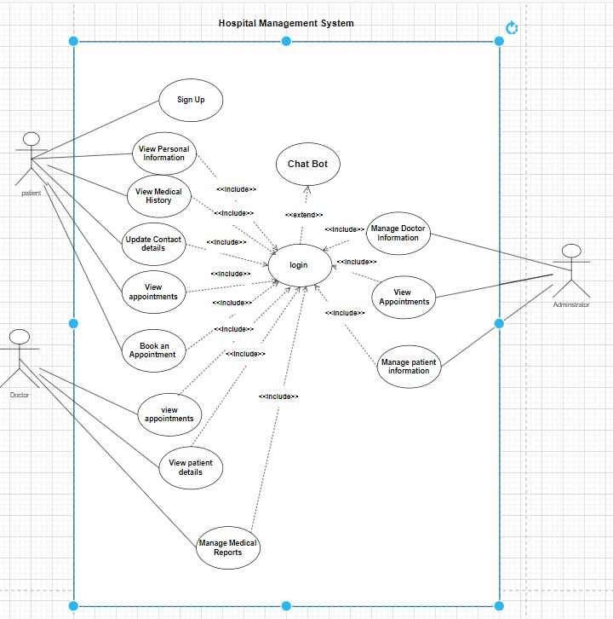
Use Case Diagram Description – SHEFAA:

The Use Case Diagram of the Hospital Management System provides a high-level graphical representation of the different actors (users) interacting with the system and the functionalities they can access. This diagram illustrates the major system capabilities, grouped according to the roles of Patient, Doctor, and Administrator, with a central login system and optional chatbot assistance.

Actor | Description & Functionalities
Patient | - Can Sign Up to the system  - Must Login before accessing functionalities  - Can:  - View Personal Information  - View Medical History  - Update Contact Details  - View Appointments  - Book an Appointment  - Can interact with Chat Bot (optional)
Doctor | - Must Login to access the system  - Can:  - View Appointments  - View Patient Details  - Manage Medical Reports
Administrator | - Must Login to access admin functions  - Can:  - Manage Doctor Information  - Manage Patient Information  - View Appointments

Use Case | Description
Login | Mandatory for all users (Patient, Doctor, Administrator)Linked with <> to all other functions
Sign Up | For new patients only
Patient Functions | - Book an Appointment- View Appointments- Update Contact Details- View Medical History- View Personal Information
Doctor Functions | - View Appointments- View Patient Details- Manage Medical Reports
Admin Functions | - Manage Doctor Information- Manage Patient Information- View Appointments
Chat Bot | Optional assistant invoked via <> after login

Relationship | Meaning
<<include>> | The included use case ( Login) is always performed as part of another use case
<<extend>> | The extended use case (ChatBot) is optional.

4.2 Activity Diagram
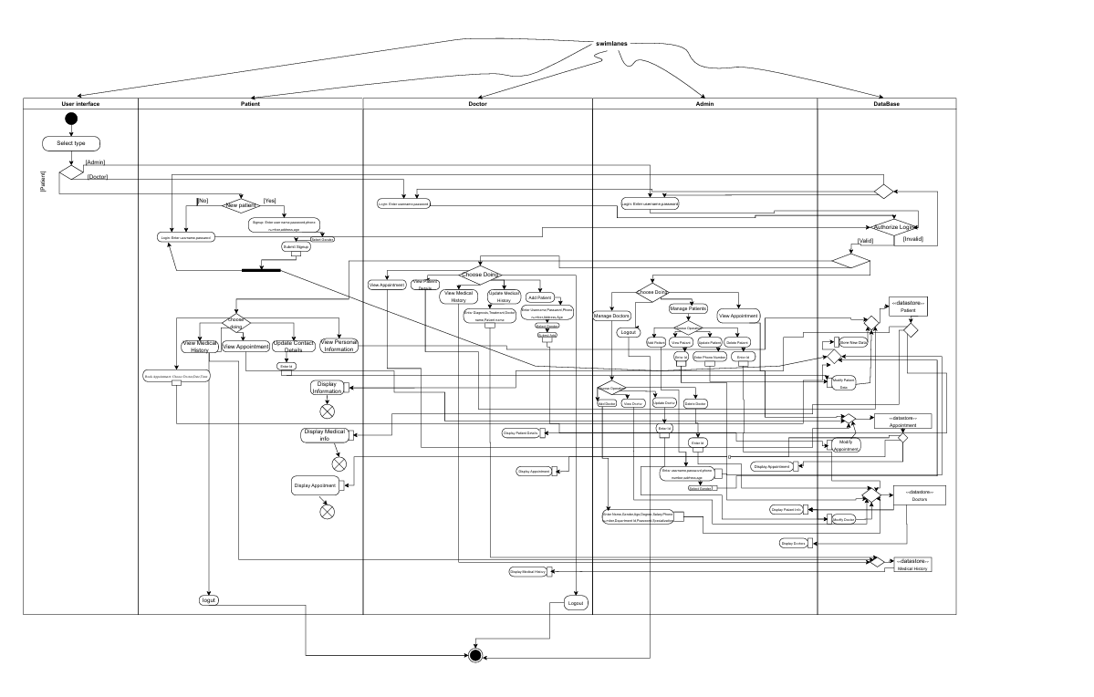Activity diagram High Quality : click the link and download Activity diagram for High Quality
{ https://drive.google.com/file/d/1TdmAyYR5l3x722_ZqerIxIvtu9m7ZV53/view?usp=drive_link }
Swimlane | Key Activities
User Interface | - Select Type (Patient/Doctor)  - Displays login and signup options  - Initiates interaction for all users
Patient | - Sign Up / Login- View Personal Information  - View / Book Appointments  - View Medical History  - Update Contact Details  - Logout
Doctor | - Login  - View Appointments  - View Patient Details  - Update / Manage Medical Reports  - Logout
Admin | - Login  - Manage Patient Information  - Manage Doctor Information  - View All Appointments  - Logout
Database | - Validate Credentials (for all roles)  - Store/Update/View: User Info, Appointments, Medical Records, Reports  - Insert/Update Data based on actions from Patients, Doctors, Admin

1. Start Process:

Initial Node: The process begins when a user accesses the system.

User Role Selection: The user selects their role: Patient, Doctor, or Administrator.

2. Patient Workflow

Registration and Authentication

Sign Up: If the patient is new, they provide personal details to register.

Login: Registered patients enter credentials to access the system.

Credential Verification: The system validates credentials against the database.

Access Granted: Upon successful verification, the patient is directed to the main dashboard.

Patient Functionalities

View Personal Information: Patients can view their stored personal details.

Update Contact Details: Patients can update their contact information, which is then saved to the database.

View Medical History: Patients can access their medical records retrieved from the database.

View Appointments: Patients can see their upcoming and past appointments.

Book Appointment:

a. Select department and preferred doctor.

b. Choose an available time slot.

c. Submit the appointment request, which is stored in the database.

Chat Bot Interaction: Patients can use the chat bot for assistance with medical advices.

3. Doctor Workflow

Authentication

Login: Doctors enter their credentials to access the system.

Credential Verification: The system checks credentials against the database.

Access Granted: Upon successful verification, doctors access their dashboard.

Doctor Functionalities

View Appointments: Doctors can see their scheduled appointments.

View Patient Details: Doctors can access patient information and medical history.

Manage Medical Reports:

Create or update medical reports for patients.

Add prescriptions and treatment plans.

Save the reports to the database

4. Administrator Workflow

Authentication

Login: Administrators enter credentials to access the system.

Credential Verification: The system validates credentials against the database.

Access Granted: Upon successful verification, administrators access the admin panel.

Administrative Functionalities

Manage Doctor Information:

Add new doctor profiles.

Edit existing doctor details.

Remove doctor profiles.

2. Manage Patient Information:

a. View and update patient records.

b. Delete patient profiles if necessary.

3. View All Appointments: Administrators can access the complete schedule of appointments across departments.

5. Database Interactions

Credential Verification: Validates login information for all users.

Data Storage and Retrieval:

Stores new registrations and updates to user information.

Retrieves patient medical history and appointment details.

Saves medical reports and prescriptions added by doctors.

Maintains records of all appointments and administrative changes.

6. End Process

Logout: Users can log out, ending their session.

Final Node: The process concludes, returning the system to the initial state, awaiting the next user interaction.

4.3 Class Diagram
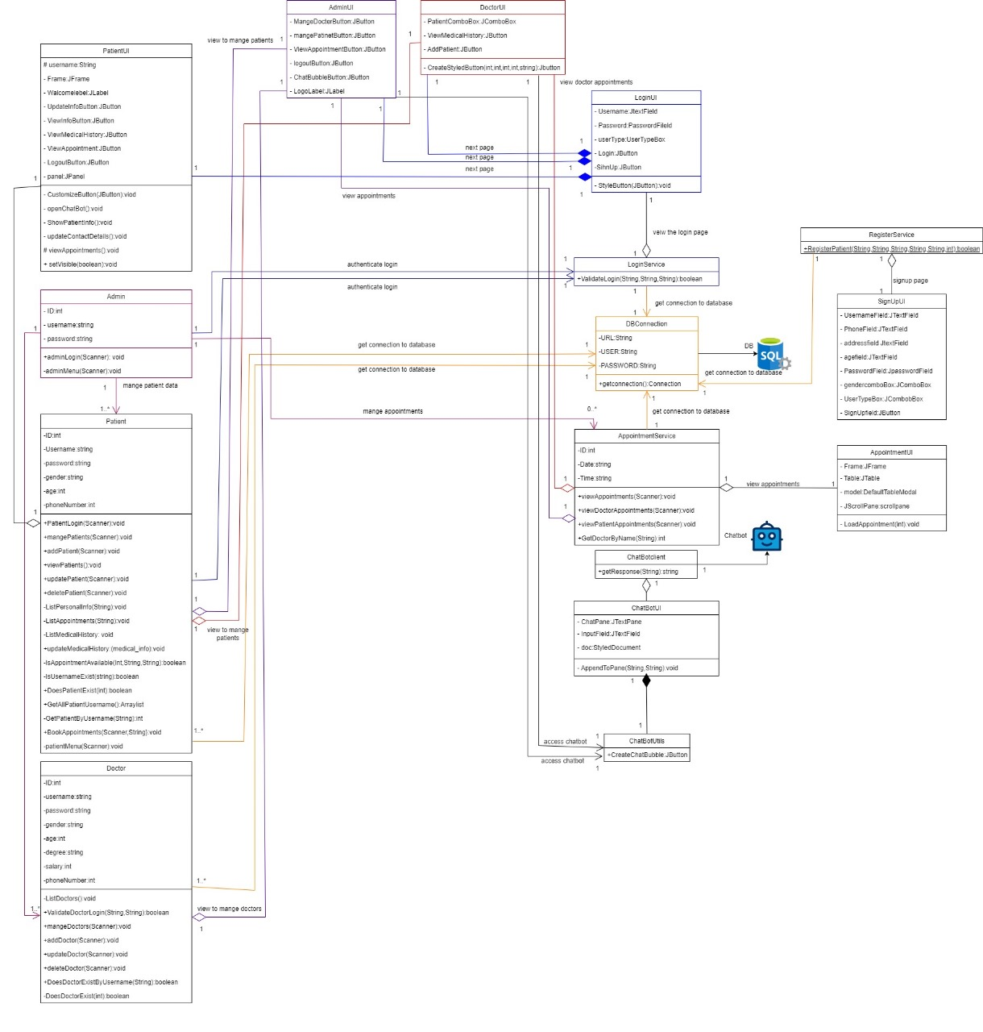
Class diagram High Quality : click the link and download Class diagram for High Quality{https://drive.google.com/file/d/1FkM8FV5xWTAh-qLEL0l2yT6RvccktvsK/view?usp=drive_link }

Detailed Explanation of the Class Diagram:
- Patient Class
  - Attributes:
    - username string
    - password string
    - name string
    - age int
    - gender string
    - phone string
    - address string
  - Methods:
    - signup() void
    - login() void
    - viewAppointment() void
    - bookAppointment() void
    - updateContact() void
    - viewMedicalHistory() void
    - logout() void

  - Explanation: The Patient class represents end users who interact with the system to manage their healthcare needs. The attributes align with REQ-2 (patient registration with basic information) and REQ-7 (updating personal info). Methods like bookAppointment() and viewMedicalHistory() support REQ-5 and REQ-6, enabling patients to schedule visits and access records. The signup() and login() methods tie into REQ-1 and REQ-8 for user authentication.

- Doctor Class
  - Attributes:
    - username string
    - password string
    - name string
    - age int
    - gender string
    - phone string
    - address string
    - specialty string
    - degree string
    - salary int

  - Methods:
    - login() void
    - viewAppointment() void
    - viewPatientDetails() void
    - manageMedicalReports() void
    - logout() void

  - Explanation: The Doctor class caters to healthcare providers, with additional attributes like specialty and degree to reflect their professional details. The viewAppointment() and viewPatientDetails() methods fulfill REQ-3 (accessing schedules and histories), while manageMedicalReports() supports REQ-6 (updating patient records). Authentication (REQ-8) is handled via login().

- Admin Class
  - Attributes:
    - username string
    - password string
    - name string

  - Methods:
    - login() void
    - managePatient() void
    - manageDoctor() void
    - viewAllAppointments() void
    - logout() void
  - Explanation: The Admin class is designed for hospital administrators, with methods like managePatient() and manageDoctor() addressing REQ-4 (managing users) and REQ-14 (restricting doctor profile changes to admins). viewAllAppointments() supports operational oversight, aligning with the administrator’s role in your stakeholder analysis.
- AppointmentService Class
  - Attributes:
    - date string
    - time string
  - Methods:
    - viewAppointment() void
    - getConnectionToDatabase() void

  - Explanation: This class manages appointment-related operations, central to REQ-5 (patient booking) and REQ-6 (doctor updates). The getConnectionToDatabase() method indicates integration with the database, ensuring data consistency as per REQ-10 (response time < 5 seconds).

- Chatbot Class
  - Attributes:
    - input string
    - output string
  - Methods:
    - chatbot() void
    - getResponse() void

  - Explanation: The Chatbot class implements REQ-9, providing triaging support. The input and output attributes facilitate user interaction, with getResponse() ensuring responses within 2 seconds (REQ-19). This enhances patient experience as outlined in the customer problem statement.
- LoginService Class
  - Attributes:
    - username string
    - password string
  - Methods:
    - authenticateLogin() void
    - getConnectionToDatabase() void

  - Explanation: This class handles user authentication (REQ-8) across all roles, ensuring secure access as mandated by REQ-12 and REQ-15 (encrypted communication). The database connection method supports centralized credential validation.

- DBConnection Class
  - Attributes:
    - (Implicitly manages connection details)
  - Methods:
    - getConnectionToDatabase() void

  - Explanation: As a singleton (per your design pattern section), this class ensures a single database connection instance, optimizing performance (REQ-10) and resource use. It interacts with all service classes, supporting data storage and retrieval as described in the activity diagram’s database swimlane.

Relationships:
- Patient to AppointmentService: A one-to-many relationship exists, as a patient can have multiple appointments (REQ-5). This is reflected by the association line connecting Patient to AppointmentService.

- Doctor to AppointmentService: A one-to-many relationship allows a doctor to manage multiple appointments, aligning with their schedule overview (REQ-3).

- Admin to Patient/Doctor: A many-to-many relationship (via managePatient() and manageDoctor()) enables admins to oversee all users, fulfilling REQ-4.

- AppointmentService to DBConnection: A dependency ensures database access for appointment data, supporting the relational model

- Chatbot to Patient: An association allows patients to interact with the chatbot, enhancing usability (REQ-16).

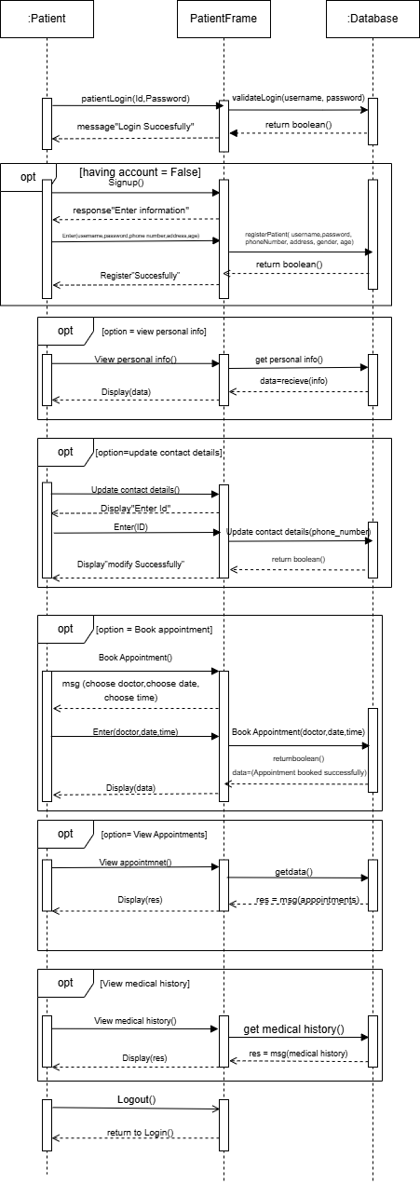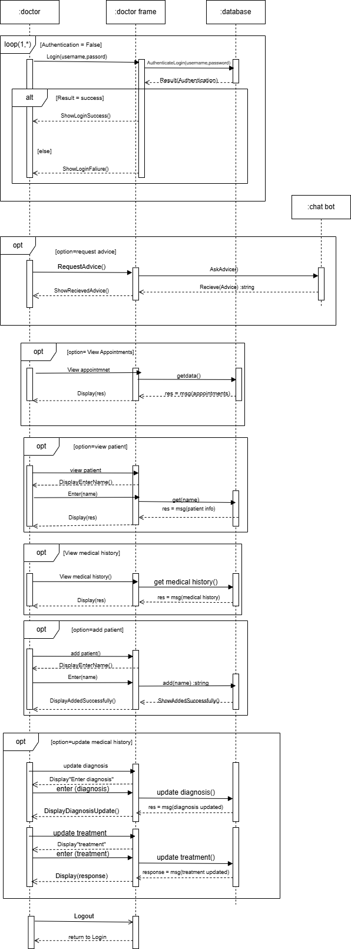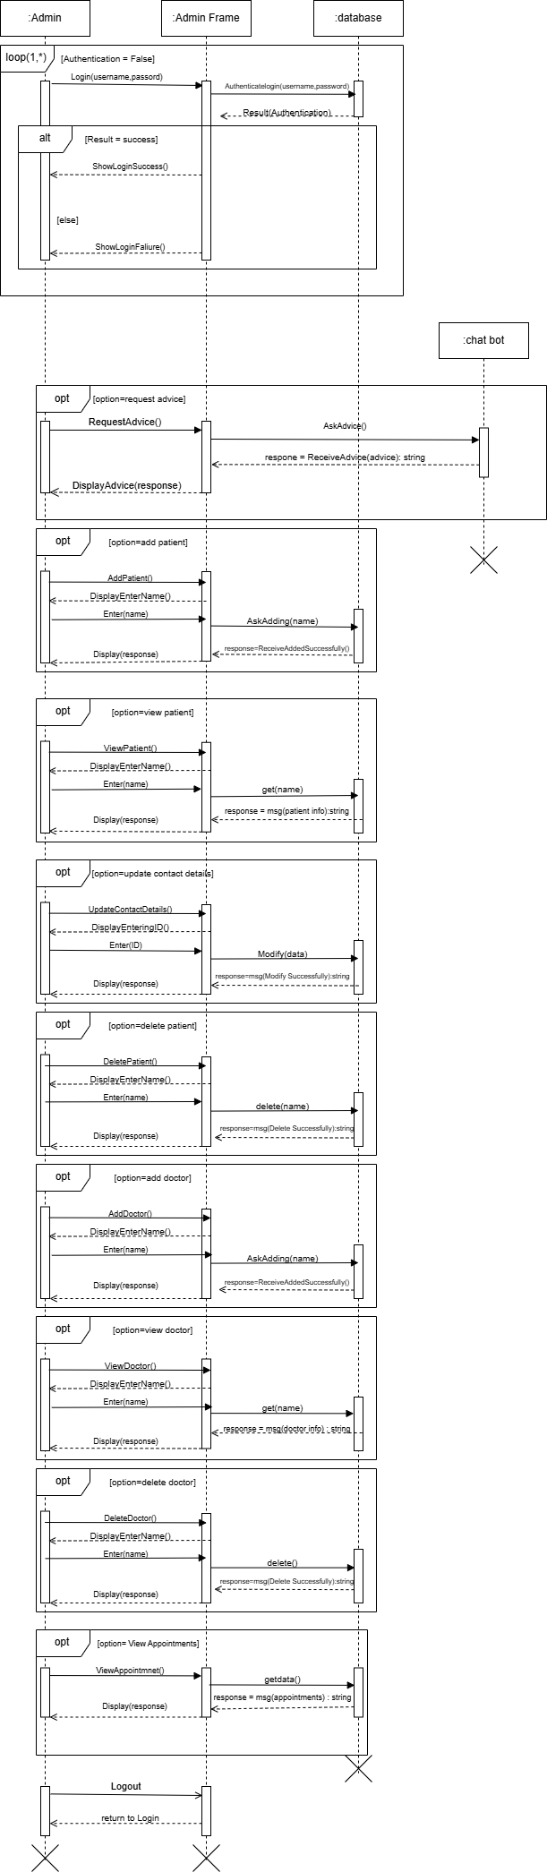

Detailed Description of the Sequence Diagram:
      - The sequence diagram presented in this section illustrates the dynamic behavior of the SHEFAA system from the perspective of a patient interacting with the system. It captures the sequence of messages exchanged between the Patient, PatientFrame, and Database actors during key operations, providing a step-by-step view of the patient workflow. This diagram is instrumental in understanding how the system processes user actions such as login, registration, appointment management, and data retrieval, aligning with the functional requirements outlined in Section 2.1 of this report.

Purpose and Scope:
The primary purpose of this sequence diagram is to model the patient’s interaction with the SHEFAA system, focusing on the core functionalities available to patients as defined by requirements REQ-1, REQ-2, REQ-5, REQ-6, and REQ-7. It serves as a blueprint for developers to implement the patient module and ensures that the system’s design supports a seamless user experience. The diagram is limited to patient-specific interactions and does not include flows for doctors, administrators, or the chatbot, which are covered in separate diagrams or planned for future documentation.

Structure and Actors:
The diagram is organized into three swimlanes, each representing a distinct layer of the system:
- Patient: The end-user initiating actions such as logging in, registering, or requesting data.

- PatientFrame: The intermediary layer, interpreted as the user interface or controller, responsible for processing patient inputs and coordinating with the database.
- Database: The data storage layer that handles validation, storage, and retrieval of patient-related information.

Flow of Interactions:
The sequence diagram is divided into several optional (opt) fragments, each representing a distinct patient action. The flow proceeds as follows:
- Login or Registration
  - If the patient has an account (having account = True), they initiate patient.login(id, password). The PatientFrame validates the credentials by calling validateLogin(username, password) on the Database, which returns a boolean() indicating success. Upon a successful validation, the PatientFrame sends a "messageLogin Successfully" back to the Patient.

  - If the patient does not have an account (having account = False), the Patient receives a "responseEnter information" prompt. They enter details (enter(username, password, phoneNumber, address, gender, age)), and the PatientFrame registers the patient by calling registerPatient(username, password, phoneNumber, address, gender, age) on the Database. A boolean() return value confirms registration success, and the Patient receives a "Register Successfully" message.

- View Personal Information
  - Under the option view personal info fragment, the Patient requests to view personal info(). The PatientFrame retrieves the data by calling get personal info() on the Database, which returns data=receive(info). The PatientFrame then displays the data to the Patient via display(data).

- Update Contact Details
  - In the option update contact details fragment, the Patient initiates update contact details(). The PatientFrame prompts with "displayEnter ID", and the Patient enters the details (enter(ID)). The PatientFrame updates the contact by calling update contact details(phoneNumber) on the Database, which returns a boolean(). A successful update triggers "displayModify Successfully" to the Patient.

- Book Appointment
  - Under the option Book appointment fragment, the Patient starts with book appointment(). They choose a doctor, date, and time (choose doctor, choose date, choose time), entering enter(doctor, date, time). The PatientFrame books the appointment by calling BookAppointment(doctor, date, time) on the Database, which returns data=appointment booked successfully and a boolean(). The PatientFrame then display(data) to confirm the booking.

- View Appointments
  - In the option View Appointments fragment, the Patient requests view appointment(). The PatientFrame retrieves the data by calling get data() on the Database, which returns res = msg.appointments(). The PatientFrame displays the results via display(res).

- View Medical History
  - Under the option view medical history fragment, the Patient initiates view medical history(). The PatientFrame retrieves the data by calling get medical history() on the Database, which returns res = msg.medical history(). The PatientFrame then display(res) to the Patient.

- Logout
  - Finally, the Patient triggers logout(), and the PatientFrame returns the user to the login screen with return to Login().

Alignment with Requirements:
This patient sequence diagram aligns with the following functional requirements:
- REQ-1: Users can sign up and log in (covered by the registration and login flows).
- REQ-2: Patients can register with basic information (implemented in the signup process).
- REQ-5: Patients can book and view appointments (supported by the booking and viewing flows).
- REQ-6: Patients can view medical history (reflected in the medical history flow).
- REQ-7: Patients can update personal information (implemented in the update contact details flow).
- REQ-8: Authentication is required (enforced by validateLogin).
It also supports non-functional requirements such as:
- REQ-10 (response time < 5 seconds, implied by direct database calls)
- REQ-16 (intuitive interface, through clear PatientFrame interactions).
.
4.5 Entity-Relationship Diagram (ERD)
The ERD defines the logical structure of the database and its entities.
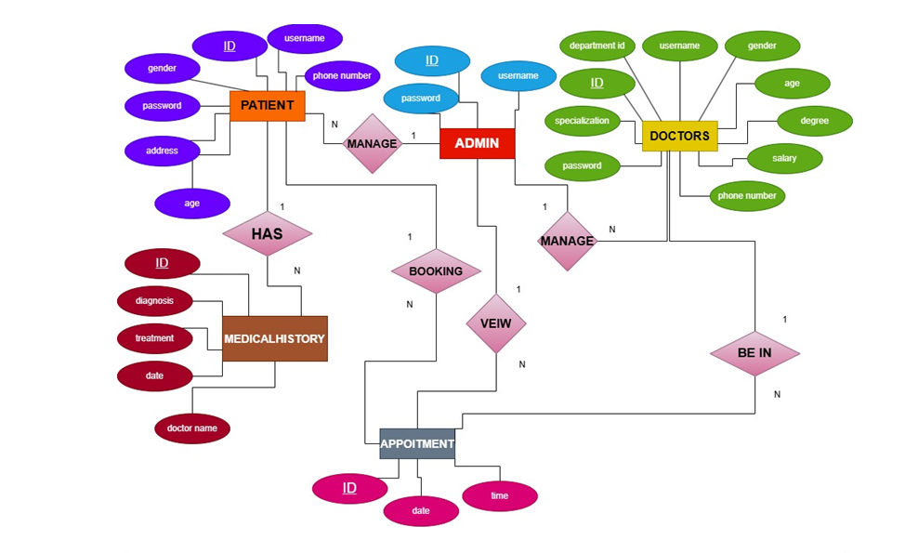

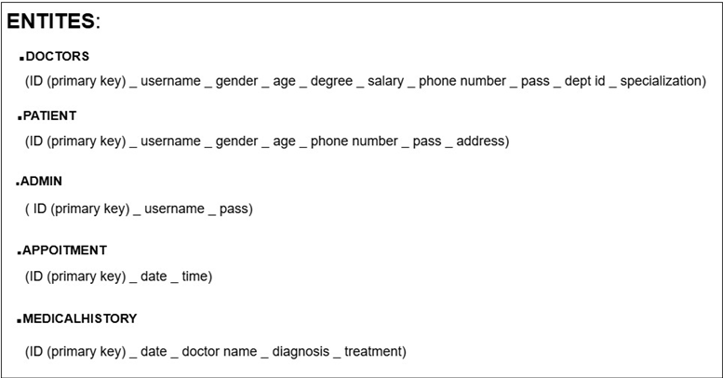

Relationships:
- A patient can have multiple appointments.

- A doctor can have many appointments and medical records.

- An appointment links one patient to one doctor.

- Admin manages doctors, patients and system logs.

4.6 Relational Model
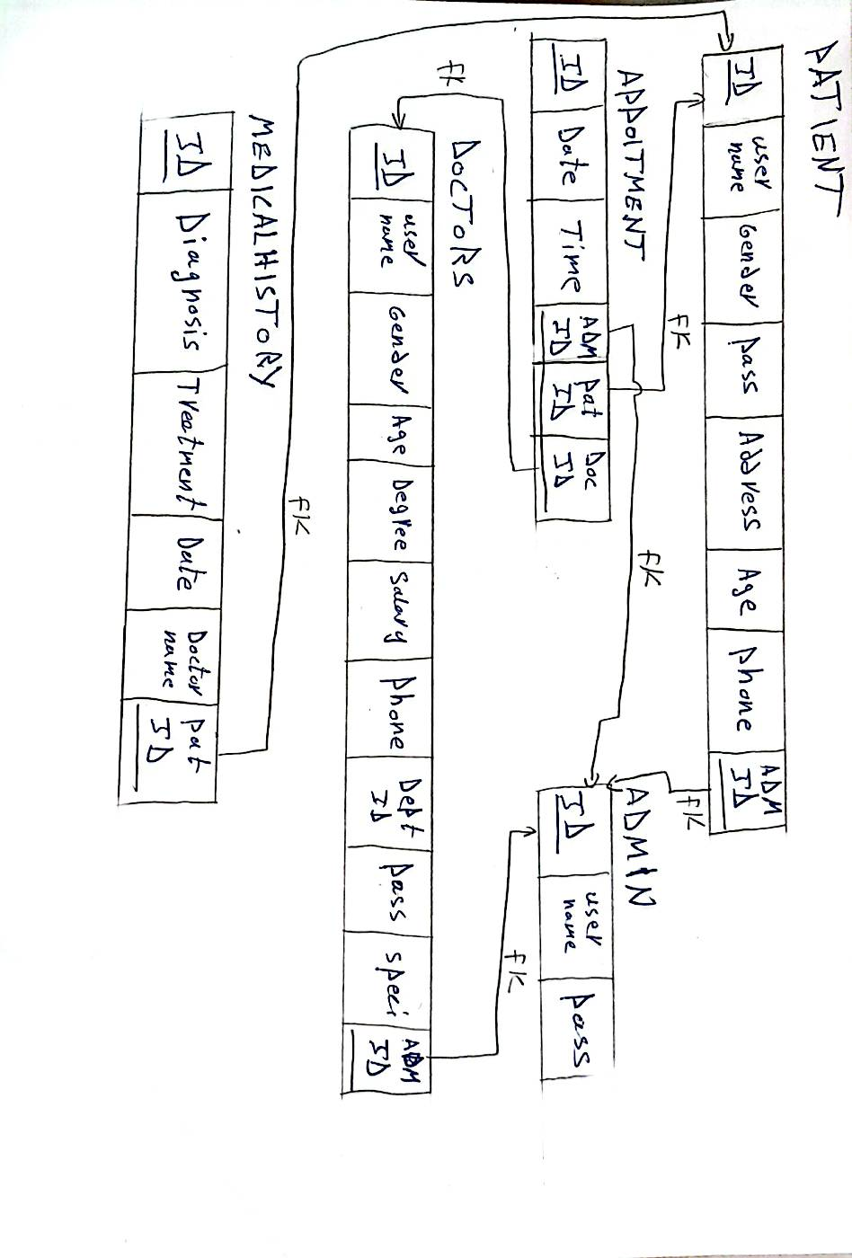
Doctor ID
Table Name | Attributes
Patients | PatientID (PK), User Name, Age, Gender, Phone, Address, password.
Doctors | DoctorID (PK), User Name, Age, Gender, Phone, Address, password, Specialty, phone
Appointments | AppointmentID (PK), PatientID (FK), DoctorID (FK), AdminID (FK), Date, Time.
Admin | AdminID (PK),User Name, Password
Medical History | RecordID (PK), PatientID (FK), DoctorID (FK), Diagnosis, Treatment, Date

4.7 Design Patterns
In designing the SHEFAA Hospital Management System, well-established software design patterns were utilized to promote modularity, maintainability, and reuse. One of the most prominent design patterns applied is the Singleton Pattern, which belongs to the creational category as classified by the Gang of Four (GoF) — the authors of “Design Patterns: Elements of Reusable Object-Oriented Software” (Gamma et al., 1994). In addition, a conceptual application of the Model-View-Controller (MVC) architectural pattern was followed to structure the system.

4.7.1 Singleton Pattern

Definition:
The Singleton Pattern ensures that a class has only one instance, and provides a global point of access to that instance. This is particularly useful when managing shared resources such as configuration files, logging systems, or database connections.

Application in SHEFAA:
The Singleton Pattern is implemented in the DBConnection class, which controls access to the SQL Server database. It guarantees that only one database connection instance is used system-wide by service classes like DoctorService, PatientService and AdminService.
Code Usage Example:
- class DBConnection:
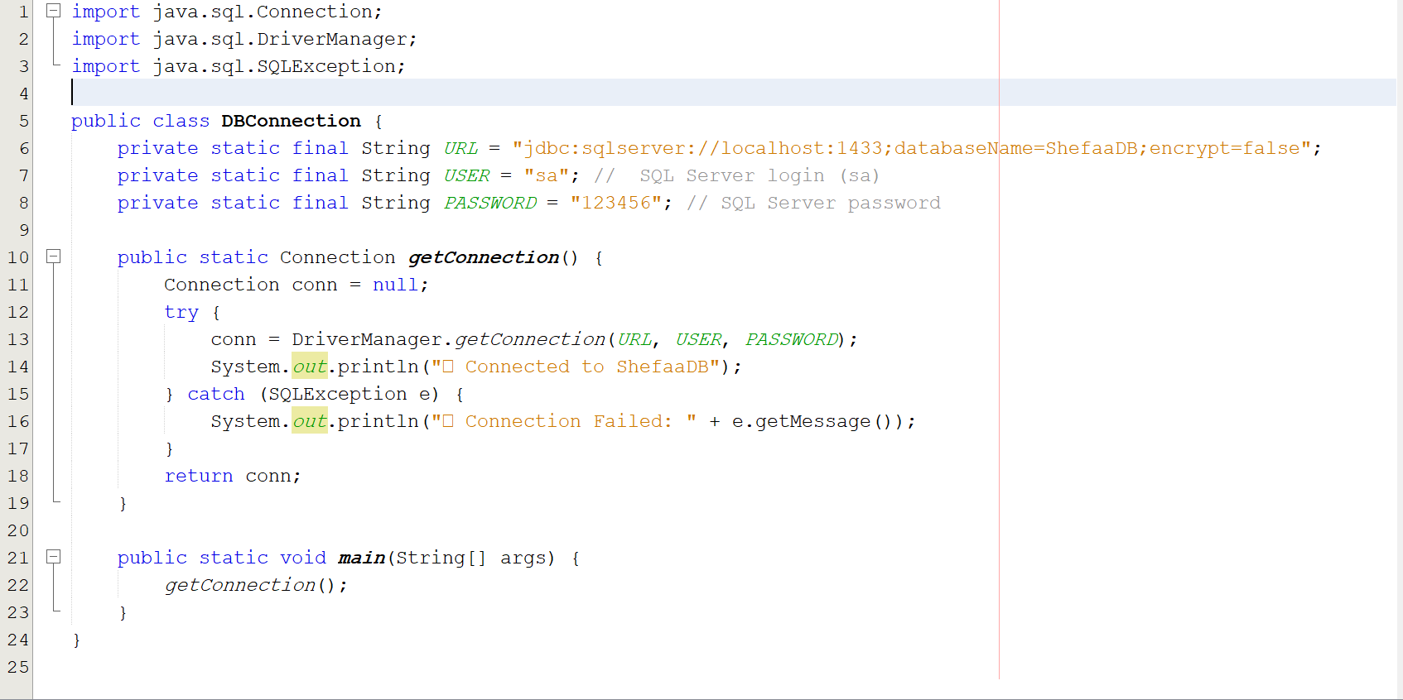
- Private constructor prevents external instantiation.
- Static method getConnection() returns the single instance.

Advantages | Disadvantages
Controlled Access to Shared Resource: All components share a single, consistent database connection. | Tight Coupling: Classes become dependent on the Singleton.
Improved Performance: Prevents unnecessary instantiation of connection objects. | Hidden Dependencies: Dependencies are less explicit.
Global Access Point: Easily accessed from any part of the system. | Concurrency Issues: Can cause race conditions if not thread-safe.
Resource Management: Reduces overhead in managing connections.

How Limitations Were Addressed
- The Singleton was written with lazy initialization and a static instance, suitable for the current single-threaded context.

- Responsibilities are separated: the DB Connection class handles only database access, while business logic is encapsulated in service classes.
- The design and usage of Singleton are clearly documented, ensuring transparency of dependencies.

4.7.2 MVC Architecture (Applied Conceptually)
The Model-View-Controller (MVC) architectural pattern was applied conceptually to maintain a clear separation of concerns:
- Model: Manages data access and business logic ( DB Connection, SQL operations).
- View: GUI elements such as Admin LoginFrame, Doctor LoginFrame, Patient dashboard, responsible for user interaction.
- Controller: Intermediaries like Admin Service and Doctor Service, which process input and connect the view with the model.
This separation enhances maintainability and supports future enhancements such as UI redesign or migration to web/mobile platforms.

4.8 Software Testing Strategy
Our testing approach was based on a combination of Test-Driven Development (TDD), black-box testing techniques, and white-box path coverage to validate the correctness, security, and usability of the system.

4.8.1 Testing Philosophy
Our development process was influenced by agile principles, where testing was conducted iteratively. In early development phases, we adopted prototyping and incremental testing, allowing us to test parts of the system as they were built.
We also applied Test-Driven Development (TDD) concepts, writing unit tests prior to implementing core functionalities, particularly in service classes such as LoginService and DBConnection.

4.8.2 Categories of Testing Applied
Testing Type | Purpose
Unit Testing | Validate individual components like login validation, DB queries
Integration Testing | Ensure modules like DoctorService interact correctly with the database
System Testing | Validate overall system behavior against requirements
Usability Testing | Informally tested the GUI (AdminLoginFrame) to ensure it is intuitive and functional
Regression Testing | After bug fixes and feature additions, previous functionality was re-tested

4.8.3 Techniques Used
- Black Box Testing
  - Equivalence Partitioning: Tested appointment booking with valid and invalid inputs.
  - Boundary Value Testing: Tested limits like age inputs (0, 1, 40,120, 121).
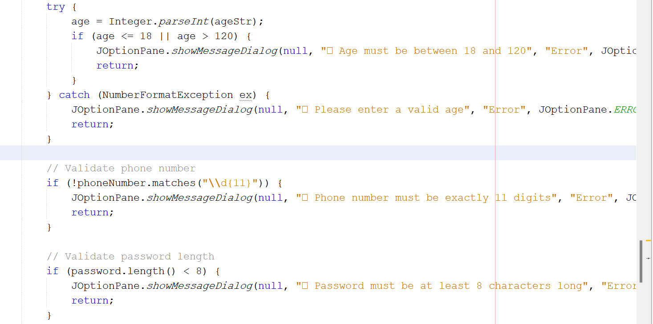
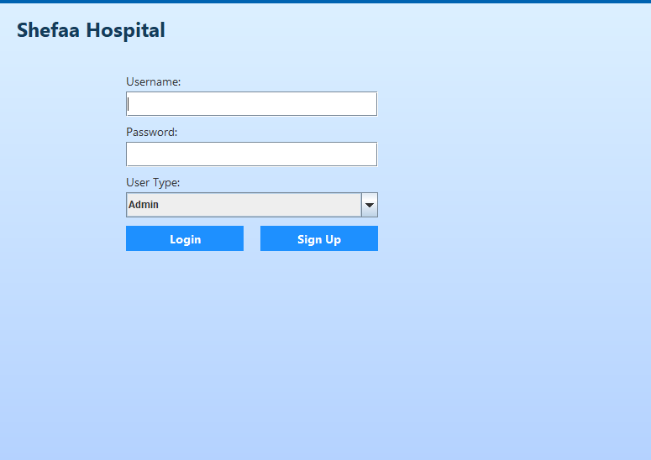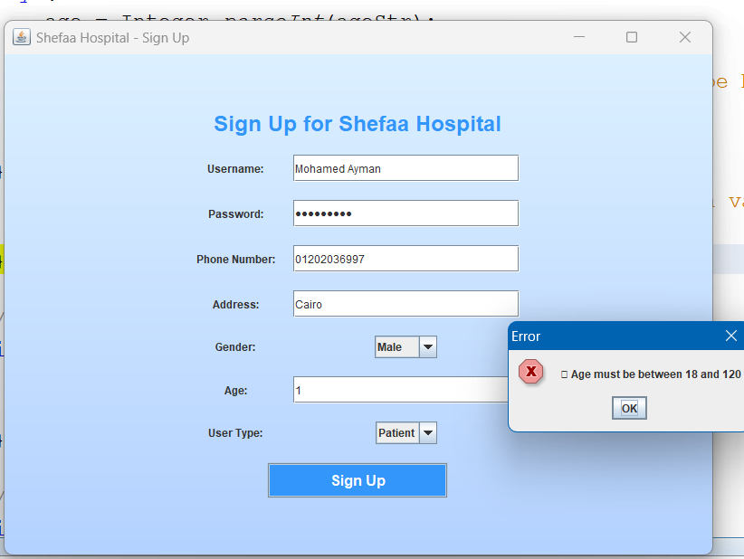

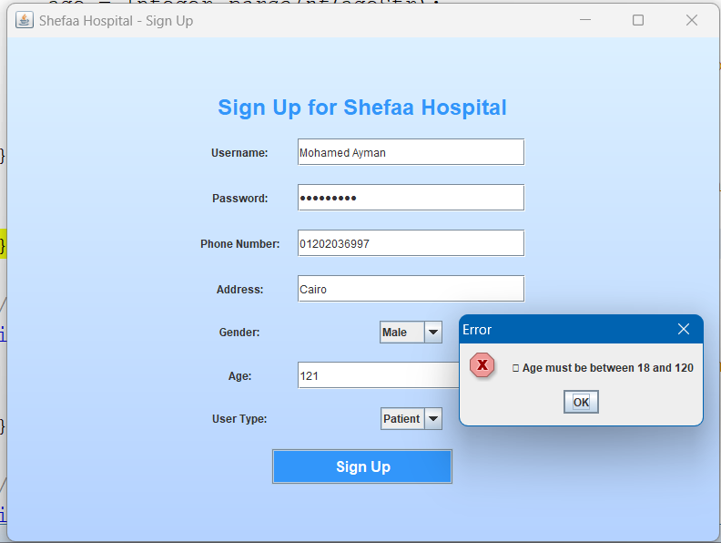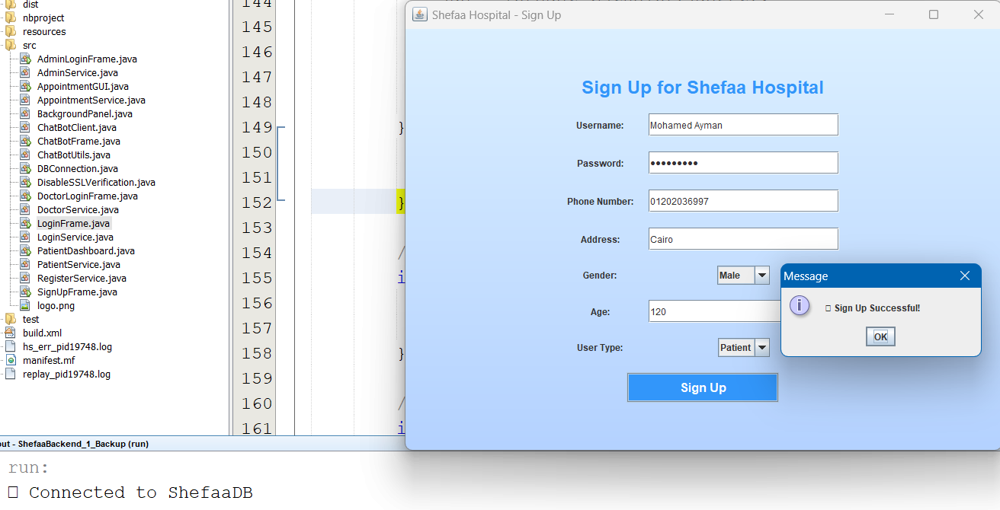

- White Box Testing
  - Path Testing was used to ensure every execution path in login logic and role-based access is covered.

4.8.4 Software Quality Factors
We considered the following key quality attributes (SQFs) as part of our testing objectives:
Factor | How It Was Ensured
Correctness | Verified against functional requirements and by validating expected outputs
Usability | Evaluated through informal GUI review and user interaction
Maintainability | Code was modular and commented for easier future modifications
Integrity | Role-based access control was tested to prevent unauthorized data access

5. System Evolution
The SHEFAA Hospital Management System has been designed with future scalability and enhancements in mind. While the initial version focuses on core hospital functions such as patient registration, appointment scheduling, and medical record management, there are planned improvements that will make the system even more intelligent and accessible.
5.1 Planned Future Enhancements
- AI-Based Patient Diagnosis:
          - Short-term (Phase 1, 6 months): Integrate a rule-based symptom checker using existing datasets

          - Long-term (Phase 2, 12–18 months): Train ML models on anonymized historical patient data for predictive diagnostics.

- Mobile Application Development:
- Priority: High (aligned with user demand).
- Timeline: MVP (3 months): Appointment booking/medical history access via React Native.
- Full rollout (9 months): Push notifications, telehealth integration.

- Telemedicine Integration:
- Dependencies: Secure API partnerships (e.g., Zoom Healthcare).
- Milestone: Pilot with 5 doctors within 4 months post-mobile app launch.

- Multi-Branch Support:
- Approach:
- Phase 1 (6 months): Extend database schema for BranchID and location-based access control.

- Phase 2 (12 months): Cloud migration (AWS/Azure) for centralized scaling.

- Smart Report Generation:
- Tools: JasperReports or Power BI embedded for admins.
- Release: Beta version in Phase 1, finalized in Phase 2.

- Multi-Language/Accessibility:
- Immediate Action: Add Arabic/English toggle (3 months).
- WCAG Compliance: Audit scheduled for Q3 2025.
5.2 Roadmap Visualization
Feature | Phase | Timeline | Dependencies
AI Symptom Checker | 1 | 2025 Q4 | Historical data collection
Mobile App MVP | 1 | 2025 Q3 | UI/UX finalization
Telemedicine Pilot | 2 | 2026 Q1 | API partnerships
5.3 Risk Mitigation
- AI Diagnostics: Start with low-risk non-critical advice ("consult a doctor for persistent fever").
- Data Security: Partner with HIPAA/GDPR-compliant vendors for telemedicine.

6. References
The following resources were used to guide the development and documentation of the SHEFAA Hospital Management System:
- "Hospital Management System: A Case Study of Bagamoyo District Hospital" – Academia.edu
https://www.academia.edu/39902772/HOSPITAL_MANAGEMENT_SYSTEM_A_CASE_STUDY_OF_BAGAMOYO_DISTRIC_HOSPITAL
- "Transforming Healthcare with Digital Innovation: Al Azhar Hospital Case Study" – Avicenna Health
https://avicenna-health.ai/case-studies

- SQL Server Documentation – Microsoft Docs
https://learn.microsoft.com/en-us/sql/sql-server

- Gamma, E., Helm, R., Johnson, R., & Vlissides, J. (1994). Design Patterns: Elements of Reusable Object-Oriented Software. Addison-Wesley. { Design Patterns Elements of Reusable Object-Oriented Software } , pages : from 127 to 133

