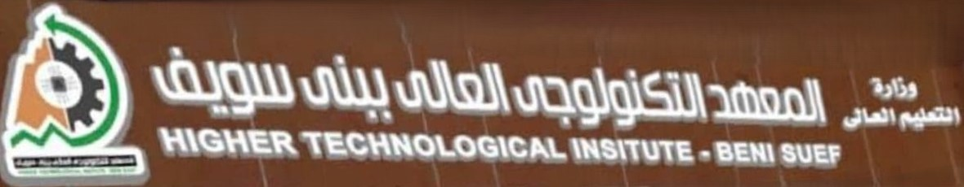

**Dr. Hatem Ahmed**

**Auto Repair Center**

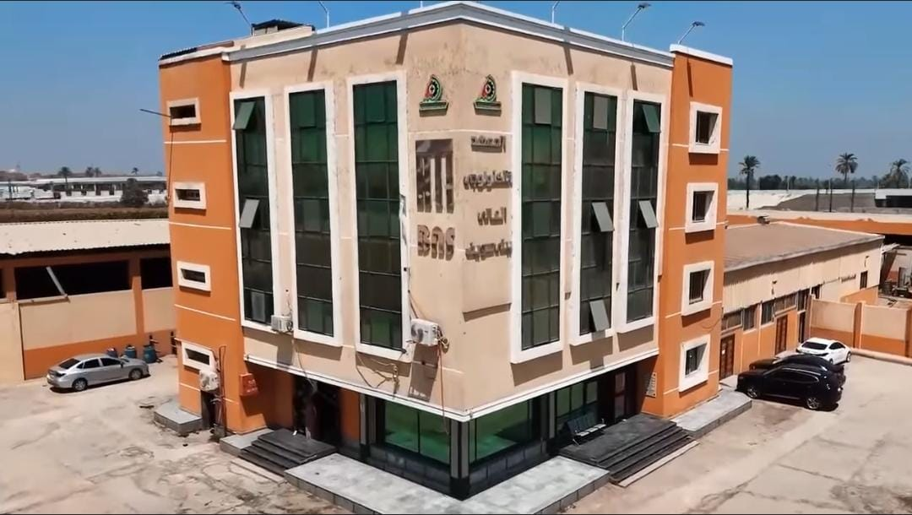



**Auto Repair Center**

**Team Members:**

|  |  |
| --- | --- |
| * Mohamed Nady | * Mohamed Walid |
| * Tarek Moawad | * **Nader Ahmed** |
| * Mustafa Sholkamy | * **Mohamed Shehata** |
| * Abdelrahman Essam | * **Omer Ahmed** |
| * Mohamed Ashraf | * **Mohamed Eid** |

**Project Supervisor:**

**Dr. Hatem Ahmed**

**Eng. Mariam Mohamed**

Project report submitted to the Higher Technological Institute for the degree of Bachelor of programming

June 2025