AIE425 Intelligent Recommender Systems, Fall Semester 24/25

Assignment #2: Significance Weighting-based Neighborhood CF Filters

A20000755, Mohamed Ayman Elnakshbandy

1. **Introduction**

Recommender systems play an important role in numerous applications, from online shopping to content streaming services, because they provide personalized recommendations according to the user's taste. Among the various methods employed in building recommender systems, Collaborative Filtering (CF) is considered the most popular approach to effectively estimate missing ratings or suggest items based on user-item interactions. This report investigates the roles that weighting schemes play in various recommender system performance with particular emphasis on user- and item-based collaborative filtering.

Two main parts are included in the assignment. Part 1 presents a report on the impact of different weighing schemes on the performance of collaborative filtering, user-based CF, for short. It may involve applying different algorithms like Cosine similarity and Pearson Correlation Coefficient for the computation of similarities between active users and other users. Besides, in some cases, bias adjustment effects are made, such as mean-centering, to see how they reflect on the recommendations. The tasks involved in the analysis include the determination of top closest users, computation of predictions for active users, and discount factors application for refining the measures of similarity.

Part 2 focuses on item-based collaborative filtering, exploring the impact of weighting schemes on item similarity and recommendation accuracy. This part develops Cosine similarity and Pearson Correlation Coefficient (PCC) for computing item-item similarities, considering bias-adjusted and non-bias-adjusted variants of each. As in Part 1, discount factors will be applied to evaluate their impact on the prediction of missing ratings for target items.

This report compares the results of various case studies in both user-based and item-based CF to provide insight into the performance of different weighting schemes and their practical implications for improving the recommendation accuracy of collaborative filtering systems.

1. **Outcomes of Section 3.1:**

Total number of users (tnu): 100

Total number of items (tni): 500

Ratings per item:

0 96

1 97

2 95

3 97

4 95

..

495 95

496 97

497 97

498 93

499 97

Length: 500, dtype: int64

Active users: U1=User_1, U2=User_8, U3=User_40

Target items: I1=1, I2=160

No_common_users: U1=484, U2=469, U3=472

No_coRated_items: U1=470, U2=470, U3=484

2-D array:

[[484 470]

[469 470]

[472 484]]

Thresholds: U1=500, U2=500, U3=500

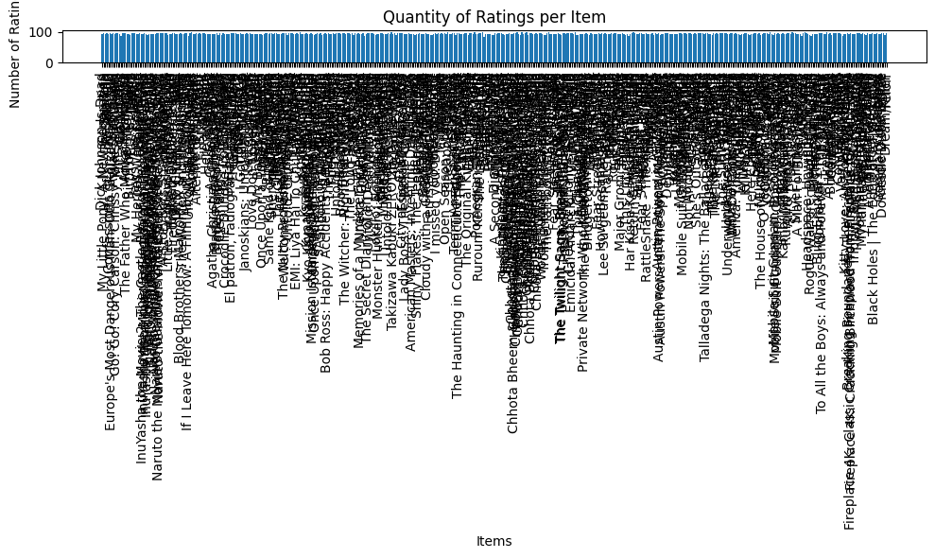

1. **Summary of the Comparison of part 1 and 2:**

* **Part1 (Case 1.1) :**

Total number of users (tnu): 100

Total number of items (tni): 500

Ratings per item:

0 96

1 97

2 95

3 97

4 95

..

495 95

496 97

497 97

498 93

499 97

Length: 500, dtype: int64

Active users: U1=User_1, U2=User_8, U3=User_40

Target items: I1=1, I2=160

No_common_users: U1=484, U2=469, U3=472

No_coRated_items: U1=470, U2=470, U3=484

2-D array:

[[484 470]

[469 470]

[472 484]]

Thresholds: U1=500, U2=500, U3=500

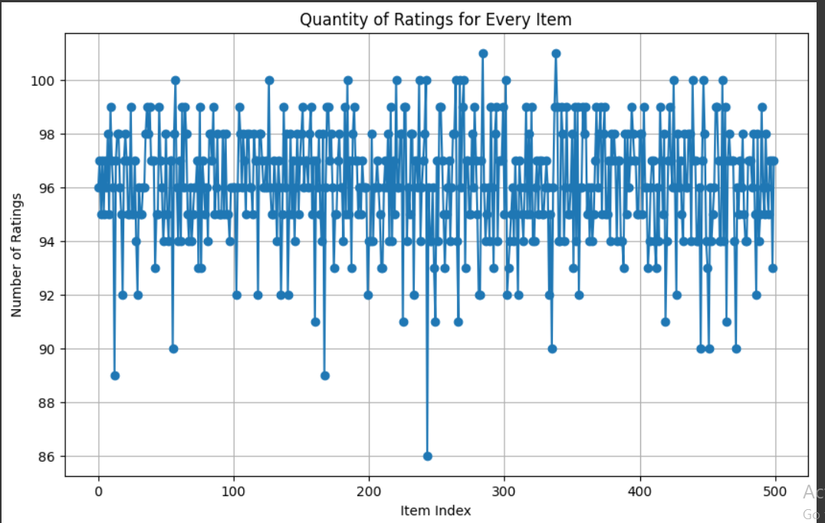

* **Part1 (case 1.2):**

Comparison of top users:

{0: {'original': array([98, 19, 39, 30, 22, 29, 18, 1, 99, 58, 55, 51, 15, 35, 83, 69, 88,

45, 46, 59]), 'discounted': array([36, 26, 27, 28, 29, 30, 31, 32, 33, 34, 35, 37, 98, 38, 39, 40, 41,

42, 43, 44])}, 1: {'original': array([77, 29, 68, 98, 19, 99, 21, 32, 44, 86, 65, 10, 14, 72, 50, 41, 30,

78, 97, 69]), 'discounted': array([36, 26, 27, 28, 29, 30, 31, 32, 33, 34, 35, 37, 98, 38, 39, 40, 41,

42, 43, 44])}, 2: {'original': array([31, 63, 69, 74, 8, 46, 65, 51, 42, 21, 10, 98, 93, 45, 39, 81, 7,

56, 19, 15]), 'discounted': array([36, 26, 27, 28, 29, 30, 31, 32, 33, 34, 35, 37, 98, 38, 39, 40, 41,

42, 43, 44])}}

Comparison of predictions:

{(0, 'My Little Pony: A New Generation'): {'original': 2.686739995004316, 'discounted': 0}, (0, 'Minsara Kanavu'): {'original': 2.685793664382083, 'discounted': 0}, (0, 'Naruto Shippuden: The Movie: The Lost Tower'): {'original': 3.000786959443743, 'discounted': 0}, (0, 'Blood Brothers: Malcolm X & Muhammad Ali'): {'original': 2.8498715257116403, 'discounted': 0}, (0, 'Shikara'): {'original': 3.1017367242765106, 'discounted': 0}, (0, 'SAS: Rise of the Black Swan'): {'original': 3.2088584642363633, 'discounted': 0}, (0, 'Shootout at Lokhandwala'): {'original': 2.7220991329653903, 'discounted': 0}, (0, 'Boomika (Telugu)'): {'original': 3.099814601414839, 'discounted': 0}, (0, 'The Edge of Seventeen'): {'original': 2.4516029791505862, 'discounted': 0}, (0, 'The Last Mercenary'): {'original': 2.8972665063536733, 'discounted': 0}, (0, 'Hostage House'): {'original': 2.9521462544174053, 'discounted': 0}, (0, 'Mimi'): {'original': 2.6633428309746665, 'discounted': 0}, (0, 'Chhota Bheem & Krishna: Mayanagari'): {'original': 2.776032148844943, 'discounted': 0}, (0, 'A Classic Horror Story'): {'original': 2.8923064724260206, 'discounted': 0}, (0, 'American Ultra'): {'original': 2.774361245071103, 'discounted': 0}, (0, 'Home Again'): {'original': 2.8538796504013426, 'discounted': 0}, (0, 'Life as We Know It'): {'original': 2.6027940945980266, 'discounted': 0}, (0, 'The Karate Kid Part III'): {'original': 3.2648680106633803, 'discounted': 0}, (0, 'Wanted'): {'original': 2.4034310432080153, 'discounted': 0}, (0, 'Into the Wind'): {'original': 3.2977726715685907, 'discounted': 0}, (0, 'Red Snow'): {'original': 2.7446295822200826, 'discounted': 0}, (0, 'Security'): {'original': 2.9427824589803127, 'discounted': 0}, (0, 'Blind Intersections'): {'original': 2.841579155299774, 'discounted': 0}, (0, 'Confusion Na Wa'): {'original': 3.158487723961323, 'discounted': 0}, (0, 'Vampire Academy'): {'original': 3.888913482510453, 'discounted': 0}, (0, 'Breaking Boundaries: The Science Of Our Planet'): {'original': 3.328635661134318, 'discounted': 0}, (0, 'Sweet & Sour'): {'original': 2.890165317636734, 'discounted': 0}, (0, 'American Outlaws'): {'original': 2.7186995102652864, 'discounted': 0}, (0, 'Dream/Killer'): {'original': 3.2911449909235455, 'discounted': 0}, (0, 'Felon'): {'original': 2.950837942365837, 'discounted': 0}, (1, 'Birth of the Dragon'): {'original': 3.5616906733190143, 'discounted': 0}, (1, 'Jaws: The Revenge'): {'original': 3.2772551293537324, 'discounted': 0}, (1, 'Naruto Shippûden the Movie: Bonds'): {'original': 3.209886567803693, 'discounted': 0}, (1, 'Naruto Shippûden the Movie: The Will of Fire'): {'original': 2.3665984720576043, 'discounted': 0}, (1, 'A StoryBots Space Adventure'): {'original': 2.8933294737294064, 'discounted': 0}, (1, 'Do the Right Thing'): {'original': 2.5552380194349067, 'discounted': 0}, (1, 'Like Crazy'): {'original': 2.9029572915972324, 'discounted': 0}, (1, "Lokillo: Nothing's the Same"): {'original': 3.097391017994854, 'discounted': 0}, (1, 'La diosa del asfalto'): {'original': 3.25010388509211, 'discounted': 0}, (1, 'Boyka: Undisputed'): {'original': 2.6311481927695435, 'discounted': 0}, (1, 'My Girl'): {'original': 2.750445339662618, 'discounted': 0}, (1, 'Bridgerton - The Afterparty'): {'original': 2.9426647092390263, 'discounted': 0}, (1, 'Ujala'): {'original': 2.8416684146013544, 'discounted': 0}, (1, 'RattleSnake - The Ahanna Story'): {'original': 2.894619805820984, 'discounted': 0}, (1, 'Fatherhood'): {'original': 2.8990257953042606, 'discounted': 0}, (1, 'Dream/Killer'): {'original': 2.8914025893262965, 'discounted': 0}, (2, 'Minsara Kanavu'): {'original': 2.7903927601046816, 'discounted': 0}, (2, 'My Heroes Were Cowboys'): {'original': 3.2511019292423216, 'discounted': 0}, (2, 'Show Dogs'): {'original': 2.9982907957621614, 'discounted': 0}, (2, 'Afterlife of the Party'): {'original': 2.6106700782280403, 'discounted': 0}, (2, 'Blade Runner: The Final Cut'): {'original': 2.998872845462948, 'discounted': 0}, (2, 'House Party 3'): {'original': 3.248057423422027, 'discounted': 0}, (2, 'Mystery Men'): {'original': 2.387774137096516, 'discounted': 0}, (2, 'Osmosis Jones'): {'original': 2.631495722927975, 'discounted': 0}, (2, 'Thimmarusu'): {'original': 3.4228256748903867, 'discounted': 0}, (2, 'Walk of Shame'): {'original': 2.6858084800020126, 'discounted': 0}, (2, 'The Kissing Booth 3'): {'original': 3.157039261375185, 'discounted': 0}, (2, 'Aftermath'): {'original': 2.9453535512239597, 'discounted': 0}, (2, 'American Masters: Inventing David Geffen'): {'original': 3.600264351303524, 'discounted': 0}, (2, "Ferris Bueller's Day Off"): {'original': 2.2768795914125035, 'discounted': 0}, (2, 'Pineapple Express'): {'original': 2.6496502876028307, 'discounted': 0}, (2, 'The Last Boy Scout'): {'original': 2.4999289224506156, 'discounted': 0}, (2, "I'm Glad I Did"): {'original': 2.7356813789356926, 'discounted': 0}, (2, 'Chhota Bheem: The Rise of Kirmada'): {'original': 2.947247309641111, 'discounted': 0}, (2, 'Home Again'): {'original': 3.103866479604558, 'discounted': 0}, (2, 'Therapy'): {'original': 2.887632109734, 'discounted': 0}, (2, 'This Little Love Of Mine'): {'original': 2.4474892940729975, 'discounted': 0}, (2, 'Snowpiercer'): {'original': 2.8935730750324713, 'discounted': 0}, (2, 'Mobile Suit Gundam Hathaway'): {'original': 2.6988852250092945, 'discounted': 0}, (2, 'Stuart Little'): {'original': 2.9467695335288298, 'discounted': 0}, (2, 'The Karate Kid'): {'original': 2.9994662985468303, 'discounted': 0}, (2, 'Osuofia in London II'): {'original': 2.786604374161411, 'discounted': 0}, (2, '#Selfie'): {'original': 3.1531795431076826, 'discounted': 0}, (2, 'Love Is a Story'): {'original': 3.0005709551616224, 'discounted': 0}, (2, 'Fan Girl'): {'original': 3.2626055446506337, 'discounted': 0}, (2, 'Blind Intersections'): {'original': 2.83452811728366, 'discounted': 0}, (2, 'Copenhagen'): {'original': 2.7498017266563948, 'discounted': 0}}

* **Part1 (case 1.2):**

Top 20% closest users:

{'U1': User_99 0.119793

User_67 0.107222

User_97 0.094250

User_31 0.092640

User_60 0.079520

User_63 0.075854

User_16 0.069874

User_33 0.066227

User_30 0.062704

User_20 0.059321

User_46 0.052048

User_85 0.049999

User_28 0.046394

User_23 0.044990

User_56 0.043341

User_40 0.041916

User_42 0.036981

User_59 0.035347

User_45 0.034992

User_66 0.033878

Name: User_1, dtype: float64, 'U2': User_78 0.097447

User_73 0.092305

User_27 0.091883

User_80 0.091356

User_20 0.083421

User_11 0.076755

User_45 0.075205

User_86 0.071092

User_69 0.067747

User_85 0.061076

User_13 0.055593

User_9 0.049281

User_33 0.047518

User_66 0.047062

User_99 0.045792

User_32 0.045378

User_68 0.042358

User_87 0.041278

User_6 0.038060

User_30 0.037589

Name: User_2, dtype: float64, 'U3': User_32 0.104225

User_9 0.094014

User_34 0.091141

User_6 0.086958

User_40 0.086768

User_43 0.081254

User_11 0.073491

User_57 0.071954

User_64 0.065808

User_47 0.065308

User_27 0.059973

User_42 0.059236

User_70 0.058339

User_50 0.056220

User_29 0.056112

User_5 0.053872

User_38 0.050212

User_54 0.050208

User_48 0.047743

User_82 0.046565

Name: User_3, dtype: float64}

Predictions without discount factor:

{'U1': {'My Little Pony: A New Generation': 2.5473852700574082, 'Minsara Kanavu': 3.18658589889658, 'Naruto Shippuden: The Movie: The Lost Tower': 3.7791608353038533, 'Blood Brothers: Malcolm X & Muhammad Ali': 3.26038859461561, 'Shikara': 3.0469044589560768, 'SAS: Rise of the Black Swan': 3.137106177738438, 'Shootout at Lokhandwala': 2.8667130244834427, 'Boomika (Telugu)': 3.049175354374597, 'The Edge of Seventeen': 2.66950074715775, 'The Last Mercenary': 2.5462568571403086, 'Hostage House': 2.967501152768899, 'Mimi': 3.138227852151244, 'Chhota Bheem & Krishna: Mayanagari': 3.2434129194238994, 'A Classic Horror Story': 2.7104099007035694, 'American Ultra': 2.664982182032401, 'Home Again': 3.2980146788125624, 'Life as We Know It': 3.0532950644070205, 'The Karate Kid Part III': 3.0131963652870835, 'Wanted': 2.9913863433316097, 'Into the Wind': 3.125233849318089, 'Red Snow': 2.608518162863933, 'Security': 2.657094916293736, 'Blind Intersections': 3.0023504780058117, 'Confusion Na Wa': 3.0539497899941956, 'Vampire Academy': 3.6604760829282856, 'Breaking Boundaries: The Science Of Our Planet': 2.7081983632158884, 'Sweet & Sour': 2.8863999591592227, 'American Outlaws': 2.9409283871565903, 'Dream/Killer': 3.0442318919256985, 'Felon': 2.548930589624193}, 'U2': {'Birth of the Dragon': 3.302324000870448, 'Jaws: The Revenge': 3.1248903743696497, 'Naruto Shippûden the Movie: Bonds': 2.98015420794767, 'Naruto Shippûden the Movie: The Will of Fire': 2.786509173941347, 'A StoryBots Space Adventure': 3.0700161284953498, 'Do the Right Thing': 2.840308598253057, 'Like Crazy': 2.953963906052174, "Lokillo: Nothing's the Same": 3.450180004773377, 'La diosa del asfalto': 3.0587447860086274, 'Boyka: Undisputed': 2.952748847690813, 'My Girl': 2.868667073088449, 'Bridgerton - The Afterparty': 2.5158902044351317, 'Ujala': 3.153546666804399, 'RattleSnake - The Ahanna Story': 2.633072836569922, 'Fatherhood': 2.9054620249078984, 'Dream/Killer': 3.064004252174879}, 'U3': {'Minsara Kanavu': 3.4605917907539476, 'My Heroes Were Cowboys': 3.0628698151062235, 'Show Dogs': 3.072268144270028, 'Afterlife of the Party': 2.937748256886967, 'Blade Runner: The Final Cut': 3.1841160397995223, 'House Party 3': 3.4523628205306682, 'Mystery Men': 2.41767932187945, 'Osmosis Jones': 2.5815055376293943, 'Thimmarusu': 3.7681958790016905, 'Walk of Shame': 2.779415661542934, 'The Kissing Booth 3': 2.807318047203282, 'Aftermath': 3.2941015712957573, 'American Masters: Inventing David Geffen': 3.425567280181727, "Ferris Bueller's Day Off": 2.89327613086676, 'Pineapple Express': 3.1923765526342356, 'The Last Boy Scout': 2.5994923240760754, "I'm Glad I Did": 2.9532021387917013, 'Chhota Bheem: The Rise of Kirmada': 3.334907726821091, 'Home Again': 3.095158602240399, 'Therapy': 3.2588126016602748, 'This Little Love Of Mine': 2.8662249630331975, 'Snowpiercer': 2.6282321869187792, 'Mobile Suit Gundam Hathaway': 3.334428291760581, 'Stuart Little': 3.064780835671094, 'The Karate Kid': 3.226584414145062, 'Osuofia in London II': 2.7388541837059734, '#Selfie': 3.967529042637176, 'Love Is a Story': 2.538478873583926, 'Fan Girl': 3.2144464313410577, 'Blind Intersections': 3.673183696088357, 'Copenhagen': 3.1039107653908817}}

Predictions with discount factor:

{'U1': {'My Little Pony: A New Generation': 2.5473852700574082, 'Minsara Kanavu': 3.18658589889658, 'Naruto Shippuden: The Movie: The Lost Tower': 3.7791608353038533, 'Blood Brothers: Malcolm X & Muhammad Ali': 3.26038859461561, 'Shikara': 3.0469044589560768, 'SAS: Rise of the Black Swan': 3.137106177738438, 'Shootout at Lokhandwala': 2.8667130244834427, 'Boomika (Telugu)': 3.049175354374597, 'The Edge of Seventeen': 2.66950074715775, 'The Last Mercenary': 2.5462568571403086, 'Hostage House': 2.967501152768899, 'Mimi': 3.138227852151244, 'Chhota Bheem & Krishna: Mayanagari': 3.2434129194238994, 'A Classic Horror Story': 2.7104099007035694, 'American Ultra': 2.664982182032401, 'Home Again': 3.2980146788125624, 'Life as We Know It': 3.0532950644070205, 'The Karate Kid Part III': 3.0131963652870835, 'Wanted': 2.9913863433316097, 'Into the Wind': 3.125233849318089, 'Red Snow': 2.608518162863933, 'Security': 2.657094916293736, 'Blind Intersections': 3.0023504780058117, 'Confusion Na Wa': 3.0539497899941956, 'Vampire Academy': 3.6604760829282856, 'Breaking Boundaries: The Science Of Our Planet': 2.7081983632158884, 'Sweet & Sour': 2.8863999591592227, 'American Outlaws': 2.9409283871565903, 'Dream/Killer': 3.0442318919256985, 'Felon': 2.548930589624193}, 'U2': {'Birth of the Dragon': 3.302324000870448, 'Jaws: The Revenge': 3.1248903743696497, 'Naruto Shippûden the Movie: Bonds': 2.98015420794767, 'Naruto Shippûden the Movie: The Will of Fire': 2.786509173941347, 'A StoryBots Space Adventure': 3.0700161284953498, 'Do the Right Thing': 2.840308598253057, 'Like Crazy': 2.953963906052174, "Lokillo: Nothing's the Same": 3.450180004773377, 'La diosa del asfalto': 3.0587447860086274, 'Boyka: Undisputed': 2.952748847690813, 'My Girl': 2.868667073088449, 'Bridgerton - The Afterparty': 2.5158902044351317, 'Ujala': 3.153546666804399, 'RattleSnake - The Ahanna Story': 2.633072836569922, 'Fatherhood': 2.9054620249078984, 'Dream/Killer': 3.064004252174879}, 'U3': {'Minsara Kanavu': 3.4605917907539476, 'My Heroes Were Cowboys': 3.0628698151062235, 'Show Dogs': 3.072268144270028, 'Afterlife of the Party': 2.937748256886967, 'Blade Runner: The Final Cut': 3.1841160397995223, 'House Party 3': 3.4523628205306682, 'Mystery Men': 2.41767932187945, 'Osmosis Jones': 2.5815055376293943, 'Thimmarusu': 3.7681958790016905, 'Walk of Shame': 2.779415661542934, 'The Kissing Booth 3': 2.807318047203282, 'Aftermath': 3.2941015712957573, 'American Masters: Inventing David Geffen': 3.425567280181727, "Ferris Bueller's Day Off": 2.89327613086676, 'Pineapple Express': 3.1923765526342356, 'The Last Boy Scout': 2.5994923240760754, "I'm Glad I Did": 2.9532021387917013, 'Chhota Bheem: The Rise of Kirmada': 3.334907726821091, 'Home Again': 3.095158602240399, 'Therapy': 3.2588126016602748, 'This Little Love Of Mine': 2.8662249630331975, 'Snowpiercer': 2.6282321869187792, 'Mobile Suit Gundam Hathaway': 3.334428291760581, 'Stuart Little': 3.064780835671094, 'The Karate Kid': 3.226584414145062, 'Osuofia in London II': 2.7388541837059734, '#Selfie': 3.967529042637176, 'Love Is a Story': 2.538478873583926, 'Fan Girl': 3.2144464313410577, 'Blind Intersections': 3.673183696088357, 'Copenhagen': 3.1039107653908817}}

Comparison of top users without and with discount factor:

U1 - Without Discount:

User_99 0.119793

User_67 0.107222

User_97 0.094250

User_31 0.092640

User_60 0.079520

User_63 0.075854

User_16 0.069874

User_33 0.066227

User_30 0.062704

User_20 0.059321

User_46 0.052048

User_85 0.049999

User_28 0.046394

User_23 0.044990

User_56 0.043341

User_40 0.041916

User_42 0.036981

User_59 0.035347

User_45 0.034992

User_66 0.033878

Name: User_1, dtype: float64

U1 - With Discount:

{'User_99': 0.11979290809746466, 'User_67': 0.10722194614519774, 'User_97': 0.09425001614164709, 'User_31': 0.0926401098544884, 'User_60': 0.07952039493528867, 'User_63': 0.07585432978637455, 'User_16': 0.06987440953557578, 'User_33': 0.06622740798076546, 'User_30': 0.06270419753977141, 'User_20': 0.059321337195144985, 'User_46': 0.05204771398194062, 'User_85': 0.04999863140717199, 'User_28': 0.04639367702570918, 'User_23': 0.04498962145919371, 'User_56': 0.04334067905471777, 'User_40': 0.04191556235458993, 'User_42': 0.03698113460775408, 'User_59': 0.0353471626389663, 'User_45': 0.034992130412039156, 'User_66': 0.03387806578635753}

U2 - Without Discount:

User_78 0.097447

User_73 0.092305

User_27 0.091883

User_80 0.091356

User_20 0.083421

User_11 0.076755

User_45 0.075205

User_86 0.071092

User_69 0.067747

User_85 0.061076

User_13 0.055593

User_9 0.049281

User_33 0.047518

User_66 0.047062

User_99 0.045792

User_32 0.045378

User_68 0.042358

User_87 0.041278

User_6 0.038060

User_30 0.037589

Name: User_2, dtype: float64

U2 - With Discount:

{'User_78': 0.0974470610620665, 'User_73': 0.09230531209574763, 'User_27': 0.09188303348529135, 'User_80': 0.09135641941302441, 'User_20': 0.08342066075218925, 'User_11': 0.07675530633563678, 'User_45': 0.07520470299018274, 'User_86': 0.07109246808600284, 'User_69': 0.06774747266027625, 'User_85': 0.061076392246142724, 'User_13': 0.055592555042963746, 'User_9': 0.04928131886310419, 'User_33': 0.04751815664557405, 'User_66': 0.047061801886362414, 'User_99': 0.04579186224891103, 'User_32': 0.045378477168982766, 'User_68': 0.04235838678257219, 'User_87': 0.04127830508165805, 'User_6': 0.03805977416957327, 'User_30': 0.03758902405574542}

U3 - Without Discount:

User_32 0.104225

User_9 0.094014

User_34 0.091141

User_6 0.086958

User_40 0.086768

User_43 0.081254

User_11 0.073491

User_57 0.071954

User_64 0.065808

User_47 0.065308

User_27 0.059973

User_42 0.059236

User_70 0.058339

User_50 0.056220

User_29 0.056112

User_5 0.053872

User_38 0.050212

User_54 0.050208

User_48 0.047743

User_82 0.046565

Name: User_3, dtype: float64

U3 - With Discount:

{'User_32': 0.10422472751192473, 'User_9': 0.09401357243728115, 'User_34': 0.09114074185515918, 'User_6': 0.0869576650189034, 'User_40': 0.08676793804616234, 'User_43': 0.081253973483883, 'User_11': 0.07349058321790705, 'User_57': 0.07195429888933569, 'User_64': 0.06580761891860358, 'User_47': 0.0653081359786897, 'User_27': 0.059973114948821626, 'User_42': 0.05923586101618128, 'User_70': 0.058339049156865476, 'User_50': 0.05621985508607481, 'User_29': 0.05611182470423957, 'User_5': 0.05387163300583474, 'User_38': 0.0502115255771451, 'User_54': 0.050207707728823284, 'User_48': 0.04774295327166289, 'User_82': 0.046565244207671476}

Comparison of predictions:

U1 - Predictions Without Discount:

{'My Little Pony: A New Generation': 2.5473852700574082, 'Minsara Kanavu': 3.18658589889658, 'Naruto Shippuden: The Movie: The Lost Tower': 3.7791608353038533, 'Blood Brothers: Malcolm X & Muhammad Ali': 3.26038859461561, 'Shikara': 3.0469044589560768, 'SAS: Rise of the Black Swan': 3.137106177738438, 'Shootout at Lokhandwala': 2.8667130244834427, 'Boomika (Telugu)': 3.049175354374597, 'The Edge of Seventeen': 2.66950074715775, 'The Last Mercenary': 2.5462568571403086, 'Hostage House': 2.967501152768899, 'Mimi': 3.138227852151244, 'Chhota Bheem & Krishna: Mayanagari': 3.2434129194238994, 'A Classic Horror Story': 2.7104099007035694, 'American Ultra': 2.664982182032401, 'Home Again': 3.2980146788125624, 'Life as We Know It': 3.0532950644070205, 'The Karate Kid Part III': 3.0131963652870835, 'Wanted': 2.9913863433316097, 'Into the Wind': 3.125233849318089, 'Red Snow': 2.608518162863933, 'Security': 2.657094916293736, 'Blind Intersections': 3.0023504780058117, 'Confusion Na Wa': 3.0539497899941956, 'Vampire Academy': 3.6604760829282856, 'Breaking Boundaries: The Science Of Our Planet': 2.7081983632158884, 'Sweet & Sour': 2.8863999591592227, 'American Outlaws': 2.9409283871565903, 'Dream/Killer': 3.0442318919256985, 'Felon': 2.548930589624193}

U1 - Predictions With Discount:

{'My Little Pony: A New Generation': 2.5473852700574082, 'Minsara Kanavu': 3.18658589889658, 'Naruto Shippuden: The Movie: The Lost Tower': 3.7791608353038533, 'Blood Brothers: Malcolm X & Muhammad Ali': 3.26038859461561, 'Shikara': 3.0469044589560768, 'SAS: Rise of the Black Swan': 3.137106177738438, 'Shootout at Lokhandwala': 2.8667130244834427, 'Boomika (Telugu)': 3.049175354374597, 'The Edge of Seventeen': 2.66950074715775, 'The Last Mercenary': 2.5462568571403086, 'Hostage House': 2.967501152768899, 'Mimi': 3.138227852151244, 'Chhota Bheem & Krishna: Mayanagari': 3.2434129194238994, 'A Classic Horror Story': 2.7104099007035694, 'American Ultra': 2.664982182032401, 'Home Again': 3.2980146788125624, 'Life as We Know It': 3.0532950644070205, 'The Karate Kid Part III': 3.0131963652870835, 'Wanted': 2.9913863433316097, 'Into the Wind': 3.125233849318089, 'Red Snow': 2.608518162863933, 'Security': 2.657094916293736, 'Blind Intersections': 3.0023504780058117, 'Confusion Na Wa': 3.0539497899941956, 'Vampire Academy': 3.6604760829282856, 'Breaking Boundaries: The Science Of Our Planet': 2.7081983632158884, 'Sweet & Sour': 2.8863999591592227, 'American Outlaws': 2.9409283871565903, 'Dream/Killer': 3.0442318919256985, 'Felon': 2.548930589624193}

U2 - Predictions Without Discount:

{'Birth of the Dragon': 3.302324000870448, 'Jaws: The Revenge': 3.1248903743696497, 'Naruto Shippûden the Movie: Bonds': 2.98015420794767, 'Naruto Shippûden the Movie: The Will of Fire': 2.786509173941347, 'A StoryBots Space Adventure': 3.0700161284953498, 'Do the Right Thing': 2.840308598253057, 'Like Crazy': 2.953963906052174, "Lokillo: Nothing's the Same": 3.450180004773377, 'La diosa del asfalto': 3.0587447860086274, 'Boyka: Undisputed': 2.952748847690813, 'My Girl': 2.868667073088449, 'Bridgerton - The Afterparty': 2.5158902044351317, 'Ujala': 3.153546666804399, 'RattleSnake - The Ahanna Story': 2.633072836569922, 'Fatherhood': 2.9054620249078984, 'Dream/Killer': 3.064004252174879}

U2 - Predictions With Discount:

{'Birth of the Dragon': 3.302324000870448, 'Jaws: The Revenge': 3.1248903743696497, 'Naruto Shippûden the Movie: Bonds': 2.98015420794767, 'Naruto Shippûden the Movie: The Will of Fire': 2.786509173941347, 'A StoryBots Space Adventure': 3.0700161284953498, 'Do the Right Thing': 2.840308598253057, 'Like Crazy': 2.953963906052174, "Lokillo: Nothing's the Same": 3.450180004773377, 'La diosa del asfalto': 3.0587447860086274, 'Boyka: Undisputed': 2.952748847690813, 'My Girl': 2.868667073088449, 'Bridgerton - The Afterparty': 2.5158902044351317, 'Ujala': 3.153546666804399, 'RattleSnake - The Ahanna Story': 2.633072836569922, 'Fatherhood': 2.9054620249078984, 'Dream/Killer': 3.064004252174879}

U3 - Predictions Without Discount:

{'Minsara Kanavu': 3.4605917907539476, 'My Heroes Were Cowboys': 3.0628698151062235, 'Show Dogs': 3.072268144270028, 'Afterlife of the Party': 2.937748256886967, 'Blade Runner: The Final Cut': 3.1841160397995223, 'House Party 3': 3.4523628205306682, 'Mystery Men': 2.41767932187945, 'Osmosis Jones': 2.5815055376293943, 'Thimmarusu': 3.7681958790016905, 'Walk of Shame': 2.779415661542934, 'The Kissing Booth 3': 2.807318047203282, 'Aftermath': 3.2941015712957573, 'American Masters: Inventing David Geffen': 3.425567280181727, "Ferris Bueller's Day Off": 2.89327613086676, 'Pineapple Express': 3.1923765526342356, 'The Last Boy Scout': 2.5994923240760754, "I'm Glad I Did": 2.9532021387917013, 'Chhota Bheem: The Rise of Kirmada': 3.334907726821091, 'Home Again': 3.095158602240399, 'Therapy': 3.2588126016602748, 'This Little Love Of Mine': 2.8662249630331975, 'Snowpiercer': 2.6282321869187792, 'Mobile Suit Gundam Hathaway': 3.334428291760581, 'Stuart Little': 3.064780835671094, 'The Karate Kid': 3.226584414145062, 'Osuofia in London II': 2.7388541837059734, '#Selfie': 3.967529042637176, 'Love Is a Story': 2.538478873583926, 'Fan Girl': 3.2144464313410577, 'Blind Intersections': 3.673183696088357, 'Copenhagen': 3.1039107653908817}

U3 - Predictions With Discount:

{'Minsara Kanavu': 3.4605917907539476, 'My Heroes Were Cowboys': 3.0628698151062235, 'Show Dogs': 3.072268144270028, 'Afterlife of the Party': 2.937748256886967, 'Blade Runner: The Final Cut': 3.1841160397995223, 'House Party 3': 3.4523628205306682, 'Mystery Men': 2.41767932187945, 'Osmosis Jones': 2.5815055376293943, 'Thimmarusu': 3.7681958790016905, 'Walk of Shame': 2.779415661542934, 'The Kissing Booth 3': 2.807318047203282, 'Aftermath': 3.2941015712957573, 'American Masters: Inventing David Geffen': 3.425567280181727, "Ferris Bueller's Day Off": 2.89327613086676, 'Pineapple Express': 3.1923765526342356, 'The Last Boy Scout': 2.5994923240760754, "I'm Glad I Did": 2.9532021387917013, 'Chhota Bheem: The Rise of Kirmada': 3.334907726821091, 'Home Again': 3.095158602240399, 'Therapy': 3.2588126016602748, 'This Little Love Of Mine': 2.8662249630331975, 'Snowpiercer': 2.6282321869187792, 'Mobile Suit Gundam Hathaway': 3.334428291760581, 'Stuart Little': 3.064780835671094, 'The Karate Kid': 3.226584414145062, 'Osuofia in London II': 2.7388541837059734, '#Selfie': 3.967529042637176, 'Love Is a Story': 2.538478873583926, 'Fan Girl': 3.2144464313410577, 'Blind Intersections': 3.673183696088357, 'Copenhagen': 3.1039107653908817}

* **Part1 (case 1.3) :**

Top neighbors: [(98, 0.14012395383890172), (19, 0.08626275036511738), (39, 0.075980817888456), (30, 0.07085165720286385), (79, 0.06954332462613175), (58, 0.05595022843635062), (32, 0.05540627238304542), (22, 0.050365429239823484), (51, 0.049950132779914155), (41, 0.04752837880547235), (62, 0.04654565397971981), (27, 0.04638693118542402), (1, 0.04638533550598825), (37, 0.044136994523840775), (38, 0.044120612783248046), (88, 0.0429055252090066), (26, 0.04215375406409176), (15, 0.04162260983795051), (55, 0.04038232398724907)]

Predictions: {1: 2.8080176827851715, 11: 2.868784376518194, 34: 3.0592327104345083, 50: 2.8929785046472882, 69: 3.263469321186432, 139: 2.7262461534682108, 140: 2.836203427331229, 154: 3.046699242425389, 226: 2.667121854145603, 241: 2.4505112698258347, 247: 3.0089332192765856, 248: 2.6297757502663246, 261: 2.380710598525656, 305: 2.592817052717832, 313: 2.4966114951567, 324: 3.429327380041397, 366: 3.0578593148696496, 390: 3.2532997232927734, 411: 2.522069669740659, 412: 3.0027972760197317, 441: 2.46661564496793, 446: 2.7028270609668765, 464: 3.049187748723555, 469: 3.1090516677355944, 471: 3.6178243553145712, 475: 2.572230677748314, 478: 2.660297162532163, 488: 2.4649116442486454, 498: 2.8551359047975935, 499: 3.317322233395789}

Top discounted neighbors: [(98, 0.1338711043564975), (19, 0.08385165879500585), (39, 0.07410399061650905), (30, 0.06921694543923387), (79, 0.06796775670328949), (58, 0.05492585702056301), (32, 0.05440154347117149), (22, 0.049533831675087174), (51, 0.04913208144920044), (41, 0.04678713983700641), (62, 0.04583452138875742), (27, 0.04568060351484018), (1, 0.04567905605902337), (37, 0.043497051482807476), (38, 0.043481141251077216), (88, 0.04230054944547734), (26, 0.0415696484845095), (15, 0.04105303173048945), (55, 0.03984596641216866)]

Discounted predictions: {1: 2.8058504033727667, 11: 2.8699452096576494, 34: 3.0603103262153026, 50: 2.8938200122454405, 69: 3.262636490534253, 139: 2.726896589634645, 140: 2.8387009915509696, 154: 3.047047425317846, 226: 2.664163850625851, 241: 2.4532101044217027, 247: 3.0060459426096977, 248: 2.6336741005384963, 261: 2.3824495038135747, 305: 2.5942980243678524, 313: 2.5022156885097764, 324: 3.429309843474102, 366: 3.0560257612951913, 390: 3.2471174751963985, 411: 2.5183601609815365, 412: 3.002992901314156, 441: 2.473509967143202, 446: 2.7108708751566817, 464: 3.053059978483835, 469: 3.1105489932903834, 471: 3.616351339918796, 475: 2.575001064108993, 478: 2.6552953483894037, 488: 2.4696753337350836, 498: 2.8553898399571467, 499: 3.311788800396973}

* **Part2 (case 2.1):**

Comparison of top 25% and top 20% closest items:

Top 25% Similarity Matrix:

[[[0.87421308 0.80226529 0.78917482 ... 0.80977092 0.84166064 0.78255405]

[0.8716184 0.8094766 0.83159335 ... 0.81576297 0.78852 0.81740062]

[0.86439463 0.78757449 0.77528482 ... 0.74615763 0.78301672 0.78537314]

...

[0.81889803 0.79568607 0.77512206 ... 0.78489018 0.80527997 0.81028316]

[0.81888495 0.80170157 0.81539283 ... 0.79763559 0.83418463 0.81631506]

[0.81880052 0.79293084 0.7761492 ... 0.79575801 0.80022886 0.7982063 ]]

[[0.82383857 0.85080482 0.8021751 ... 0.79840889 0.82398891 0.78214033]

[0.80061033 0.84941778 0.78905017 ... 0.81859483 0.81893871 0.82699667]

[0.85506637 0.84787621 0.82779432 ... 0.83934285 0.84001133 0.80452722]

...

[0.82136773 0.79823305 0.83866725 ... 0.82455161 0.77626609 0.8139177 ]

[0.80979167 0.79823084 0.82672545 ... 0.78291894 0.80728918 0.79206689]

[0.78802412 0.79808175 0.76781798 ... 0.76314409 0.81815222 0.82281315]]

[[0.83467351 0.77847203 0.87381882 ... 0.80479458 0.8039069 0.79998614]

[0.81058204 0.78954797 0.86083148 ... 0.87457321 0.81114102 0.81216889]

[0.77570117 0.76267893 0.85272352 ... 0.79914316 0.82285435 0.80405809]

...

[0.791223 0.81335635 0.81845744 ... 0.80254263 0.79467108 0.81279408]

[0.78210231 0.79242068 0.81839679 ... 1. 0.78373476 0.79410666]

[0.83068976 0.79667151 0.8183266 ... 0.80268888 0.83489666 0.80515849]]

...

[[0.81058204 0.78954797 0.86083148 ... 0.87457321 0.81114102 0.81216889]

[0.83710244 0.79642955 0.82272091 ... 0.85706055 0.81432683 0.82019935]

[0.80938 0.80789974 0.79729277 ... 0.85032923 0.83760993 0.81598571]

...

[0.83753481 0.78571472 0.82530726 ... 0.81301653 0.83612344 0.79603176]

[0.79695719 0.75543235 0.83830191 ... 0.81271667 0.80212969 0.81833443]

[0.82156289 0.77793079 0.82929841 ... 0.81271364 0.82894774 0.81628703]]

[[0.84804288 0.83714397 0.81817997 ... 0.82000153 0.86022056 0.83238934]

[0.83064447 0.83252397 0.80452116 ... 0.80188585 0.85967309 0.81814753]

[0.80854695 0.77895328 0.78645839 ... 0.83068369 0.858137 0.78565022]

...

[0.8254196 0.75363003 0.79233419 ... 0.78306906 0.81424632 0.82422339]

[0.77494516 0.72301414 0.74084667 ... 0.7688987 0.81422527 0.72629084]

[0.84599626 0.79099629 0.82951443 ... 0.82955885 0.8141469 0.80963065]]

[[0.82058089 0.79197529 0.78122927 ... 0.79491182 0.78331392 0.86334101]

[0.82847692 0.77787984 0.8312916 ... 0.82847489 0.78825938 0.85555905]

[0.78645152 0.76869111 0.78956909 ... 0.77290026 0.75533015 0.85236648]

...

[0.81571247 0.80544394 0.78349044 ... 0.78456262 0.81025948 0.81372401]

[0.80858338 0.76728454 0.81327517 ... 0.79542159 0.80487181 0.81369423]

[0.80521712 0.79702878 0.78968953 ... 0.81719396 0.81746681 0.81363917]]]

Top 20% Discounted Similarity Matrix:

[[[0.57421308 0.50226529 0.48917482 ... 0.50977092 0.54166064 0.48255405]

[0.5716184 0.5094766 0.53159335 ... 0.51576297 0.48852 0.51740062]

[0.56439463 0.48757449 0.47528482 ... 0.44615763 0.48301672 0.48537314]

...

[0.52348357 0.51273064 0.49264932 ... 0.48981449 0.51164748 0.48840671]

[0.52344699 0.44904303 0.47240408 ... 0.46277007 0.47693246 0.42787448]

[0.52329903 0.45452731 0.52403879 ... 0.49053074 0.5067108 0.48176731]]

[[0.52383857 0.55080482 0.5021751 ... 0.49840889 0.52398891 0.48214033]

[0.50061033 0.54941778 0.48905017 ... 0.51859483 0.51893871 0.52699667]

[0.55506637 0.54787621 0.52779432 ... 0.53934285 0.54001133 0.50452722]

...

[0.51827706 0.5015914 0.5084691 ... 0.49398568 0.5147949 0.49700344]

[0.50312551 0.50144272 0.49264932 ... 0.51589819 0.50953106 0.48062958]

[0.50346526 0.50126127 0.50285173 ... 0.50403446 0.5194466 0.5218946 ]]

[[0.53467351 0.47847203 0.57381882 ... 0.50479458 0.5039069 0.49998614]

[0.51058204 0.48954797 0.56083148 ... 0.57457321 0.51114102 0.51216889]

[0.47570117 0.46267893 0.55272352 ... 0.49914316 0.52285435 0.50405809]

...

[0.4952687 0.49613334 0.52267913 ... 0.52836155 0.49480313 0.49455603]

[0.53169332 0.50005197 0.52236208 ... 0.52020015 0.49709416 0.47644302]

[0.52153664 0.44902321 0.52234354 ... 0.44976291 0.49789328 0.47217935]]

...

[[0.51058204 0.48954797 0.56083148 ... 0.57457321 0.51114102 0.51216889]

[0.53710244 0.49642955 0.52272091 ... 0.55706055 0.51432683 0.52019935]

[0.50938 0.50789974 0.49729277 ... 0.55032923 0.53760993 0.51598571]

...

[0.48970804 0.48175112 0.5213815 ... 0.51660297 0.53238182 0.51991262]

[0.50629681 0.49220061 0.52011163 ... 0.51621116 0.51018029 0.49199519]

[0.50326153 0.51893203 0.51608566 ... 0.51619044 0.51123999 0.52711281]]

[[0.54804288 0.53714397 0.51817997 ... 0.52000153 0.56022056 0.53238934]

[0.53064447 0.53252397 0.50452116 ... 0.50188585 0.55967309 0.51814753]

[0.50854695 0.47895328 0.48645839 ... 0.53068369 0.558137 0.48565022]

...

[0.50521712 0.49702878 0.48968953 ... 0.51719396 0.51746681 0.51363917]

[0.49704885 0.46968814 0.51077972 ... 0.46825914 0.51625886 0.46878101]

[0.54232087 0.49037758 0.51199264 ... 0.46863972 0.51624056 0.51719307]]

[[0.52058089 0.49197529 0.48122927 ... 0.49491182 0.48331392 0.56334101]

[0.52847692 0.47787984 0.5312916 ... 0.52847489 0.48825938 0.55555905]

[0.48645152 0.46869111 0.48956909 ... 0.47290026 0.45533015 0.55236648]

...

[0.51569388 0.49525884 0.51828573 ... 0.51684173 0.50115445 0.51667422]

[0.48642064 0.46218227 0.50206031 ... 0.49278694 0.4934875 0.51652965]

[0.46892075 0.46904407 0.51678195 ... 0.47633044 0.52223912 0.51639196]]]

Comparison of Predictions:

Predictions using top 25% closest items:

User_1 User_2 User_3 User_4 \

title

Dick Johnson Is Dead 3.000000 4.000000 2.0 3.000000

My Little Pony: A New Generation 2.636611 3.000000 3.0 3.000000

Sankofa 4.000000 2.000000 5.0 1.000000

The Starling 3.000000 5.000000 4.0 2.000000

Je Suis Karl 2.000000 4.000000 5.0 3.000000

... ... ... ... ...

Company of Heroes 3.000000 1.000000 4.0 4.000000

Cradle 2 the Grave 3.000000 5.000000 4.0 2.447124

Domestic Disturbance 1.000000 1.000000 3.0 1.000000

Dream/Killer 2.496381 2.592389 3.0 1.000000

Felon 2.504314 3.000000 5.0 2.000000

User_5 User_6 User_7 User_8 \

title

Dick Johnson Is Dead 2.000000 5.000000 4.0 2.000000

My Little Pony: A New Generation 2.000000 4.000000 4.0 5.000000

Sankofa 5.000000 3.000000 2.0 2.430515

The Starling 2.000000 2.614591 4.0 1.000000

Je Suis Karl 2.000000 2.000000 3.0 5.000000

... ... ... ... ...

Company of Heroes 3.000000 5.000000 2.0 3.000000

Cradle 2 the Grave 3.000000 2.000000 5.0 2.000000

Domestic Disturbance 5.000000 2.000000 5.0 3.000000

Dream/Killer 2.633148 2.000000 2.0 3.000000

Felon 3.000000 5.000000 4.0 2.000000

User_9 User_10 ... User_91 User_92 \

title ...

Dick Johnson Is Dead 3.0 3.0 ... 2.000000 5.0

My Little Pony: A New Generation 5.0 3.0 ... 5.000000 3.0

Sankofa 4.0 2.0 ... 2.878911 4.0

The Starling 2.0 1.0 ... 5.000000 4.0

Je Suis Karl 1.0 3.0 ... 2.000000 2.0

... ... ... ... ... ...

Company of Heroes 4.0 5.0 ... 5.000000 4.0

Cradle 2 the Grave 3.0 1.0 ... 4.000000 2.0

Domestic Disturbance 1.0 2.0 ... 1.000000 1.0

Dream/Killer 2.0 5.0 ... 3.000000 5.0

Felon 3.0 3.0 ... 4.000000 4.0

User_93 User_94 User_95 User_96 \

title

Dick Johnson Is Dead 3.0 3.0 4.0 1.0

My Little Pony: A New Generation 3.0 3.0 2.0 3.0

Sankofa 2.0 2.0 5.0 4.0

The Starling 1.0 1.0 1.0 4.0

Je Suis Karl 2.0 3.0 4.0 3.0

... ... ... ... ...

Company of Heroes 5.0 5.0 1.0 3.0

Cradle 2 the Grave 4.0 4.0 5.0 1.0

Domestic Disturbance 4.0 2.0 5.0 3.0

Dream/Killer 2.0 4.0 1.0 1.0

Felon 4.0 3.0 1.0 2.0

User_97 User_98 User_99 User_100

title

Dick Johnson Is Dead 4.000000 1.0 5.000000 3.0

My Little Pony: A New Generation 3.000000 2.0 2.765937 4.0

Sankofa 2.000000 3.0 3.000000 3.0

The Starling 4.000000 4.0 5.000000 4.0

Je Suis Karl 4.000000 5.0 5.000000 2.0

... ... ... ... ...

Company of Heroes 2.376634 4.0 4.000000 4.0

Cradle 2 the Grave 3.000000 5.0 4.000000 2.0

Domestic Disturbance 2.000000 3.0 3.000000 4.0

Dream/Killer 5.000000 1.0 3.000000 3.0

Felon 1.000000 4.0 5.000000 5.0

[500 rows x 100 columns]

Predictions using top 20% closest items with discounted similarity:

User_1 User_2 User_3 User_4 \

title

Dick Johnson Is Dead 3.000000 4.000000 2.0 3.000000

My Little Pony: A New Generation 2.546140 3.000000 3.0 3.000000

Sankofa 4.000000 2.000000 5.0 1.000000

The Starling 3.000000 5.000000 4.0 2.000000

Je Suis Karl 2.000000 4.000000 5.0 3.000000

... ... ... ... ...

Company of Heroes 3.000000 1.000000 4.0 4.000000

Cradle 2 the Grave 3.000000 5.000000 4.0 2.350679

Domestic Disturbance 1.000000 1.000000 3.0 1.000000

Dream/Killer 2.432506 2.668726 3.0 1.000000

Felon 2.432191 3.000000 5.0 2.000000

User_5 User_6 User_7 User_8 \

title

Dick Johnson Is Dead 2.000000 5.000000 4.0 2.000000

My Little Pony: A New Generation 2.000000 4.000000 4.0 5.000000

Sankofa 5.000000 3.000000 2.0 2.417447

The Starling 2.000000 2.636681 4.0 1.000000

Je Suis Karl 2.000000 2.000000 3.0 5.000000

... ... ... ... ...

Company of Heroes 3.000000 5.000000 2.0 3.000000

Cradle 2 the Grave 3.000000 2.000000 5.0 2.000000

Domestic Disturbance 5.000000 2.000000 5.0 3.000000

Dream/Killer 2.680908 2.000000 2.0 3.000000

Felon 3.000000 5.000000 4.0 2.000000

User_9 User_10 ... User_91 User_92 \

title ...

Dick Johnson Is Dead 3.0 3.0 ... 2.000000 5.0

My Little Pony: A New Generation 5.0 3.0 ... 5.000000 3.0

Sankofa 4.0 2.0 ... 2.907129 4.0

The Starling 2.0 1.0 ... 5.000000 4.0

Je Suis Karl 1.0 3.0 ... 2.000000 2.0

... ... ... ... ... ...

Company of Heroes 4.0 5.0 ... 5.000000 4.0

Cradle 2 the Grave 3.0 1.0 ... 4.000000 2.0

Domestic Disturbance 1.0 2.0 ... 1.000000 1.0

Dream/Killer 2.0 5.0 ... 3.000000 5.0

Felon 3.0 3.0 ... 4.000000 4.0

User_93 User_94 User_95 User_96 \

title

Dick Johnson Is Dead 3.0 3.0 4.0 1.0

My Little Pony: A New Generation 3.0 3.0 2.0 3.0

Sankofa 2.0 2.0 5.0 4.0

The Starling 1.0 1.0 1.0 4.0

Je Suis Karl 2.0 3.0 4.0 3.0

... ... ... ... ...

Company of Heroes 5.0 5.0 1.0 3.0

Cradle 2 the Grave 4.0 4.0 5.0 1.0

Domestic Disturbance 4.0 2.0 5.0 3.0

Dream/Killer 2.0 4.0 1.0 1.0

Felon 4.0 3.0 1.0 2.0

User_97 User_98 User_99 User_100

title

Dick Johnson Is Dead 4.000000 1.0 5.000000 3.0

My Little Pony: A New Generation 3.000000 2.0 2.746638 4.0

Sankofa 2.000000 3.0 3.000000 3.0

The Starling 4.000000 4.0 5.000000 4.0

Je Suis Karl 4.000000 5.0 5.000000 2.0

... ... ... ... ...

Company of Heroes 2.429539 4.0 4.000000 4.0

Cradle 2 the Grave 3.000000 5.0 4.000000 2.0

Domestic Disturbance 2.000000 3.0 3.000000 4.0

Dream/Killer 5.000000 1.0 3.000000 3.0

Felon 1.000000 4.0 5.000000 5.0

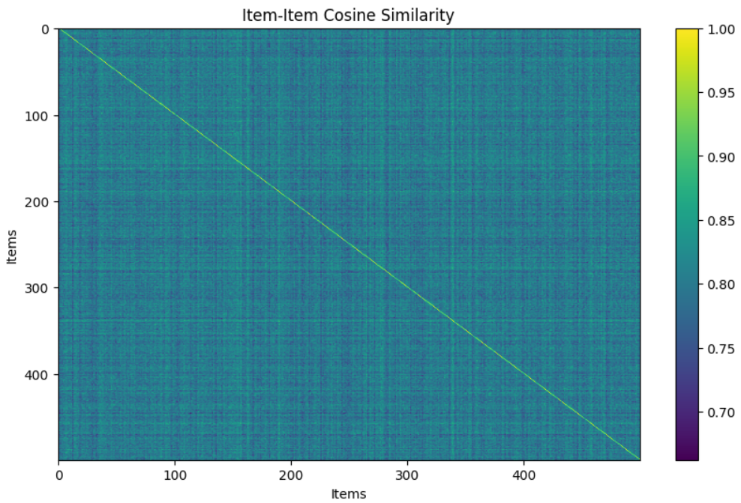

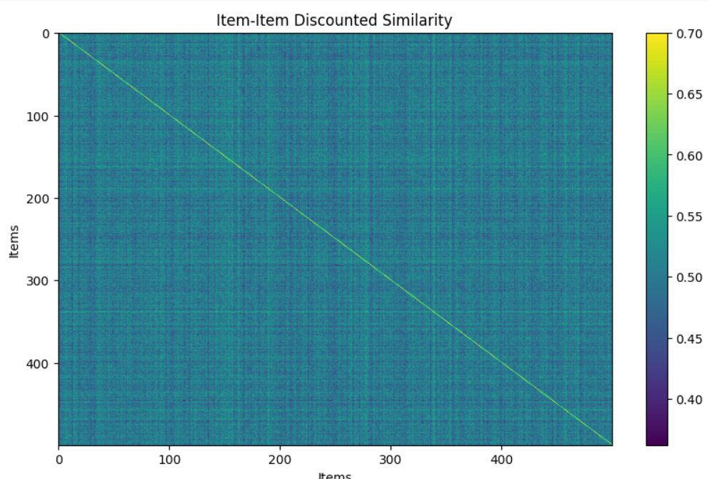

* 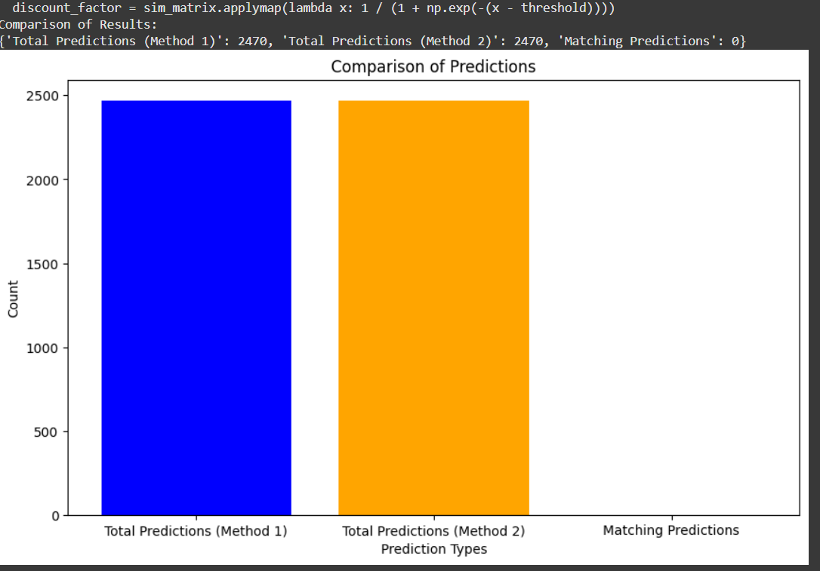**Part2 (case 2.2):**
* **Part2 (case 2.3):**

Prediction without DF: 3.2891571595653235

Prediction with DF: 3.2865331614289683

1. **Conclusion:**

In this paper, we deeply explore the world of recommender systems and focus on how different weighting schemes may affect the accuracy of the Collaborative Filtering recommendations. The careful consideration of the factors affecting users' preferences significantly enhances the quality of the recommendations.

Key Takeaways:

Discounting the Past: We found the use of discount factors applied to similarity measures to be a good technique for focusing on the most recent and relevant information, yielding much more up-to-date and personalized recommendations.

Bias Correction: Once user and item biases are taken into account, ratings can be predicted in a fair and much more accurate manner.

Choosing the appropriate tool will, of course, make quite a difference. This will also depend on the type of data: Cosine similarity or Pearson correlation can be good alternatives depending on the case.

Looking Ahead:

To enhance recommender systems even more, it could be interesting to try the following approaches:

Hybrid Approach: In general, it's worth mentioning that we could go even further in developing an even more complete and precise recommender by combining content-based filtering with knowledge-based methods.

Context is everything: User mood, time of day, or location may serve to enhance recommendation even more. Cold-start problem: The ability to suggest items to new users or items with scarce data is a challenging task; however, this can be resolved by using different techniques such as content-based filtering or hybrid approaches.

Measuring Performance: This can be quantified through various metrics, which include, but are not limited to, precision, recall, F1-score, and Mean Absolute Error. Feature Engineering: In this regard, effective feature generation from user-item interaction will lead to an enhancement in the accuracy of CF models. It is by further investigating such areas that we can build even more effective personalized recommender systems that actually 'get' our preferences and needs.