Retail Intelligence Platform
Using Azure PostgreSQL Data Warehousing, Power BI, Customer Segmentation, Market Basket Analysis, and Recommendation Prototyping
Prepared for | Details
Institution | Nile University
Department | Department of Computer Science
Project Type | Retail data warehouse, business intelligence, and data mining project
Main Technologies | Python, SQL, Azure PostgreSQL, Power BI, Streamlit, Scikit-learn, Association Rule Mining
Core Dataset | Dunnhumby Complete Journey retail dataset
External Dataset | U.S. Federal Holidays dataset

Document Structure
- Executive Summary
- Problem Statement and Objectives
- Dataset Selection and Data Sources
- System Architecture and Data Pipeline
- Data Cleaning and Preprocessing
- Azure PostgreSQL Data Warehouse Design
- Data Quality Validation
- Power BI Dashboard Documentation
- Customer Segmentation Methodology and Results
- Market Basket Analysis and Algorithm Performance
- Campaign, Coupon, Promotion, and Holiday Insights
- Amazon-like Recommendation Prototype
- Research Paper Draft Mapping
- Limitations, Challenges, and Future Work
- Appendices and References

1. Executive Summary
This document rewrites and expands the original IEEE paper draft to match the actual Retail Intelligence Platform project. The project builds an end-to-end retail analytics system that starts from raw retail datasets and ends with a validated Azure PostgreSQL data warehouse, Power BI dashboards, customer segmentation, market basket analysis, and an Amazon-like recommendation prototype.
The system integrates the Dunnhumby Complete Journey dataset with a U.S. Federal Holidays dataset. The final platform supports executive sales monitoring, product performance analysis, campaign and coupon analysis, holiday/event impact analysis, customer segmentation, association rule mining, and prototype recommendation testing.
The project is positioned as both a data warehouse/business intelligence project and a data mining research project. Its main technical contribution is combining ETL, dimensional modeling, data validation, Power BI reporting, clustering-based segmentation, association rule mining, and recommendation prototyping in one integrated retail intelligence pipeline.
Area | Project Output
Data Engineering | Cleaning, preprocessing, chunk loading, staging, ETL, validation, and transformation scripts.
Data Warehouse | Azure PostgreSQL schema retail_dw with dimensions, facts, staging tables, and validation views.
Business Intelligence | Power BI report pages for overview, sales, customer segments, campaigns/coupons, holidays, and validation.
Customer Segmentation | RFM-based segmentation using K-Means, DBSCAN, and Hierarchical Clustering, with DBSCAN selected for business interpretation.
Market Basket Analysis | Apriori, FP-Growth, and ECLAT comparison using support, confidence, lift, rule count, runtime, and memory usage.
Prototype | Amazon-like shopping prototype where users add items to cart and receive association-rule-based recommendations.

2. Problem Statement and Objectives
Retail businesses collect large volumes of transaction, product, household, coupon, campaign, promotion, and calendar data. However, raw data is often fragmented across many files, contains duplicates or quality issues, and cannot directly support strategic decision-making. Business users also need dashboards and interpreted insights rather than raw database tables.
The project addresses the following problem: how can a multi-source retail analytics platform transform raw retail data into reliable, visual, and actionable insights for sales monitoring, customer targeting, campaign optimization, holiday planning, and product recommendation?

2.1 Research Objectives
- Design and implement a retail data warehouse on Azure PostgreSQL.
- Clean, preprocess, validate, and load large retail datasets using Python and SQL.
- Design fact and dimension tables that support Power BI reporting and mining algorithms.
- Build interactive dashboards for sales, products, customers, campaigns, coupons, holidays, and data quality.
- Apply customer segmentation using RFM features and clustering models.
- Apply market basket analysis using Apriori, FP-Growth, and ECLAT.
- Compare association rule algorithms using runtime, memory usage, frequent itemsets, rule count, support, confidence, and lift.
- Analyze campaign, coupon, promotion, and holiday effects on retail behavior.
- Prepare a recommendation prototype based on association rules.

3. Dataset Selection and Data Sources
The project originally considered a smaller retail dataset. It was replaced because the previous dataset did not contain strong temporal fields, campaign/coupon details, household information, or useful enrichment keys. It was weak for Phase 2 requirements, especially merging with external data and building richer analytical stories.
The selected dataset is the Dunnhumby Complete Journey dataset. This dataset provides a much richer retail environment because it contains transactions, products, households, coupons, campaigns, coupon redemptions, and promotions. A U.S. Federal Holidays dataset was added as an external enrichment source to support event and holiday impact analysis.
Source | Purpose in the Project
Transactions | Sales value, quantity, basket, household, product, store, discount, coupon usage, and transaction dates.
Products | Product hierarchy including department, category, product type, brand, manufacturer, and package size.
Demographics / Households | Age, income, household size, marital status, home ownership, household composition, and children category.
Campaigns and Campaign Descriptions | Campaign identifiers, campaign type, start date, end date, and duration.
Coupons and Coupon Redemptions | Coupon availability and redemption behavior by household, coupon, and campaign.
Promotions | Product-store promotion records such as display and mailer attributes.
U.S. Federal Holidays | Holiday names, dates, definitions, and event metadata for holiday impact analysis.

4. System Architecture and Data Pipeline
The platform follows a layered architecture. Each layer has a clear responsibility, which makes the system easier to maintain, extend, and explain academically.
Layer | Role
Raw Data Layer | Contains original and preprocessed CSV files.
Data Engineering Layer | Python and SQL scripts perform cleaning, validation, transformation, chunk loading, and ETL.
Data Warehouse Layer | Azure PostgreSQL stores staging tables, dimensions, facts, and validation views under retail_dw.
Business Intelligence Layer | Power BI connects to Azure PostgreSQL and provides interactive dashboards.
Advanced Analytics Layer | Python notebooks and scripts run customer segmentation and association rule mining.
Prototype Layer | Streamlit prototype demonstrates e-commerce recommendations using association rules.

4.1 End-to-End Pipeline
- Collect and organize Complete Journey and U.S. holiday datasets.
- Clean and preprocess raw CSV files.
- Load cleaned data into Azure PostgreSQL staging tables using chunk loading.
- Build dimensions and fact tables using SQL and Python ETL scripts.
- Create validation views and analytical views.
- Connect Power BI to Azure PostgreSQL.
- Build dashboards and KPI measures.
- Run customer segmentation and association rule mining.
- Export algorithm outputs to CSV for Power BI and prototype integration.
- Build a prototype shopping recommender based on association rules.

5. Data Cleaning and Preprocessing
The cleaning strategy was conservative. Instead of deleting every suspicious record, the project preserved business records whenever possible and added flags, capped values, or unknown mappings. This approach protects sales analysis from losing important behavior.
Issue | Decision | Reason
Coupon duplicates | Removed 4,872 exact duplicate rows. | Duplicates can inflate joins and bias coupon analysis.
Invalid quantity values | Kept and flagged quantity <= 0 records. | They may represent returns, corrections, or special retail operations.
Missing product or household references | Kept transaction rows and mapped missing references to unknown dimensions when needed. | Deleting transactions can damage sales analysis.
Outliers in sales, quantity, retail discount, coupon discount | Detected using IQR, flagged, and added capped columns. | High values may reflect real bulk purchases or high discount behavior.
Rare coupon usage | No oversampling was applied. | Oversampling would distort support, confidence, basket frequency, and coupon patterns.
Dates and timestamps | Converted and standardized for date dimension, campaign periods, and holiday matching. | Time-based analysis and merging require reliable date fields.
Key cleaned files included basket_items_for_mba.csv, coupon_redemptions_clean.csv, campaigns_clean.csv, coupons_clean.csv, demographics_clean.csv, campaign_descriptions_clean.csv, products_clean.csv, promotions_clean.csv, and transactions_clean.csv.

6. Azure PostgreSQL Data Warehouse Design
The data warehouse was implemented on Azure PostgreSQL under the schema retail_dw. The design follows a galaxy/star-inspired model where fact tables store measurable business events and dimension tables provide descriptive context. The warehouse is the source of truth for Power BI and downstream mining scripts.

6.1 Warehouse Tables
Category | Tables
Staging | stg_transactions, stg_products, stg_promotions, stg_holidays, stg_demographics, stg_coupons, stg_coupon_redemptions, stg_campaigns, stg_campaign_descriptions, stg_basket_items_for_mba
Dimensions | dim_date, dim_product, dim_household, dim_store, dim_campaign, dim_coupon, dim_holiday
Facts | fact_transaction_item, fact_coupon_redemption, fact_campaign_participation, fact_product_promotion
Validation Views | vw_table_row_counts, vw_data_quality_summary
Main fact grain: fact_transaction_item represents one product purchased inside one basket by one household at one store on a transaction date. This grain supports sales, product, household, store, date, discount, coupon, and basket-level analysis.
Table | Purpose
dim_date | Calendar attributes including day, week, month, quarter, year, and merged holiday fields.
dim_product | Product hierarchy, category, department, brand, product type, manufacturer, and package size.
dim_household | Household demographic attributes such as age, income, home ownership, household size, and children category.
dim_campaign | Campaign type, start date, end date, and calculated duration_days.
dim_coupon | Coupon identifiers and coupon-product/campaign relationships.
dim_holiday | U.S. holiday names, dates, definitions, and event information.
fact_transaction_item | Sales value, quantity, basket, household, product, store, date, discount, and coupon flags.
fact_coupon_redemption | Coupon redemption events by household, coupon, campaign, and date.
fact_campaign_participation | Household participation in campaigns.
fact_product_promotion | Product promotion records by product, store, and date.

7. Data Quality Validation
Validation was performed to ensure that mining and dashboarding use reliable warehouse data. The project also fixed campaign duration and holiday date values after loading.
Validation Item | Result
fact_transaction_item row count | 1,469,307 rows
stg_basket_items_for_mba row count | 1,469,307 rows
dim_product row count | 92,349 rows
Unique baskets for market basket analysis | 155,848
Unique products | 68,509
Null basket_id | 0
Null product_id | 0
Duplicate basket_id + product_id pairs | 0
Unmatched product_key references | 0
Unmatched product_id references | 0
Unknown product_key rows | 0
Campaign duration fix: duration_days was calculated using end_date - start_date for campaigns with valid dates. Holiday date fix: holiday_date values were mapped to 2017 dates so that U.S. holidays can be joined with the date dimension and analyzed in Power BI.

8. Power BI Dashboard Documentation
Power BI is the reporting layer. It connects to Azure PostgreSQL and visualizes the final dimensions, facts, and validation views. Staging tables are excluded from final dashboard visuals except during debugging.
Page | Purpose | Main KPIs / Visuals
Executive Overview | High-level retail snapshot. | Total Sales, Total Baskets, Average Basket Value, Active Households, Coupon Usage Rate, weekly sales, segment sales.
Sales and Product Performance | Department and product performance analysis. | Total Quantity, Products Sold, Sales by Department, Top Product Categories, Sales Moving Average, Treemap.
Customer Segmentation | Behavioral customer grouping. | Customer Count, VIP, Active Shoppers, Churned, Avg Recency, Avg Frequency, Avg Monetary, scatter and profile table.
Campaign, Coupon and Promotion Analysis | Marketing and discount performance. | Total Campaigns, Households in Campaign, Coupon Redemptions, Discounts, Campaign Type Analysis, Monthly Redemptions.
Holiday and Event Impact | Holiday-aware retail behavior. | Holiday Sales, Non-Holiday Sales, Holiday Sales %, Uplift %, Coupon Usage During Holidays, Sales by Holiday.
Data Quality / DWH Validation | Trust and validation reporting. | Table row counts, issue counts, validation checks, failed/passed checks.
The dashboard design was refined using a professional layout with clean KPI cards, a navigation panel, consistent colors, chart containers, short titles, and date slicers. The current dashboard emphasizes decision-making rather than raw technical tables.

9. Customer Segmentation Methodology and Results
Customer segmentation was performed using RFM analysis. RFM summarizes customer behavior using recency, frequency, and monetary value. Clustering algorithms were then used to group households into interpretable business segments.

9.1 Model Comparison
Method | Clusters | Silhouette Score | Notes
K-Means | 2 | 0.656 | Clean result, but mainly separates Active vs Churned customers.
DBSCAN | 3 | 0.758 | Selected final model; discovers VIP outliers automatically.
Hierarchical Clustering | 3 | Used as comparison baseline | Supports validation of segment structure.
DBSCAN was selected as the final segmentation model because it achieved the strongest silhouette score and could identify the high-value VIP segment without requiring the number of clusters to be specified manually.

9.2 Final Segment Summary
Segment | Recency | Frequency | Monetary | Size
Active Shoppers | 22 days | 103 baskets/year | $3,080 avg | 2,431 (97%)
VIP | 83 days | 476 baskets/year | $10,304 avg | 55 (2.2%)
Churned | 544 days | 4 baskets/year | $163 avg | 14 (0.6%)
Business interpretation: Active Shoppers represent the core customer base. VIP customers spend approximately three times more than the average active shopper and should receive loyalty treatment. Churned customers have very high recency and low frequency, making them candidates for win-back campaigns.

9.3 Action Plan per Segment
Segment | Business Action
VIP | Launch a VIP loyalty program with early access, personalized offers, and account-managed retention. Losing one VIP has a high revenue impact.
Active Shoppers | Use personalized promotions on top categories such as soft drinks, beef, and cheese to increase basket size rather than visit frequency.
Churned | Run re-engagement campaigns with coupons targeted at their last known purchase categories. Even partial recovery can recover meaningful annual revenue.

10. Market Basket Analysis and Algorithm Performance
Market basket analysis was applied to discover category-level product relationships. The objective is to support cross-selling and recommendation scenarios such as "customers who bought this also bought" or "recommended for your cart".
The validated input used 1,078,691 basket-category rows, 155,691 baskets, and 303 product-category items. Product-category mining was selected first because product-level mining contains 68,509 unique products and can be computationally expensive.
Metric | Definition
Support | The fraction of baskets that contain an itemset.
Confidence | The probability of the consequent appearing when the antecedent appears.
Lift | How much stronger the rule is compared to random chance. Lift greater than 1 indicates positive association.
Runtime | Execution time in seconds.
Memory usage | Resident memory usage in MB during the algorithm run.
Three algorithms were compared: Apriori, FP-Growth, and ECLAT. The experiment varied minimum support and minimum confidence thresholds and measured frequent itemset count, rule count, runtime, and memory usage.

10.1 Representative Performance Results
Algorithm | Support | Confidence | Itemsets | Rules | Runtime (s) | Memory (MB)
Apriori | 0.001 | 0.3 | 104,795 | 99,066 | 41.79 | 258.29
FP-Growth | 0.001 | 0.3 | 104,795 | 99,066 | 68.33 | 324.45
ECLAT | 0.001 | 0.3 | 104,795 | 99,066 | 12.49 | 449.01
Apriori | 0.010 | 0.6 | 2,407 | 977 | 10.27 | 188.98
FP-Growth | 0.010 | 0.6 | 2,407 | 977 | 7.65 | 469.67
ECLAT | 0.010 | 0.6 | 2,407 | 977 | 3.69 | 418.32
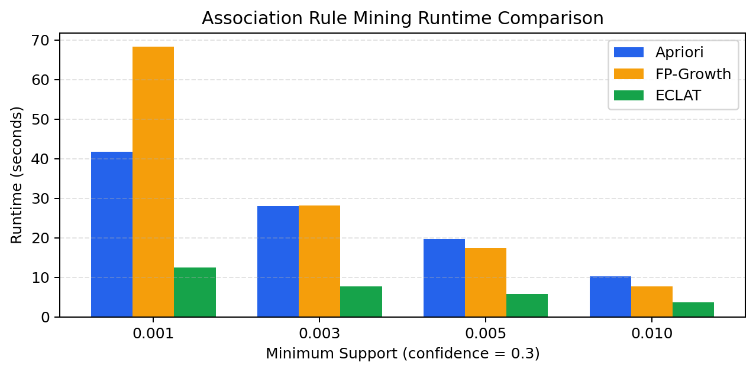
Figure 1. Runtime comparison for Apriori, FP-Growth, and ECLAT at confidence = 0.3.
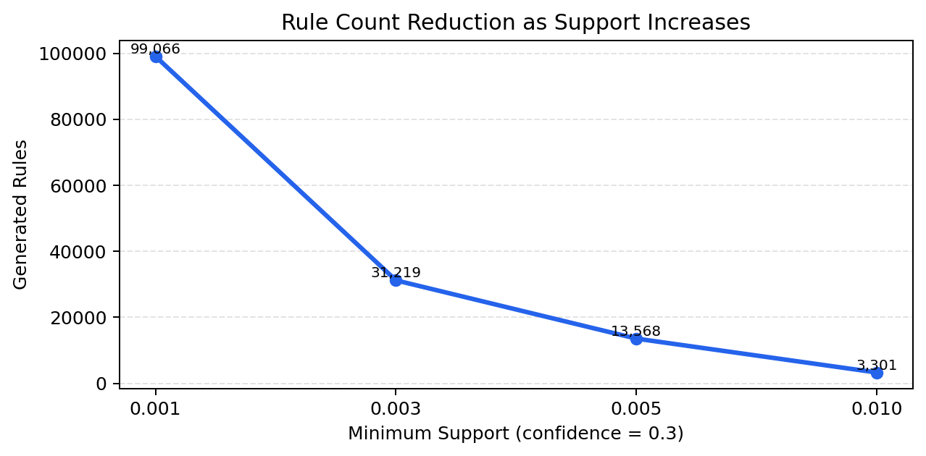
Figure 2. Rule count reduction as the minimum support threshold increases.
Key result: ECLAT achieved the fastest runtime across all tested thresholds. Apriori used the lowest memory in most configurations. FP-Growth was competitive at higher support thresholds, but in this implementation it was not the fastest. Lower support generated more frequent itemsets and rules, while higher confidence filtered the rules into stricter recommendations.
Best Highlight | Value
Maximum generated rules | 99,066 rules at support 0.001 and confidence 0.3
Maximum frequent itemsets | 104,795 frequent itemsets
Fastest runtime | ECLAT, 3.69 seconds at support 0.010 and confidence 0.6
Highest average lift | 4.27 at support 0.001 and confidence 0.3
Highest maximum lift | 25.50
Input baskets | 155,691
Input item count | 303 product categories

11. Campaign, Coupon, Promotion, and Holiday Insights
The platform includes analysis pages for campaign participation, coupon redemptions, product promotions, and holiday sales behavior. These pages help connect marketing activity with business outcomes.
Analysis Area | Business Question | Example Dashboard Elements
Campaign Analysis | Which campaign types attract the most households and sales? | Campaign participation by type, sales in campaign window, campaign performance table.
Coupon Analysis | How often are coupons redeemed and which categories receive discounts? | Monthly coupon redemptions, coupon usage rate, coupon discount by category.
Promotion Analysis | Which products and departments receive promotional exposure? | Promotion rows by product category, promoted products count.
Holiday Impact | Do holidays change sales, baskets, product categories, or coupon usage? | Holiday sales, non-holiday sales, holiday uplift, holiday sales by category.
The holiday table was merged into the date dimension so holiday filters correctly propagate through fact_transaction_item. This avoids redundant holiday names and incorrect cross-join behavior in Power BI visuals.

12. Amazon-like Recommendation Prototype
The project includes a prototype idea that simulates an e-commerce shopping experience. Instead of only showing association rules in a dashboard, the user browses products, adds items to a cart, and receives recommendations based on association rules.
Prototype Feature | Description
Product Grid | Displays product cards similar to a simple e-commerce store.
Search and Filters | Allows filtering by department, category, or product type.
Cart | User adds products to a cart and can remove or clear items.
Recommended for Your Cart | Rules where antecedents are a subset of the current cart generate recommended consequents.
Rule Explanation | Each recommendation shows support, confidence, lift, algorithm, and explanation.
Data Source | Initial version reads association rule CSV outputs; future version can connect to the database.
Recommendation score can combine normalized lift, confidence, and support. A recommended formula is: 0.45 x normalized lift + 0.35 x normalized confidence + 0.20 x normalized support.

13. Research Paper Draft Mapping
The project can be written as an IEEE-style research paper titled: "A Multi-Source Retail Intelligence Framework Using Data Warehousing, Customer Segmentation, Market Basket Analysis, and Holiday-Aware Analytics."
Paper Section | Content to Include
Abstract | Summarize the problem, multi-source data warehouse, Power BI dashboard, segmentation, association rule mining, and key results.
Introduction | Motivation for retail intelligence, business value, and system contribution.
Related Work | Retail BI, dimensional modeling, RFM segmentation, clustering, association rule mining, recommendation systems.
Data Sources | Complete Journey dataset and U.S. Federal Holidays dataset.
Methodology | Cleaning, ETL, warehouse design, validation, segmentation, association rule mining.
Experimental Setup | Azure PostgreSQL, Power BI, Python scripts, threshold settings, algorithm metrics.
Results and Discussion | Data quality results, segmentation results, market basket performance results, dashboard insights.
Conclusion and Future Work | Summarize achievements and propose deployment, automation, collaborative filtering, and additional data sources.
Suggested research contribution: many projects focus only on dashboards, only market basket analysis, or only customer segmentation. This work combines data warehousing, data validation, BI dashboards, customer segmentation, association rule mining, algorithm performance comparison, holiday-aware analysis, and a recommendation prototype in one complete system.

14. Limitations, Challenges, and Future Work

14.1 Challenges
- The initial dataset had to be replaced because it did not support Phase 2 enrichment requirements.
- Large data loading required chunk loading and optimized ETL techniques.
- Power BI sometimes showed cached data that differed from Azure PostgreSQL until refresh or query fixes were applied.
- Holiday dates required mapping to 2017 dates before holiday impact analysis could work correctly.
- Product-level association rule mining can be memory-heavy because of 68,509 unique products.
- Categorical demographic clustering requires careful interpretation because encoded categories do not always represent numeric distance.

14.2 Limitations
- Some demographic data is only available for a subset of households.
- Customer segments require business validation beyond statistical metrics.
- Holiday impact analysis depends on the completeness and correctness of the holiday dataset.
- The recommendation prototype is a demonstration layer and not yet a production real-time system.
- Association rule results may differ if product-level mining is used instead of category-level mining.

14.3 Future Work
- Complete the final customer segmentation comparison across K-Means, DBSCAN, and Hierarchical Clustering.
- Build and deploy the Streamlit recommendation prototype.
- Test product-level association rules if memory and runtime are acceptable.
- Add collaborative filtering and personalized recommendations.
- Automate ETL and Power BI refresh.
- Add more external event datasets such as weather, regional events, or economic indicators.
- Add campaign ROI and churn prediction models.
- Publish the dashboard with proper role-based or read-only access control.

15. Conclusion
The Retail Intelligence Platform successfully integrates data engineering, data warehousing, business intelligence, customer segmentation, market basket analysis, and recommendation prototyping. It transforms fragmented raw retail datasets into a structured Azure PostgreSQL warehouse and interactive Power BI dashboard suite.
The project produced a validated market basket dataset with no null basket/product identifiers, no duplicate basket-product pairs, and no unmatched product references. Association rule mining showed that ECLAT was the fastest algorithm in the tested category-level setting, while Apriori consumed the least memory in many configurations. Customer segmentation identified business-useful groups such as VIP, Active Shoppers, and Churned customers.
Overall, the project provides a strong foundation for retail decision support, targeted promotions, cross-selling, campaign optimization, holiday-aware planning, and future recommendation systems.

Appendix A: Key Power BI Measures
Measure | DAX Logic Summary
Total Sales | SUM(fact_transaction_item[sales_value_capped])
Total Quantity | SUM(fact_transaction_item[quantity_capped])
Total Baskets | DISTINCTCOUNT(fact_transaction_item[basket_id])
Average Basket Value | DIVIDE([Total Sales], [Total Baskets])
Coupon Usage Rate | Coupon Used Items divided by transaction item count.
Holiday Sales | Sales filtered where dim_date[is_holiday] = TRUE.
Customer Count | DISTINCTCOUNT(Customer Segments[household_key])
Number of Segments | DISTINCTCOUNT(Customer Segments[Final Segment])

Appendix B: Important Repository Structure
Folder / File | Purpose
sql/ | Schema creation, dimension/fact scripts, indexes, views, validation queries.
scripts/ | ETL scripts, model scripts, performance utilities, database connection helpers.
notebooks/ | EDA, customer segmentation, market basket analysis, and explanation notebooks.
outputs/ | Generated rule files, segmentation outputs, model comparison files, and sample exports.
prototype/ | Streamlit e-commerce recommendation prototype.
README.md | Project overview and setup guide.
.env.example | Credential template without real secrets.

References
[1] R. Agrawal, T. Imielinski, and A. Swami, "Mining Association Rules Between Sets of Items in Large Databases," ACM SIGMOD, 1993.
[2] J. Han, J. Pei, and Y. Yin, "Mining Frequent Patterns without Candidate Generation," ACM SIGMOD, 2000.
[3] J. Han, M. Kamber, and J. Pei, Data Mining: Concepts and Techniques, 3rd ed., Morgan Kaufmann, 2011.
[4] R. Kimball and M. Ross, The Data Warehouse Toolkit: The Definitive Guide to Dimensional Modeling, 3rd ed., Wiley, 2013.
[5] M. J. Zaki, "Scalable Algorithms for Association Mining," IEEE Transactions on Knowledge and Data Engineering, 2000.
[6] PostgreSQL Global Development Group, PostgreSQL Documentation.
[7] Microsoft, Power BI Documentation.
[8] F. Pedregosa et al., "Scikit-learn: Machine Learning in Python," Journal of Machine Learning Research, 2011.

