­

**

Prepared by

NTG Egypt

Business Analysis Team, Project Management

[2019]

|  |  |  |
| --- | --- | --- |
|  |  |  |
| Business Support Systems | | |
| High Level Design  Version : 1.1 Dated :02/07/2019 | | |

Prepared To

Vodafone Egypt

IT, Business Solutions

**Confidential**

Document description

|  |  |
| --- | --- |
| **property** |  |
| Client | Vodafone Egypt |
| Project title | HRAT - Human Resource Automated Tool |
| Document title | NTG-VFE HRAT - HLD |
| Reference |  |
| Version | 1.1 |
| Classification |  |
| Author | Mohamed Barakat |

|  |  |  |  |  |
| --- | --- | --- | --- | --- |
| Status |  | Read | Validated | Approved |

|  |  |  |  |  |
| --- | --- | --- | --- | --- |
| Approval  (Name) |  |  |  |  |
| Date | 02/07/2019 | | | |

Version history

|  |  |  |  |  |
| --- | --- | --- | --- | --- |
| **Version** | **Title** | **Name** | **Section** | **Date** |
| 1.0 | 1st Draft | Mohamed Barakat |  | 02/07/2019 |
| 1.1 |  | Mohamed Barakat | Apply the requested modification on the screenshots | 05/11/2019 |
|  |  |  |  |  |
|  |  |  |  |  |
|  |  |  |  |  |
|  |  |  |  |  |

Referenced documents

|  |  |  |  |
| --- | --- | --- | --- |
| **No.** | **Title** | **Reference** | **Version** |
|  | | | |
| 1 |  |  |  |

Contents

Referenced documents 2

Acronyms 6

1 Executive summary 7

1.1. Scope 7

1.1.1. Functionality and Business Processes 7

1.1.2. Business assumptions 8

1.1.3. Design assumptions 8

2 Solution Overview 9

3 HR Request Submission 10

3.1 Overview 10

3.2 Assumptions 11

3.3 Business processes 11

3.3.1 Phone Program 12

3.3.2 Medical Cards 21

3.3.3 Installments 32

3.3.4 Loan against Pension 37

3.3.5 Travel Form 42

3.3.6 Timesheet 47

4 HR Request Approval 49

3.1. Overview 49

3.2. Assumptions 49

3.3. Business processes 49

4.1.1 List Tasks 49

4.1.2 Approve Request 52

5 Other Interfaces 55

5.1 Overview 55

5.2 Support Interfaces 55

5.2.1 Interface Description 55

6 APPENDIX I 56

7 Approvals 57

Figures

Figure 11 : Development Process workflow 35

Tables

No table of figures entries found.

Acronyms

|  |  |
| --- | --- |
| Acronym | Description |
| API | Application programming interface |
| DB | Database |
| SLA | Service Level Agreement |
| SMS | Short Message Service |
| SOA | Service Oriented Architecture |
| SOAP | Simple Object Access protocol |
| WS | Web Service |
| XML | extended Markup Language |

# Executive summary

* The purpose of this project is to cover the mobilization of the HR systems
  1. Scope
* This document represents the continuity of the functional specifications for different HR systems, The mobilization will contain the Following functionalities:-
* Phone Program
* Medical Cards
* Installments
* Loans against Pension
* Travel Form
* Timesheet
* List The Assigned Tasks
* Assigned User Action (response)
* The previous functionalities will be applied by using the provided Web Services (API functions) to integrate the Mobile Application with the back end systems that handle the HR functionalities.

The outcome should give a clear definition of what is needed in order to begin the following activities:-

* let the implementation team know what to build
* let the testers know what tests to run
* let stakeholders know what they are getting
  + 1. Functionality and Business Processes

Based on the scope document as those depict the business processes required to be established to fulfill the scope of the current project implementation, this document as well the rest of the Design documents, will be consisted of the following sections:-

* HR Request submission
* HR Request approval

* + 1. Business assumptions
    2. Design assumptions

The integration between different systems involved in the proposed solution will be handled through TIBCO.

# Solution Overview

# HR Request Submission

## Overview

* This section describes the functionalities related to HR system that will be available in the mobile application and relevant interfaces will be used.
* Vodafone employee can access the main screen that has icons for the different requests as shown in figure “1”.

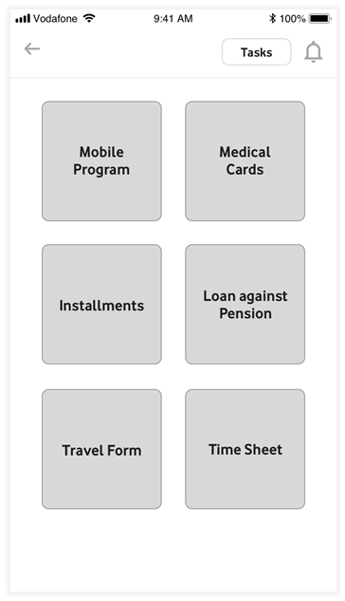

Figure 1

## Assumptions

* N/A

## Business processes

| Business Process ID | Name | Description | Initiation by | System(s) |
| --- | --- | --- | --- | --- |
| **001** | Phone Program | Submit request for Handset or new Rate plan | Mobile App. |  |
| **002** | Medical Cards | Submit a request to activate / deactivate medical card. | Mobile App. |  |
| **003** | Installments | Submit Installment request | Mobile App. |  |
| **004** | Loan Against Pension | Submit a request for a loan against pension | Mobile App. |  |
| **005** | Travel Form | Submit a travel request | Mobile App. |  |
| **006** | Time Sheet | Fill and submit time sheet | Mobile App. |  |

### Phone Program

#### Screenshot / Wireframe

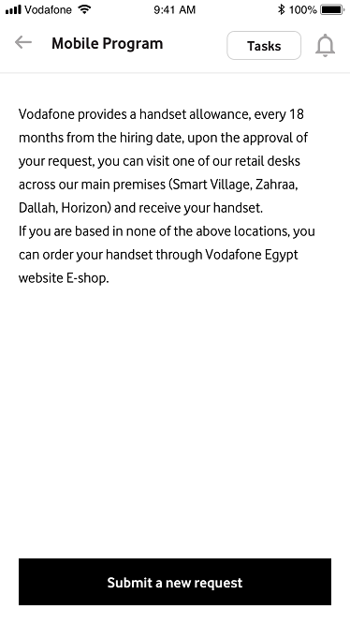

Figure 1.1

Option 1:

On the same page, add the below intro:

Vodafone provides a handset allowance, every 18 months from the hiring date, upon the approval of your request, you can visit one of our retail desks across our main premises (Smart Village, Zahraa, Dallah, Horizon) and receive your handset.

If you are based in none of the above locations, you can order your handset through Vodafone Egypt website E-shop.

Option 2:

A pop up appears before this page: Is this your first time requesting a phone program?

Yes/No

If yes: another pop up appears with this message:

Vodafone provides a handset allowance, every 18 months from the hiring date, upon the approval of your request, you can visit one of our retail desks across our main premises (Smart Village, Zahraa, Dallah, Horizon) and receive your handset.

If you are based in none of the above locations, you can order your handset through Vodafone Egypt website E-shop.

If no: he will reach Figure 1.1

+++ change ‘Add a new request’ to ‘Submit a new request’

I recommend option 1

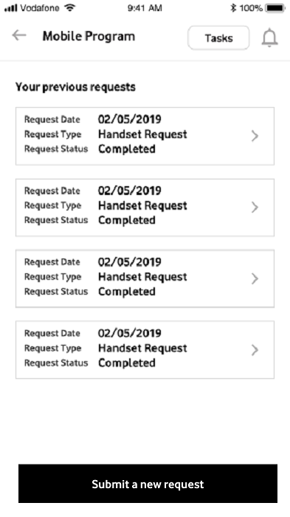

Figure 1.2

Typo: Request NOT Reqest

What does ‘See all’ refers to? We want to see its page

A full list for all the previous requests, I will work on the page but so far it will be the request unit which in figure 1.2 repeated by the number of previous requests

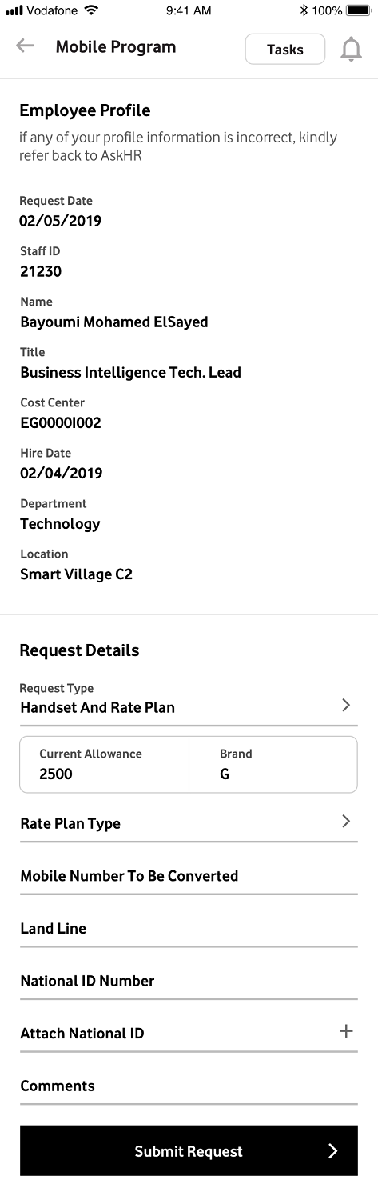

Figure 1.3

Remove ‘Employee Profile and add its data in ‘Request Details’

Remove Request Details tab as the page directly refers to this tab already

This is not the best experience for a mobile view, although it will be easier for design and development phases, removing the wizard tabs and keep everything in the same view will hide the most important part which is the form to the bottom and user should recognize scrolling without the guidance that the wizard gives.   
  
Also the view will be very crowded and long scrollable which is not preferable

Request NOT Reqest

Before ‘Request type’: Add Employee Profile with a drop down info arrow – add sentence ‘if any of your profile information is incorrect, kindly refer back to AskHR’

Will be done

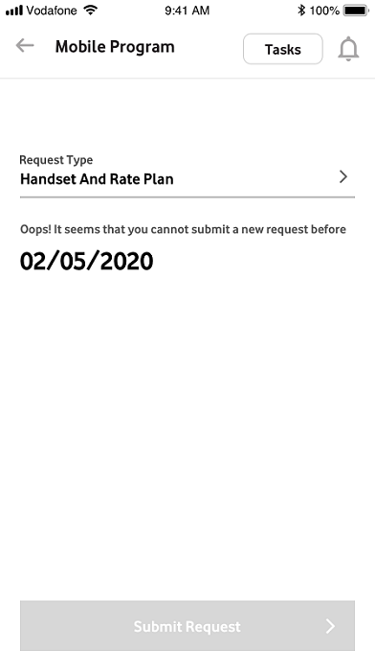

Figure 1.4

Request NOT Reqest

Change the above disclaimer to : Oops! It seems that you cannot submit a new request before (date)

Will be done

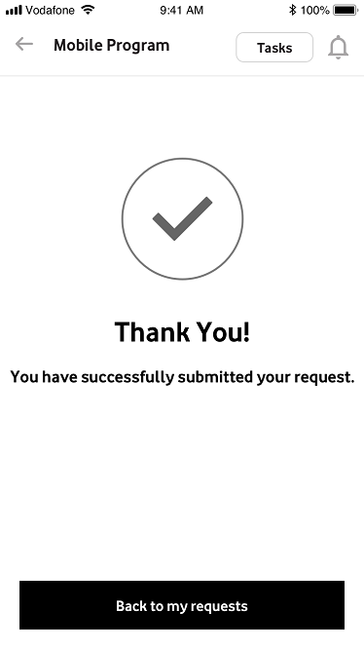

Figure 1.5

You have successfully submitted your request.

:” Back to my requests” instead of “back”

Will be done

#### Screen Description

|  |  |
| --- | --- |
|  |  |
| **Description** | * The process will manage to submit the phone program request for an employee. * The employee will press the phone program icon in the main screen to be able to manage the phone program request as shown in the figure “1”. |
| **Steps** | * Once the Vodafone employee press the phone program icon in the main screen then first screen will be run and will display the latest phone program requests as following:- * In case the employee doesn’t have any phone program request then the screen will acknowledge the employee that he doesn’t have any phone program request and the employee will be able to submit a new request as shown in figure “1.1”. * In case the employee has a phone program request then the screen will display summary information for the request (i.e. request date, request type and request status), and the employee will be able to submit a new request as shown in figure “1.2”. * The screen will display the latest phone program and the employee will be able to list all phone program submitted ordered by request date in a descending order by pressing “see all” link as shown in in figure “1.2”. * In case the employee is not eligible to submit a new phone program (handset request) then a message will be displayed to the employee with the eligibility date as shown in the figure “1.4”. * To run the screen that will be used to submit a new phone program request the employee should press the button “Add a New Request” as shown in figure “1.2”. |
| * The phone program request screen will be displayed with employee information and required data for the phone program as shown in figure “1.3”. * The employee information will be displayed and will be in read only mode and can be shown in figure “1.3”. * The employee information will be as following:- * Request Date * Staff ID * Name * Title * Cost center * Hire Date * Department * Location * The request detail section will have the phone program request detail information and can be shown in figure “1.3”. * The request detail tab will have two sections as following:- * Request Type * Phone Program Information * The request types will have the following values that can be selected by the employee:- * Handset * Settlement * Handset and rate plan * Change rate plan * The phone program information will depend on the selected request type value as following:-   Handset   * Current Allowance – Read Only * Band – Read Only * Eligibility Date – Read Only * Comments – Read/Write   Settlement   * Last handset Request Number – Read Only * Last Allowance – Read Only * Band – Read Only * Eligibility Date – Read Only * Bank Receipt attachment – Read/Write, will have the path of the attachment * Comment – Read/Write   Handset and rate plan   * Current Allowance – Read Only * Band – Read Only * Eligibility Date – Read Only * Rate Plan Type – List item and read/write * Mobile Number to be converted – Read/Write * Land Line – Read/Write * National ID – Read/Write * National ID Attachment – Read/Write, will have the path of the attachment * Comment – Read/Write   Change rate plan   * Rate Plan Type – List item and read/write * Mobile Number to be converted – Read/Write * Land Line – Read/Write * National ID – Read/Write * National ID Attachment – Read/Write, will have the path of the attachment * Comment – Read/Write * The employee can submit the request by pressing the button submit. |
| * In case the request type is Handset or Handset and Rate plan then the system will validate the employee eligibility and display an acknowledge message in case the employee is not eligible as shown in figure “1.4” |
| * In case the request submitted successfully then a message will be displayed as shown in the figure “1.5” |
|  |
|  |  |
| **Business rules** | * The employee profile for the login user will be populated automatically and will be read only * The login user will be able to submit a phone program request against his staff id only. |
| **Validation** | * Request Date will be filled automatically by system date and can’t be updated. |
| * Validate national ID number of digits |
| * Validate the number of digit for the entered phone number |
| * The mandatory information should be entered by the employee:- * Bank Receipt attachment * Rate Plan Type * Mobile Number to be converted * Land Line * National ID * National ID Attachment |
| **Interfaces** | The following web services will be used to manage phone program:-   * Phone Program (getMyRequests): will be used to populate the phone program requests for an employee by staff ID. * Umbrella (UserInfo): Get User details based on user account. * Phone Program (getRequestType): Return all Request Types. * Phone Program (getEmpBandAndAllowance): Used to return employee detail * Employee Band * Available allowance for Band * Last Allowance: total amount for last approved handset Request * Last Handset Request Number: Request ID for last approved handset Request * Phone Program (getRatePlanType): Return all Rate Plane Types * Phone Program (addRequest): Add phone Program Request |

#### Interface Description

|  |  |  |  |
| --- | --- | --- | --- |
| Operation Name |  | | |
| Description |  | | |
| Return Type | XML as String | | |
| Input Parameters | | Type | Description |
|  | |  |  |
|  | |  |  |
|  | |  |  |

### Medical Cards

#### Screenshot / Wireframe

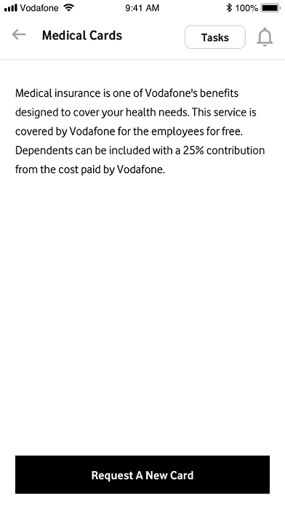

Figure 2.1

Same scenario of mobile program intro

Medical insurance is one of Vodafone's benefits designed to cover your health needs. This service is covered by Vodafone for the employees for free. Dependents can be included with a 25% contribution from the cost paid by Vodafone.

Same recommendations

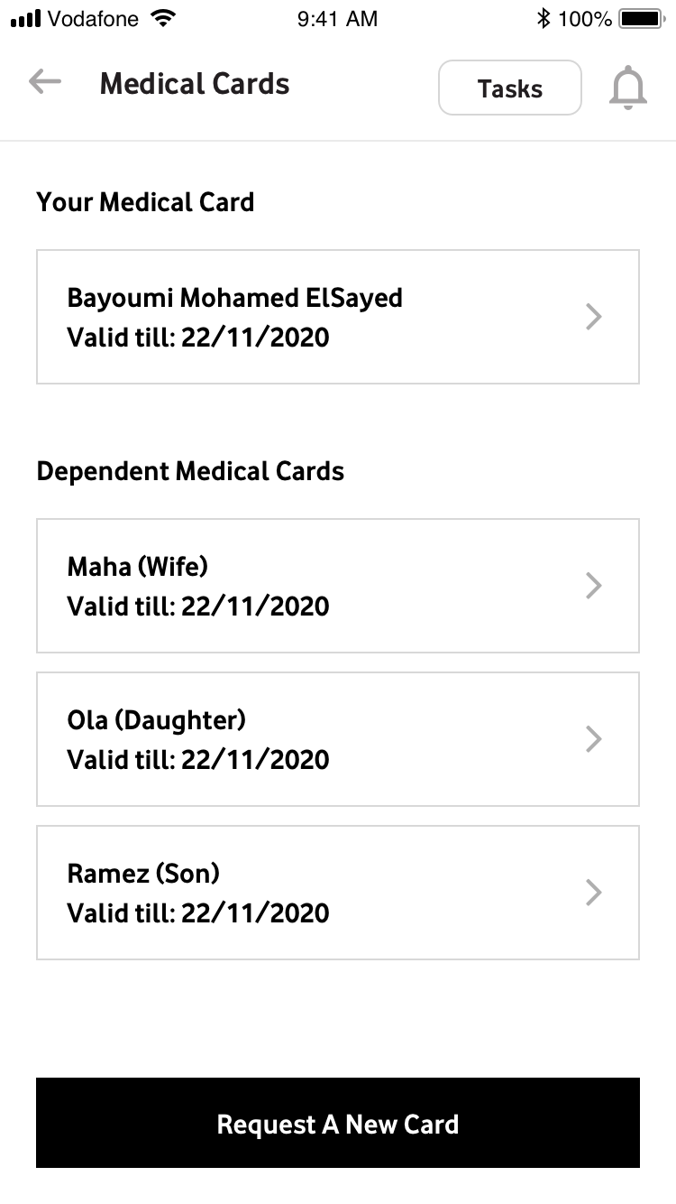

Figure 2.2

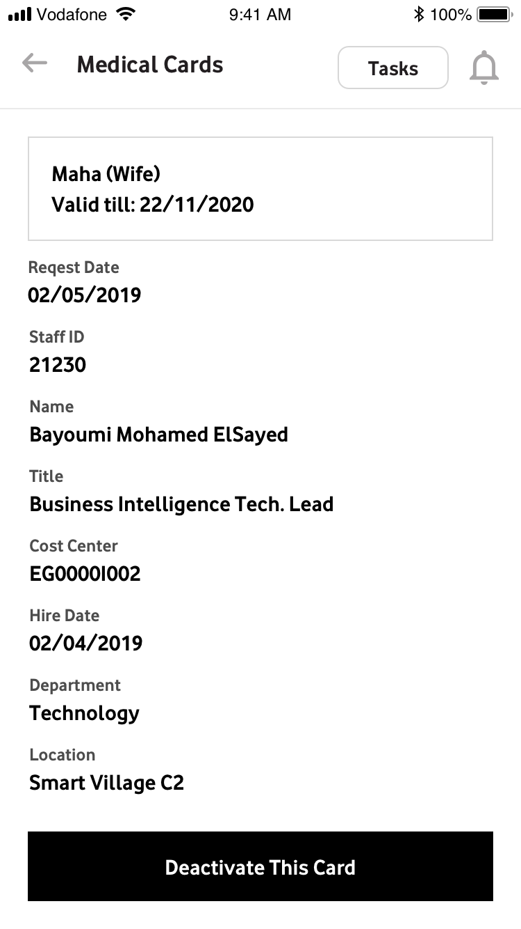

Figure 2.3

Write details of Maha’s card request and remove the employee’s data

Need the details of that card request

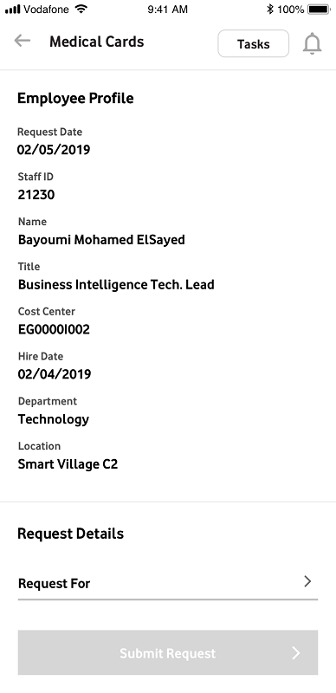

Figure 2.4

Same scenario of mobile program request

Same recommendations

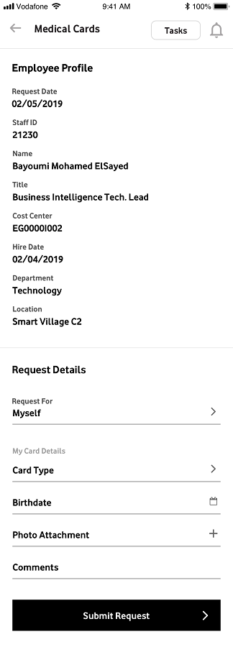

Figure 2.5

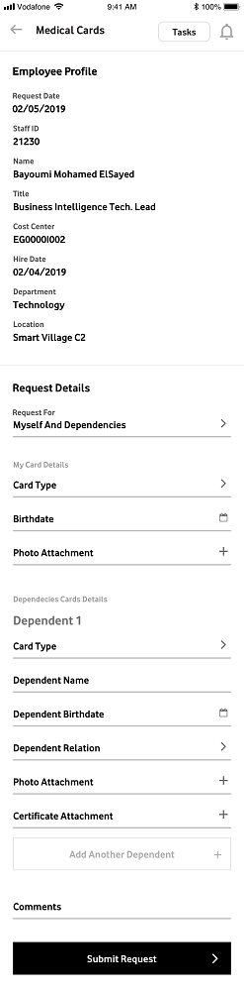

Figure 2.6

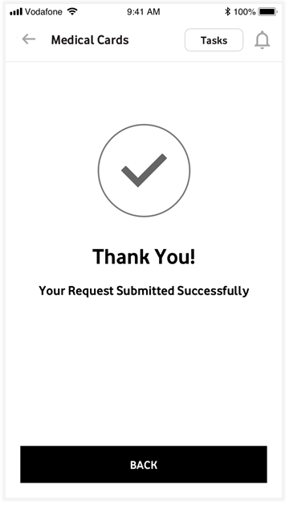

Figure 2.7

#### Screen Description

|  |  |
| --- | --- |
|  |  |
| **Description** | * The process will manage to submit the request to activate/deactivate the medical card for an employee. * The deactivation will be allowed for dependences only. * The employee will press the medical card icon in the main screen to be able to manage the medical card request as shown in the figure 1. |
| **Steps** | * Once the Vodafone employee press the medical card icon in the main screen then first screen will be run and will display the latest medical cards requests as following:- * In case the employee doesn’t have any medical card then the screen will acknowledge the employee that he doesn’t have any medical card and the employee will be able to submit a new request as shown in the figure “2.1” * In case the employee has a medical card then the screen will display summary information for the medical cards as shown in figure 2.2, the information will be displayed as following:-   Employee Medical Card   * Name * Validity Date   Dependencies Medical Card   * Name and relation * Validity date * The employee will be able to submit a new request by pressing the button “Request a new card” as shown in figure “2.2”. |
| * The employee can deactivate a medical card for any of dependencies by pressing the medical card to be deactivated as shown in the figure “2.2” * The detail information for the medical cards will be displayed as shown in the figure “2.3” * The medical card information will be displayed in read only mode as following:- * Name and relation * Validity date * Request Date * Staff ID * Name * Title * Cost center * Hire Date * Department * Location * Vodafone employee will be able submit a request to deactivate the card by pressing the button “Deactivate This Card” as shown in the figure “2.3”. |
| * The medical card request screen will be displayed with employee information and required data for the medical card request as shown in figure “2.4”, figure “2.5” and figure “2.6”. * The screen will have the “Employee Profile” and the request detail. * The employee profile will display the employee information and will be in read only mode and can be shown in figure “2.4”. * The employee profile tab will display the following information in read only mode:- * Request Date * Staff ID * Name * Title * Cost center * Hire Date * Department * Location * The request detail information can be shown in figure “2.5”. * The request detail tab will have two sections as following:- * Request For * Card Information * The request for will have the following values that can be selected by the employee:- * My Self * Dependencies * My Self and Dependencies * The card information will depend on the selected request for value as following:-   My Self   * Card Type * Birth Date * Photo Attachment * Comments   Dependencies   * Card Type * Dependent Name * Dependent Birth Date * Dependent Relation * Photo Attachment * Certificate Attachment * Add Another Dependent * Comments   My Self and Dependencies   * Card Type * Birth Date * Photo Attachment * Comments * Card Type * Dependent Name * Dependent Birth Date * Dependent Relation * Photo Attachment * Certificate Attachment * Add Another Dependent (Button) * Comments * The employee can submit the request by pressing the button “submit Request”. |
| * In case the request submitted successfully then a message will be displayed as shown in the figure “2.7” |
|  |
|  |  |
| **Business rules** | * The deactivation action for the medical card will be allowed for dependences only. |
| * The employee profile for the login user will be populated automatically and will be read only |
| * The login user will be able to submit a medical card request against his staff id only. |
| **Validation** | * Request Date will be filled automatically by system date and can’t be updated. |
| * Birth Date should be less than system date. |
| * The mandatory information should be entered by the employee:- * Request For * Card Type * Birth Date * Photo Attachment * Dependent Name * Dependent Relation |
|  |
| **Interfaces** | The following web services will be used to manage Medical card request:-   * Medical Cards (getMyRequests): will be used to populate the medical card requests for an employee by staff ID. * Umbrella (UserInfo): Get User details based on user account. * Medical Cards (getRequestFor): Return Request for List (Myself, Dependent, Both) * Medical Cards (getRequestType): Return all Request Types (Activate-Deactivate) * Medical Cards (getCardType): Add phone Program Request * Medical Cards (getDependentRelation) : Return all Dependent Relation Types List * Medical Cards (activateRequest) : Add activation Request * Medical Cards (deactivateRequest): Add deactivation Request |

#### Interface Description

|  |  |  |  |
| --- | --- | --- | --- |
| Operation Name |  | | |
| Description |  | | |
| Return Type | XML as String | | |
| Input Parameters | | Type | Description |
|  | |  |  |
|  | |  |  |
|  | |  |  |

### Installments

#### Screenshot / Wireframe

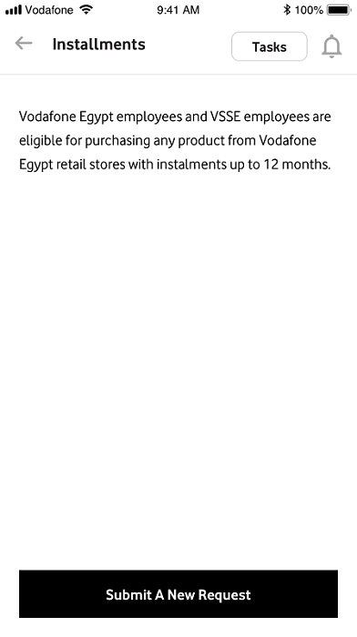

Figure 3.1

Same intro scenario

Vodafone Egypt employees and VSSE employees are eligible for purchasing any product from Vodafone Egypt retail stores with instalments up to 12 months.

Same recommendations

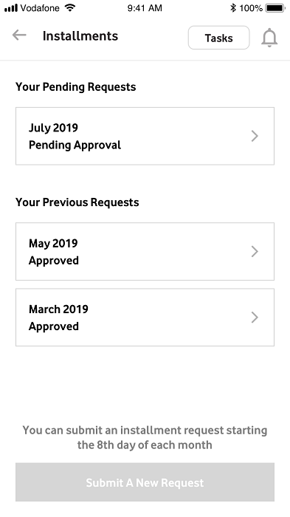

Figure 3.2

Same as phone program

You can submit an installment request starting the 8th day of each month …..

Same recommendations

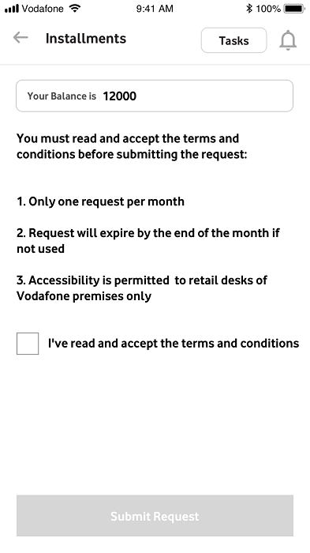

Figure 3.3

#### Screen Description

|  |  |
| --- | --- |
|  |  |
| **Description** | * The process will manage to submit the request for installments for an employee. * The employee will press the installment icon in the main screen to be able to manage the installment request as shown in the figure 1. |
| **Steps** | * Once the Vodafone employee press the installment icon in the main screen then first screen will be run and will display as following:- * In case the employee doesn’t have any installments request then the screen will acknowledge the employee that he doesn’t have any installment request and the employee will be able to submit a new request as shown in the figure “3.1” * In case the employee has an installment request already submitted and in pending status, then the screen will display the installment detail as shown in figure 3.2, the information will be displayed as following:-   Pending Requests   * Request Date (Month/Year) * Request Status   Previous Requests   * Request Date (Month/Year) * Request Status * The employee will be able to submit a new request by pressing the button “Submit a new Request” as shown in figure “3.1”. |
| * The installment request screen will be displayed with employee balance and conditions as shown in figure “3.3”. * The employee should confirm that he read the conditions and agree on it using the check box. |
| **Business rules** | * The request date should be valid to create installment request. |
| **Validation** | * The Check Box that confirming that the employee read the terms and conditions is mandatory to be checked before submitting the request. |
|  |
|  |
| **Interfaces** | * Installments (getMyRequests): Return all Installment requests by employee staff ID. * Installments (addRequest): Add Installment Request * Installments (CheckAvailabltytoInstallment) : Check if current date is available to create installment request * Installments (GetInstallmentBalance) : Return User Balance |

#### Interface Description

|  |  |  |  |
| --- | --- | --- | --- |
| Operation Name |  | | |
| Description |  | | |
| Return Type | XML as String | | |
| Input Parameters | | Type | Description |
|  | |  |  |
|  | |  |  |
|  | |  |  |

### Loan against Pension

#### Screenshot / Wireframe

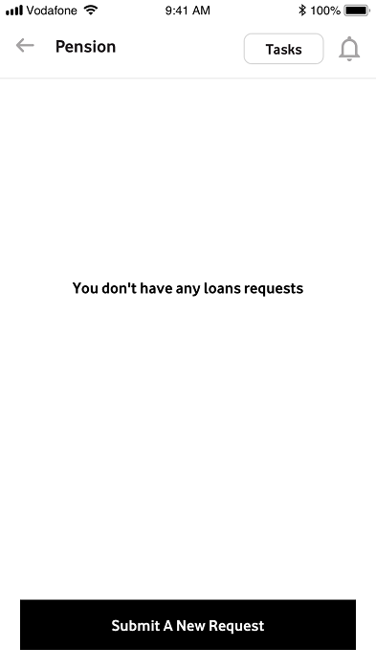

Figure 4.1

Pension not loan against pension

You don’t have any pension requests – same intro scenario

Same recommendations

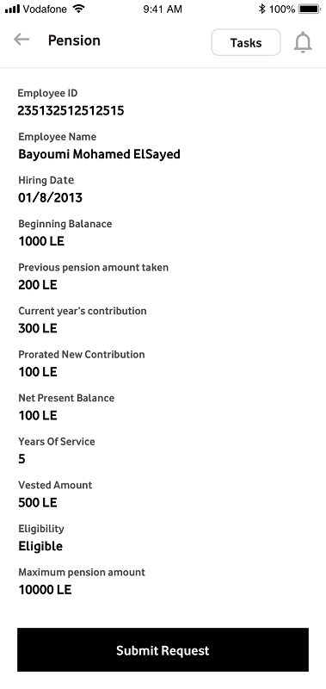

Figure 4.2

Employee ID ????

Balance (typo)

Hiring Date instead of hire date

Previous pension amount taken instead of previous loan taken

Current year’s contribution instead of current year contribution

Net present value??

Maximum pension amount instead of maximum lean amount

What are the ?? marks? That what was in the document! If not please send me a CLEAR and detailed list of the info

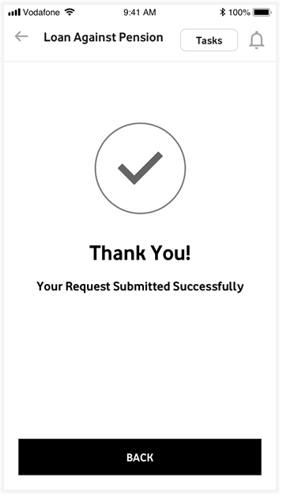

Figure 4.3

Same exit scenario (back to)

Will be done

#### Screen Description

|  |  |
| --- | --- |
|  |  |
| **Description** | * The process will manage to submit the request for loan against pension for an employee. * The employee will press the loan against pension icon in the main screen to be able to manage the loan against pension request as shown in the figure 1. |
| **Steps** | * Once the Vodafone employee press the loan against pension icon in the main screen then first screen will be run as following:- * In case the employee doesn’t have any loan against pension request then the screen will acknowledge the employee that he doesn’t have any loan against pension request and the employee will be able to submit a new request as shown in the figure “4.1” |
| * The employee can submit the request by pressing the button “submit Request”. * In case the request submitted successfully then a message will be displayed as shown in the figure “4.3” |
|  |
|  |  |
| **Business rules** |  |
| **validation** |  |
|  |
| **Interfaces** | * Pension (getMyRequests): Return all Pension requests by employee staff ID. * Pension (addRequest): Add Pension Request * Pension (getPensionInformation) : Get Pension Information by staff id |

#### Interface Description

|  |  |  |  |
| --- | --- | --- | --- |
| Operation Name |  | | |
| Description |  | | |
| Return Type | XML as String | | |
| Input Parameters | | Type | Description |
|  | |  |  |
|  | |  |  |
|  | |  |  |
|  | |  |  |

### Travel Form

#### Screenshot / Wireframe

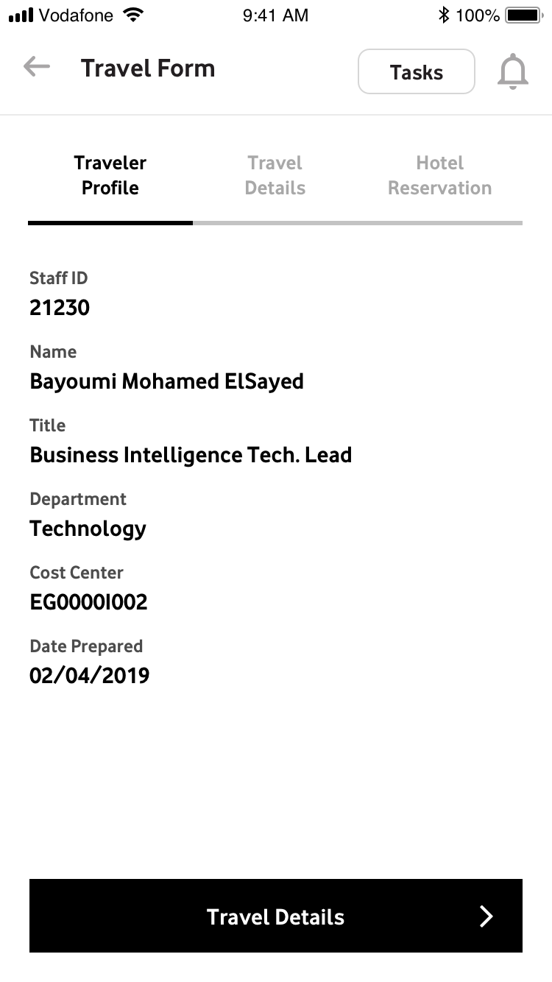

Figure 5.1

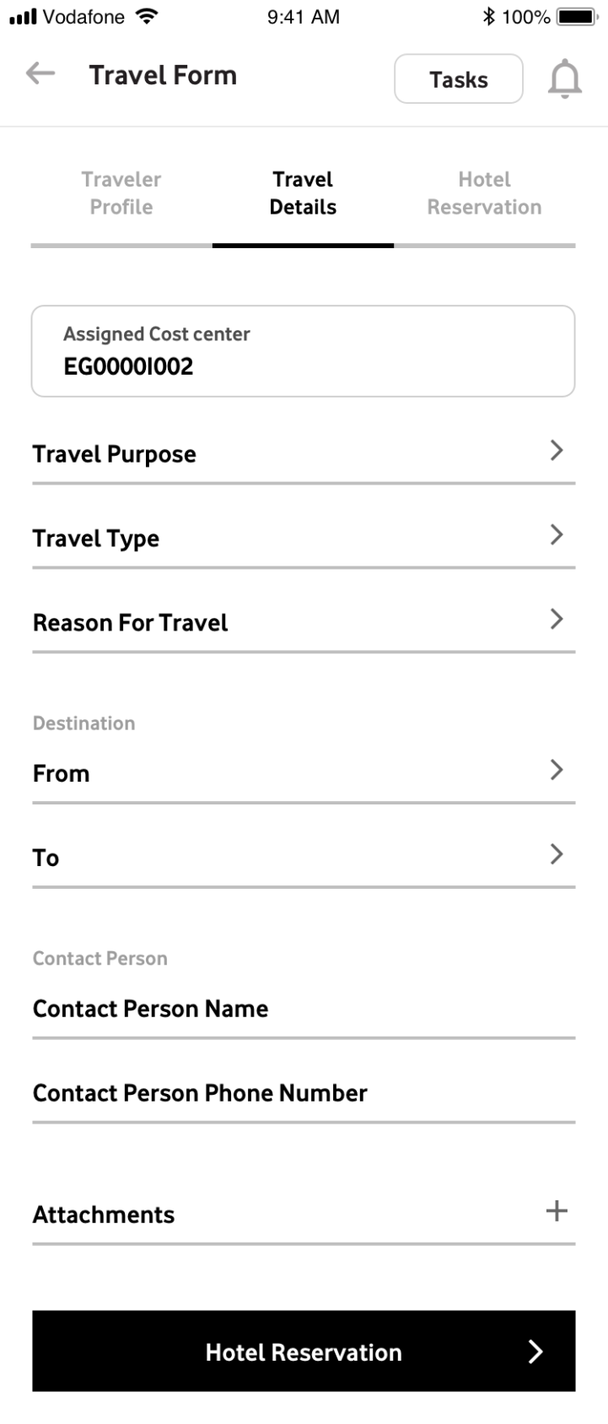

Figure 5.2

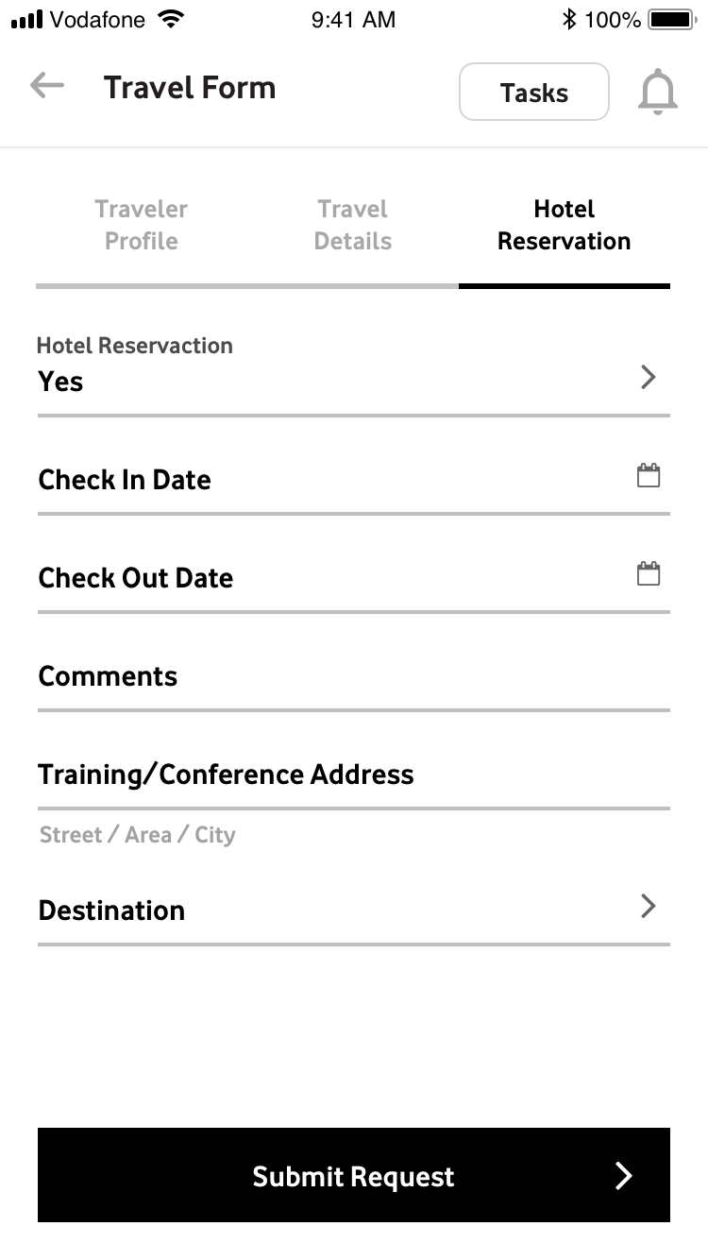

Figure 5.3

#### Screen Description

|  |  |
| --- | --- |
|  |  |
| **Description** | * The process will manage to submit the travel request for an employee. * The employee will press the travel form icon in the main screen to be able to manage the travel form request as shown in the figure 1. |
| **Steps** | * Once the Vodafone employee press the travel form icon in the main screen then travel form will be run and display the required information distributed in three tabs as following:- * Traveler Profile * Travel Detail * Hotel reservation |
| * The Traveler profile tab will have the following information in read only mode:- * Request Date * Staff ID * Name * Title * Department * Cost center * The screen can be shown in the figure “5.1”. |
| * The Travel detail tab will have the following information:- * Travel Purpose (Business/Training) * Travel Type * Assigned Cost center (Read Only) * Destination From * Destination To * Reason For Travel (List item) * Contact Person * Contact Person Phone Number * Attachments * The screen can be shown in the figure “5.2” |
| * The hotel reservation tab will have the following information:- * Hotel Reservation (Yes/No) * Check In date * Check out date * Comments * Training /Conference Address * Destination * The screen can be shown in the figure “5.2” |
| * The employee will be able to add the following services:- * Air * Request Driver (Yes/No) * Check out date * Visa Issuance * Meet & Assist * Car Hire * Meeting / Team Building |
|  |  |
| **Business rules** | * The employee profile for the login user will be populated automatically and will be read only |
| * The login user will be able to submit a travel request against his staff id only. |
| **Validation** | * Request Date will be filled automatically by system date and can’t be updated. |
| * The mandatory information should be entered by the employee:- * Travel Purpose * Travel Type * Destination From * Destination To * Reason For Travel * Contact Person * Contact Person Phone Number |
|  |
| **Interfaces** | * Travel Form (getMyRequests): Return all Travel Form requests by employee staff ID. * Travel Form (addRequest):Add Travel Form Request * Travel Form (GetTravelTypeList): Return list of travel type values (Domestic, and Overseas) * Travel Form (GetTravelPurpose): Return list of travel purpose values (Business, and Training) * Travel Form (GetTravelBasis): Return list of travel Basis values (Economy, and others) * Travel Form (GetYesNoList): Return code and values of Yes, and No List * Travel Form (GetCounteries): Return List of all countries * Travel Form (GetTypeofVisa): Return List contains types of visa (Single Entry, and Multiple Entry) |

#### Interface Description

|  |  |  |  |
| --- | --- | --- | --- |
| Operation Name |  | | |
| Description |  | | |
| Return Type | XML as String | | |
| Input Parameters | | Type | Description |
|  | |  |  |
|  | |  |  |
|  | |  |  |
|  | |  |  |
|  | |  |  |

### Timesheet

#### Screenshot / Wireframe

#### Screen Description

|  |  |
| --- | --- |
|  |  |
| **Description** |  |
| **Actors/Systems** |  |
| **Pre-conditions** |  |
|  |
|  |
| **Steps** |  |
|  |
|  |  |
| **Interfaces** |  |

#### Interface Description

|  |  |  |  |
| --- | --- | --- | --- |
| Operation Name |  | | |
| Description |  | | |
| Return Type | XML as String | | |
| Input Parameters | | Type | Description |
|  | |  |  |
|  | |  |  |
|  | |  |  |
|  | |  |  |

# Request Approval

* 1. Overview
* This section describes the functionalities related to HR system that will be available in the mobile application and relevant interfaces will be used.
* Vodafone employee can access the screen to be able to list his tasks and approve on the requests assigned to him.
  1. Assumptions
* N/A
  1. Business processes

| Business Process ID | Name | Description | Initiation by | System(s) |
| --- | --- | --- | --- | --- |
| **001** | List Tasks |  | Mobile App. |  |
| **002** | Request Approval |  | Mobile App. |  |

### List Tasks

#### Screenshot / Wireframe

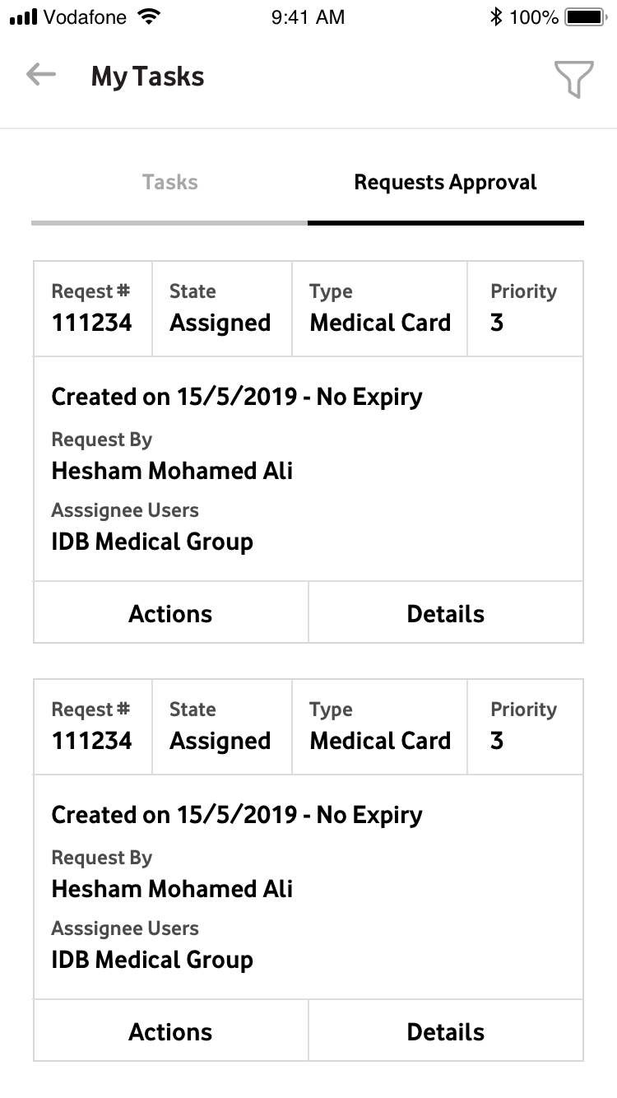

Request Status not approval

Figure 6.1

#### Screen Description

|  |  |
| --- | --- |
|  |  |
| **Description** | * The employee will press tasks link in the main screen to be able to display the list of tasks assigned to him as shown in figure 1. |
| **Steps** | * The screen will display the following information:- * Request # * State * Type * Priority * Created On * Requested By * Assignee User * Actions * Detail |
|  | * The employee can display the task detail for a specific task by pressing the button “Detail” as shown in the figure “6.1” |
| **Business rules** |  |
| **validation** |  |
|  |
|  |
| **Interfaces** | * Umbrella (myTasks) : Get all tasks assigned to specific user |

#### Interface Description

|  |  |  |  |
| --- | --- | --- | --- |
| Operation Name |  | | |
| Description |  | | |
| Return Type | XML as String | | |
| Input Parameters | | Type | Description |
|  | |  |  |
|  | |  |  |
|  | |  |  |
|  | |  |  |
|  | |  |  |
|  | |  |  |

### Approve Request

#### Screenshot / Wireframe



Figure 6.2

#### Screen Description

|  |  |
| --- | --- |
|  |  |
| **Description** | * The process will manage to approve the requests assigned for an employee. |
| **Steps** | * The employee can check the list of tasks assigned to him as shown in figure “6.2”. * The screen will display the following information:- * Request # * State * Type * Priority * Created On * Requested By * Assignee User * Actions * Detail |
| * The employee can take action on a specific task by pressing the button “Action”. |
| * The available actions will be a list item and the employee can select from it (i.e. Approve, Reject…). |
| **Business rules** |  |
| **validation** |  |
|  |
|  |
| **Interfaces** | * Umbrella (myTasks) : Get all tasks assigned to specific user * Umbrella (Action): Make an action on specific tasks (Approve, Reject….). |

#### Interface Description

|  |  |  |  |
| --- | --- | --- | --- |
| Operation Name |  | | |
| Description |  | | |
| Return Type | XML as String | | |
| Input Parameters | | Type | Description |
|  | |  |  |
|  | |  |  |
|  | |  |  |
|  | |  |  |

# Other Interfaces

## Overview

This section describes the functionality for interfaces used through almost all business processes.

## Support Interfaces

| Business Process ID | Name | Description | Initiation by | System(s) |
| --- | --- | --- | --- | --- |
|  |  |  |  |  |
|  |  |  |  |  |
|  |  |  |  |  |

### Interface Description

|  |  |  |  |
| --- | --- | --- | --- |
| Operation Name |  | | |
| Description |  | | |
| Return Type | XML as String | | |
| Input Parameters | | Type | Description |
|  | |  |  |
|  | |  |  |
|  | |  |  |
|  | |  |  |
|  | |  |  |

# APPENDIX I

# Approvals

|  |  |
| --- | --- |
| Signoff | |
| VFE |  |
| Signature: | Signature: |
| Name: | Name: |
| Date: | Date: |
|  |  |
|  |  |
|  |  |
| Signoff | |
| NTG |  |
| Signature: | Signature: |
| Name: | Name: |
| Date: | Date: |