AINE204
Artificial Intelligence Tools

E-commerce Customer Behavior Analysis
Final Project Report

Lecturer Name: Dr. Hussain Adedoyin Ahmed
Student Name: Mohamed Mohamed
Student ID: 2303070006

Table of Contents:
1. Introduction………………………………………………………....2
2. Problem Statement………………………………………………...2
3. Objectives……………………………………………………………2
4. AI Tools Used…………….………………………………………....2
5. Methodology…………………………………………………………3
5.1 Data Loading & Preprocessing…………………………...…...3
5.2 Prediction of Total Spend (Random Forest Regressor) ……4
5.3 Customer Demographics Analysis……………………….……4
5.4 Items per Spend Analysis………………………………………4
5.5 City-Based Aggregate Analysis………………………………..5
5.6 Recency Analysis………………………………………………..5
6. Results…………………………………………………………………6
7. Analysis & Discussion………………………………………………..6
8. Ethical Considerations………………………………………………..7
9. Limitations……………………………………………………………...7
10. Conclusion…………………………………………………………….8
11. References…………………………………………………………….8
12. Appendix……………………………………………………………….8

Introduction
E-commerce has become one of the most data-rich industries in the modern economy. Every customer interaction — from browsing to purchasing — generates valuable data that, when analyzed effectively, can unlock significant competitive advantage. Understanding customer behavior is no longer a luxury but a necessity for businesses seeking to personalize experiences, optimize pricing, and reduce churn.
This project applies Artificial Intelligence and machine learning tools to analyze customer behavior data from an e-commerce platform. Using a combination of predictive modeling and data visualization, the project aims to surface actionable insights about customer spending patterns, demographics, purchasing efficiency, geographic distribution, and engagement recency.

Problem Statement
E-commerce businesses struggle to understand customer spending patterns and effectively segment their customer base. Without data-driven insights, marketing efforts are broad and inefficient, and businesses miss opportunities to personalize experiences for high-value customers. This project uses AI and machine learning tools to predict total customer spend, categorize customers by demographics and behavior, and visualize key metrics — providing a foundation for more informed, data-driven business decisions.
Objectives
By the end of this project, the following objectives will be achieved:
- Predict customer Total Spend using a Random Forest Regressor model.
- Segment customers by age group and analyze demographic distribution.
- Analyze the Items per Spend ratio to identify purchasing efficiency patterns.
- Perform city-based aggregate analysis across Total Spend, Items Purchased, and Satisfaction Level.
- Categorize customers by purchase recency and assess overall engagement levels.

AI Tools Used

Tool / Library | Purpose | Justification
scikit-learn (Random Forest Regressor) | Spend prediction model | Handles mixed data types, resistant to overfitting, provides feature importance scores.
scikit-learn (LabelEncoder) | Categorical encoding | Lightweight, integrates seamlessly with the scikit-learn pipeline.
pandas | Data manipulation | Intuitive DataFrame operations for cleaning, grouping, and transforming tabular data.
numpy | Numerical operations | Backbone of pandas and scikit-learn; ensures fast and reliable computation.
matplotlib | Data visualization | Fine-grained chart control; supports bar charts, pie charts, histograms, and scatter plots.

Methodology

5.1 Data Loading & Preprocessing
Dataset Description
The dataset used in this project contains 351 customer records from an e-commerce platform, with 11 columns:

Column | Type | Description
Customer ID | Identifier | Unique identifier for each customer
Gender | Categorical | Customer's gender
Age | Numerical | Customer's age in years
City | Categorical | City where the customer is located
Membership Type | Categorical | Tier of membership (e.g. Gold, Silver)
Total Spend | Numerical | Total amount spent — target variable
Items Purchased | Numerical | Number of items bought
Average Rating | Numerical | Customer's average product rating
Discount Applied | Categorical | Whether a discount was applied
Days Since Last Purchase | Numerical | Recency indicator
Satisfaction Level | Categorical | Customer satisfaction label

Loading the Data
The dataset was loaded from a CSV file using pandas.read_csv(), which reads the file into a DataFrame. After loading, the shape of the dataset was confirmed as 351 rows and 11 columns.
Handling Missing Values
- Numerical columns — filled with the column mean, preserving the overall distribution.
- Categorical columns — filled with the column mode (most frequent value).
Encoding Categorical Variables
LabelEncoder from scikit-learn was applied to each categorical column, converting string labels into integer representations. This was applied to: Gender, City, Membership Type, Discount Applied, and Satisfaction Level.
Defining Features and Target
The dataset was split into features (X) — all columns except Customer ID and Total Spend — and target (y) — Total Spend. Customer ID was excluded as it is an arbitrary identifier with no predictive value.

5.2 Prediction of Total Spend (Random Forest Regressor)
Model Selection
A Random Forest Regressor from scikit-learn was selected to predict Total Spend. Random Forest is an ensemble learning method that constructs multiple decision trees and outputs the average prediction, reducing variance and making the model more robust.
Train/Test Split
The preprocessed dataset was divided into an 80/20 split — approximately 280 records for training and 71 for evaluation — ensuring the model is assessed on data it has never seen before.
Model Evaluation
Performance was evaluated using Mean Squared Error (MSE):
MSE = 85.62
An MSE of 85.62 corresponds to an average prediction deviation of approximately ±9.25 spending units (√85.62 ≈ 9.25), indicating strong predictive accuracy relative to the spend range in the dataset.
Visualization
The actual vs. predicted Total Spend values were plotted to visually assess model performance. Data points clustered close to the diagonal line confirm the model has successfully learned spending patterns within the dataset.

5.3 Customer Demographics Analysis
Approach
Customers were categorized by age and visualized using a pie chart. Rather than broad age brackets, individual age values were preserved, providing a granular view of the customer age distribution. One-hot encoding was applied to age categories for further analysis.
Results
- Age 30 is the largest segment at 13.7% of all customers.
- Age 32 follows at 9.4%, with ages 31, 43, 35, 27, 36, 34, and 28 each contributing 6.9%–7.1%.
- Ages 38, 26, 42, 33, 29, and 41 each represent 2.6%–3.1% of the customer base.
- The customer base is largely concentrated in the late 20s to early 40s range.
Business Insight
Marketing efforts, product offerings, and loyalty programs should be primarily tailored to customers aged 30–35, while smaller segments such as ages 41–43 represent growth opportunities.

5.4 Items per Spend Analysis
Approach
A derived metric called Items per Spend was calculated by dividing Items Purchased by Total Spend for each customer, indicating purchasing efficiency. The distribution was visualized using a histogram with mean and median reference lines.
Results
- The distribution spans approximately 0.012 to 0.020.
- The median is 0.01 and the mean is 0.02 — indicating a mild right skew.
- Two concentration peaks are visible: around 0.013–0.014 and around 0.018–0.019, suggesting a bimodal distribution.
- Very few customers fall at the extreme ends, confirming these are outlier behaviors.
Business Insight
The bimodal distribution suggests two distinct customer purchasing profiles: budget-conscious shoppers buying many lower-cost items, and premium shoppers spending more per item but buying fewer. Businesses could tailor bundle deals for the high-volume group and premium recommendations for the high-spend group.

5.5 City-Based Aggregate Analysis
Approach
The dataset was grouped by city and three key metrics were aggregated: Average Total Spend, Average Items Purchased, and Average Satisfaction Level. Results were visualized using three side-by-side bar charts across six cities. Note: City names were label-encoded alphabetically (0=Chicago, 1=Houston, 2=Los Angeles, 3=Miami, 4=New York, 5=San Francisco).
Results

City | Avg Total Spend | Avg Items Purchased | Avg Satisfaction
Chicago (0) | ~$500 | ~9.5 items | 2.0 (Satisfied)
Houston (1) | ~$450 | ~7.5 items | ~0 (Low)
Los Angeles (2) | ~$800 | ~11.5 items | ~0.15 (Low)
Miami (3) | ~$700 | ~11.5 items | 2.0 (Satisfied)
New York (4) | ~$1,160 | ~15.5 items | 1.0 (Neutral)
San Francisco (5) | ~$1,460 | ~20 items | 1.0 (Neutral)

Business Insight
San Francisco and New York are the highest-value markets but show lower satisfaction scores compared to Chicago and Miami. High-spending customers with lower satisfaction are at greater churn risk, warranting investigation into root causes such as delivery speed or product availability.

5.6 Recency Analysis
Approach
Using the Days Since Last Purchase column, each customer was categorized into one of three recency groups:

Category | Definition
Recent | Purchased within the last 30 days
Lapsed | Purchased between 31 and 60 days ago
Dormant | No purchase in over 60 days

Results
- Recent: 226 customers (64.4%) — majority of customers are actively engaged.
- Lapsed: 121 customers (34.5%) — significant group at risk of disengaging.
- Dormant: 3 customers (0.9%) — very minimal long-term churn.
Business Insight
The 121 Lapsed customers represent a meaningful re-engagement opportunity. Targeted campaigns such as discount codes or loyalty reward nudges could bring them back before they become Dormant.

Results
The project produced the following key quantitative results:

Analysis | Key Finding
Spend Prediction | MSE = 85.62 (±9.25 average deviation)
Top Customer Age Group | Age 30 — 13.7% of customers
Items per Spend Mean | 0.02 (bimodal distribution observed)
Highest Spend City | San Francisco — ~$1,460 average spend
Most Satisfied City | Chicago & Miami — satisfaction score 2.0
Active Customers | 226 (64.4%) purchased within last 30 days
Lapsed Customers | 121 (34.5%) — re-engagement opportunity

Analysis & Discussion

Spend Prediction Performance
The Random Forest Regressor demonstrated strong predictive performance with an MSE of 85.62, corresponding to an average deviation of approximately ±9.25 spending units. In a real business setting, this model could be integrated into a CRM system to flag high-value customers proactively.

Customer Demographics
The platform's audience is predominantly working-age adults in their late 20s to early 40s, consistent with typical e-commerce demographics. Grouping into broader brackets (e.g., 25–34, 35–44) in future analyses could surface cleaner trends.

Purchasing Efficiency
The bimodal distribution in Items per Spend is the most analytically interesting finding, suggesting two distinct customer purchasing profiles. This segmentation insight could directly inform product bundling strategies and personalized recommendation engines.

Geographic Patterns
San Francisco and New York are the highest-value markets in both spend and items purchased. The paradox of high spend but lower satisfaction in these cities compared to Chicago and Miami raises important questions about what drives satisfaction beyond transaction volume.

Customer Engagement & Recency
The platform enjoys a healthy and engaged customer base, with 64.4% of customers having purchased within the last 30 days. The 34.5% of Lapsed customers should be prioritized for re-engagement before they become Dormant.

Overall Assessment
The combination of machine learning and data visualization proved to be an effective approach for deriving actionable business intelligence from a moderately sized customer dataset. The six analyses complement each other well, with the predictive model providing forward-looking capability while the demographic, geographic, and recency analyses provide descriptive and diagnostic insight.

Ethical Considerations

Data Privacy
The dataset contains attributes such as age, city, and spending habits that could be considered personally identifiable information (PII). In a real-world deployment, customer data should be anonymized before use and stored securely in compliance with data protection regulations such as GDPR.

AI Bias
The Random Forest model may reflect bias if certain age groups or cities are underrepresented in the dataset, producing less accurate predictions for those segments. Imbalanced data could skew predictions and should be addressed through techniques such as oversampling or stratified sampling.

Responsible Use of Predictions
ML predictions should be used to inform business decisions rather than automate them entirely. Businesses should ensure human oversight is maintained, avoiding discriminatory pricing or targeting based on demographic attributes.

Limitations
- The dataset contains only 351 records, which may not fully represent the broader customer population.
- City names were label-encoded, which can imply a false ordinal relationship between cities.
- MSE alone does not capture all aspects of model quality — additional metrics such as R² would provide a fuller picture.
- The recency categories (Recent, Lapsed, Dormant) were manually defined and may not reflect the business's actual customer lifecycle thresholds.
- No real-time data was used, meaning findings reflect a static snapshot rather than evolving behavior.

Conclusion
This project successfully demonstrated the application of AI and machine learning tools to analyze e-commerce customer behavior. Using scikit-learn, pandas, numpy, and matplotlib, six analyses were conducted covering spend prediction, demographics, purchasing efficiency, geographic patterns, and recency. The Random Forest model achieved an MSE of 85.62, and the visualizations surfaced actionable insights across all customer segments. The project highlights the practical value of AI-driven analytics in supporting data-informed business decisions, and demonstrates how relatively accessible tools can generate meaningful business intelligence from moderately sized datasets.

References
Pedregosa, F. et al. (2011). Scikit-learn: Machine Learning in Python. Journal of Machine Learning Research, 12, 2825–2830.
McKinney, W. (2010). Data Structures for Statistical Computing in Python. Proceedings of the 9th Python in Science Conference.
Harris, C.R. et al. (2020). Array programming with NumPy. Nature, 585, 357–362.
Hunter, J.D. (2007). Matplotlib: A 2D Graphics Environment. Computing in Science & Engineering, 9(3), 90–95.
Dataset source: Kaggle — E-commerce Customer Behavior Dataset.

Appendix
The following screenshots are included as evidence of AI tool usage and output:
Appendix | File | Description
Appendix A | prediction_total_spend.png | Actual vs Predicted Total Spend — Random Forest output
Appendix B | age_group_distribution.png | Pie chart: Distribution of Customers by Age Group
Appendix C | frequency_diagram_items_per_spend_improved.png | Histogram: Distribution of Items per Spend
Appendix D | Calculating_City_based_aggregates.png | Bar charts: City-Based Aggregate Analysis
Appendix E | recency_distribution.png | Bar chart: Distribution of Customers by Recency Category

Appendix A
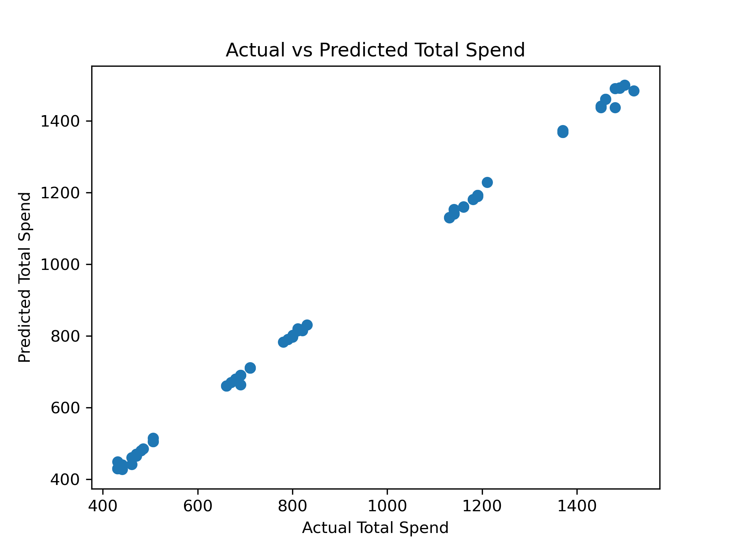
Actual vs Predicted Total Spend — Random Forest output

Appendix B
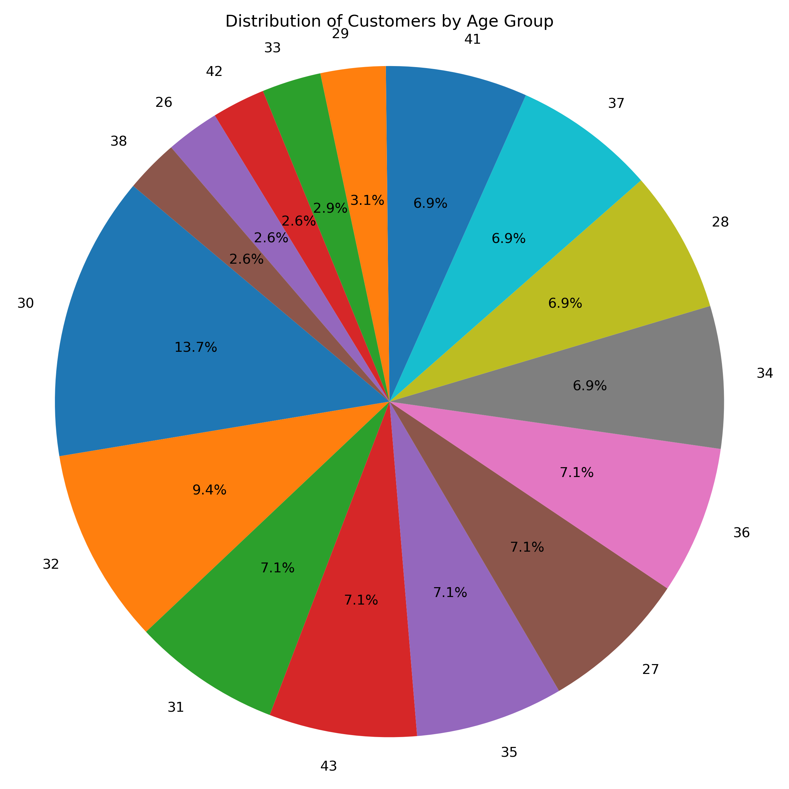
Distribution of Customers by Age Group
Appendix C
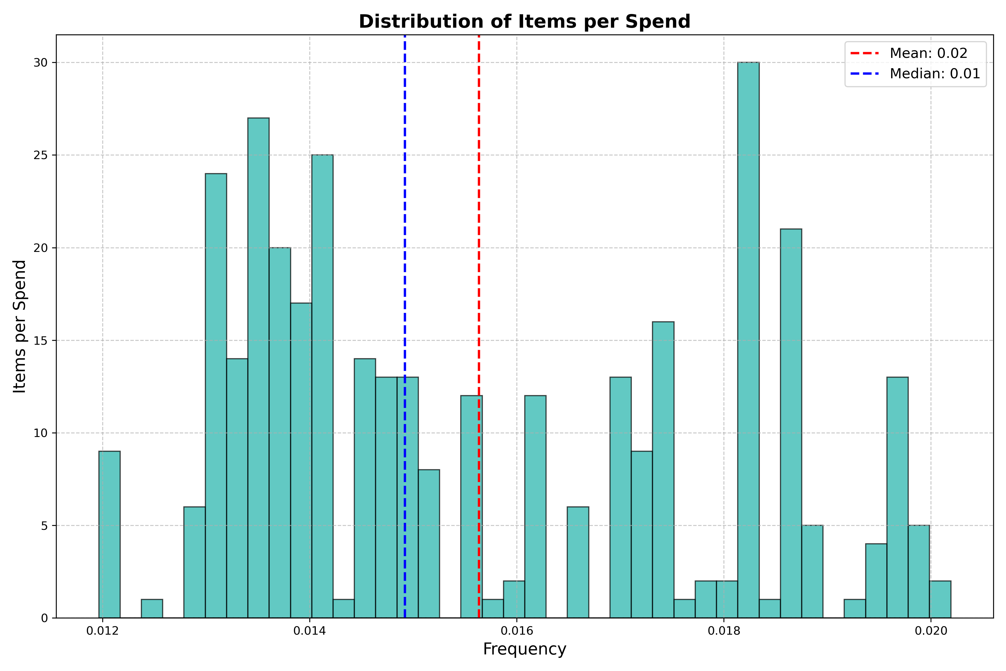
Distribution of Items per Spend
Appendix D
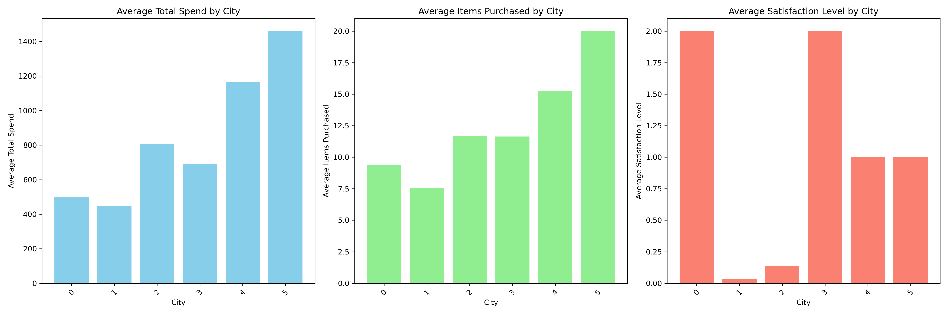
City-Based Aggregate Analysis
Appendix E
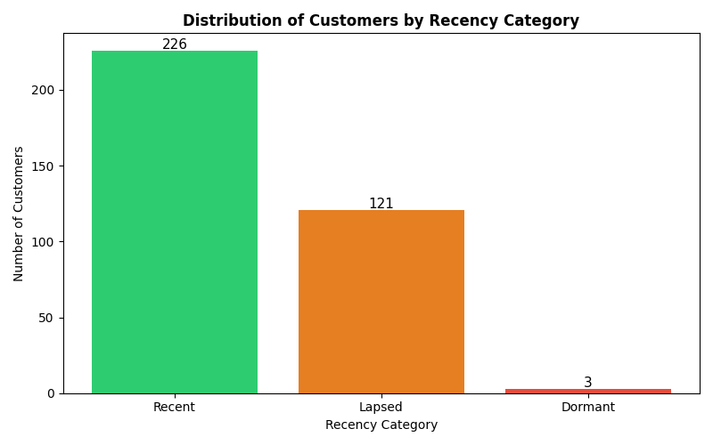
Distribution of Customers by Recency Category
Appendix F: AI Tool Interaction Screenshots

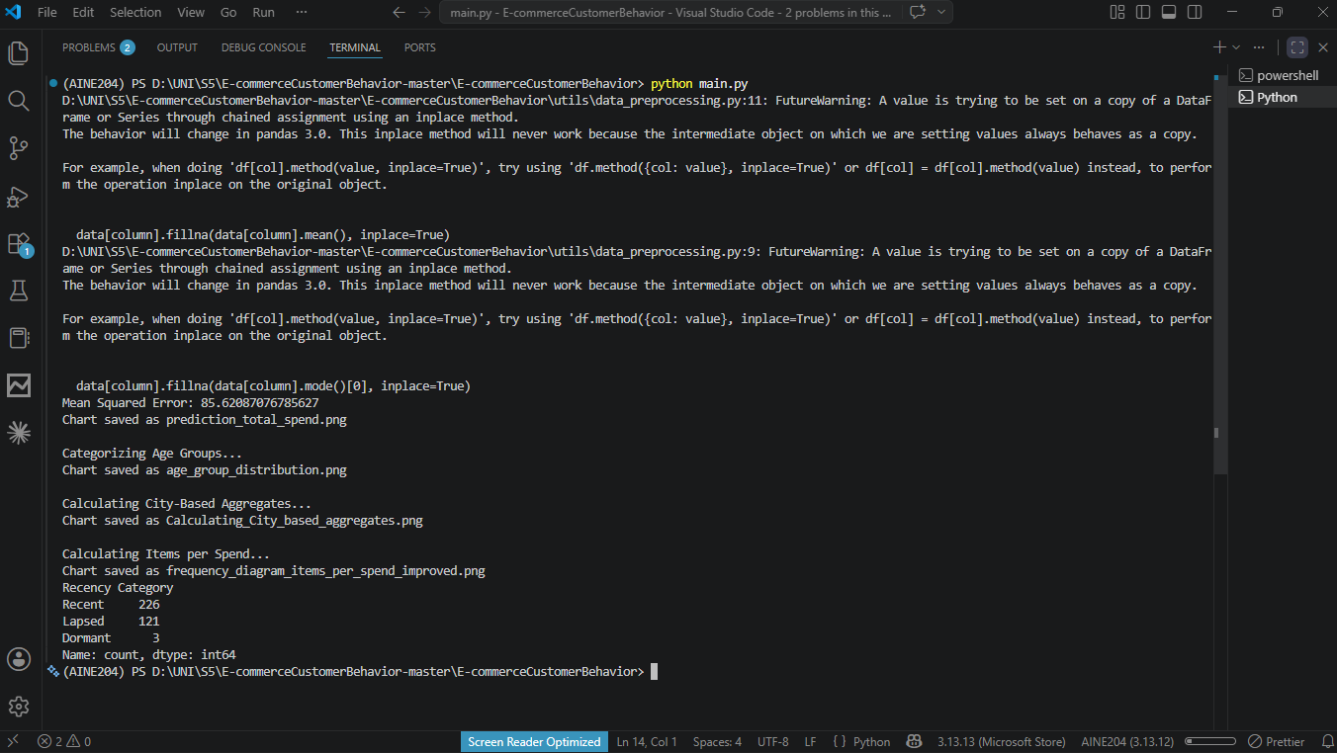
VSCode terminal — script running & MSE output

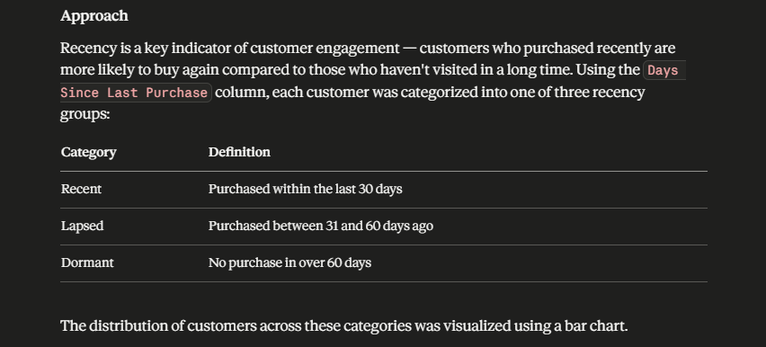
Claude AI screenshot — recency analysis

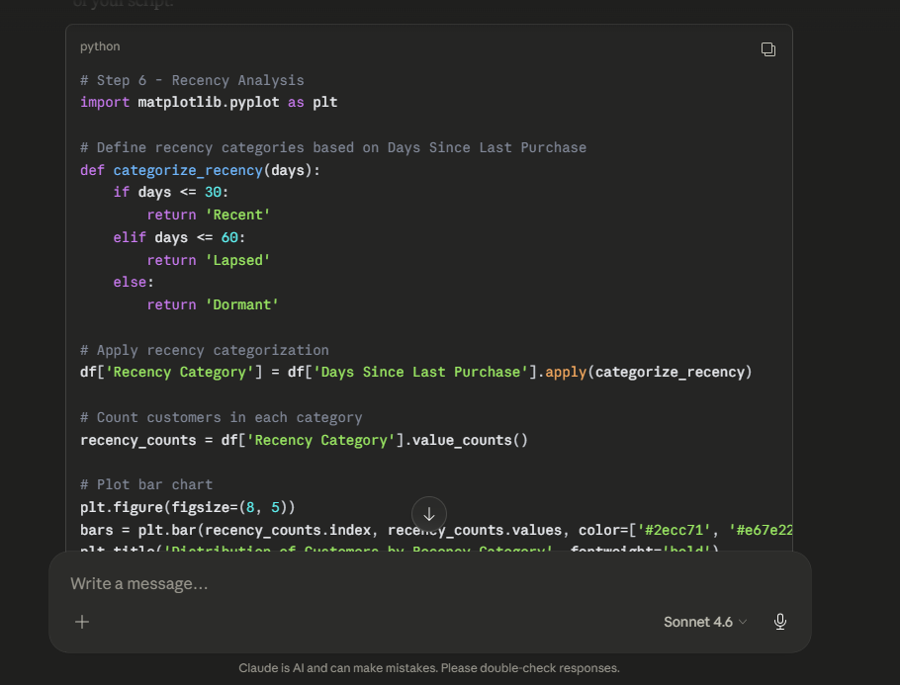
Claude AI screenshot — recency analysis chart plot code
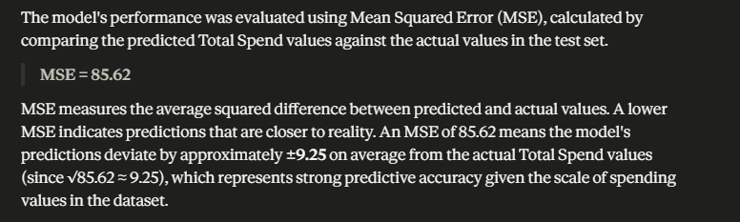
Claude AI screenshot —MSE Explain

