## horizontal line



MRNet

Team :

Mohamed Essam Mohamed ID : 3879

Mostafa Yousry ID : 4505

# Overview

The MRNet dataset consists of 1,370 knee MRI exams performed at Stanford University

Medical Center. The dataset contains 1,104 (80.6%) abnormal exams, with 319 (23.3%)

ACL tears and 508 (37.1%) meniscal tears; labels were obtained through manual

extraction from clinical reports.

# Goals

1- detect the patient suffering from (abnormal OR ACL OR meniscal tears)from different angle (Axial, Coronal, sagittal) and print the accuracy of this detect.

2- Build a deep CNN model to perform the classification.

3- Use Transfer Learning and ensemble.

4- Plot accuracy, F-score, and loss of both training and validation sets per

epoch.

# Steps :

1- Loading dataset using **glob.glob()**  and ***np.load()*** the sort the data set using **Sorted()**.

2- Extract each exam stack slice (Contain s slices) to 3 because most of model CNN accept only 3 channel .

3- Loading the labels of training data for each knee.

4-we use **InceptionV3**. model with shape 265*265*3.

5- get the output of the **InceptionV3** model "feature extraction" and add Dense layers so that the model is designed to classify our data.

6- freeze the layers and unfreeze the rest.

*7-* the loss function is binary_crossentropy as our labels are binary***(0|1)***

Adam optimizer use small learning rate(lr) to ***0.0001.***

8 - Using call back method to manage our model to calculate f_score.

9- *train the model with 2214 training data & 46 validation data.*

*save the model that has the min validation loss.*

*10 - plot the training loss & accuracy, validation loss & accuracy & F-score.*

11- Evaluate model.

12- *predict if the knee has an acl tear by using the data of the 3 knee angel (axial, coronal & sagittal) and the 3 models that accept one of these data and predict if the knee has an* ***abnormal tear or not*** *or* ***has acl or not*** *or* ***has meniscus*** *tear or not*  *by doing a majority voting between the 3 models*

# Screenshot :

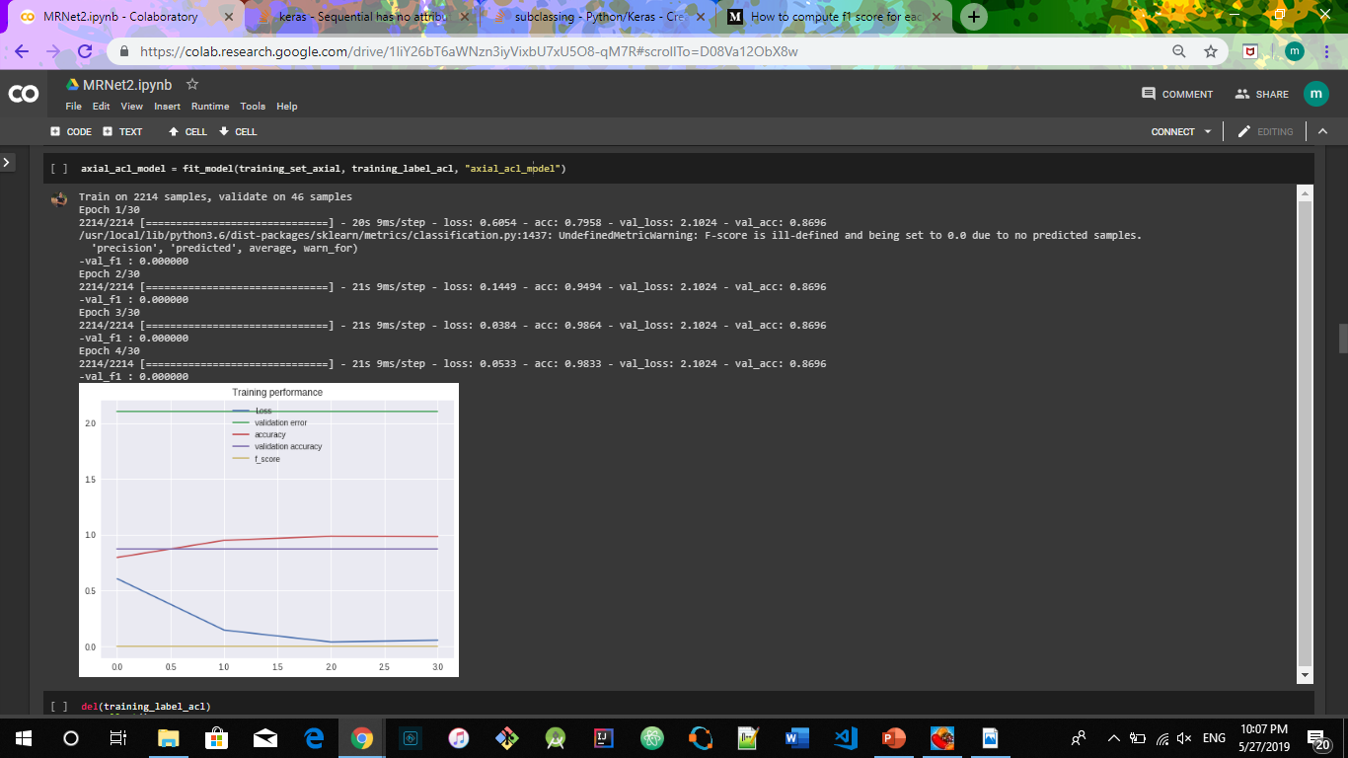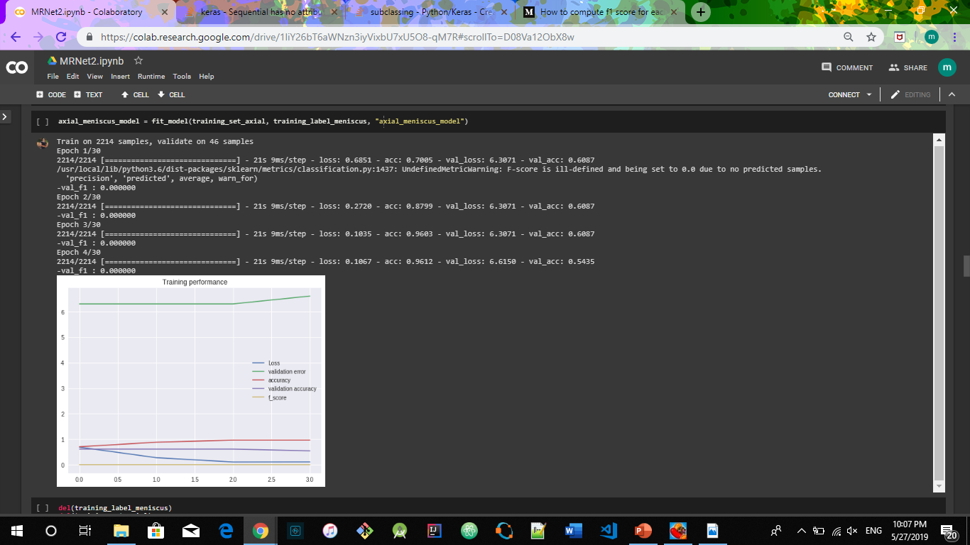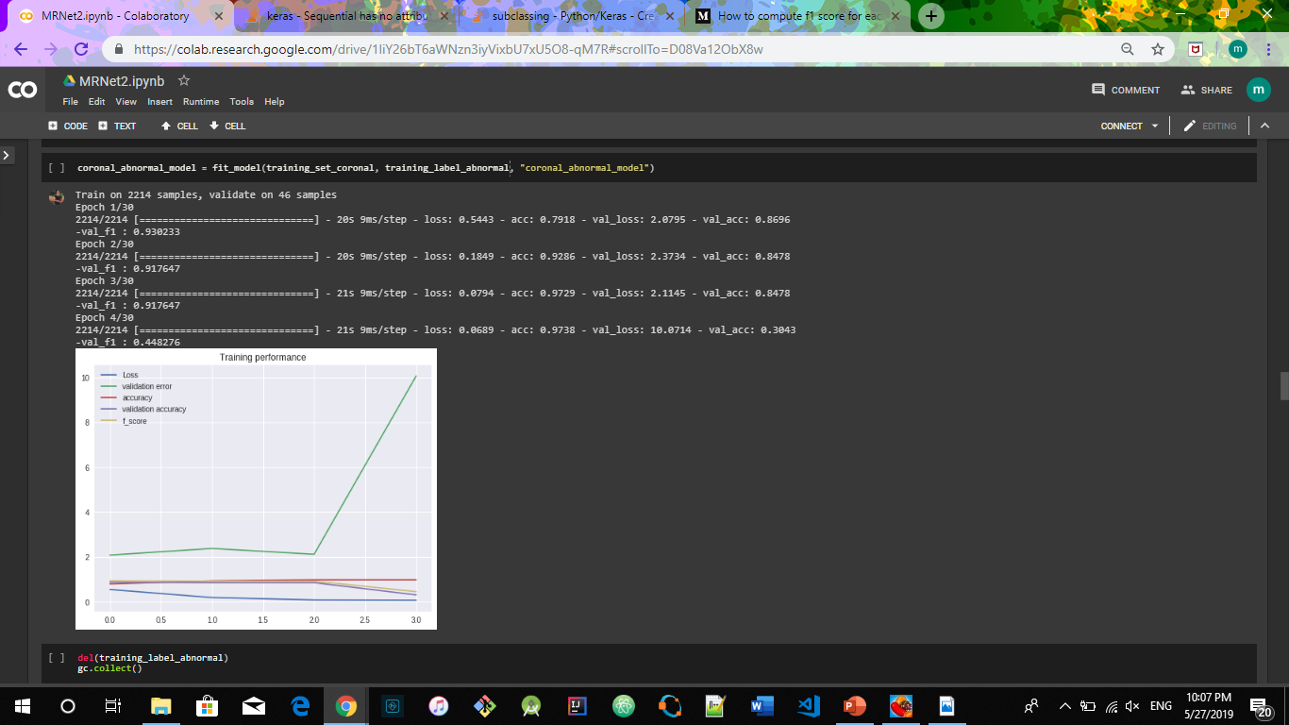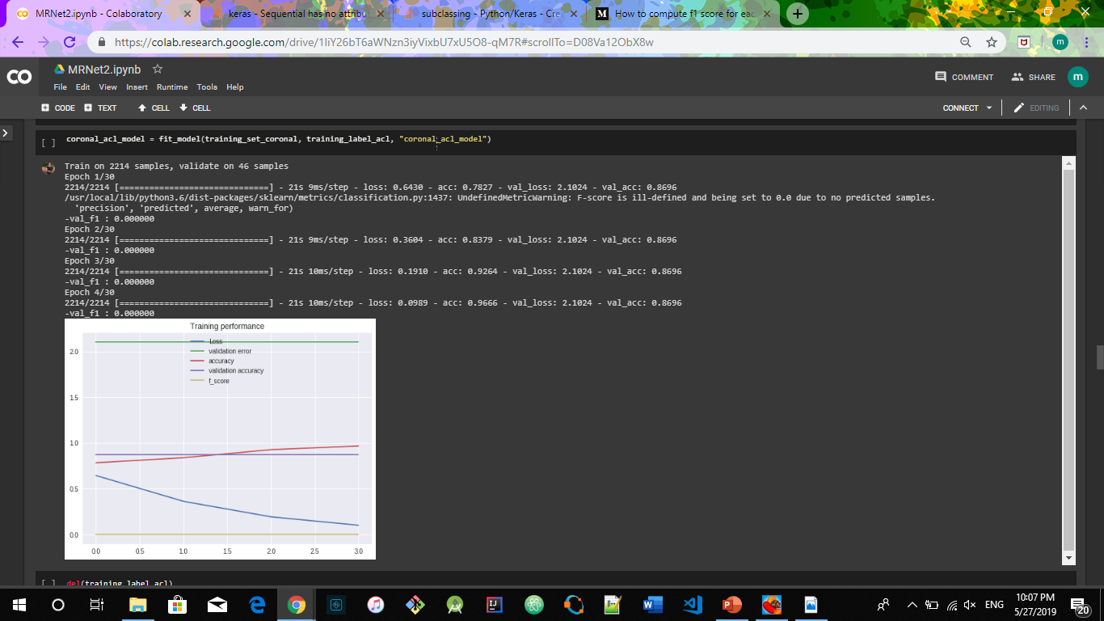

***Our Accuracy to predict :***

***1- abnormal : 79.16666666666666***

***2- ACL : 55.00000000000001***

***3- meniscus*** *:* ***56.666666666666664***