**Task – 7**

Linux Games – Over the wire – Bandit

Name – Mohamed Faheem M

Roll no. – 21029

**Level 0:**

**Password – bandit0**

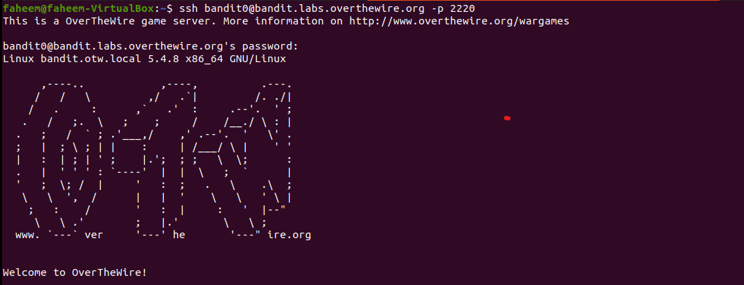

**Level 0 🡪 Level 1:**

**Password - boJ9jbbUNNfktd78OOpsqOltutMc3MY1**

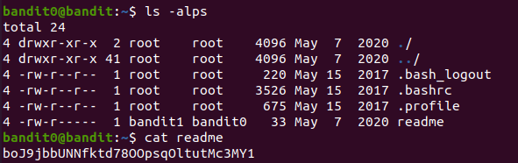

**Level 1 🡪 Level 2:**

**Password – CV1DtqXWVFXTvM2F0k09SHz0YwRINYA9**

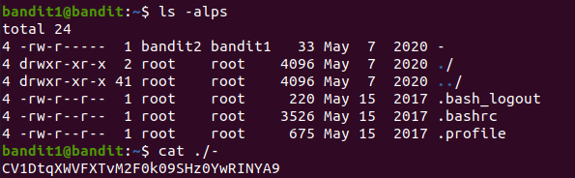

**Level 2 🡪 Level 3:**

**Password – UmHadQclWmgdLOKQ3YNgjWxGoRMb5luK**

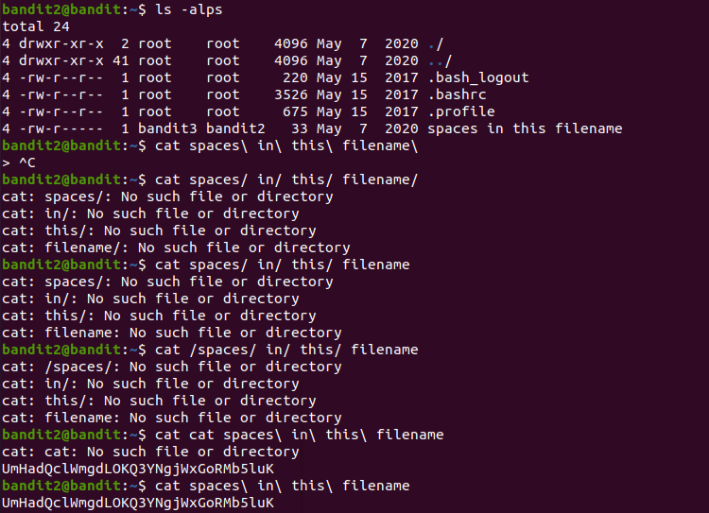

**Level 3 🡪 Level 4:**

**Password - pIwrPrtPN36QITSp3EQaw936yaFoFgAB**

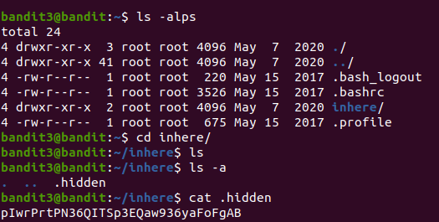

**Level 4 🡪 Level 5:**

**Password – koReBOKuIDDepwhWk7jZC0RTdopnAYKh**

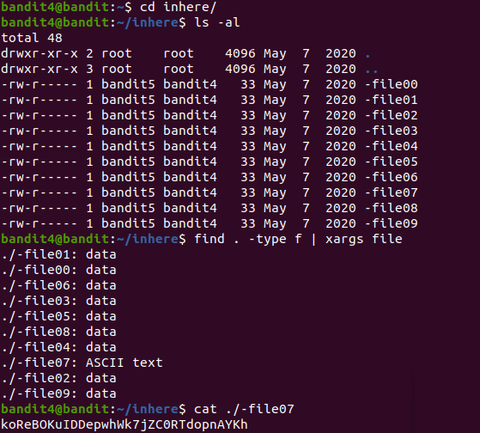

**Level 5 🡪 Level 6:**

**Password - DXjZPULLxYr17uwoI01bNLQbtFemEgo7**

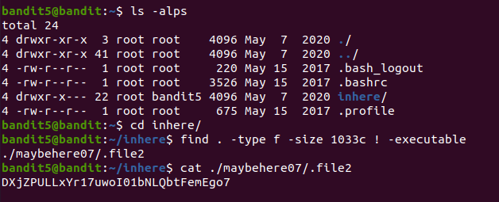

**Level 6 🡪 Level 7:**

**Password - HKBPTKQnIay4Fw76bEy8PVxKEDQRKTzs**

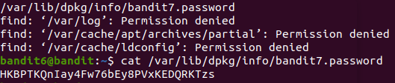

**Level 7 🡪 Level 8:**

**Password - cvX2JJa4CFALtqS87jk27qwqGhBM9plV**



**Level 8 🡪 Level 9:**

**Password – UsvVyFSfZZWbi6wgC7dAFyFuR6jQQUhR**





**Level 9 🡪 Level 10:**

**Password - truKLdjsbJ5g7yyJ2X2R0o3a5HQJFuLk**

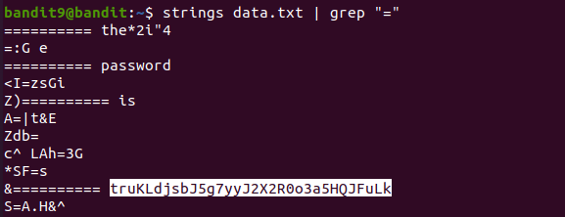

**Level 10 🡪 Level 11:**

**Password - IFukwKGsFW8MOq3IRFqrxE1hxTNEbUPR**

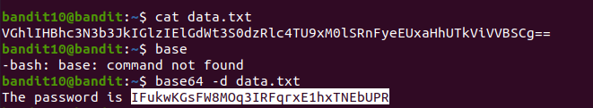

**Level 11 🡪 Level 12:**

**Password - 5Te8Y4drgCRfCx8ugdwuEX8KFC6k2EUu**



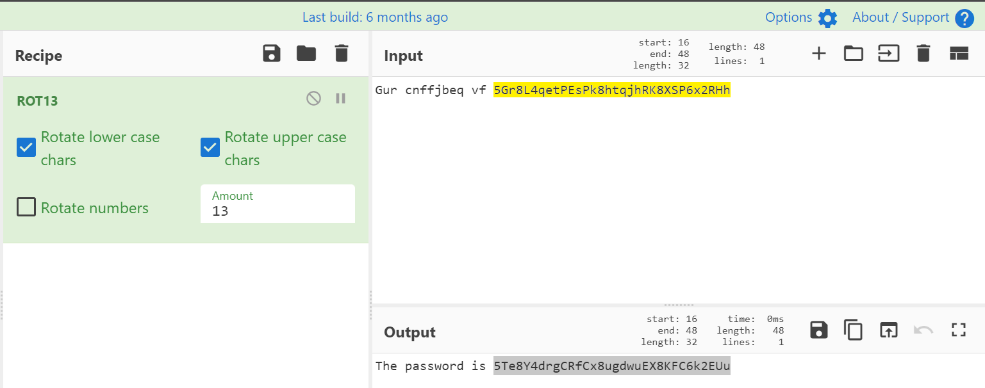

**Level 12 🡪 Level 13:**

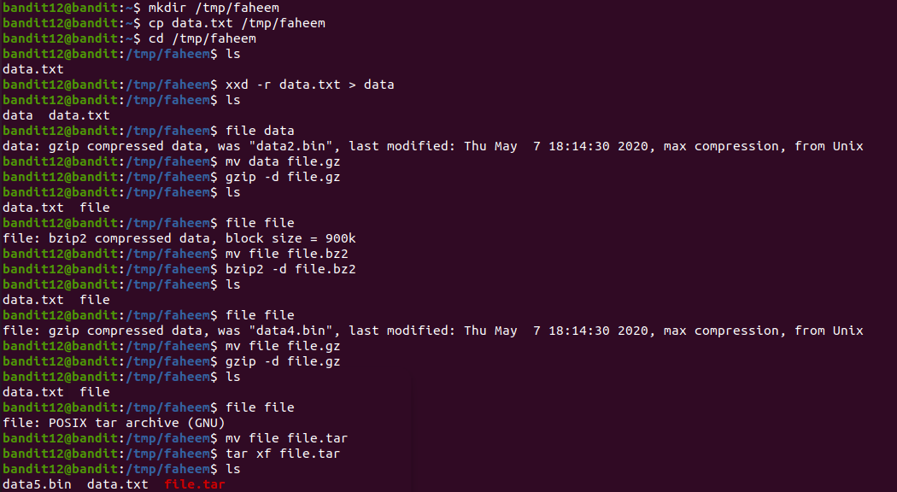**Password - 8ZjyCRiBWFYkneahHwxCv3wb2a1ORpYL**

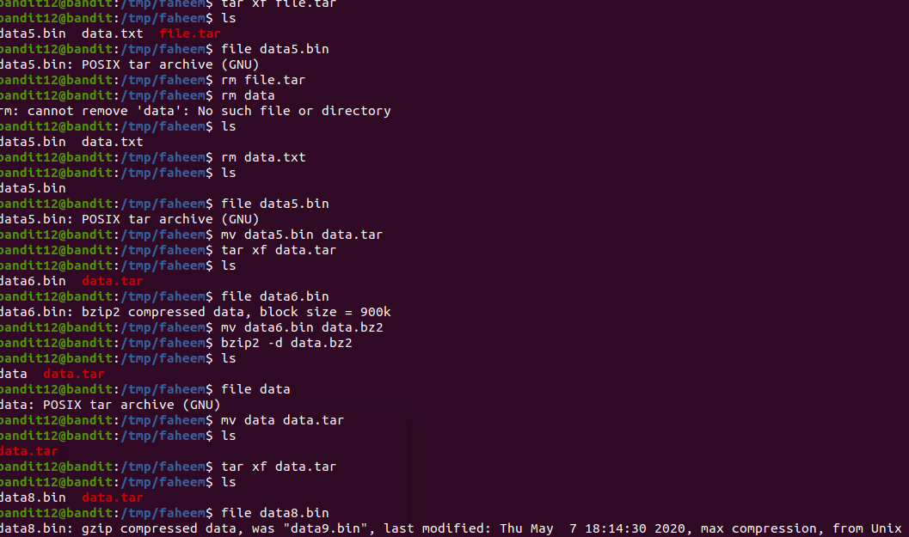

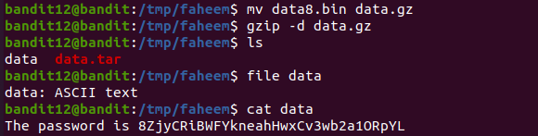

Level 13 🡪 Level 14:

Password - 4wcYUJFw0k0XLShlDzztnTBHiqxU3b3e



Level 14 🡪 Level 15:

Password - BfMYroe26WYalil77FoDi9qh59eK5xNr

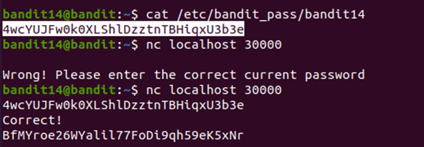

Level 15 🡪 Level 16:

Password – cluFn7wTiGryunymYOu4RcffSxQluehd

