**Task – 8**

Name – Mohamed Faheem

Roll no. – CH.EN.U4AIE21029

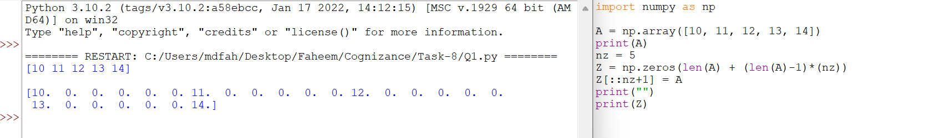**Question 1 – Output:**

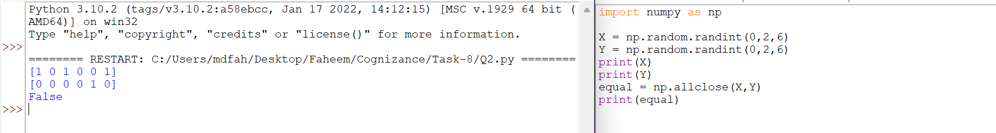**Question 2 – Output:**

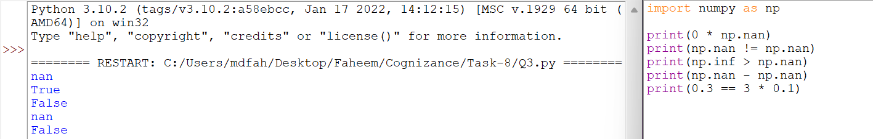**Question 3 – Output:**

**Question 4 – Output:**

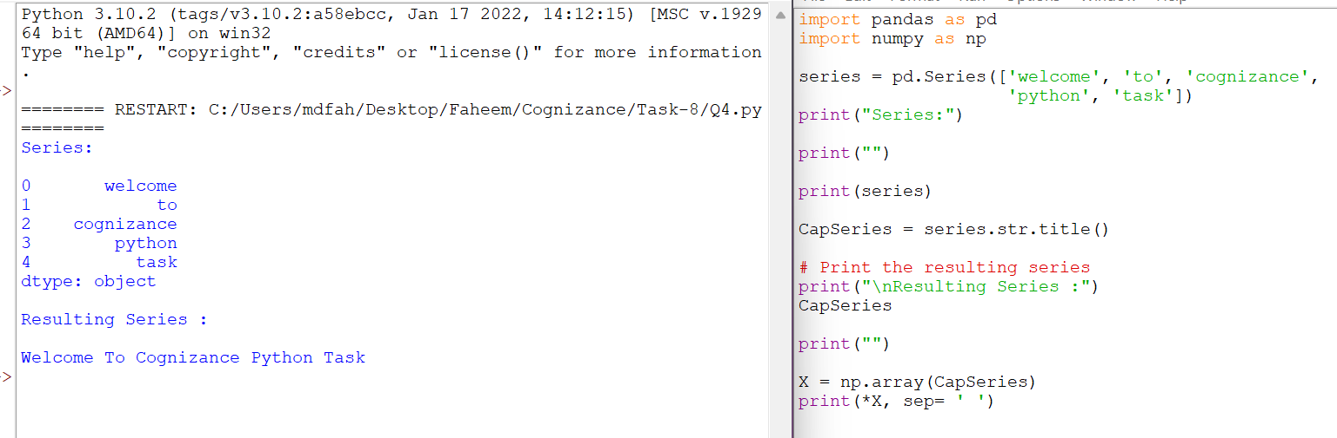

**Question 5 – Output:**

