**Title:**

Covid 19 Vaccine Analysis.

**Abstract:**

COVID-19 vaccine analysis involves the comprehensive examination of vaccine development, distribution, efficacy, safety, public perception, global collaboration, policy considerations, and their impact on public health and economies. It's a dynamic process crucial for navigating the complexities of the pandemic and ensuring equitable access to vaccines.

**Problem Statement:**

The problem statement for COVID-19 vaccine analysis highlights critical challenges, including vaccine efficacy against emerging variants, equitable distribution, public hesitancy, safety monitoring, regulatory adaptability, economic and societal impact assessment, global collaboration, and ethical considerations. This analysis is essential to ensure effective pandemic control and a successful vaccination campaign on a global scale.

**Phase Of Development:**

Certainly, here's a concise summary of the key components and steps involved in a COVID-19 vaccine analysis model:

Data Collection:

Gather comprehensive data on COVID-19 vaccines, including clinical trial results, real-world effectiveness, safety data, and distribution information.

Data Preprocessing:

Clean, format, and integrate data sources to make them suitable for analysis. Handle missing or inconsistent data.

Exploratory Data Analysis (EDA):

Explore the data through statistical summaries, visualizations, and basic insights to understand the dataset's characteristics.

Vaccine Efficacy Analysis:

Assess vaccine effectiveness in preventing COVID-19 infections, severe cases, and hospitalizations. Consider various vaccine types and their performance against emerging variants.

Safety Analysis:

Examine and analyze reports of adverse events related to the vaccine, categorize them, and assess their severity and frequency.

Geospatial Analysis:

Analyze vaccine distribution and coverage across different regions to identify areas with low vaccination rates or disparities.

Time Series Analysis:

Investigate the temporal trends in vaccine coverage and efficacy. Consider the evolution of these metrics over time.

Hypothesis Testing:

Formulate hypotheses related to vaccine efficacy and safety, then use statistical tests to confirm or reject them.

Machine Learning Models:

Develop machine learning models to predict vaccine coverage, analyze adverse event trends, or assess factors affecting vaccine efficacy.

Data Visualization:

Create informative charts, graphs, and maps to present findings and insights in a visually engaging manner.

Reporting and Communication:

Summarize the analysis in a clear and concise report or presentation, providing actionable recommendations based on the results.

Ethical Considerations:

Address ethical concerns related to data privacy, informed consent, and responsible data usage throughout the analysis.

Continuous Monitoring:

Implement ongoing data collection and analysis procedures to track vaccine performance and adapt to changing circumstances.

This summary covers the essential steps in a COVID-19 vaccine analysis model, which aims to provide insights into the efficacy, safety, and impact of COVID-19 vaccines on public health. The analysis is a dynamic process that may evolve as new data becomes available and the global situation changes.

Program: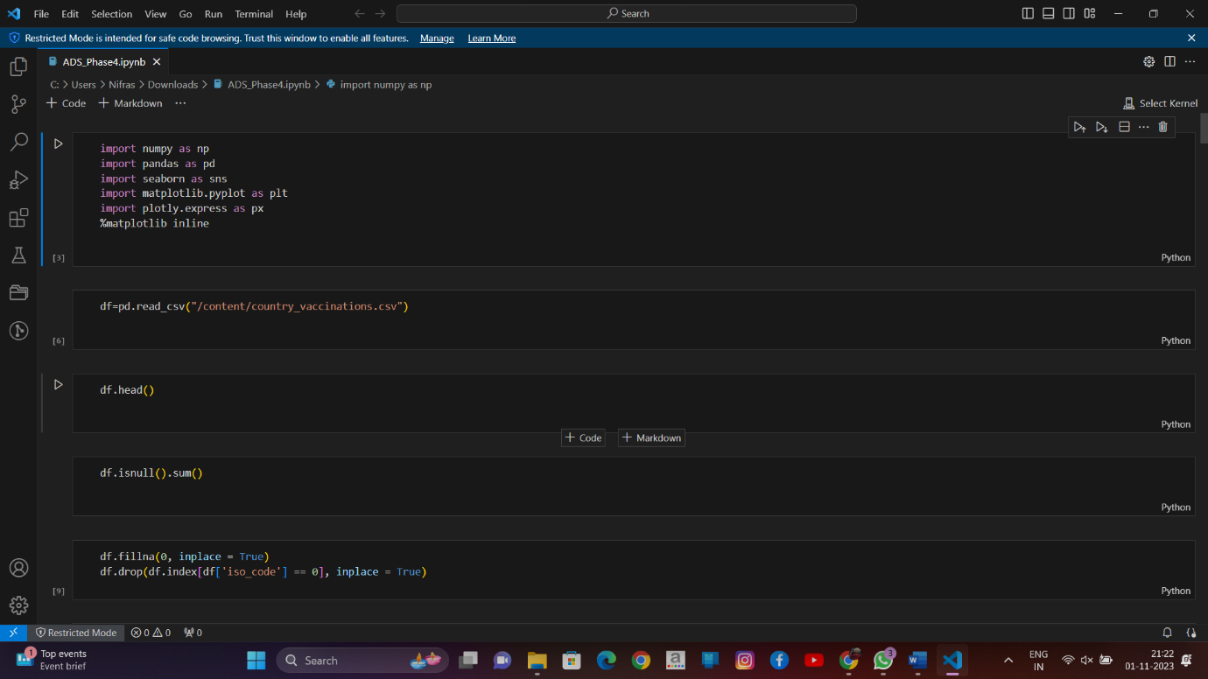

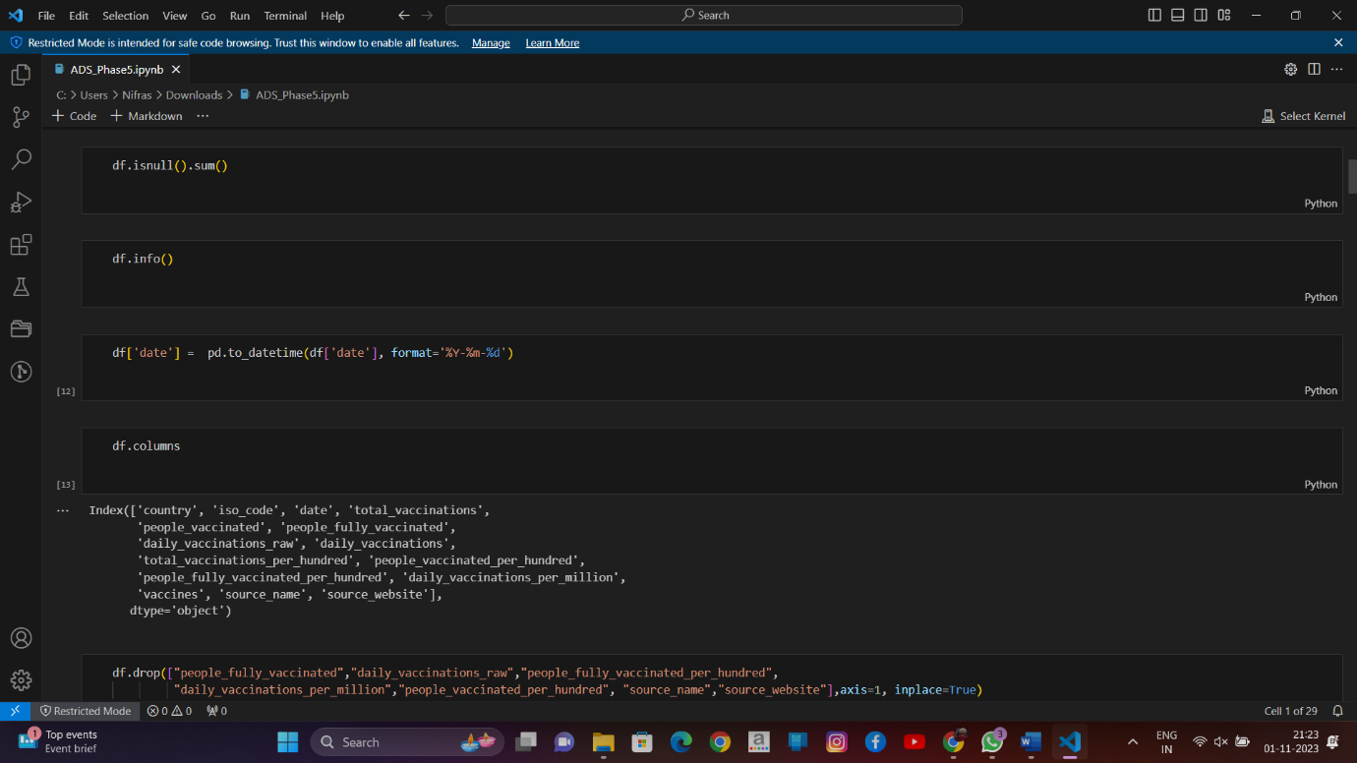

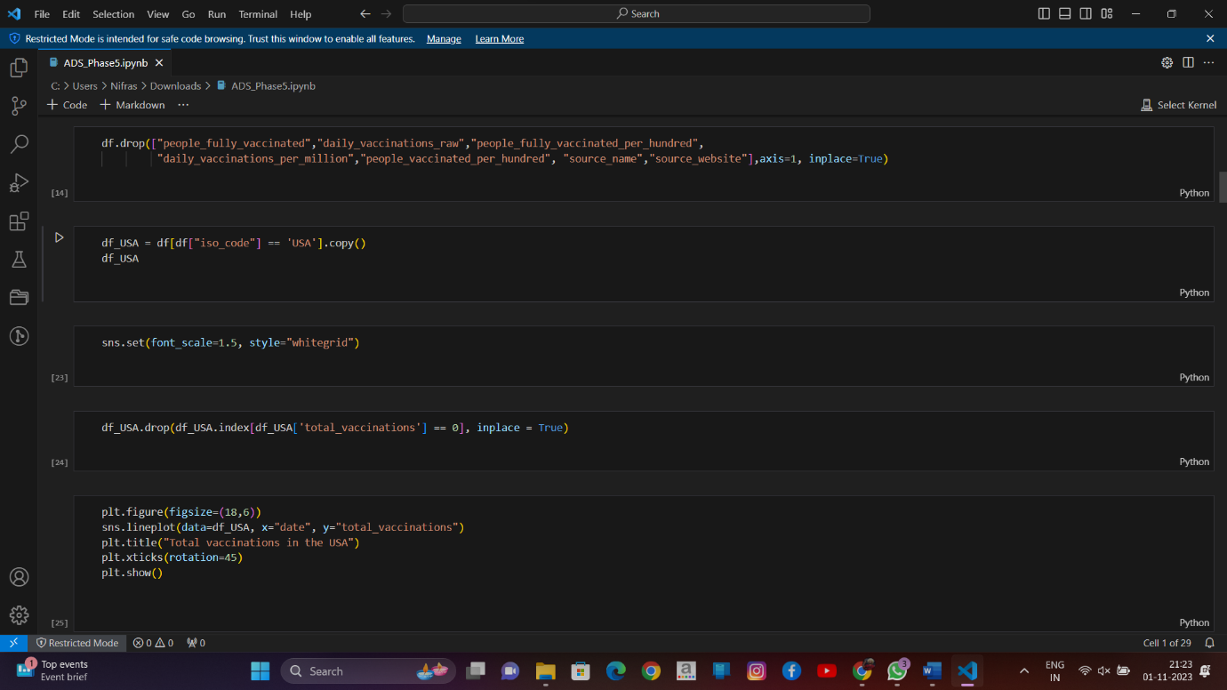

y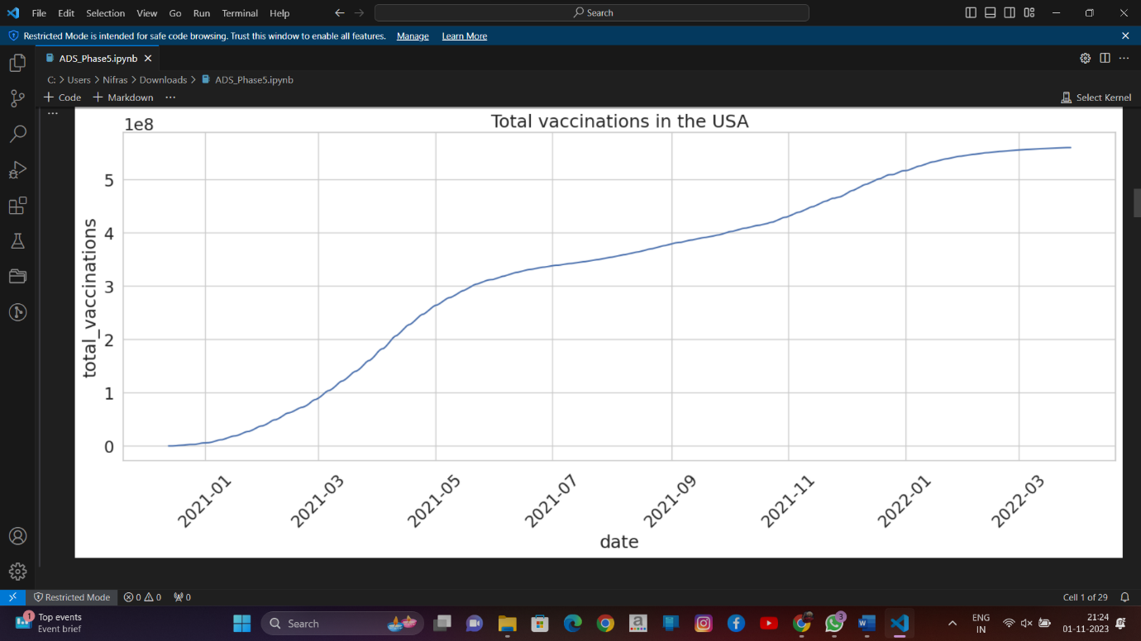

0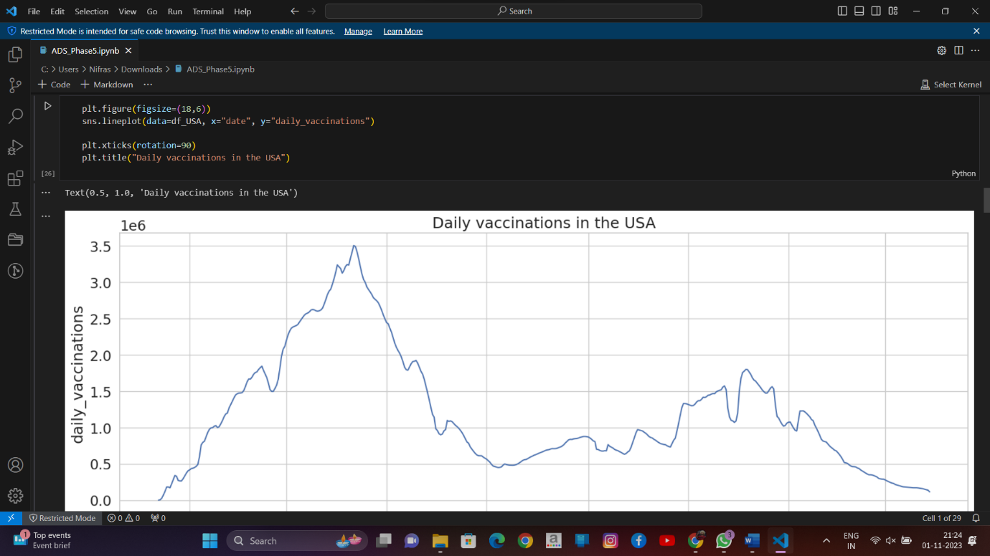

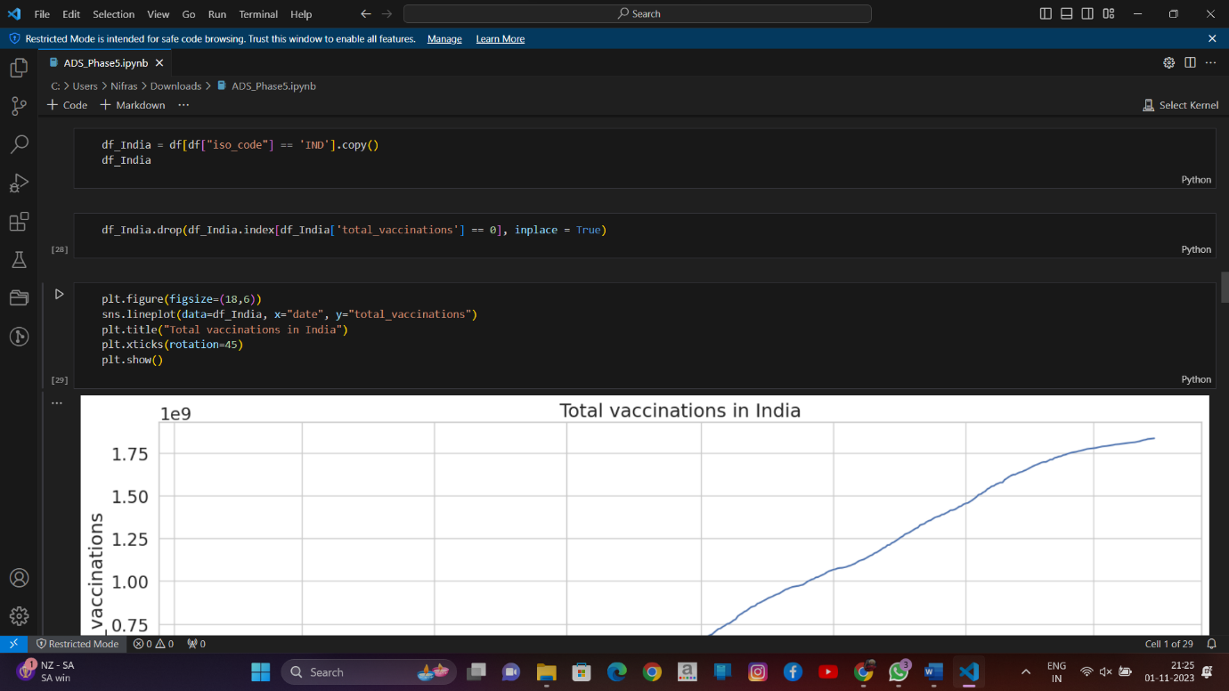

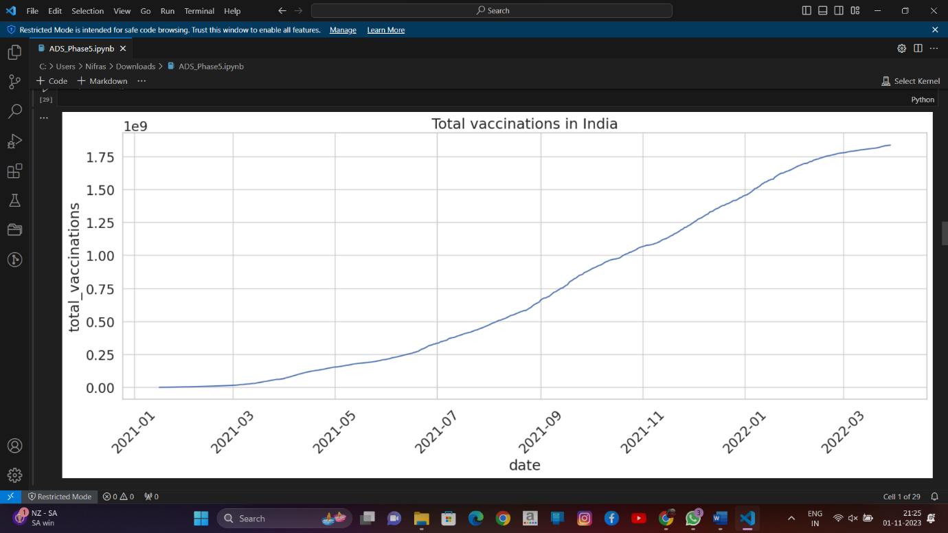

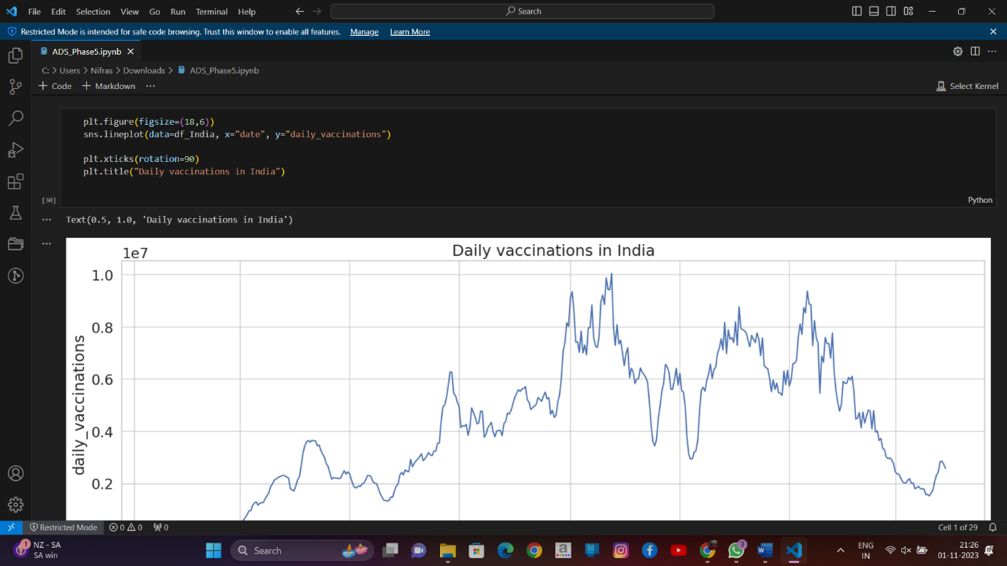

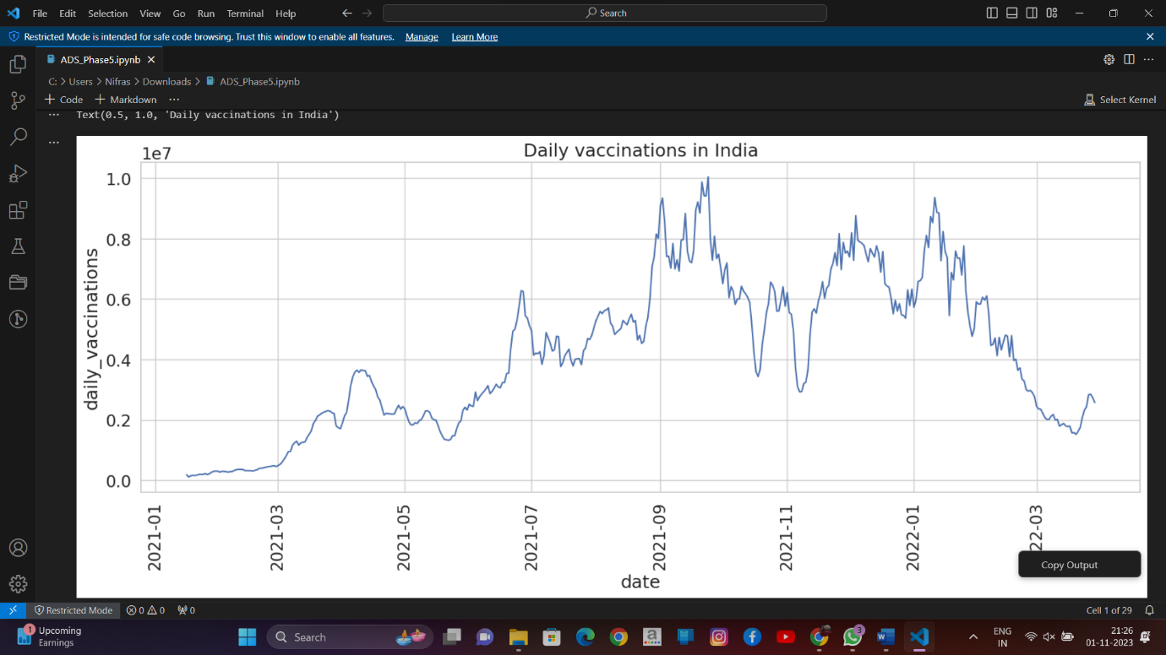

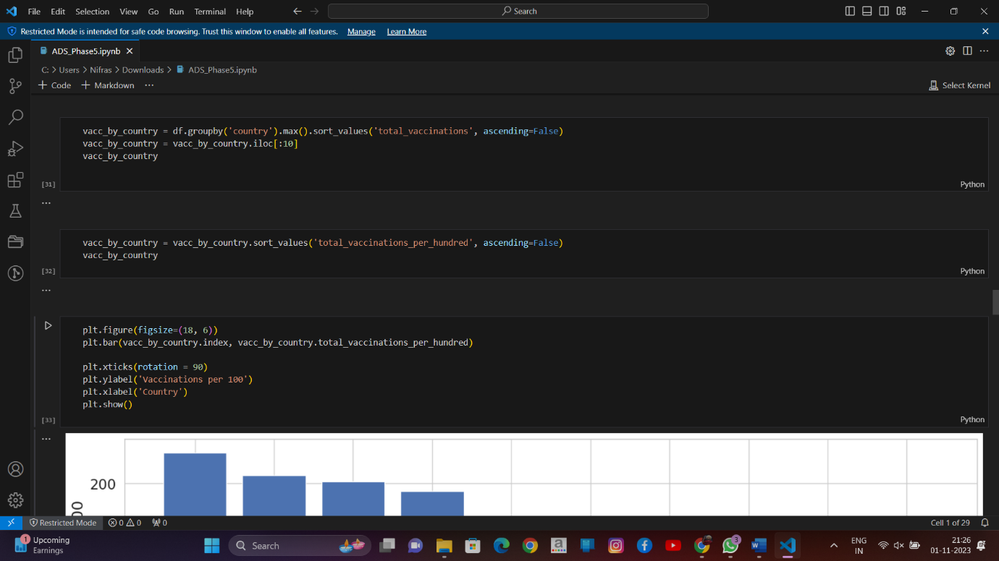

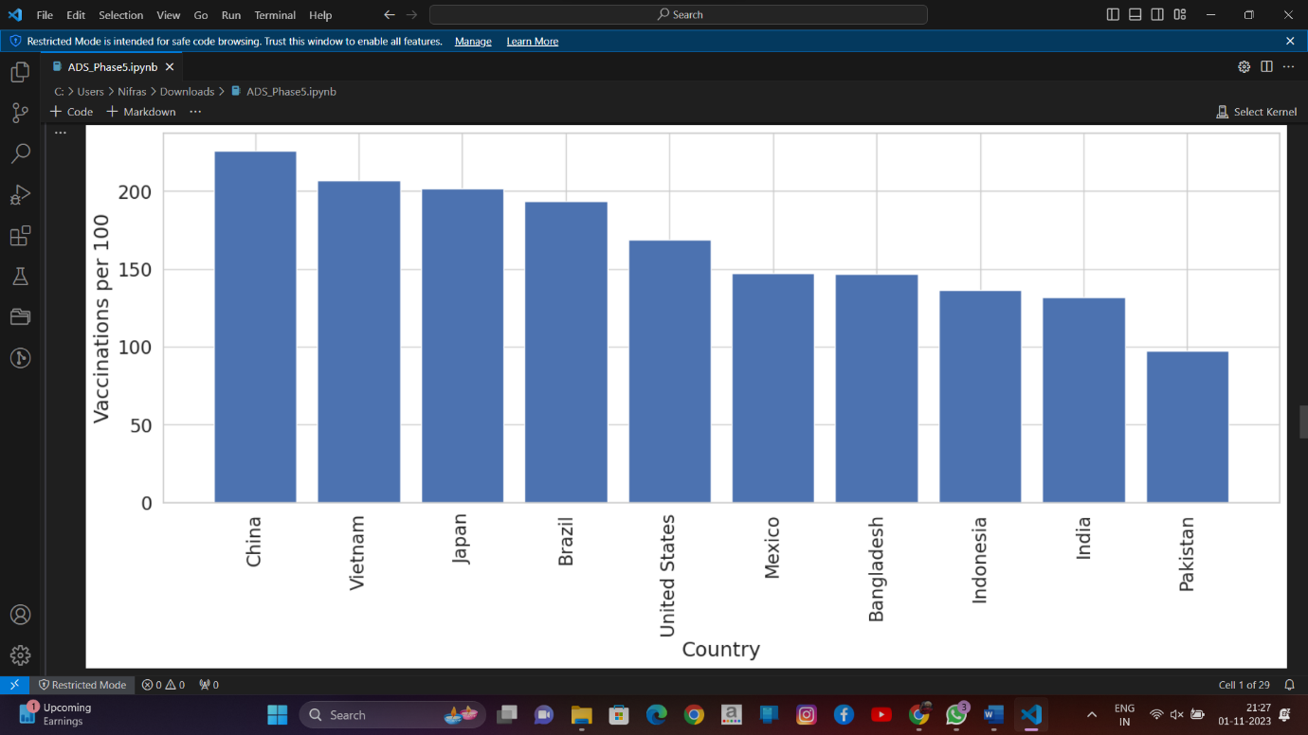

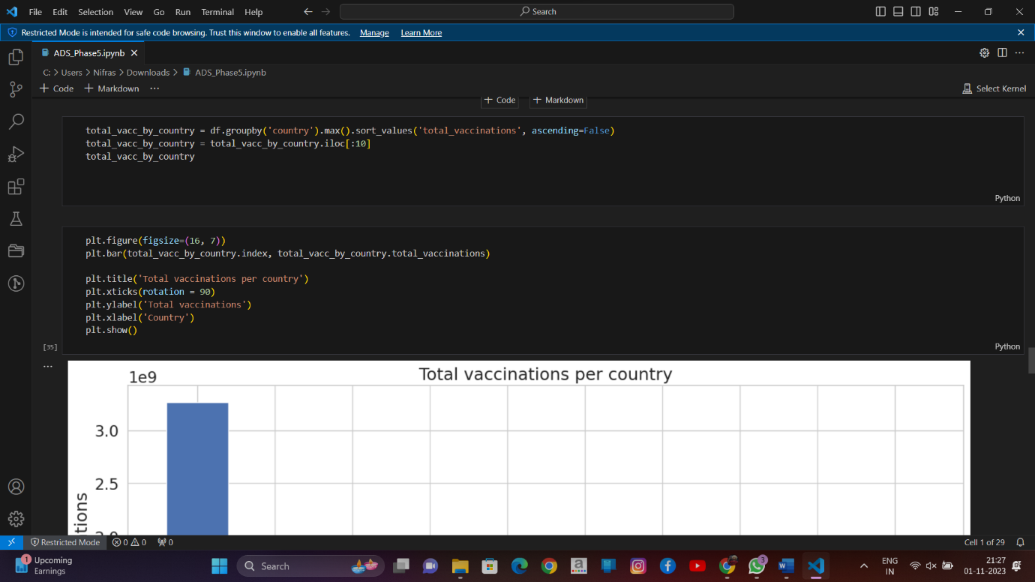

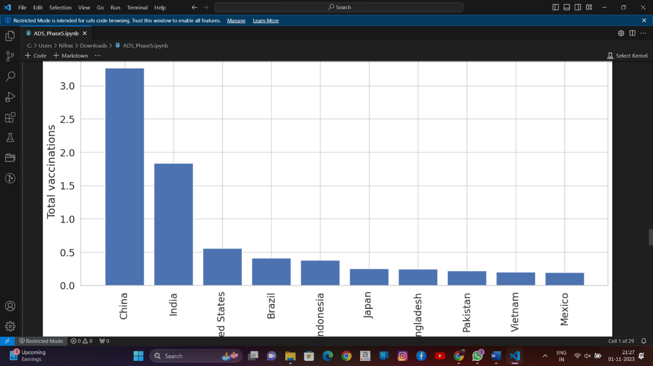

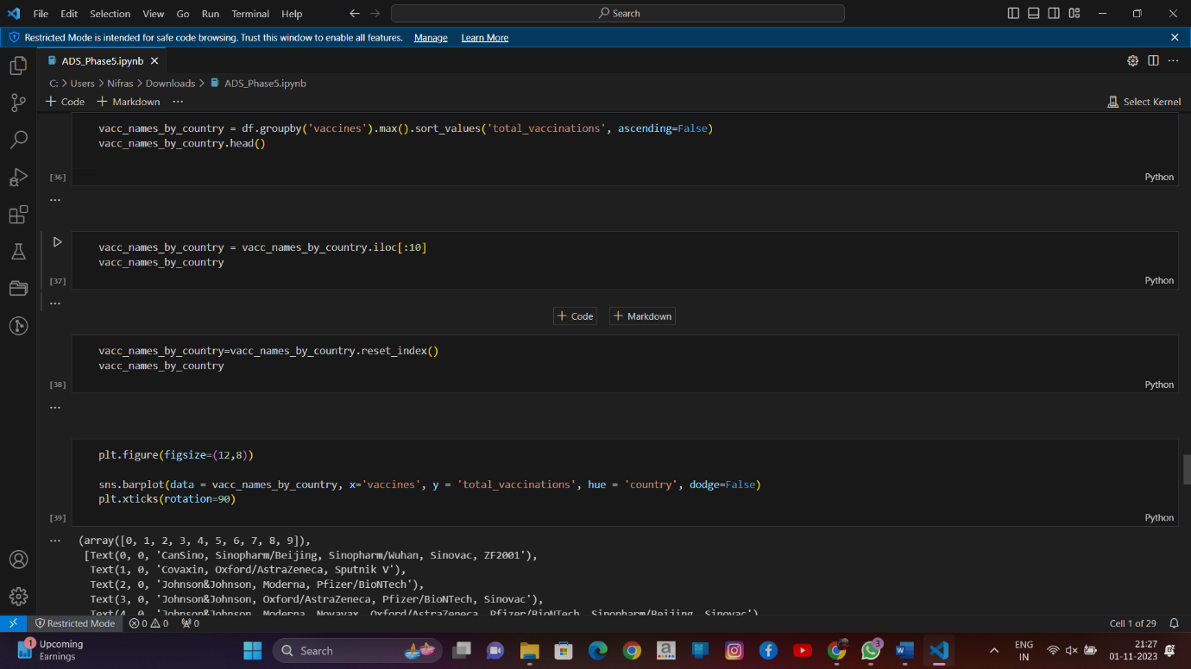

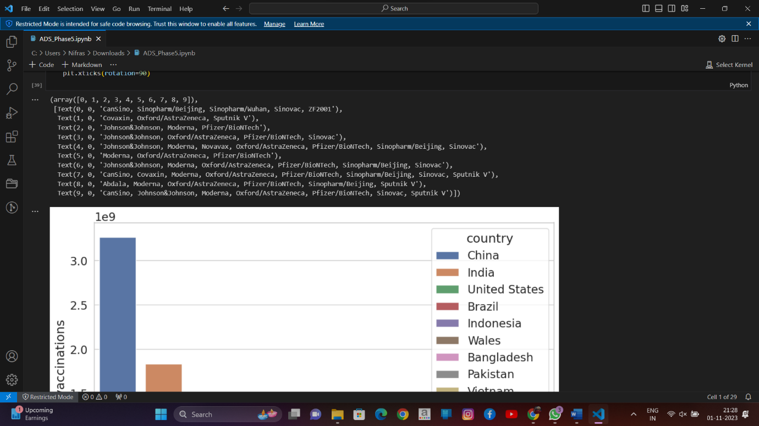

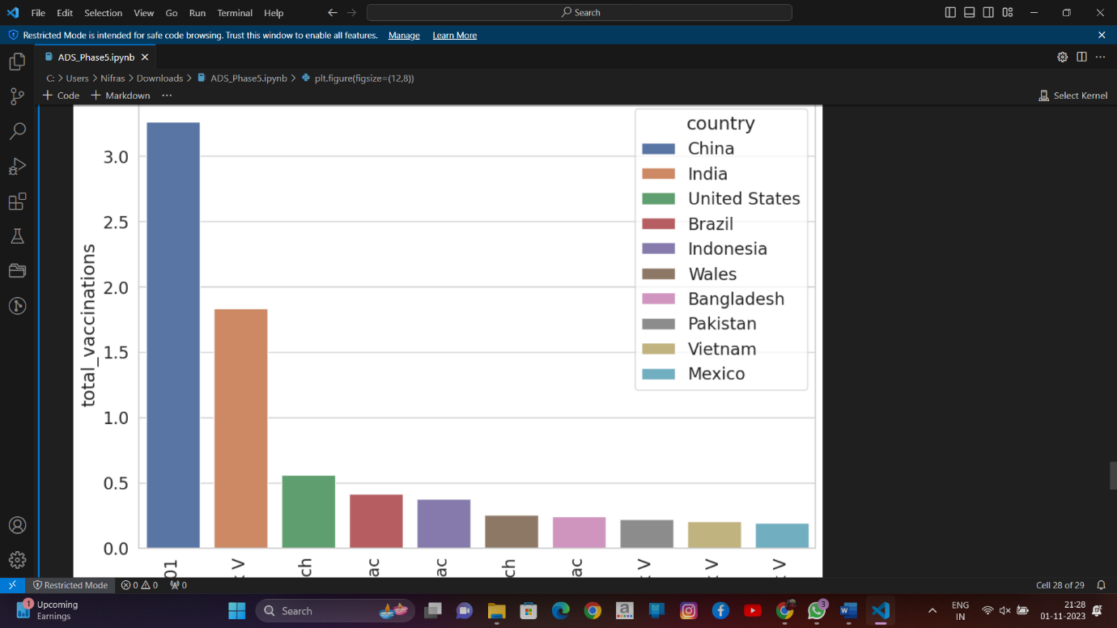

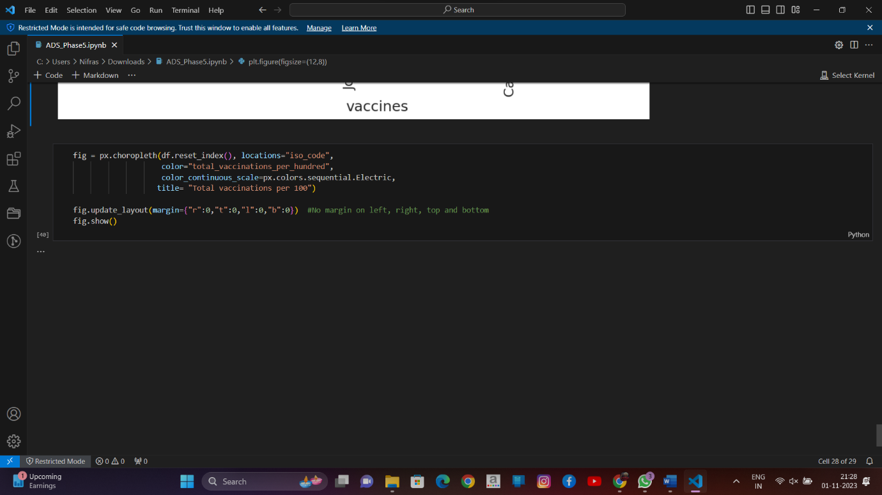

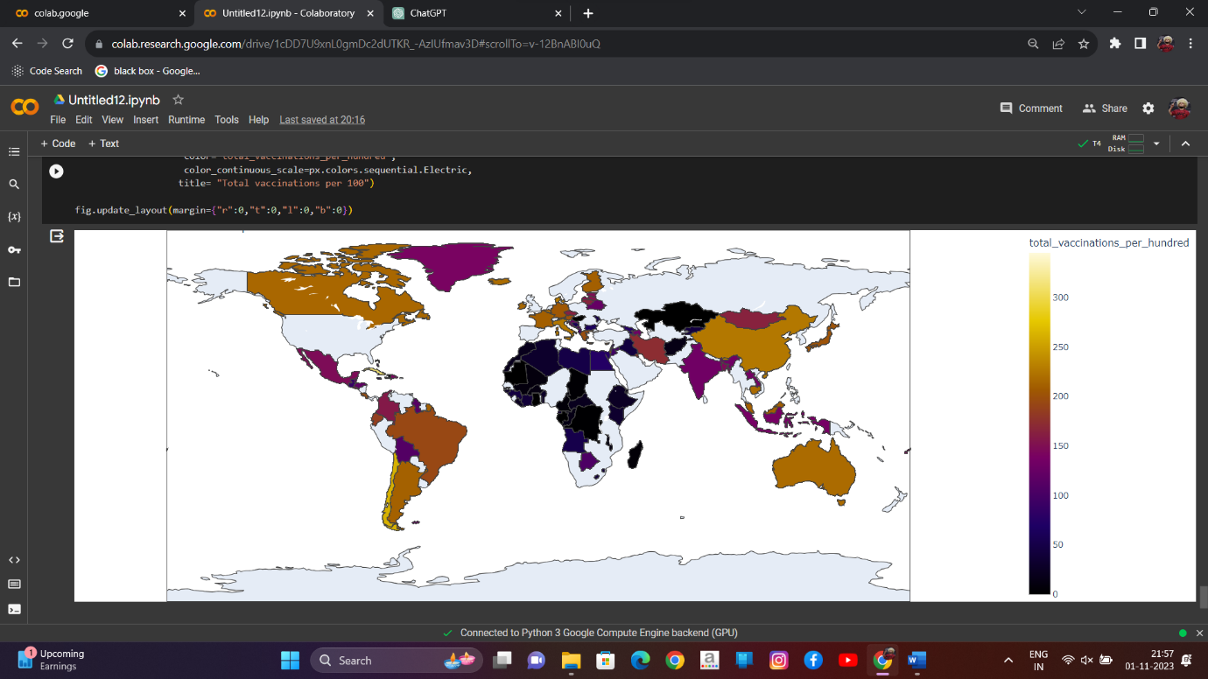

Conclusion:

In conclusion, COVID-19 vaccines have proven effective in reducing the spread of the virus, preventing severe illness, and saving lives. However, challenges such as vaccine hesitancy, global disparities in distribution, and ongoing research on long-term protection remain. Vaccine safety has generally been confirmed, and booster doses have been administered to address variant concerns.