

Project 1 Learn in Depth
  - Pressure Detection System
Mohamed Fathalla Ahmed | Mastering Embedded Systems | 05.08.2024
Table of Contents
Case Study 2
Methodology 2
Requirement Diagram 3
System Analysis / Use Case Diagram 3
Activity Diagram 4
Sequence Diagram 5
System / Software Design 6
State Diagrams: 7
• Pressure Sensor Diver 7
• Pressure Detection Main Functionality 8
• Alarm handling 9
• Pressure Alarm Driver 10
Software Implementation 11
System Verification with Proteus Simulation 12

Case Study
For this project, the use case is defined as follows: a pressure controller shall inform an airplane cabin crew with an alarm when the pressure will exceed 20 bar.
The alarm duration should be 60 seconds.
A nice to have feature is to keep track or rather save the measured values into the memory.
For this use case a system has to be designed to fulfill this use case.
In order to have a clear definition of the use case, these main assumptions have been taken into consideration:
- The system maintenance is not included.
- The pressure sensor never fails.
- The alarm never fails.
- The system never faces power cut.
The system setup and shutdown procedures are not modeled.

Methodology
In order to develop a proper system, one of software development life cycle models has to be followed. In this project, the V-Model has been chosen to be used and followed, since it has a lot of advantages that help us have a proper methodology to achieve the project goals.
In this following section, we start from the left side of the V-Model with requirements elicitation and management in way that is clear for all parties (customer & supplier), and then moving forward to the next phases of documentations using Unified Modelling Language UML. This is used as common language, to illustrate the main aspects of the projects till detailed design. Finally, simulations of the entire system have been performed that ensure the proper functionality of the entire software design.

Requirement Diagram
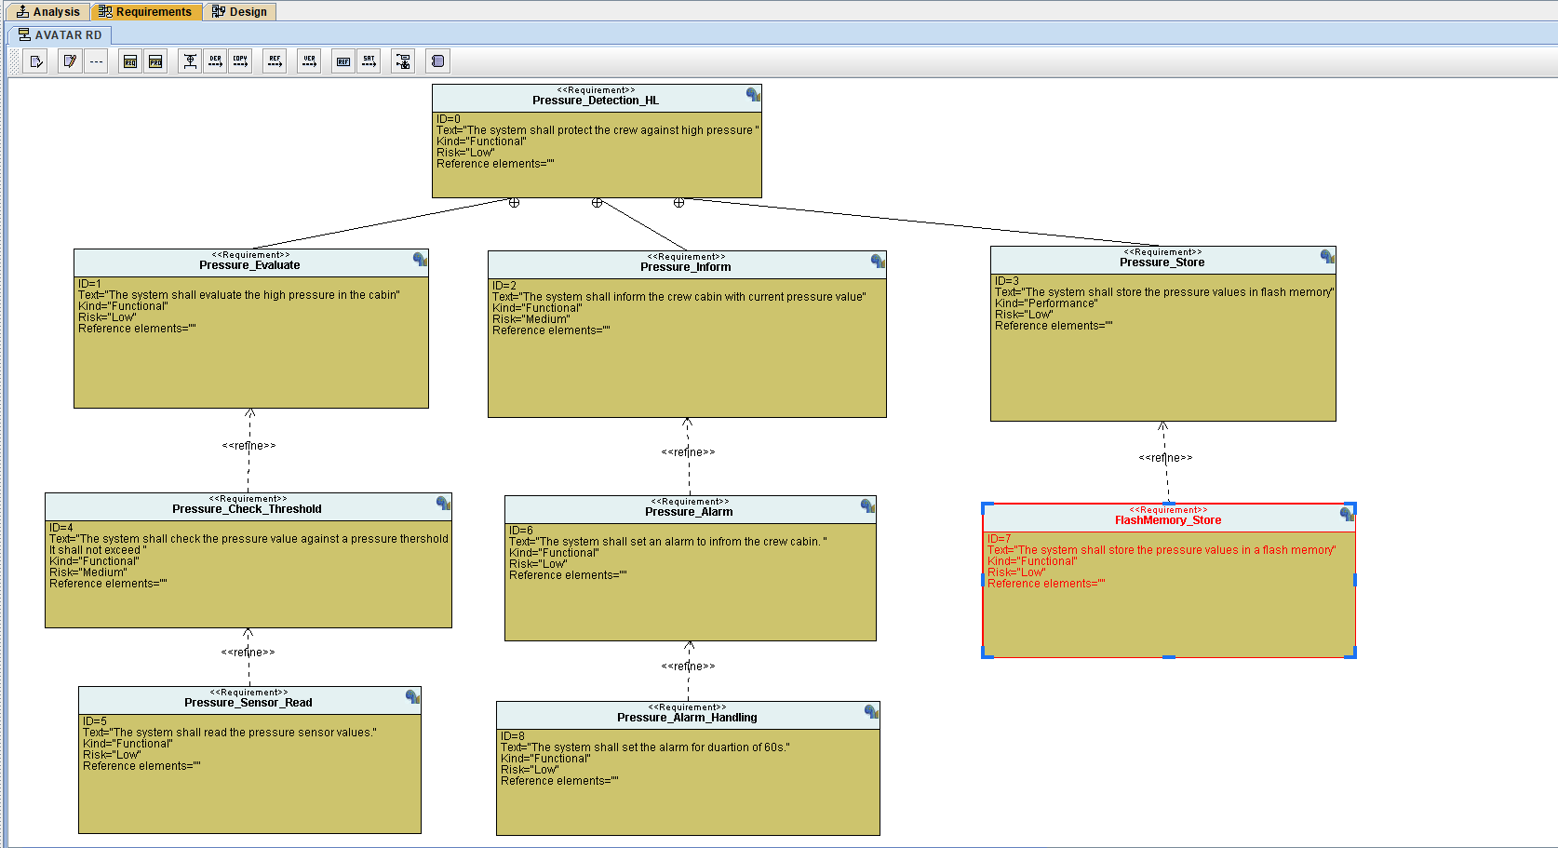

System Analysis / Use Case Diagram
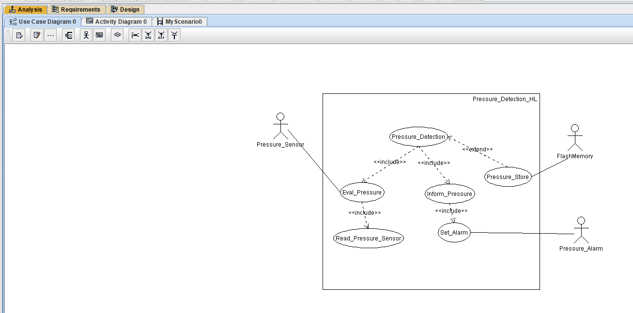

Activity Diagram
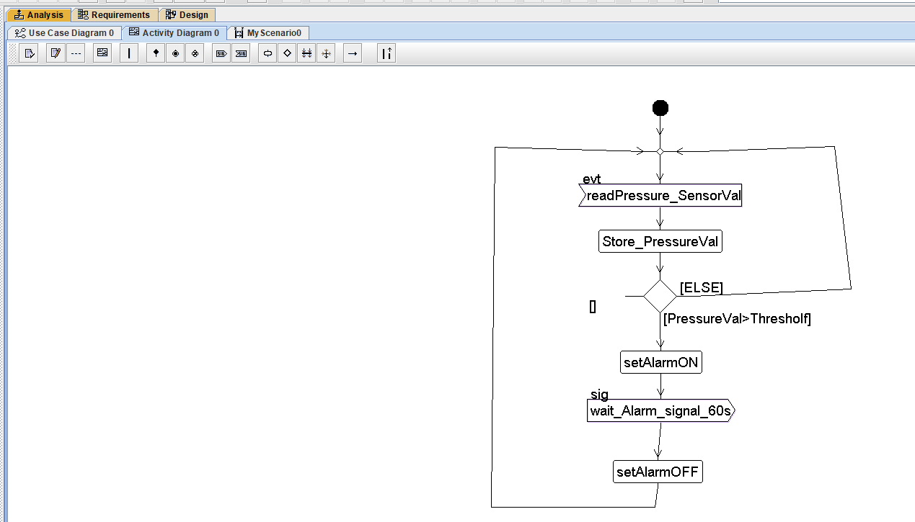

Sequence Diagram
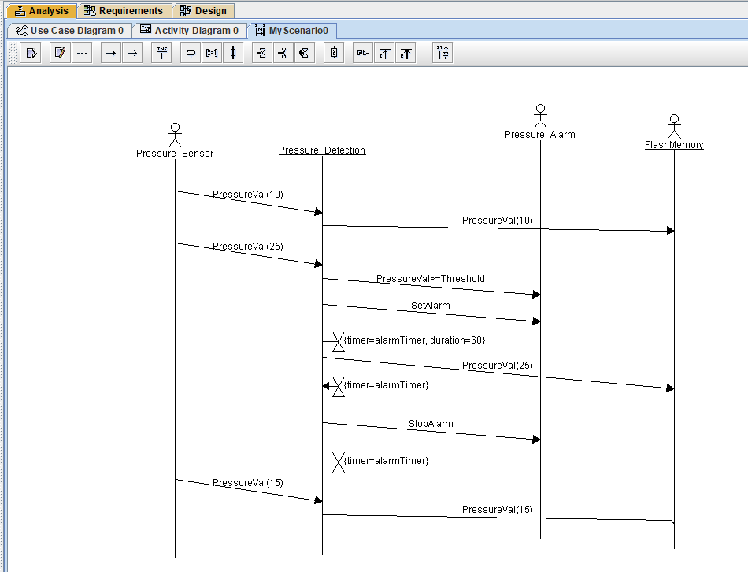

System / Software Design
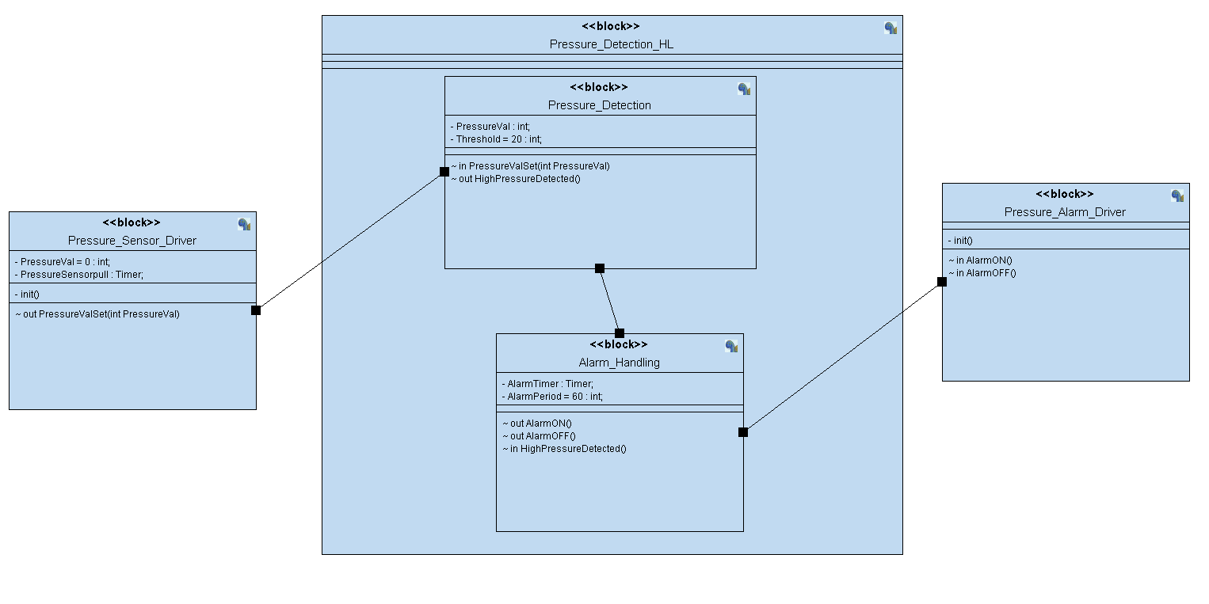

State Diagrams:

Pressure Sensor Diver
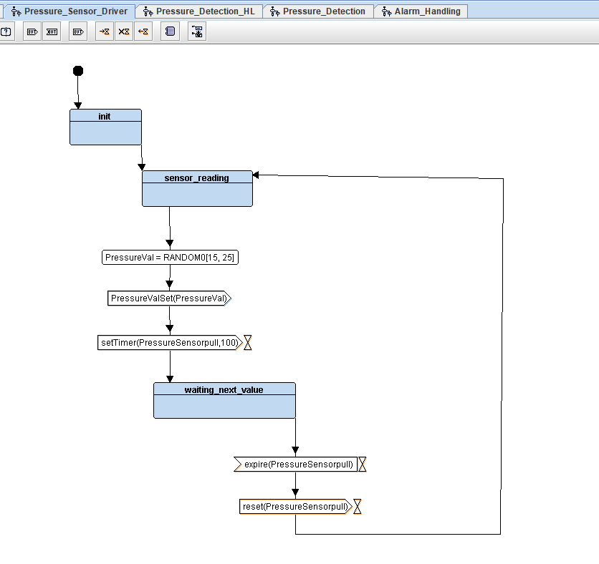

Pressure Detection Main Functionality
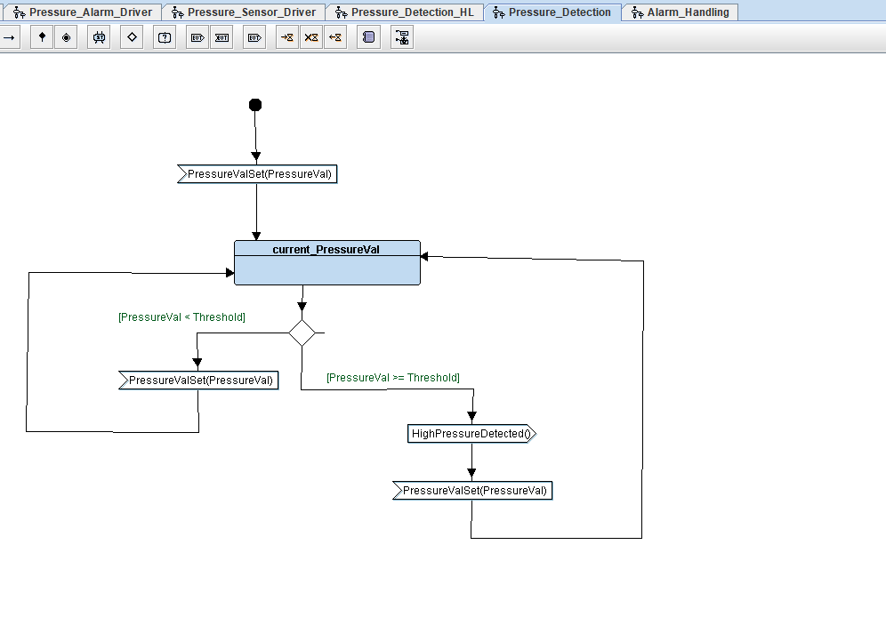

Alarm handling
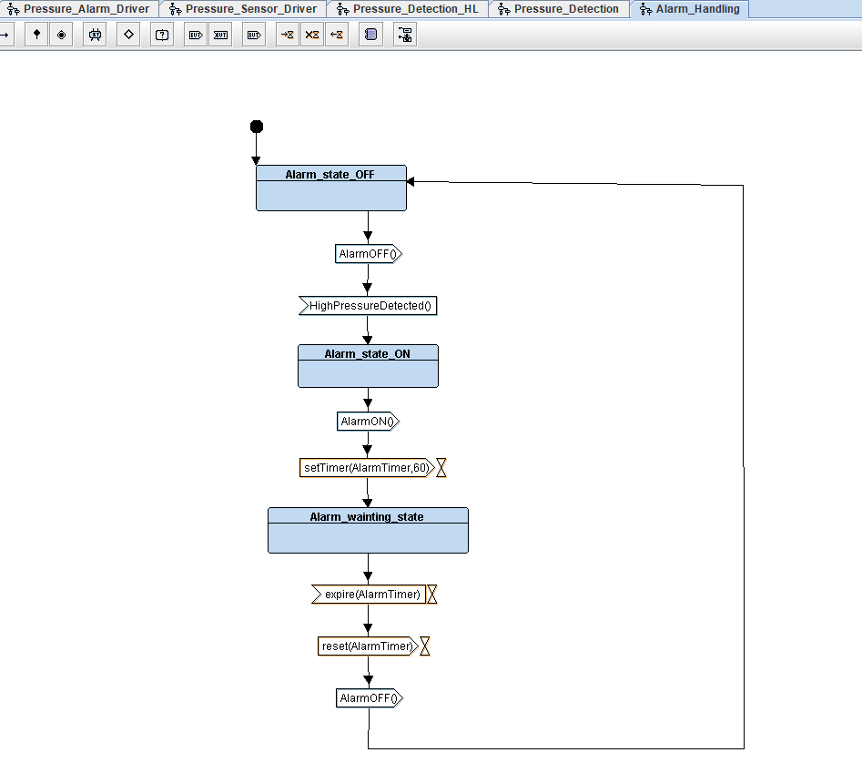

Pressure Alarm Driver
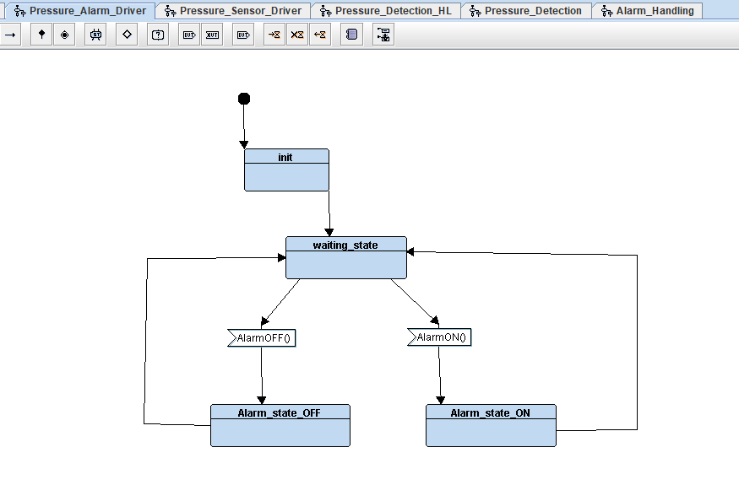

Software Implementation
After going through all above diagrams documentation, it was directly started with implementation of each software module as .c & .h files. In the GitHub project, one can find all related files along with startup & linker scripts that are used to bring up the entire software on STM32 Controller.

Symbol Table:
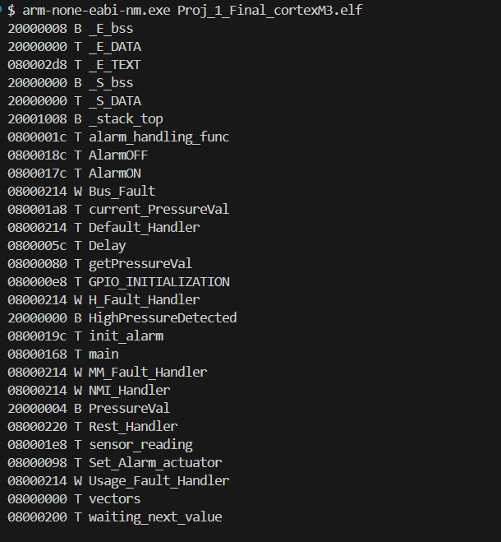

System Verification with Proteus Simulation
Initial State
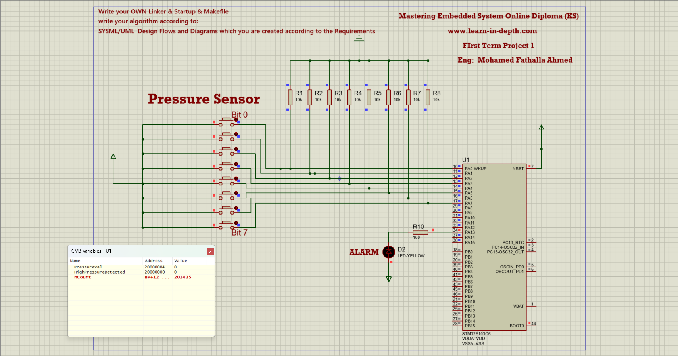
High Pressure Detected = 1
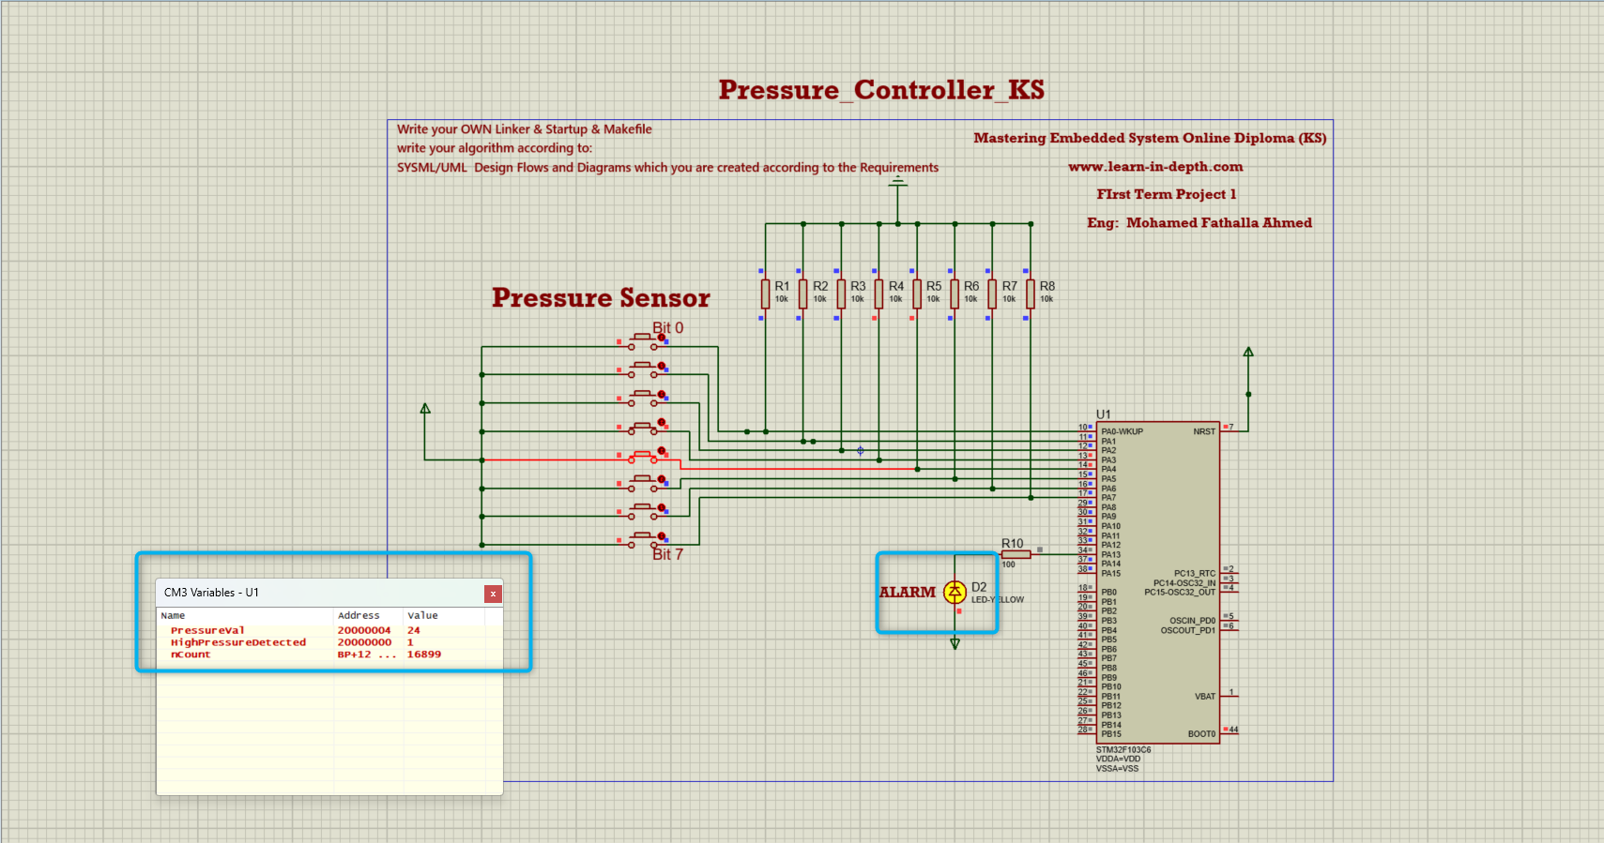

High Pressure NOT Detected = 0
