

Project 2 Learn in Depth
  - student MAnagement system
Mohamed Fathalla Ahmed | Mastering Embedded Systems | 16.08.2024
Table of Contents
Project Scope / Problem Statement 2
Methodology / Approach 2
Functions Description 3
Software Testing Results 6

Project Scope / Problem Statement
For this project, a student information management system software has to be implemented using queue method.
The following operations have to be included in the system:
- Store the first name of the student
- Store the last name of the student
- Store the unique roll number of the student
- Store the GPA of every student
- Store the courses registered by the student

Methodology / Approach
The main idea is to develop different functions for each operation. All functions together will form the entire software. As mentioned earlier, the mechanism of queue data structure (as a dynamic linked list) is the underlying methodology behind the entire software.
The entire SW is built up based on the following files:
- Queue_LinkedList.c
- Queue_LinkedList.h
- main.c
- student_data_file.txt

More details of the functions will follow in the next chapters.

Functions Description
Main.c is including the main infinite loop with all options to be selected by the user of the software. As well as, Queue_LinkedList.h is included which provides all functions needed for the software.
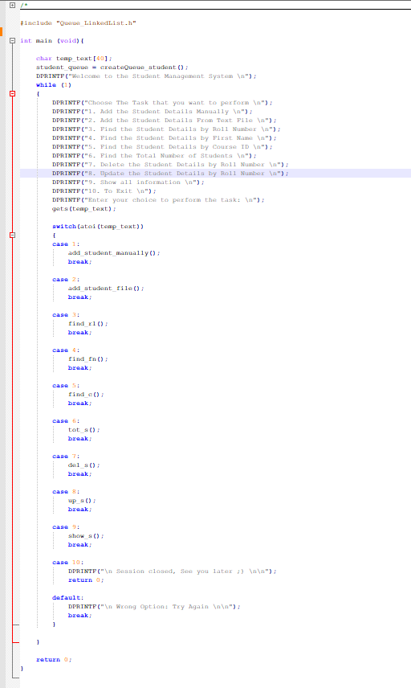
In the “Queue_LinkedList.h” the queue structure is defined along with the declarations of the functions needed to handle the queue mechanism and also the user functions:
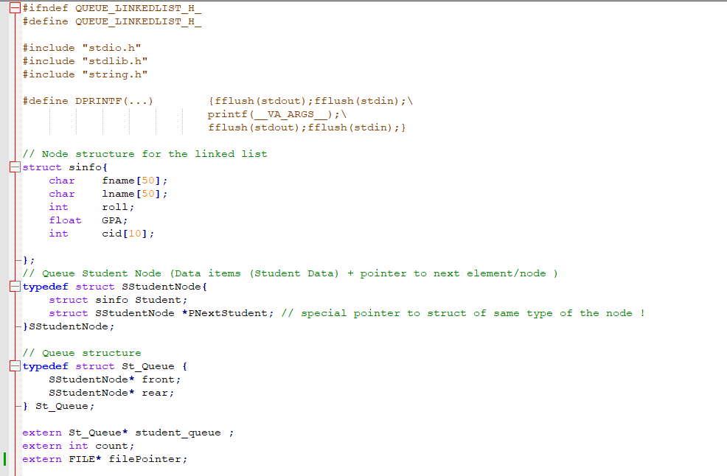

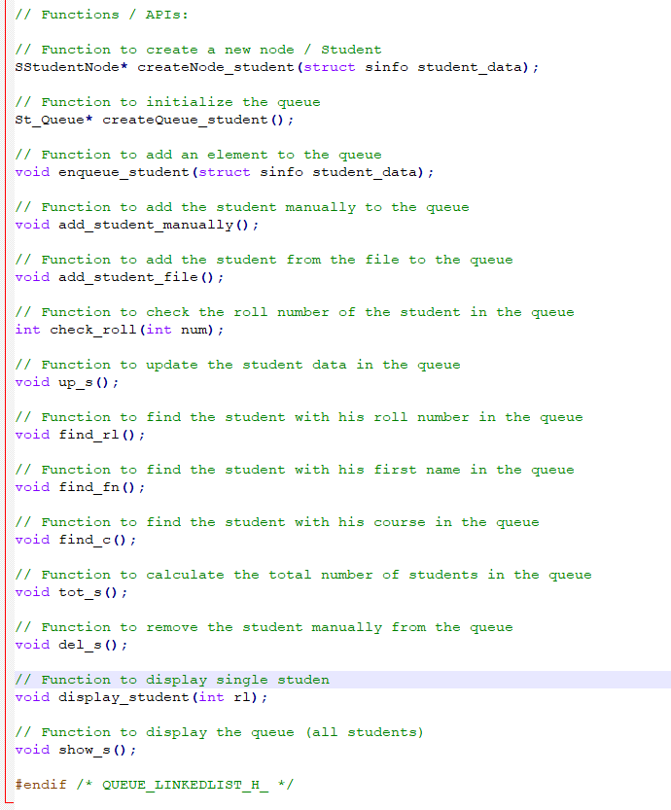
The implementation file “Queue_LinkedList.c” is huge and would take a lot of screenshots to cover. Therefore, I would only refer to it here with the following github.com project under this link: https://github.com/MohamedFathalla91/Master_Embedded_Systems/blob/development/Unit_5_First_Term_Projects/Project2_Student_Management_System/Queue_LinkedList.c

Software Testing Results
Add Students from File:
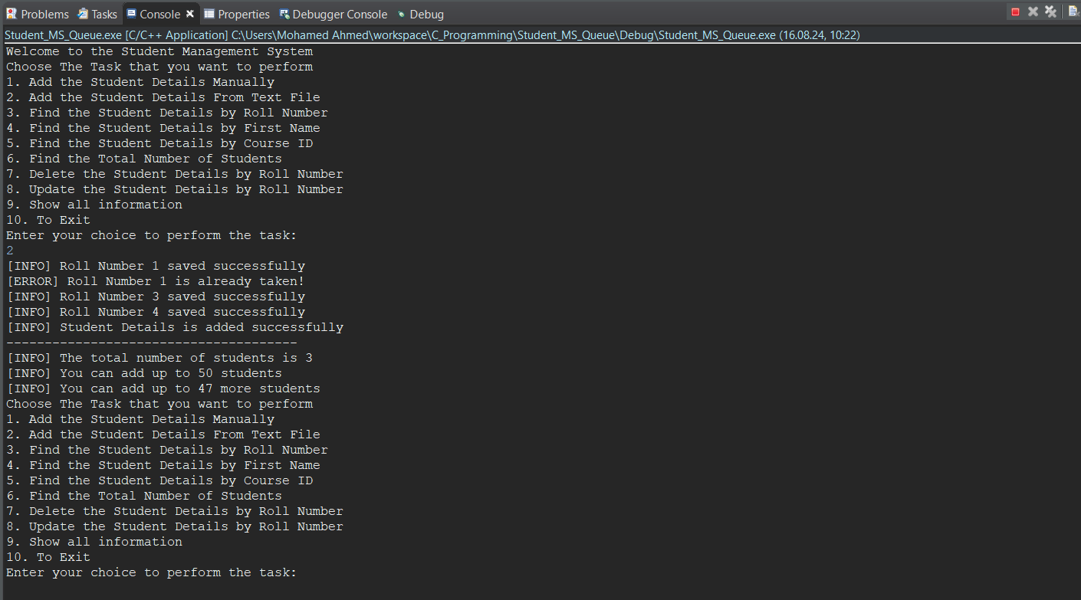
Add Student Manually:
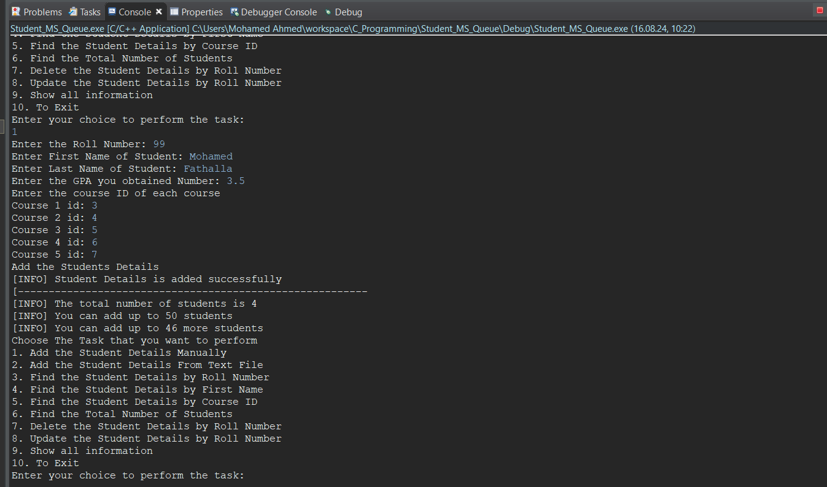

Find the student by roll number:
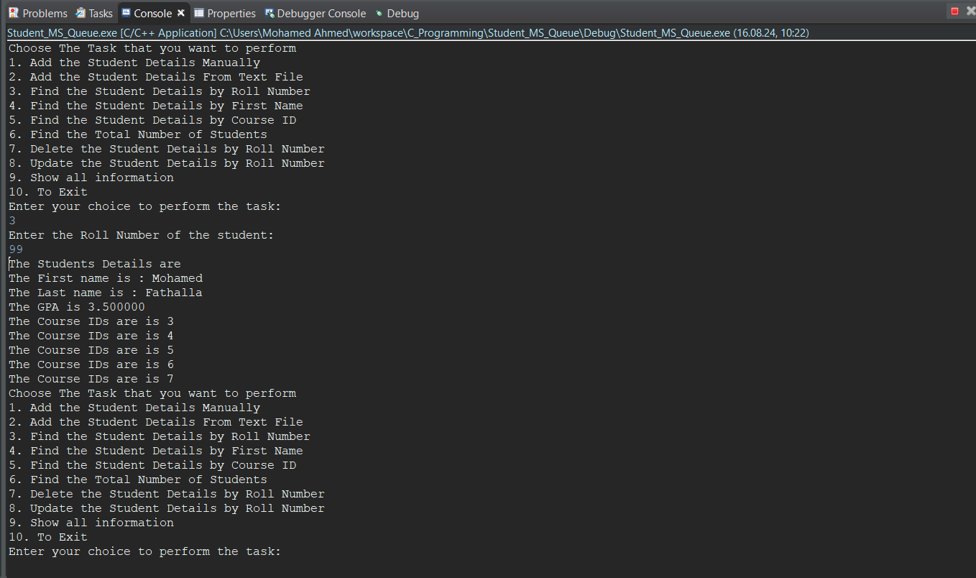
Find the student by the first name:
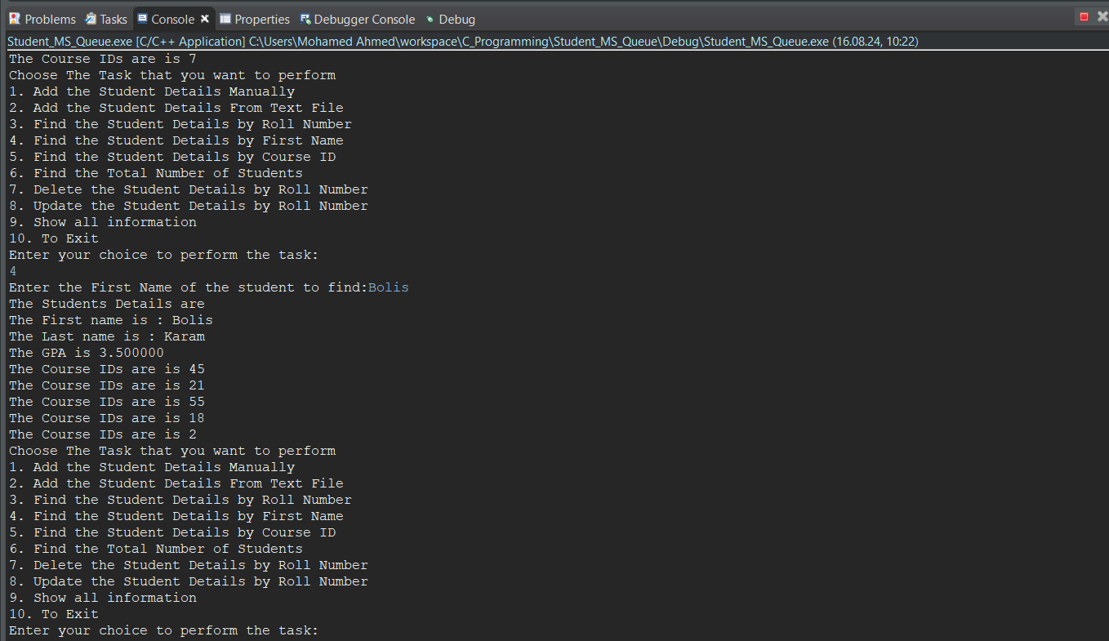

Find all students with the same course ID:
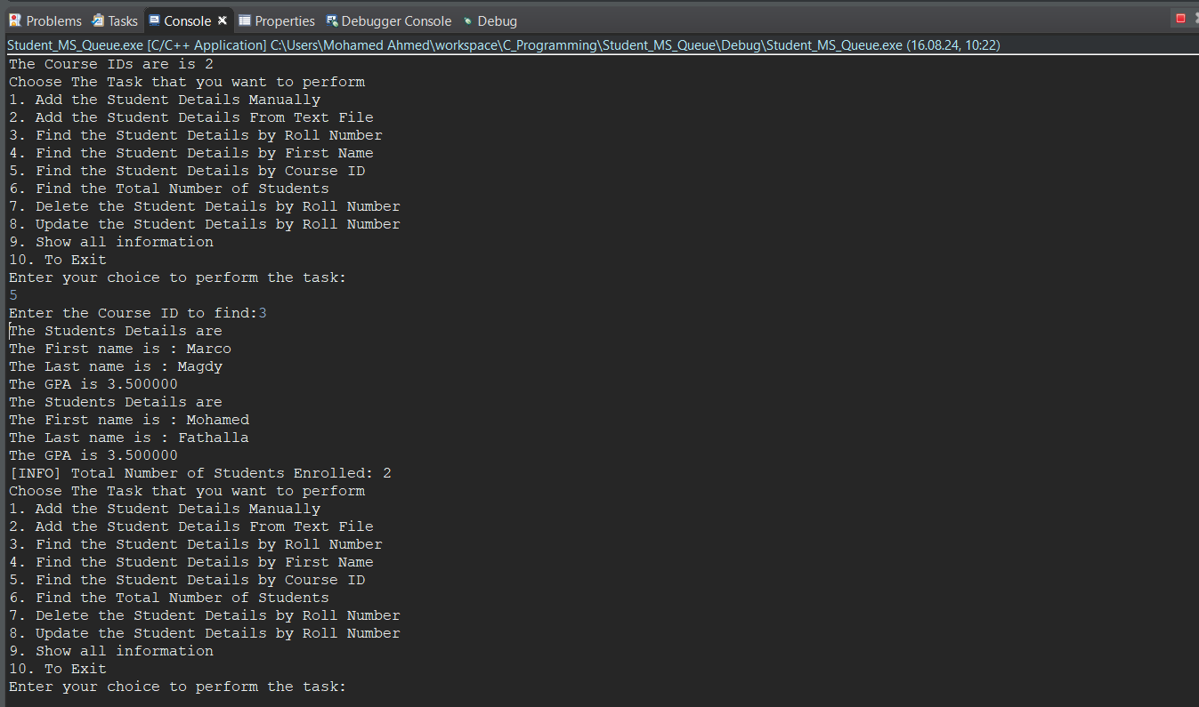
Calculate the total number of students:
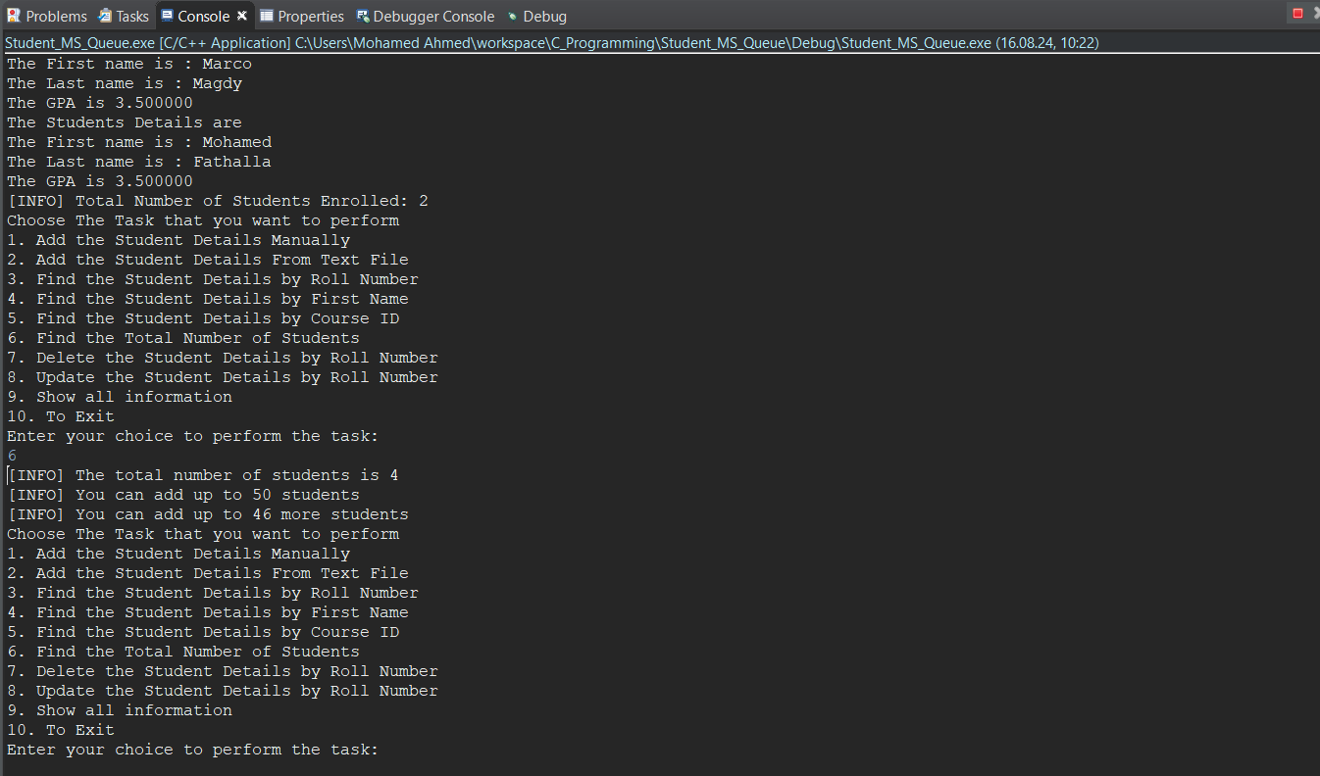
Remove single student by his roll number & display all students:
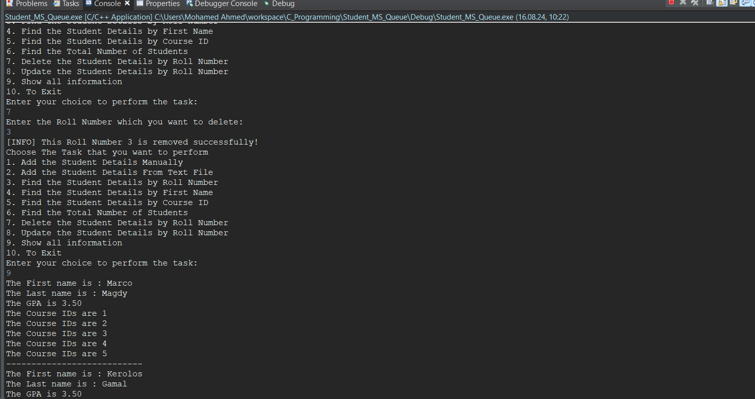
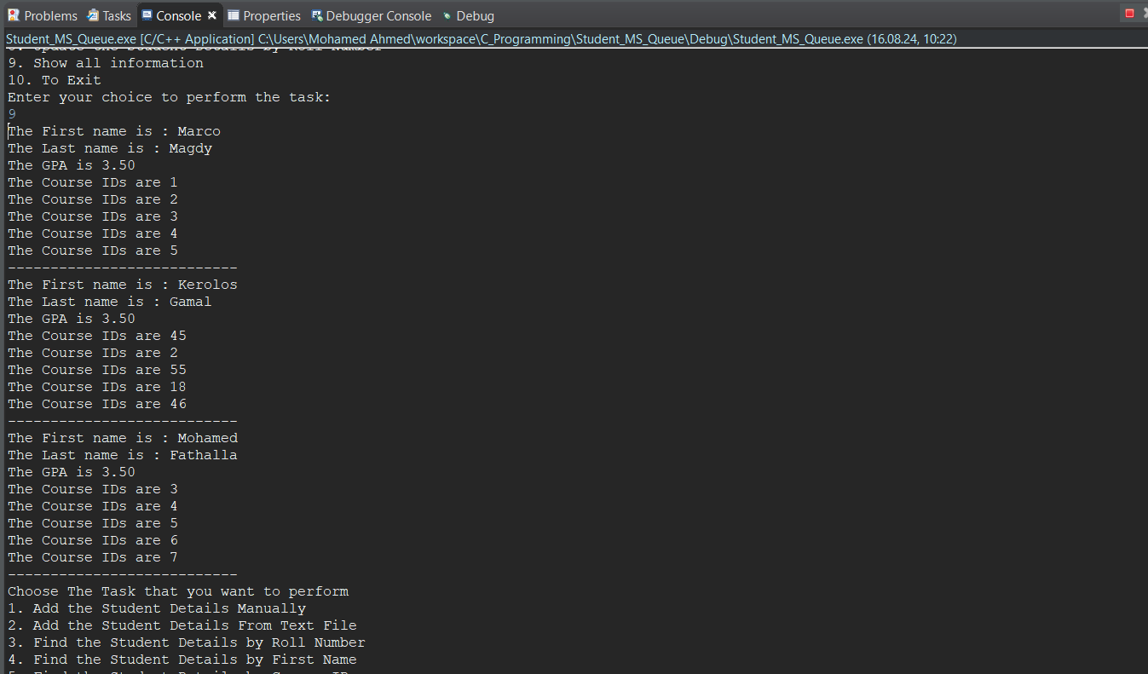

Update single student and display the all students:
