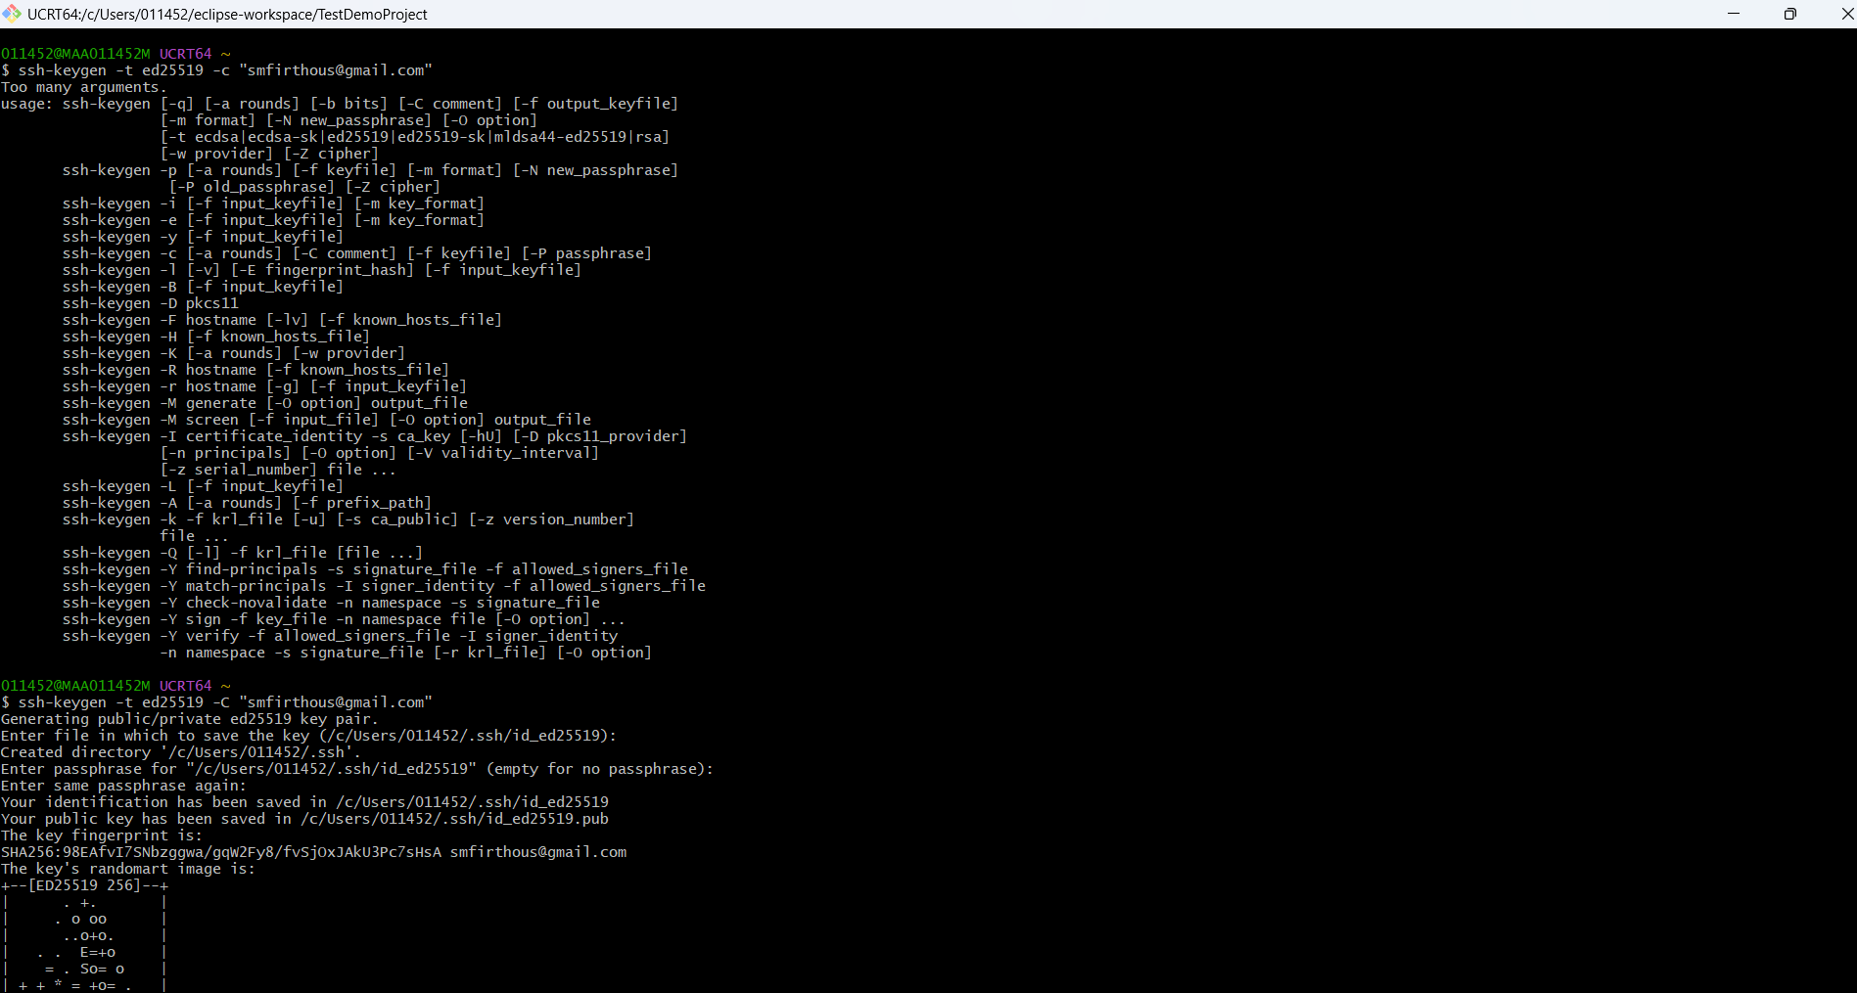

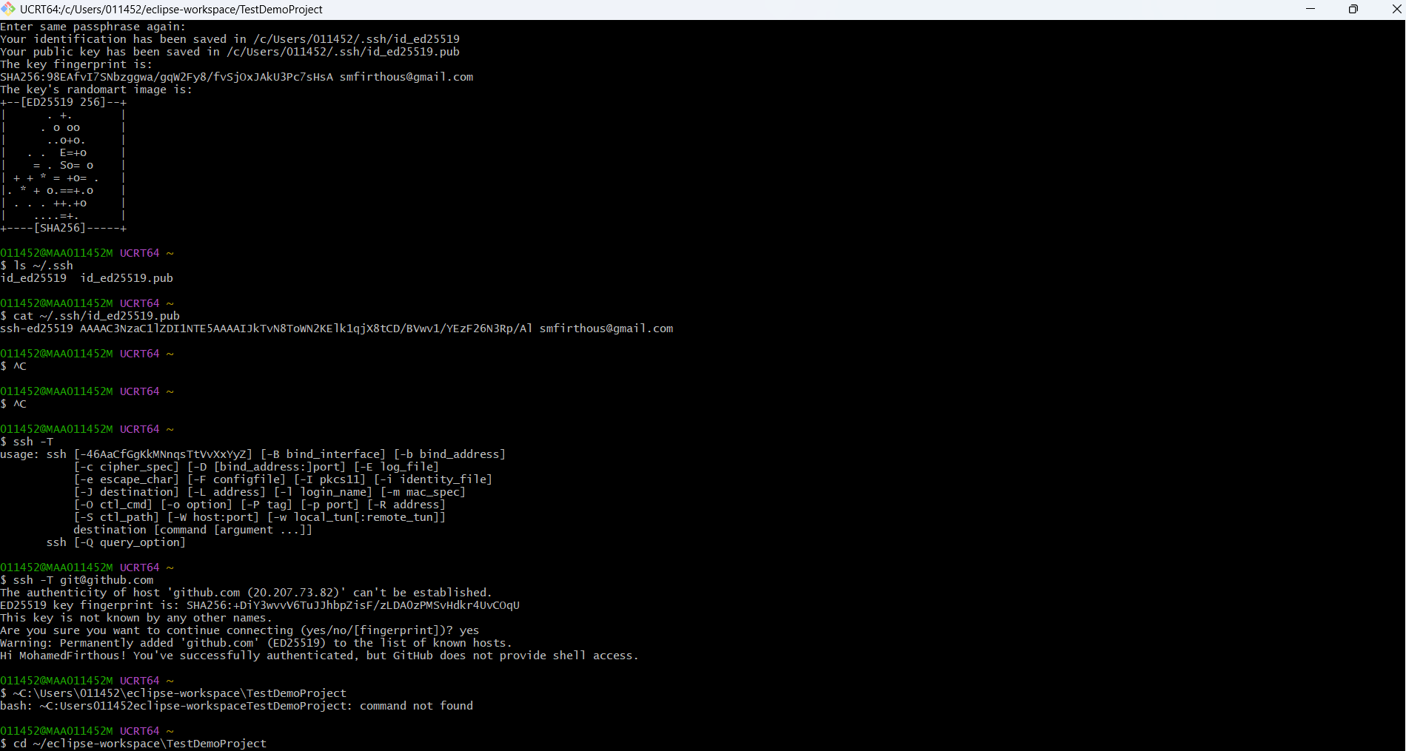

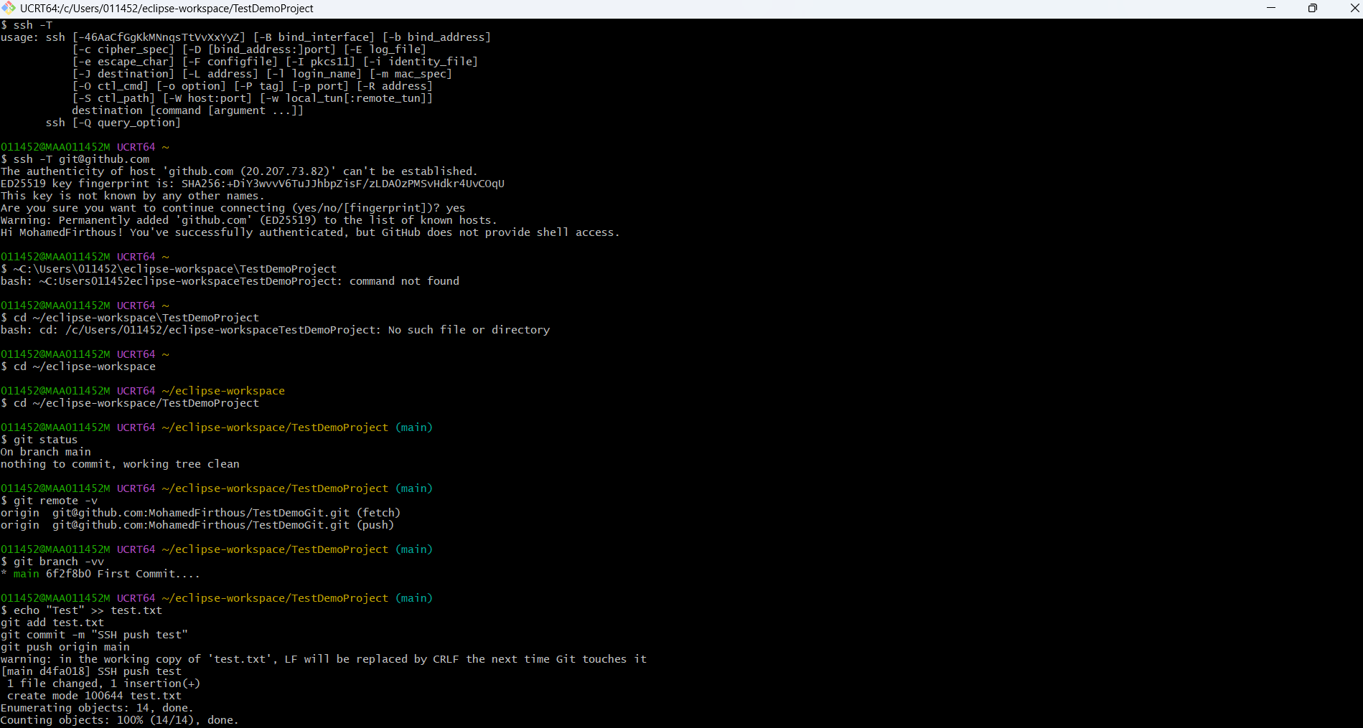

011452@MAA011452M UCRT64 ~
$ ssh-keygen -t ed25519 -c "smfirthous@gmail.com"
Too many arguments.
usage: ssh-keygen [-q] [-a rounds] [-b bits] [-C comment] [-f output_keyfile]
[-m format] [-N new_passphrase] [-O option]
[-t ecdsa|ecdsa-sk|ed25519|ed25519-sk|mldsa44-ed25519|rsa]
[-w provider] [-Z cipher]
ssh-keygen -p [-a rounds] [-f keyfile] [-m format] [-N new_passphrase]
[-P old_passphrase] [-Z cipher]
ssh-keygen -i [-f input_keyfile] [-m key_format]
ssh-keygen -e [-f input_keyfile] [-m key_format]
ssh-keygen -y [-f input_keyfile]
ssh-keygen -c [-a rounds] [-C comment] [-f keyfile] [-P passphrase]
ssh-keygen -l [-v] [-E fingerprint_hash] [-f input_keyfile]
ssh-keygen -B [-f input_keyfile]
ssh-keygen -D pkcs11
ssh-keygen -F hostname [-lv] [-f known_hosts_file]
ssh-keygen -H [-f known_hosts_file]
ssh-keygen -K [-a rounds] [-w provider]
ssh-keygen -R hostname [-f known_hosts_file]
ssh-keygen -r hostname [-g] [-f input_keyfile]
ssh-keygen -M generate [-O option] output_file
ssh-keygen -M screen [-f input_file] [-O option] output_file
ssh-keygen -I certificate_identity -s ca_key [-hU] [-D pkcs11_provider]
[-n principals] [-O option] [-V validity_interval]
[-z serial_number] file ...
ssh-keygen -L [-f input_keyfile]
ssh-keygen -A [-a rounds] [-f prefix_path]
ssh-keygen -k -f krl_file [-u] [-s ca_public] [-z version_number]
file ...
ssh-keygen -Q [-l] -f krl_file [file ...]
ssh-keygen -Y find-principals -s signature_file -f allowed_signers_file
ssh-keygen -Y match-principals -I signer_identity -f allowed_signers_file
ssh-keygen -Y check-novalidate -n namespace -s signature_file
ssh-keygen -Y sign -f key_file -n namespace file [-O option] ...
ssh-keygen -Y verify -f allowed_signers_file -I signer_identity
-n namespace -s signature_file [-r krl_file] [-O option]

011452@MAA011452M UCRT64 ~
$ ssh-keygen -t ed25519 -C "smfirthous@gmail.com"
Generating public/private ed25519 key pair.
Enter file in which to save the key (/c/Users/011452/.ssh/id_ed25519):
Created directory '/c/Users/011452/.ssh'.
Enter passphrase for "/c/Users/011452/.ssh/id_ed25519" (empty for no passphrase):
Enter same passphrase again:
Your identification has been saved in /c/Users/011452/.ssh/id_ed25519
Your public key has been saved in /c/Users/011452/.ssh/id_ed25519.pub
The key fingerprint is:
SHA256:98EAfvI7SNbzggwa/gqW2Fy8/fvSjOxJAkU3Pc7sHsA smfirthous@gmail.com
The key's randomart image is:
+--[ED25519 256]--+
| . +. |
| . o oo |
| ..o+o. |
| . . E=+o |
| = . So= o |
| + + * = +o= . |
|. * + o.==+.o |
| . . . ++.+o |
| ....=+. |
+----[SHA256]-----+

011452@MAA011452M UCRT64 ~
$ ls ~/.ssh
id_ed25519 id_ed25519.pub

011452@MAA011452M UCRT64 ~
$ cat ~/.ssh/id_ed25519.pub
ssh-ed25519 AAAAC3NzaC1lZDI1NTE5AAAAIJkTvN8ToWN2KElk1qjX8tCD/BVwv1/YEzF26N3Rp/Al smfirthous@gmail.com

011452@MAA011452M UCRT64 ~
$ ^C

011452@MAA011452M UCRT64 ~
$ ^C

011452@MAA011452M UCRT64 ~
$ ssh -T
usage: ssh [-46AaCfGgKkMNnqsTtVvXxYyZ] [-B bind_interface] [-b bind_address]
[-c cipher_spec] [-D [bind_address:]port] [-E log_file]
[-e escape_char] [-F configfile] [-I pkcs11] [-i identity_file]
[-J destination] [-L address] [-l login_name] [-m mac_spec]
[-O ctl_cmd] [-o option] [-P tag] [-p port] [-R address]
[-S ctl_path] [-W host:port] [-w local_tun[:remote_tun]]
destination [command [argument ...]]
ssh [-Q query_option]

011452@MAA011452M UCRT64 ~
$ ssh -T git@github.com
The authenticity of host 'github.com (20.207.73.82)' can't be established.
ED25519 key fingerprint is: SHA256:+DiY3wvvV6TuJJhbpZisF/zLDA0zPMSvHdkr4UvCOqU
This key is not known by any other names.
Are you sure you want to continue connecting (yes/no/[fingerprint])? yes
Warning: Permanently added 'github.com' (ED25519) to the list of known hosts.
Hi MohamedFirthous! You've successfully authenticated, but GitHub does not provide shell access.

011452@MAA011452M UCRT64 ~
$ ~C:\Users\011452\eclipse-workspace\TestDemoProject
bash: ~C:Users011452eclipse-workspaceTestDemoProject: command not found

011452@MAA011452M UCRT64 ~
$ cd ~/eclipse-workspace\TestDemoProject
bash: cd: /c/Users/011452/eclipse-workspaceTestDemoProject: No such file or directory

011452@MAA011452M UCRT64 ~
$ cd ~/eclipse-workspace

011452@MAA011452M UCRT64 ~/eclipse-workspace
$ cd ~/eclipse-workspace/TestDemoProject

011452@MAA011452M UCRT64 ~/eclipse-workspace/TestDemoProject (main)
$ git status
On branch main
nothing to commit, working tree clean

011452@MAA011452M UCRT64 ~/eclipse-workspace/TestDemoProject (main)
$ git remote -v
origin git@github.com:MohamedFirthous/TestDemoGit.git (fetch)
origin git@github.com:MohamedFirthous/TestDemoGit.git (push)

011452@MAA011452M UCRT64 ~/eclipse-workspace/TestDemoProject (main)
$ git branch -vv
* main 6f2f8b0 First Commit....

011452@MAA011452M UCRT64 ~/eclipse-workspace/TestDemoProject (main)
$ echo "Test" >> test.txt
git add test.txt
git commit -m "SSH push test"
git push origin main
warning: in the working copy of 'test.txt', LF will be replaced by CRLF the next time Git touches it
[main d4fa018] SSH push test
1 file changed, 1 insertion(+)
create mode 100644 test.txt
Enumerating objects: 14, done.
Counting objects: 100% (14/14), done.
Delta compression using up to 14 threads
Compressing objects: 100% (10/10), done.
Writing objects: 100% (14/14), 1.49 KiB | 509.00 KiB/s, done.
Total 14 (delta 1), reused 0 (delta 0), pack-reused 0 (from 0)
remote: Resolving deltas: 100% (1/1), done.
To github.com:MohamedFirthous/TestDemoGit.git
* [new branch] main -> main

011452@MAA011452M UCRT64 ~/eclipse-workspace/TestDemoProject (main)
$

